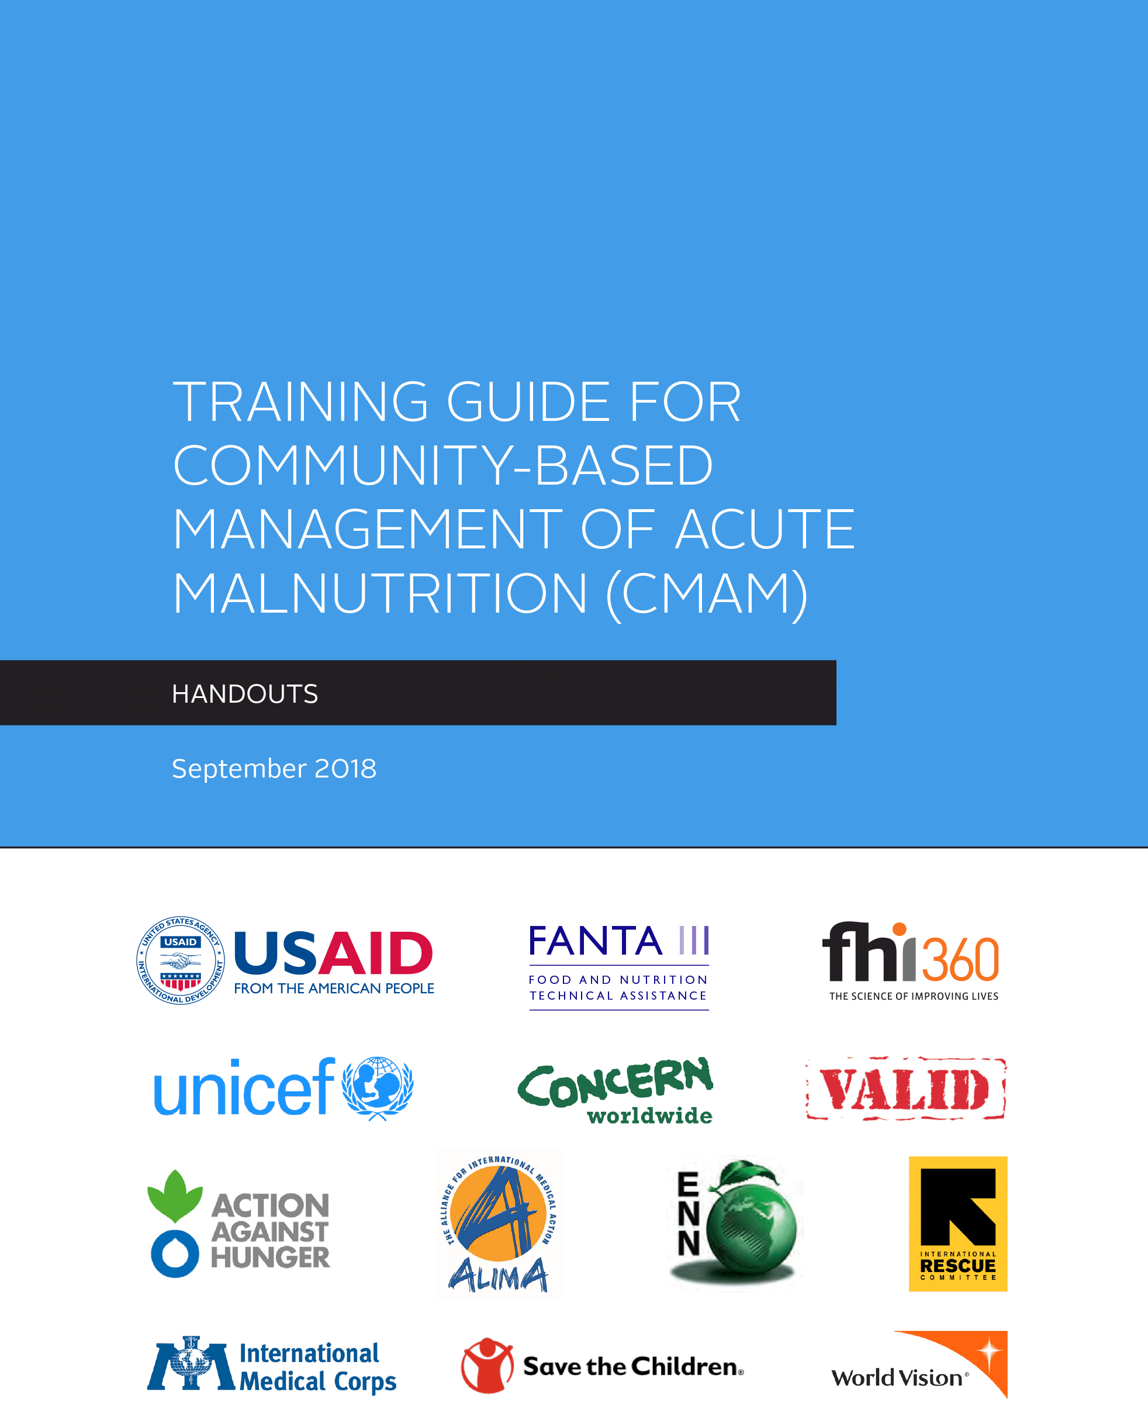

Recommended Citation: Food and Nutrition Technical Assistance III Project (FANTA). 2018. Training Guide for Community-Based Management of Acute Malnutrition (CMAM): Handouts. Washington, DC: FHI 360/FANTA.
September 2018
The training materials are made possible by the generous support of the American people through the support of the Office of Maternal and Child Health and Nutrition, Bureau for Global Health, U.S. Agency for International Development (USAID) and USAID/Botswana under terms of Cooperative Agreement No. AID-OAA-A-12-00005, through the Food and Nutrition Technical Assistance III Project (FANTA), managed by FHI 360.
The contents are the responsibility of FHI 360 and do not necessarily reflect the views of USAID or the United States Government.

CONTENTS

Acknowledgements 7
Preface 8
Module One: Overview of Community-Based Management of Acute Malnutrition (CMAM) 1
Handout 1.1 Abbreviations and Acronyms 4
Handout 1.2 Terminology for CMAM 7
Handout 1.3 Key Information on Undernutrition 14
Handout 1.4 CMAM Principles 16
Handout 1.5 Classification of Acute Malnutrition for CMAM 17
Handout 1.6 Screening, Admission, and Discharge Using MUAC 18
Handout 1.7 CMAM Components and How They Work Together 20
Handout 1.8 Case Studies 23
Handout 1.9 Implementing CMAM in Different Contexts 25
Handout 1.10 Factors to Consider in Seeking to Provide Services for the Management of SAM 26
Handout 1.11 Integrating CMAM into Routine Health Services at the District Level 29
Handout 1.12 Essentials of CMAM 30
Handout 1.13 Field Visit Checklist 32
Handout 1.14 PowerPoint Presentation Slide Images 33
Module Two: Defining and Measuring Acute Malnutrition 43
Handout 2.1 Causal Framework of Undernutrition 46
Handout 2.2 Undernutrition Definitions, Indices, Indicators, and Indicator Cutoffs 47
Handout 2.3 Clinical Manifestations of Acute Malnutrition 50
Handout 2.4 Assessing Age, Bilateral Pitting Oedema, MUAC, Weight, and Height 52
Handout 2.5 Weight-for-Height/Length Tables For Field Use 61
Handout 2.6 C-MAMI Tool Version 2.0 64
Exercise 2.1 Grades of Bilateral Pitting Oedema 77
Exercise 2.2 Calculating WFL/WFH and Classifying Acute Malnutrition 79
Module Three: Community Outreach 81
Handout 3.1 Principles of Community Outreach in the Context of CMAM 84
Handout 3.2 Community Assessments 86
Handout 3.3 Community Assessment Steps and Methods 89
Handout 3.4 Community Outreach: From Assessment to Strategy 91
Handout 3.5 Community Outreach Strategy 92
Handout 3.6 Example: Selecting Candidates for House-to-House Case-Finding 94
Handout 3.7 Developing Simple and Standardised CMAM Messages 95
Handout 3.8 Reference: Handbill Messages 97
Handout 3.9 Reference: Visual Communication Tools 101
Handout 3.10 Key Actions in Community Mobilisation and Training 105
Handout 3.11 Planning and Implementing a Mass Training Campaign for Mothers and Family Members 108
Handout 3.12 Elements and Sequencing of CMAM Community Outreach 110
Handout 3.13 Team Checklist for Community Outreach Field Visit 111
Exercise 3.2 Overcoming Obstacles to Community Participation in CMAM 113
Exercise 3.3 Comparison of Case-finding Models 114
Exercise 3.4 Worksheet: Selecting Candidates for Community Outreach 115
Module Four: Outpatient Care for the Management of SAM Without Medical Complications 116
Handout 4.1 Admission Criteria and Entry Categories for CMAM 120
Handout 4.2 Outpatient Care: Admission Criteria Infants Under 6 Months and Children 6–59 Months 124
Handout 4.3 Outpatient Care: Admission Process for Children 6–59 Months 126
Handout 4.4 Outpatient Care Treatment Card for Children 6–59 Months 130
Handout 4.5 RUTF Ration Card for Children 6–59 Months 132
Handout 4.6 Using Outpatient Care Treatment Card and RUTF Ration Card for Children 6–59 Months 133
Handout 4.7 Medical Treatment for Management of SAM in Outpatient Care 135
Handout 4.8 Routine Medicines for SAM in Outpatient Care 137
Handout 4.9 Supplemental Medicines for SAM in Outpatient Care* 138
Handout 4.10 Medicine Protocol Rationale for Outpatient Care (Reference) 139
Handout 4.11 Nutrition Rehabilitation and RUTF for Children 6– 59 Months 142
Handout 4.12 Key Messages for Individual Counselling for Caregivers/Mothers of Children 6–59 Months in Outpatient Care 145
Handout 4.13 C-MAMI Tool Version 2.0: Breastfeeding Counselling and Support Actions 147
Handout 4.14 Outpatient Care: Admission Process for At-Risk Mothers and Infants Under 6 Months 171
Handout 4.15 Outpatient Care Treatment Card for At-Risk Mothers and Infant Under 6 Months 172
Handout 4.16 Outpatient Care Action Protocol for Infants Under 6 Months and Children 6–59 Months 174
Handout 4.17 Referral to Inpatient Care or Follow-Up Home Visits for Infants Under 6 Months and Children 6–59 Months 175
Handout 4.18 Referral Slip for Infants Under 6 Months and Children 6–59 Months 177
Handout 4.19 Outpatient Care Discharge Criteria for At-risk Mothers and Infants Under 6 Months and Children 6–59 Months 178
Handout 4.20 Discharge Criteria and Exit Categories for CMAM 180
Handout 4.21 Essentials of Outpatient Care for SAM Without Medical Complications 184
Handout 4.22 Outpatient Care Field Practice Checklist 185
Exercise 4.1 Outpatient Care Admission for Infants Under 6 Months and Children 6–59 Months 188
Exercise 4.2 Outpatient Care Treatment Card and RUTF Ration Card for Children 6–59 Months 189
Exercise 4.3 Identifying Infants Under 6 Months and Children 6-59 Months Who May Need Referral to Inpatient Care or Follow-Up Home Visits 191
Exercise 4.4 Partially Completed Outpatient Care Treatment Cards (examples) 192
Module Five: Inpatient Care for the Management of SAM with Medical Complications in the Context of CMAM 198
Handout 5.1 Essentials for the Management of Infants and Children with Medical Complications in Inpatient Care 201
Handout 5.2 Admission Process in Inpatient Care 203
Handout 5.3 Admission Criteria and Entry Categories for CMAM 206
Handout 5.4 Discharge Procedures in Inpatient Care 210
Handout 5.5 Discharge Criteria and Exit Categories for CMAM 211
Handout 5.6 Medical and Dietary Treatment of SAM With Medical Complications 215
Handout 5.7 Practical Implications in Discharges from Inpatient Care 217
Handout 5.8 Inpatient Care Field Visit Checklist 219
Exercise 5.1 Referral from Inpatient to Outpatient Care 221
Module Six: Management of Moderate Acute Malnutrition (MAM) in the Context of CMAM 222
Handout 6.1 Management of Moderate Acute Malnutrition (MAM) in Emergencies 225
Handout 6.2 Principles of Supplementary Feeding for the Management of Moderate Acute Malnutrition (MAM) 230
Handout 6.3 Admission Procedures in Supplementary Feeding 231
Handout 6.4 Admission Criteria and Entry Categories for CMAM 233
Handout 6.5 Discharge Criteria and Exit Categories for CMAM 237
Handout 6.6 Classification of Acute Malnutrition for CMAM 242
Handout 6.7 Supplementary Feeding Treatment Card 243
Handout 6.8 Medical Treatment Protocols for the Management of MAM in Supplementary Feeding 244
Handout 6.9 Nutrition Rehabilitation Protocol for the Management of MAM 245
Handout 6.10 Food Commodities Used for the Management of Acute Malnutrition 247
Handout 6.11 Supplementary Feeding Ration Card 249
Handout 6.12 Referral Slip 250
Handout 6.13 Supplementary Feeding Field Visit Checklist 251
Exercise 6.1 Referrals in CMAM 253
Module Seven: Planning CMAM Services at the District Level 254
Handout 7.1 Key Elements Of CMAM Framework Aligned with the Health Systems Strengthening (HSS) Building Blocks 257
Handout 7.2 Case Study: Situation Analysis, Ghana 260
Handout 7.3 Assessing the Nutrition Situation 268
Handout 7.4 Mapping Matrices 272
Handout 7.5 Capacity Grid for CMAM at the District Level 276
Handout 7.6 SWOT Analysis for CMAM 280
Handout 7.7: Example Capacity Grids for Outpatient Care at the Health Facility Level and CMAM at the National Level 281
Handout 7.8 Using a Logical Framework for CMAM 286
Handout 7.9 Example Logical Framework for CMAM 289
Handout 7.10 Calculating Estimated SAM and MAM Cases 291
Handout 7.11 Staff Needs, Roles and Responsibilities 292
Handout 7.12 Calculating Estimated RUTF Needs 294
Handout 7.13 Overview of Resources for CMAM 295
Handout 7.14 Matrix for Action Planning 299
Handout 7.15 Matrix for Transition Planning of CMAM 302
Handout 7.16 Guidance for Contingency Planning for CMAM 305
Module Eight: Monitoring and Reporting on CMAM 309
Handout 8.1 Monitoring the Individual Infant or Child in Outpatient Care 312
Handout 8.2 Registration Numbering System Proposed for CMAM 313
Handout 8.3 Monitoring and Reporting on CMAM 314
Handout 8.4 Filing Outpatient Care Treatment Cards 317
Handout 8.5 Site Tally Sheet for the Management of SAM and Nutritionally Vulnerable Infants Under 6 Months 319
Handout 8.6 Site Report Sheet for the Management of SAM and Nutritionally Vulnerable Infants Under 6 Months 320
Handout 8.7 District or National Reporting for the Management of SAM and Nutritionally Vulnerable Infants Under 6 Months 321
Handout 8.8 CMAM Indicators 322
Handout 8.9 Principles of Coverage 326
Handout 8.10 Monitoring Barriers to Access 327
Handout 8.11 Support and Supervision for CMAM 328
Handout 8.12 Support and Supervision Checklist for Outpatient Care (Example) 331
Handout 8.13 Support and Supervision Checklist for Community Outreach (Example) 333
Handout 8.14 Guidance on CMAM Reporting 335
Exercise 8.1 Outpatient Care Site Tally Sheet and Site Reporting Sheet 337
Exercise 8.1(b) Outpatient Care Site Reporting Sheet 338
Exercise 8.2 Completing Site Tally Sheet 339
Exercise 8.4 Analysis of the Site Reports of Three Outpatient Care Sites and One Inpatient Care Site 341

Acknowledgements
The development of the original 2008 Training Guide for Community-Based Management of Acute Malnutrition (CMAM) and the 2018 revision were the product of collaboration between many different people and organisations, all of whom contributed greatly to the final product. We would like to acknowledge the contribution of the following people and organisations:

Development of the Original 2008 Training Guide for CMAM
We would like to thank Hedwig Deconinck, Kristen Cashin, and Joan Whelan (Food and Nutrition Technical Assistance Project [FANTA]); Valerie Gatchell (Concern Worldwide); Tanya Khara (UNICEF); Anne Walsh (Valid International); Chantal Gegout (World Health Organisation [WHO]); and Margaret Ferris-Morris, Caroline Grobler-Tanner, Jamie Lee, and Maryanne Stone-Jiménez (independent consultants) for their valuable contributions as authors of various sections of the modules.
We would like to thank Caroline Abla and Eunyong Chung (U.S. Agency for International Development [USAID]); Mohamed Ayoya, Leah Richardson, Mahendra Sheth, Adriana Zarrelli, and others (UNICEF); Andre Briend (WHO); Mike Neequaye (Ghana Health Service); Marie-Sophie Simon (Action Against Hunger); Nicky Dent, Kate Golden, Lynda Kiess, and others (Concern Worldwide), Kathryn Bolles (Save the Children); Mesfin Teklu (World Vision International); Fred Grant (formerly FANTA); Sandra Remancus (FANTA); Tula Michaelides and Renata Seidel (FHI 360); and Joseph Somuah Akuamoah and Sheikh Shahed Rahman (independent consultants) for technical inputs and review that strengthened the document.

2018 Revision of the Training Guide for CMAM
We would like to thank Alice Nkoroi, Rebecca Egan, and Sandra Remancus (FANTA); Amanda Yourchuck (formerly FANTA); Marie McGrath (Emergency Nutrition Network); and Mary Lung’aho and Maryanne Stone-Jiménez (independent consultants) for their valuable contributions in the revision of various sections of the modules.
We would like to thank Lindy Fenlason, Timothy Quick, Erin Boyd, Sonia Walia, Judy Canahuati, and Elizabeth Bontrager (USAID); Zita Weise Prinzo (WHO); Dolores Rio (UNICEF); Andre Briend (University of Copenhagen and University of Tampere); Catherine Adu-Asare (Ghana Health Service); Saul Guerrero, Grace Funnell, and others (Action Against Hunger); Kate Golden, Natalie Sessions, and others (Concern Worldwide); Susan Butler and Nicky Connell (Save the Children); Colleen Emary (World Vision International); Suzanne Brinkmann (International Medical Corp [IMC]); Jeanette Bailey and Bethany Marron (International Rescue Committee [IMC]); and Kevin Phelan (Alliance for International Medical Action [ALIMA]).
We would also like to thank the following members of the Management of At-risk Mothers and Infants Under 6 Months (MAMI) Special Interest Group: Marko Kerac and Louise Day (London School of Hygiene & Tropical Medicine), Jay Berkely (KEMRI/Wellcome Trust); Hatty Barthorp (GOAL); Katie Beck (Partners in Health); Indi Trehan and Kirrily de Polnay (Médecins Sans Frontièrs [MSF]); Nigel Rollins (WHO); and Mija-Tesse Ververs (U.S. Centers for Disease Control and Prevention [CDC]).
For her work editing the revised training materials, we would like to acknowledge Pam Sutton (FANTA).

We also would like to thank all the agencies that have implemented community-based therapeutic care (CTC) and CMAM programmes and that have directly and indirectly contributed to the experience and learning to date from which these modules have been developed.

Preface

In 2017, the World Health Organisation (WHO), United Nations Children’s Fund (UNICEF), and the World Bank estimated that wasting, a form of acute malnutrition, affects the lives of approximately 50.5 million children under 5 years of age globally. Most of these children live in South Asia and Sub-Saharan Africa. Malnutrition is a major public health concern and the underlying cause of deaths in children under 5 years of age; children with acute malnutrition are also three to nine times more likely to die than well-nourished children.
To address the high rates of acute malnutrition, community-based management of acute malnutrition (CMAM), which evolved from the Community-Based Therapeutic Care (CTC) approach, was developed in 2001. The approach aims to reach the maximum number of children with acute malnutrition and to ensure quality, access, and coverage by allowing a majority of children to be treated at many decentralised outpatient care sites. In many countries, CMAM was introduced as an emergency intervention, but it is now increasingly being integrated into routine health service delivery and scaled up as an essential solution for the management of acute malnutrition. Over 70 countries are currently implementing CMAM, with many of them integrating the management of severe acute malnutrition (SAM) into government policies.
The CMAM approach consists of four main components: community outreach, outpatient care for the management of SAM without medical complications, inpatient care for the management of SAM with medical complications, and programmes for the management of moderate acute malnutrition (MAM), such as a supplementary feeding programme (SFP).

The Scope of the Training Guide for CMAM
This training guide focuses on the management of SAM in children 6–59 months of age and takes into account emerging evidence on the management of MAM and the “management of at-risk mothers and infants under 6 months of age (MAMI)”. The training guide is designed to increase participants’ knowledge of and build practical skills to implement CMAM in emergency and non-emergency settings. The guide complements the WHO guidelines and protocols for the management of acute malnutrition and the WHO training modules for inpatient management of severely malnourished children. The guide is intended to be adapted to the local context to ensure that national guidelines and protocols for the management of acute malnutrition and local models and materials are considered. Note that while national guidelines must be respected, this guide reflects evidence-based guidance and/or current best practices, unless otherwise stated.

What Is New in the 2018 Revision?
The 2018 revision of this training guide reflects guidance and recommendations from the following publications: Updates on the Management of Severe Acute Malnutrition in Infants and Children (WHO 2013), Updates on HIV and Infant Feeding (WHO 2016), the Technical Note on Supplementary Foods for the Management of Moderate Acute Malnutrition in Infants and Children 6–59 Months of Age (WHO 2012), and the Joint Statement on WHO Child Growth Standards and the Identification of SAM in Infants and Children (WHO/UNICEF 2009). The revision also provides additional guidance based on the most recent evidence, lessons learned, and best practices. Below are highlights of the changes made to the training guide:

Identification, Admission, and Discharge of Children with Acute Malnutrition: Mid-upper arm circumference (MUAC) and bilateral pitting oedema are used as the primary criteria in the community for the initial screening of acute malnutrition and referral for treatment. Training mothers and family members on MUAC measurement and assessment of bilateral pitting oedema of their children has been added as a strategy to facilitate early case detection and referral for treatment. In addition, the following changes have been made:
- Admission of children 6–59 months for treatment of SAM is based on a MUAC of <115 mm and any degree of bilateral pitting oedema; for MAM treatment, admission is based on a MUAC of 115 to <125 mm.
- The weight-for-height/weight-for-length (WFH/WFL) <-3 z-score of the WHO reference standards is also used to admit for treatment of SAM, and WFH/WFL -3 to <-2 z-score is used to admit for treatment of MAM.
- The same anthropometric indicator used to identify and confirm SAM or MAM on admission is used to determine recovery and discharge from treatment.
- Vitamin A Supplementation in the Treatment of SAM: A high dose of vitamin A is not given to infants and children if they are receiving therapeutic foods that comply with WHO specifications. A high dose of vitamin A is given on admission only if the therapeutic foods provided are not fortified as recommended in the WHO specifications and vitamin A is not part of other daily supplements.
- A high dose of vitamin A is given on day 1 to children with SAM who also have eye signs of vitamin A deficiency and to children with SAM who recently had measles, with a second and a third dose on day 2 and day 15, respectively, regardless of the type of therapeutic food the child is receiving.

Management of HIV-Infected Children with SAM: In addition to the recommendations provided in the 2013 WHO updates on the management of SAM in infants and children, treatment of HIV-infected children with acute malnutrition should follow the national HIV protocols. In high prevalence areas, universal testing of children with acute malnutrition is encouraged if HIV status is unknown. If a child is failing to respond to treatment of acute malnutrition, and HIV status is unknown, it is recommended that the child be tested for HIV as part of the routine treatment.

Management of At-Risk Mothers and Infants under 6 Months of Age (MAMI): Following the 2013 WHO updates on the management of SAM in infants and children, infants under 6 months should be managed according to the same basic principles as children age 6–59 months, including distinguishing those infants with medical complications from those without medical complications and managing the uncomplicated cases in outpatient care. Currently, there is a lack of evidence on the case management of at-risk mothers and infants under 6 months of age; this includes an ongoing debate on anthropometric and non-anthropometric indicators and what criteria to use to define nutritional risk. While research on MAMI is ongoing, expert opinion and programming experiences from members of the MAMI Special Interest Group have been used to provide guidance in this training guide. The technical content is drawn from and references to the C-MAMI Tool Version 2.0. Prior to country level implementation, it is recommended that users refer to latest evidence and recommendations as details of case management strategies and approaches are evolving rapidly. Additional references are available here: https://www.ennonline.net/ourwork/research/mami.

Key guiding principles to the MAMI content in this training guide are as follows:
- Instead of “acute malnutrition”, the term “nutrition vulnerability” is preferred because it captures broader characteristics of the needs of infants under 6 months of age and recognizes that not all these infants are equally vulnerable; for example, some had a low birth weight but are subsequently growing well, while other infants are presently not wasted but are at risk and therefore in need of intervention. It is important that infants “at risk” are distinguished and that the case management identifies and addresses underlying problems such as ability to feed, underlying medical conditions, maternal illness and poor mental health, and adverse social circumstances.
- Nutritionally vulnerable infants under 6 months of age without complications are managed in outpatient care, whereas nutritionally vulnerable infants with complications are referred for 24-hour inpatient care.
- Nutrition support, particularly establishment of effective exclusive breastfeeding, is the main intervention in the case management of infants under 6 months.
- The well-being of an infant is strongly influenced by a mother’s health, mental health, nutrition, and social circumstances; therefore, the mother and infant are best considered as a “mother-infant pair” and are enrolled and managed together.

Combined Protocol for SAM and MAM Treatment: In exceptional emergency situations, the combined protocol for SAM and MAM treatment has been provided as an option in the absence of a SFP and/or outpatient care for the management of SAM without medical complications.

Strengthening the Health System and Planning and Managing Increased Demand for Acute Malnutrition: The training guide emphasizes integration of services for management of acute malnutrition into national health care systems where they exist and provides additional guidance and references on how health systems can better cope with periodic peaks in demand for CMAM services.

Emerging Evidence on the Management of Acute Malnutrition
Ongoing research and emerging evidence on the management of acute malnutrition is anticipated to become available in 2018–2020. Some of the priority research topic areas are:
- Effective approaches to detect, diagnose, and treat acute malnutrition
- Appropriate entry and discharge criteria for treatment of acute malnutrition on a continuum to ensure optimal outcomes
- Optimal dosage of ready-to-use food (RUF) for treatment of acute malnutrition
- Effective treatment of diarrhoea in children with SAM
- Rates and causal factors of post-treatment relapse across contexts
- Identification and management of at-risk mothers and of infants under 6 months of age
- Alternative formulations for RUF for acute malnutrition
Where necessary, online links to the research and global discussions on the topic areas have been provided in the training guide modules.

Module One: Overview of Community-Based Management of Acute Malnutrition (CMAM)

Module Overview
This module is a general orientation and overview of community-based management of acute malnutrition (CMAM). It describes the extent of the problem of acute malnutrition, and outlines the key concepts, principles, and components of CMAM. The module also discusses ready-to-use therapeutic food (RUTF) and the use of mid-upper arm circumference (MUAC) as a rapid screening and admission tool for potential beneficiaries. The module briefly looks at the evidence to date and notes how CMAM might be applicable in different contexts and incorporated into routine health services, national policies, and guidelines. In addition, global commitments to CMAM are mentioned.
CMAM evolved from Community-Based Therapeutic Care (CTC), a community-based approach for the management of acute malnutrition developed in 2001. The CMAM approach consists of four main components: community outreach, outpatient care for the management of SAM without medical complications, inpatient care for the management of SAM with medical complications, and programmes for the management of moderate acute malnutrition (MAM), such as a supplementary feeding programme (SFP). In some countries, CMAM is referred to as the integrated management of acute malnutrition (IMAM).

Learning Objectives | Duration | Handouts and Exercises
Introduce Participants, Training Course, Modules, and Course Objectives | 10 minutes | Handout 1.1 Abbreviations and Acronyms  Handout 1.2 Terminology for CMAM  PowerPoint: Overview of Community-Based Management of Acute Malnutrition (CMAM)
- Discuss Acute Malnutrition and the Need for a Response | 10 minutes | Handout 1.3 Key Information on Undernutrition  PowerPoint: Overview of Community-Based Management of Acute Malnutrition (CMAM)
- Identify the Principles of CMAM | 10 minutes | Handout 1.4 CMAM Principles  PowerPoint: Overview of Community-Based Management of Acute Malnutrition (CMAM)
- Describe Innovations and Evidence Making CMAM Possible | 15 minutes | Handout 1.5 Classification of Acute Malnutrition for CMAM  Handout 1.6 Screening, Admission, and Discharge Using MUAC  PowerPoint: Overview of Community-Based Management of Acute Malnutrition (CMAM)  RUTF packets  Coloured MUAC tapes (designed for use in community-based programmes)
- Identify the Components of CMAM and How They Work Together | 15 minutes | Handout 1.7 CMAM Components and How They Work Together  PowerPoint: Overview of Community-Based Management of Acute Malnutrition (CMAM)
- Explore How CMAM Can Be Implemented in Different Contexts | 15 minutes | Handout 1.8 Case Studies  Handout 1.9 Implementing CMAM in Different Contexts  Handout 1.10 Factors to Consider in Seeking to Provide Services for the Management of SAM  Handout 1.11 Integrating CMAM into Routine Health Services at the District Level  PowerPoint: Overview of Community-Based Management of Acute Malnutrition (CMAM)
- Identify Key National and Global Developments and Commitments Relating to CMAM | 10 minutes | 2007 joint statement on community-based management of severe acute malnutrition by WHO, WFP, the UN/SCN, and UNICEF  PowerPoint: Overview of Community-Based Management of Acute Malnutrition (CMAM)- also see Handout 1.14 PowerPoint Presentation Slide Images.
Wrap-Up and Module Evaluation | 5 minutes | Handout 1.12 Essentials of CMAM
Field Visit to Outpatient Care Site | 1 day | Handout 1.13 Field Visit Checklist

Module Duration: 1½ hours in classroom followed by a one-day site visit
Note: Depending on the needs of their audience(s), trainers may choose to skip or spend more or less time on certain learning objectives and activities. The module duration is an estimate of the time it takes to complete all learning objectives and activities.

Reference Resources
- World Health Organisation (WHO). 2013. Guideline: Updates on the Management of Severe Acute Malnutrition in Infants and Children. Geneva: WHO. Available at: http://www.who.int/nutrition/publications/guidelines/updates_management_SAM_infantandchildren/en.
- WHO and UNICEF. 2009. WHO Child Growth Standards and Identification of Infants and Children with Severe Acute Malnutrition: A Joint Statement. Available at: http://www.who.int/nutrition/publications/severemalnutrition/9789241598163/en/.
- WHO, World Food Programme (WFP), the United Nations System Standing Committee on Nutrition (UN/SCN), and UNICEF. 2007. Community-Based Management of Severe Acute Malnutrition: A Joint Statement. Available at: https://www.unicef.org/publications/files/Community_Based_Management_of_Sever_Acute__Malnutirtion.pdf.
- Valid International. 2006. Community-based Therapeutic Care: A Field Manual. Oxford: Valid International. Chapters 9 and 10. Available at: https://www.fantaproject.org/sites/default/files/resources/CTC-Field-Manual-Oct2006-508.pdf.

Further Reading Resources
- Bhutta, Z.A. et al. 2017. “Severe Childhood Malnutrition.” Nature Reviews Disease Primers. 3, 17067. Available at: https://www.nature.com/articles/nrdp201767.
- Council of Research & Technical Advice on Acute Malnutrition (CORTASAM). 2018. A Research Agenda for Acute Malnutrition. Available at: https://static1.squarespace.com/static/58da81cdd1758e39ca705526/t/5a5cbfcdf9619a9a191c6f34/1516027854696/NoWastedLives_Research_Agenda_2018.pdf.
- UNICEF/WHO/World Bank. 2017. Levels and Trends in Child Malnutrition. UNICEF, WHO and World Bank Group. Available at: http://www.who.int/nutgrowthdb/estimates2016/en/.
- UNICEF. 2013. Evaluation of Community Management of Acute Malnutrition: Global Synthesis Report. Available at: https://www.unicef.org/evaldatabase/index_CMAM.html.
- Bhutta, Z.A. et al. 2013. “Evidence-Based Interventions for Improvement of Maternal and Child Nutrition: What Can Be Done and at What Cost?” The Lancet maternal and child health series. Available at: https://www.thelancet.com/series/maternal-and-child-nutrition.
- Caulfield, L.; de Onis, M.; Blössner, M.; and Black, R. 2004. “Undernutrition as an Underlying Cause of Child Deaths Associated With Diarrhea, Pneumonia, Malaria, and Measles.” American Journal of Clinical Nutrition. 80:193–8.
- Collins, S. 2004. “Community-Based Therapeutic Care: A New Paradigm for Selective Feeding in Nutritional Crisis.” Humanitarian Practice Network Paper 48, Overseas Development Institute (ODI). Available at: www.validinternational.org.
- Collins, S. et al. 2006. “Management of Severe Acute Malnutrition in Children.” Lancet. 368:1992–2000. Available at: www.validinternational.org.
- Collins, S. and Yates, R. 2003. “The Need to Update the Classification of Acute Malnutrition.” Lancet. 362:249.
- Diop, E. et al. 2003. “Comparison of the Efficacy of a Solid Ready to Use Food and Liquid Milk Based Diet for the Rehabilitation of Severely Malnourished Children: A Randomized Trial. American Journal of Clinical Nutrition. 78:302–7.
- Gatchell, V.; Forsythe, V.; and Rees Thomas, P. The Sustainability of Community-Based Therapeutic Care (CTC) in Non-Acute Emergency Contexts. WHO Technical Background Paper. Available at: http://www.who.int/nutrition/topics/backgroundpapers_The_sustainability.pdf.
- Gross, R. and Webb, P. 2006. “Wasted Time for Wasted Children: Severe Child Undernutrition Must Be Resolved in Non-Emergency Settings.” Lancet. 367:1209–1211. Available at: www.thelancet.com.

Handout 1.1 Abbreviations and Acronyms

ACF | Action Contre La Faim
ACT | artemisinin-based combination therapy
AED | Academy for Educational Development
ARI | acute respiratory infection
ART | antiretroviral therapy
ARV | antiretroviral
AWG | average daily weight gain
BCC | behaviour change communication
BMS | breast milk substitute
CBO | community-based organisation
CCC | Community Care Coalition
CDC | U.S. Centers for Disease Control and Prevention
CHC | child health card
CHP | community health promoter
CHPS | Community-Based Health Planning and Services Initiative
CHPS-TA | Community-Based Health Planning and Services Initiative – Technical Assistance
CHW | community health worker
CMAM | community-based management of acute malnutrition
C-MAMI | Community-Based Management of At-Risk Mothers and Infants under 6 Months
CMV | combined mineral and vitamin mix
CRS | Catholic Relief Services
CSAS | centric systematic area sampling
CSB | corn-soy blend
CTC | community-based therapeutic care
DHMT | district health management team
DHS | Demographic Health Survey
DSM | dry skim milk
EBF | exclusive breastfeeding
EDL | Essential Drug List
ENA | Essential Nutrition Actions
ENN | Emergency Nutrition Network
EPI | expanded programme of immunisation
FANTA | Food and Nutrition Technical Assistance Project
FAO | Food and Agriculture Organisation of the United Nations
FBF | fortified blended food
GAM | global acute malnutrition
GHS | Ghana Health Services
GI | gastrointestinal
GMP | growth monitoring and promotion
GSHP | Ghana Sustainable Health Project
HBC | home-based care
HEW | health extension worker
HFA | height-for-age
HIRD | High Impact and Rapid Delivery
HIV | human immunodeficiency virus
HMIS | health management information system
IEC | information, education, and communication
IFE | Infant Feeding in Emergencies
IMAM | integrated management of acute malnutrition
IMCI | integrated management of childhood illness
INAAM | Integrated Nutrition Action Against Malnutrition
ITN | insecticide-treated net
IU | international units
IYCF | infant and young children feeding
KCAL | kilocalories
LFA | length-for-age
LNS | lipid-based nutrient supplement
LOS | average length of stay
LRTI | lower respiratory tract infection
M&E | monitoring and evaluation
MAM | moderate acute malnutrition
MAMI | Management of Acute Malnutrition in Infants Project of the Institute of Child Health
MAMI | management of at-risk mothers and infants under 6 months of age
MCH | maternal and child health
MCHN | maternal and child health and nutrition
MDG | Millennium Development Goal
MICS | Multiple Indicator Cluster Survey
MOH | Ministry of Health
MSF | Médecins Sans Frontièrs
MUAC | mid-upper arm circumference
NCHS | National Centre for Health Statistics
NFDM | nonfat dry milk
NGO | nongovernmental organisation
NRC | nutrition rehabilitation centre
NRU | nutrition rehabilitation unit
OI | opportunistic infection
OICI | Opportunities Industrialization Centers International
OPD | outpatient department
OTP | outpatient therapeutic programme
OVC | orphans and vulnerable children
PD | Positive Deviance
PHC | primary health care
PLHIV | people living with HIV
PMTCT | prevention of mother-to-child transmission of HIV
PRA | Participatory Rural Appraisal
QHP | Quality Health Partners
ReSoMal | Rehydration Solution for Malnutrition
RRA | Rapid Rural Appraisal
RUF | ready-to-use food
RUSF | ready-to-use supplementary food
RUTF | ready-to-use therapeutic food
SAM | severe acute malnutrition
SC | stabilisation centre
SC-USA | Save the Children USA
SD | standard deviation
SFP | supplementary feeding programme
SMART | Standardised Monitoring and Assessment for Relief and Transition
SNNPR | Southern Nations, Nationalities, and People’s Region
SQUEAC | semi-quantitative evaluation of access and coverage
SST | supplementary suckling technique
SWOT | strengths, weaknesses, opportunities, and threats
TB | tuberculosis
TF | task force
TFC | therapeutic feeding centre
UN | United Nations
UNICEF | United Nations Children’s Fund
UN/SCN | United Nations System Standing Committee on Nutrition
USAID | United States Agency for International Development
VCT | voluntary counselling and testing
WFA | weight-for-age
WFH | weight-for-height
WFL | weight-for-length
WFP | World Food Programme
WHO | World Health Organisation
WSB | wheat-soy blend

Handout 1.2 Terminology for CMAM

Acute Malnutrition | Acute malnutrition is a form of undernutrition. It is caused by a decrease in food consumption and/or illness resulting in bilateral pitting oedema or sudden weight loss. It is defined by the presence of bilateral pitting oedema or wasting (low mid-upper arm circumference [MUAC] or low weight-for-height [WFH]).  Also see Mid-Upper Arm Circumference (MUAC) Indicator, Weight-for-Height Index (WFH) and Bilateral Pitting Oedema.
Anthropometry | Anthropometry is the study and technique of human body measurement. It is used to measure and monitor the nutritional status of an individual or population group.
Appetite | Appetite is the decisive criteria for participation in outpatient care.  The test is done at admission and at all outpatient care follow-on sessions to ensure that the infant under 6 months of age is feeding effectively on breast milk or artificial feed and that the child 6–59 months can eat ready-to-use therapeutic food (RUTF). If the child has no appetite, s/he must receive inpatient care.
Bilateral Pitting Oedema | Bilateral pitting oedema, also known as nutritional oedema, kwashiorkor or oedematous malnutrition, is a sign of severe acute malnutrition (SAM). It is defined by bilateral pitting oedema of the feet and verified when thumb pressure applied on top of both feet for three seconds leaves a pit (indentation) in the foot after the thumb is lifted. It is an abnormal infiltration and excess accumulation of serous fluid in connective tissue or in a serous cavity.  The categories of bilateral pitting oedema are:  Mild : Both feet (can include ankles), Grade +  Moderate: Both feet, lower legs, hands or lower arms, Grade + +  Severe: Generalized bilateral pitting oedema including both feet, legs, hands, arms and face, Grade + + +
Centre-Based Care for SAM | Centre-based care for SAM refers to the management of SAM with or without medical complications in inpatient care until weight recovery is achieved.  Before the development of CMAM or in the absence of the CMAM approach, children with SAM were exclusively managed as inpatients receiving medical treatment and nutrition rehabilitation until weight recovery is achieved.
Community-Based Management of Acute Malnutrition (CMAM) | CMAM refers to the management of acute malnutrition through: 1) inpatient care for children 6–59 months with SAM with medical complications and infants under 6 months who are nutritionally vulnerable with medical complications; 2) outpatient care for children 6–59 months with SAM without medical complications and infants under 6 months who are nutritionally vulnerable without medical complications; 3) community outreach; and 4) services or programmes for children with moderate acute malnutrition (MAM) that may be provided depending on the context.  CMAM evolved from Community-Based Therapeutic Care (CTC), which was a community-based approach for the management of acute malnutrition in emergency settings, and comprises the key components of community outreach, supplementary feeding programmes (SFPs), outpatient care programmes (OCPs) and stabilisation centres (SCs).  In some countries, CMAM is also referred to as integrated management of acute malnutrition (IMAM).
CMAM Programmes versus CMAM Services | Implementing agencies manage CMAM programmes. The Ministry of Health (MOH) or private health care providers at health facilities (or in the communities) provide CMAM services.
Community Outreach | Community outreach for CMAM is a continuous process that includes the following activities: community assessment, formulating a community outreach strategy, developing and disseminating messages and materials, training on community outreach, community mobilisation, active case-finding and referral, home visits and follow-up, and linking with other community services, programmes and initiatives.
Community Referral | Community referral is the process of identifying children with acute malnutrition in the community and sending them to the health facility for CMAM services.
Community Volunteer | A community volunteer is a person who conducts outreach for community mobilisation, screening, referral and follow-up in the community. He or she can receive an incentive but no remuneration.
Coverage | Geographical coverage refers to the availability of CMAM services (i.e. geographical access) through the decentralisation and scale-up of CMAM services. Service or programme coverage refers to the uptake of CMAM services (service access and use).  Geographical coverage can be defined by the ratio of health facilities with CMAM services to health facilities per district, or by the ratio of children with SAM in treatment to children with SAM in the community (estimated with direct methods or indirect methods).  Geographical coverage, defined by the ratio of children with SAM in treatment to the total number of children with SAM identified in the community at a particular time, is measured by a population survey in the study population (i.e., cluster survey; the study population is living in an area that can be larger than the catchment area of the health facilities with CMAM services).  Service or program coverage, defined by the ratio of children with SAM in treatment to the total number of children with SAM identified in the community at a particular time, is measured by a population survey (e.g., centric systematic area sampling [CSAS] method, semi-quantitative evaluation of access and coverage [SQUEAC] method, the study population is living within the catchment area of the health facilities with CMAM services).
Coverage Ratio | Coverage ratio is expressed as the ratio of children with SAM under treatment (a) to the total number of children with SAM identified in the community at a particular time (a+b). Children with SAM identified in the community are calculated as children with SAM under treatment (a) plus children with SAM who are not under treatment (b). [Coverage ratio = a/(a+b)].
Essential Health Care Package | Essential health care package refers to the set of services provided at health facilities, as mandated by the national health policy. The package varies based on the health facility type (e.g., health centre versus health post).
F75 | Formula 75 (75 kcal/100ml) is the milk-based diet recommended by WHO for the stabilisation of children with SAM in inpatient care.
F100 | Formula 100 (100 kcal/100ml) is the milk-based diet recommended by WHO for the nutrition rehabilitation of children with SAM after stabilisation in inpatient care and was used in this context before RUTF was available. Its current principal use in CMAM services is for children with SAM who have severe mouth lesions and cannot swallow RUTF, and who are being treated in inpatient care.  Diluted F100 is used for the stabilisation and rehabilitation of infants under 6 months of age in inpatient care.
Global Acute Malnutrition  (GAM) | GAM is a population-level indicator referring to overall acute malnutrition defined by the presence of bilateral pitting oedema or wasting defined by WFH < -2 z-score (WHO standards). GAM is divided into severe and moderate acute malnutrition (GAM = SAM + MAM).
Hand-Over of CMAM | Hand-over refers to the actual transfer of roles and responsibility for CMAM services from the nongovernmental organisation (NGO) to the MOH. While the NGO or other partner may continue to provide some financial or technical support following the hand-over (e.g., purchase and transport of supplies, provision of training), MOH staff conducts CMAM planning and provides CMAM services.
Health Care | Health care is the prevention, treatment and management of illness and the preservation of mental and physical well-being through the services offered by health care providers. Health care embraces all the goods and services designed to promote health, including preventive, curative and palliative interventions, whether directed to individuals or to populations.
Health Care Provider | Health care provider refers to the medical, nursing and allied health professionals, including community health workers (CHWs).
Health Care System | A health care system refers to the organised delivery of health care.
Health System | A health system consists of all structures, resources, policies, personnel, services and programmes involved in the promotion, restoration and maintenance of health.
Height-for-Age Index  (HFA) | The HFA index is used to assess stunting. It shows how a child’s height compares to the height of a child of the same age and sex in the WHO standards. This index reflects a child’s past nutritional status.
Inpatient Care for the Management of SAM with Medical Complications | Inpatient care is a CMAM service treating children with SAM with medical complications until their medical condition is stabilised and the complication is resolved (usually four to seven days). Treatment then continues in outpatient care until weight recovery is achieved. Inpatient care for SAM with medical complications is provided in a hospital or health facility with 24-hour care capacity.
In-Service Training | In-service training prepares health professionals to provide CMAM services by developing specific knowledge and skills according to their job qualifications while accounting for prior learning and work experience. It includes theoretical and practical training (e.g., on-the-job training, tutoring or mentoring, refresher training sessions).
Integration of CMAM or CMAM Services | Integration of CMAM refers to the incorporation of CMAM into the national health system.  Integration of CMAM services refers to the incorporation of the CMAM services of inpatient care, outpatient care, management of MAM and community outreach into the national health care system. It assumes that the health care system has the capacity and competence for providing, strengthening, adapting, and maintaining quality and effective CMAM services with minimal external support.  Minimal external support refers to financial and technical support to the MOH for capacity strengthening and access to supplies.
Kwashiorkor | See Bilateral Pitting Oedema.
Management of Illness | Management of a specific illness is the prevention, detection, referral for treatment, treatment, follow-up, and prevention of relapse of the illness.
Marasmic Kwashiorkor | Marasmic kwashiorkor is the simultaneous condition of severe wasting (marasmus) and bilateral pitting oedema (kwashiorkor).
Marasmus | See Severe Wasting.
Medical Complications in the Presence of SAM | The major medical complications that indicate the need for referral of an infant or a children to inpatient care are: anorexia or no appetite, convulsions, high fever, hypoglycaemia or hypothermia, intractable vomiting, lethargy or not alert, lower respiratory tract infection (LRTI), severe anaemia, dehydration, persistent diarrhoea, unconsciousness, eye signs of vitamin A deficiency, and skin lesion  Other cases needing inpatient care include the following:  Infants under 6 months with any grade of bilateral pitting oedema, nutritionally vulnerable infants in outpatient care who have weight loss for three weeks or with static weight for five weeks, or upon mother/caregiver’s request. In addition, infants with cleft lip or palate; abnormal tone or posture; excessively open or clenched jaw; unable to support head or control trunk; when held, infant’s arms and legs fall to the sides; infant’s body still, hard to move; not willing or able to suckle at the breast or feed by cup or bottle; coughing and eye tearing (signs of unsafe swallowing) while feeding.  Children 6–59 months with severe bilateral pitting oedema (+++), marasmic kwashiorkor, children with SAM in outpatient care who have weight loss for three weeks or have static weight for five weeks, or upon mother/caregiver’s request.
Micronutrient Deficiencies | Micronutrient deficiencies are a consequence of reduced or excess micronutrient intake and/or absorption in the body. The most common forms of micronutrient deficiencies are related to iron, vitamin A and iodine deficiency.
Mid-Upper Arm Circumference (MUAC) Indicator | Low MUAC is an indicator for wasting, used for a child that is 6–59 months of age. MUAC < 115 mm indicates severe wasting, or SAM. MUAC ≥ 115 mm and < 125 mm indicates moderate wasting, or MAM.  MUAC is a better indicator of mortality risk associated with acute malnutrition than WFH.  Note: There is recent growing evidence on the use of MUAC to identify nutrition vulnerability in infants under 6 months. However, a classification cutoff for this age group has not yet been established. Countries and programmes are encouraged to collect MUAC data for infants under 6 months to help build the evidence base for cutoffs and case management.
Moderate Acute Malnutrition (MAM)  Moderate Wasting | MAM, or moderate wasting, is defined by a MUAC ≥ 115 mm and < 125 mm or a WFH ≥ -3 z-score and < -2 z-score of the median (WHO standards).  MAM can also be used as a population-level indicator defined by WFH ≥ -3 z-score and < -2 z-score (WHO standards).
Family-MUAC Screening | Family-MUAC screening refers to when mothers and other family members such as grandmothers, aunts, and fathers are trained on how to use a MUAC tape to measure MUAC and on how to identify bilateral pitting oedema.  The mothers and family members are encouraged to regularly screen their children for wasting or bilateral pitting oedema, which helps with early identification of acute malnutrition and promotes their involvement in the health and well-being of their child.
Nutritional Oedema | See Bilateral Pitting Oedema.
Nutrition Vulnerability | “Nutrition vulnerability” is a term used to capture a broad range of characteristics of the needs of infants under 6 months of age. The term is preferred because it recognizes that not all the infants are equally vulnerable; for example, some had a low birth weight but are subsequently growing well while other infants are presently not wasted but are at risk and therefore in need of intervention. It is important that infants “at risk” are distinguished and that the case management identifies and addresses underlying problems such as poor ability to feed, underlying medical conditions, maternal illness and poor mental health, and adverse social circumstances.
Oedematous Malnutrition | See Bilateral Pitting Oedema.
Outpatient Care for the Management of SAM Without Medical Complications | Outpatient care is a CMAM service treating children 6–59 months with SAM without medical complications through the provision of routine medical treatment and nutrition rehabilitation with RUTF. Children 6–59 months attend outpatient care at regular intervals (usually once a week) until weight recovery is achieved.  Outpatient care also provides services for the management of at-risk mothers and their infants under 6 months of aged who are nutritionally vulnerable without medical complications (i.e., have moderate nutrition risk). These mother-infant pairs receive feeding support and counselling, and attend outpatient care at regular intervals (usually once a week). The mother-infant pairs are discharged when the infant is effectively exclusively breastfeeding or, for non-breastfed infants – is receiving an exclusive, safe, and appropriate breast milk substitute; consistently gaining weight, and clinically well and alert, and the mother is confident about the feeding, care, and condition of the infant.
Outreach Worker for CMAM | An outreach worker is a CHW, health extension worker (HEW) or community volunteer who identifies and refers children with acute malnutrition from the community to the CMAM services and follows up with the children in their homes when required.
Pre-Service Training | Pre-service training is conducted at a teaching institution as part of the curriculum for a professional qualification. It can be at the pre-graduate, post-graduate or diploma level (e.g., in medical or nursing schools). It includes theoretical and practical training. Practical training sessions can be simulations, demonstrations, on-the-job training, mentoring, etc.
Ready-to-Use Therapeutic Food (RUTF) | RUTF is an energy-dense, mineral- and vitamin-enriched food specifically designed to treat SAM. RUTF has a similar nutrient composition to F100. RUTF is soft and can be consumed easily by children from the age of 6 months without adding water. Unlike F100, RUTF is not water-based, meaning that bacteria cannot grow in it and that it can be used safely at home without refrigeration and in areas where hygiene conditions are not optimal. It does not require preparation before consumption. Plumpy’nut® is an example of a commonly known lipid-based RUTF.
Referral | A referral is a child who is moved to a different component of CMAM (e.g., from outpatient care to inpatient care for medical reasons) but has not left the program.
Routine Health Services | Routine health services refer to those services provided at health facilities depending on staff capacity and facility resources. These services include the essential health care package and other services.
Scale-Up | Scale-up involves the expansion of services (e.g., from the pilot phase to the program phase, as part of a strategy to expand geographical coverage to the targeted area or nationally).
Self-Referral | Self-referral occurs when mothers/caregivers bring children to the outpatient care or inpatient care site without a referral from outreach workers (e.g., CHWs, volunteers).
Severe Acute Malnutrition  (SAM) | SAM is defined by the presence of bilateral pitting oedema or severe wasting (MUAC < 115 mm or a WFH < -3 z-score [WHO standards]).  A child with SAM is highly vulnerable and has a high mortality risk.  SAM can also be used as a population-based indicator defined by the presence of bilateral pitting oedema or severe wasting (WFH < -3 z-score [WHO standards]).
Severe Wasting | Severe wasting is a sign of SAM. It is defined by a MUAC < 115 mm or a WFH < -3 z-score [WHO standards]).  Severe wasting is also called marasmus. The child with severe wasting has lost fat and muscle and appears very thin (e.g., signs of “old man face” or “baggy pants” [folds of skin over the buttocks]).
Sphere Project or Sphere Standards | The Sphere Project Humanitarian Charter and Minimum Standards in Disaster Response is a voluntary effort to improve the quality of assistance provided to people affected by disaster and to enhance the accountability of the humanitarian agencies in disaster response. Sphere has established Minimum Standards in Disaster Response (often referred to as Sphere Standards) and indicators to describe the level of disaster assistance to which all people have a right. Visit www.sphereproject.org for more information.
Stunting | Stunting, or chronic undernutrition, is a form of undernutrition. It is defined by a height-for-age (HFA) z-score below two SDs of the median (WHO standards). Stunting is a result of prolonged or repeated episodes of undernutrition starting before birth. This type of undernutrition is best addressed through multi-sector nutrition interventions including preventive maternal health programmes aimed at pregnant women, infants, and children under age 2. Programme responses to stunting require longer-term planning and policy development.
Transition of Programmes | Transition refers to the process leading up to hand-over, including planning and preparation for the gradual transfer of roles and responsibilities for CMAM services from the NGO to the MOH, until hand-over is complete.
Undernutrition | Undernutrition is a consequence of a deficiency in nutrient intake and/or absorption in the body. The different forms of undernutrition that can appear isolated or in combination are acute malnutrition (bilateral pitting oedema and/or wasting), stunting, underweight (combined form of wasting and stunting), and micronutrient deficiencies.
Underweight | Underweight is a composite form of undernutrition including elements of stunting and wasting and is defined by a weight-for-age (WFA) z-score below 2 SDs of the median (WHO standards). This indicator is commonly used in growth monitoring and promotion (GMP) and child health and nutrition programmes aimed at the prevention and treatment of undernutrition.
Wasting | Wasting is a form of acute malnutrition. It is defined by a MUAC < 125 mm or a WFH < -2 z-score [WHO standards]).
Weight-for-Age Index (WFA) | The WFA index is used to assess underweight. It shows how a child’s weight compares to the weight of a child of the same age and sex in the WHO standards. The index reflects a child’s combined current and past nutritional status.  Note: A recent review has shown that WFA can help identify underweight infants who are nutritionally vulnerable and at higher risk of mortality. WFA is therefore used as a criterion for enrolment of nutritionally vulnerable infants under 6 months. A cutoff of WFA <-2 is used for consistency with weight-for-length (WFL) cutoffs.
Weight-for-Height Index (WFH) | The WFH index is used to assess wasting. It shows how a child’s weight compares to the weight of a child of the same length/height and sex in the WHO standards. The index reflects a child’s current nutritional status.

Handout 1.3 Key Information on Undernutrition

What Is Undernutrition?
Undernutrition is a consequence of a deficiency in nutrient intake and/or absorption in the body and can take the form of:
- Acute malnutrition (bilateral pitting oedema and/or wasting)
- Stunting
- Underweight
- Micronutrient deficiencies
Note: Malnutrition comprises both overweight/obesity and undernutrition, but the term malnutrition is often used for forms of undernutrition (e.g., acute malnutrition).
- Undernutrition in all its forms is a significant public health concern and an underlying factor in over 50 percent of the 10 million deaths from preventable causes among children under 5 each year. All four types of undernutrition can overlap in the same child.

Undernutrition Indicators
 | Acute Malnutrition | Stunting | Underweight | Micronutrient Deficiencies
Indicators | Low mid-upper arm circumference (MUAC) or low weight-for-height (WFH), wasting  or  Presence of bilateral pitting oedema | Low height-for-age (HFA) | Low weight-for-age (WFA), combining wasting and stunting | Clinical signs and biochemical markers

What Is Acute Malnutrition?
- Acute malnutrition is caused by a decrease in food consumption and/or illness resulting in bilateral pitting oedema or sudden weight loss. It is defined by the presence of bilateral pitting oedema or wasting (low MUAC or low WFH).
- Acute malnutrition comprises both severe acute malnutrition (SAM) and moderate acute malnutrition (MAM) and can have the following indicators (with cutoffs):
 | Bilateral Pitting Oedema | MUAC | WFH z-score  (WHO standards)
SAM: | Present | < 115 mm | < -3 z-score
MAM: | Not present | ≥ 115 mm and < 125 mm | ≥ -3 and < -2

Why Focus on Acute Malnutrition?
- In 2017, the World Health Organisation (WHO), United Nations Children’s Fund (UNICEF), and the World Bank estimated that wasting affects the lives of approximately 50.5 million children under 5 years of age globally and that 16.4 million of these children are severely wasted.
- The Lancet Nutrition Series, published in 2013, estimated that 875,000 deaths were attributed to wasting, which was a cause of deaths in 12.6 percent of children under 5 years of age, with 516,000 deaths related to severe wasting. Children with wasting are three to nine times more likely to die than well-nourished children.
- The importance of underweight (low WFA) and stunting (low HFA) in contributing to child illness and mortality is well accepted. As such, development programmes (e.g., growth monitoring and promotion [GMP], integrated management of childhood illnesses [IMCI]) and child survival interventions have focused on these forms of undernutrition in health and nutrition prevention and treatment programmes. Until recently, acute malnutrition has not been given much recognition beyond humanitarian emergency interventions.
- Since the 1990s, an effective SAM treatment protocol with low case fatality has been developed and made available. The availability of ready-to-use therapeutic food (RUTF) and the CMAM approach in the early 2000s made large-scale management of SAM possible with improved access and coverage.
- A larger number of children are affected by underweight and stunting than are by acute malnutrition, which demonstrates that a higher mortality risk is associated with acute malnutrition. Addressing acute malnutrition with an effective treatment at large scale will have a significant impact on mortality at the population level (see the Lancet's 2008 and 2013 "Maternal and Child Undernutrition" series for further information).
- Acute malnutrition occurs in both emergency and non-emergency settings, but it is sometimes difficult to draw the line between the two:
- Many countries experience protracted emergencies (e.g., South Sudan, Democratic Republic of Congo).
- Some non-conflict settings like India have high global acute malnutrition (GAM) because of poverty.
- The SAM/MAM case load in a country is determined by both prevalence and total population. Both are high in Pakistan and India. Therefore, a large concentration of cases can occur outside high-profile emergencies.
- Children have a right to treatment for acute malnutrition, as they do for other illnesses (e.g., malaria, pneumonia), regardless of where they live. It is vital to find ways to reach them over the short, medium and long term.
- Other factors, like HIV and TB, can lead to high SAM levels even when GAM is low.

Handout 1.4 CMAM Principles

1. Maximum access and coverage
Goal: Bring treatment close to where people live and make it less costly to access by having many decentralised sites and regular (weekly or biweekly) outpatient services.
- Outpatient care can be managed by health care providers with a variety of expertise. This reduces the need for highly trained clinical staff.
Bringing care into the home reduces opportunity costs and disruption to the family.

2. Timeliness
Goal: Start treatment before the onset of life-threatening illnesses.
- Strong community outreach allows for early detection of acute malnutrition, ensuring that children are found, referred and treated on a timely basis.
Decentralized services allow for early presentation because families can be referred to health facilities with outpatient care close to home.

3. Appropriate medical care and nutrition rehabilitation
Goal: Provide the right treatment to children in need.
- CMAM recognises that the severity of illness in children with SAM can range widely. Those with medical complications or no appetite are referred to inpatient care. Those with no medical complications and an appetite are referred to outpatient care.
- Once children are identified with acute malnutrition, they must be seen by a health care provider with the skills to assess them.

4. Care as long as it is needed
Goal: Reduce barriers to access and prevent relapse.
- Programmes are designed to minimise default to ensure that children stay in the programme until they recover.
- Strong community outreach helps to identify and reduce barriers to access.
- Strong health service capacity ensures that treatment can be offered on an ongoing basis and is available as long as there is a need and supplies are present.

Handout 1.5 Classification of Acute Malnutrition for CMAM

Acute Malnutrition

APPETITE TEST

Severe acute malnutrition (SAM)
with medical complications*
Severe acute malnutrition (SAM)
without medical complications
Moderate acute malnutrition (MAM)
without medical complications***

Inpatient care**
Outpatient care
Supplementary feeding

* Medical complications in infants and children include severe bilateral pitting oedema, marasmic kwashiorkor, anorexia, intractable vomiting, convulsions, lethargy or not alert, unconsciousness, lower respiratory tract infection (LRTI), high fever, dehydration, persistent diarrhea, severe anaemia, hypoglycaemia, hypothermia, eye signs of vitamin A deficiency, and skin lesions.

** Others admitted to inpatient care are:
Infants under 6 months with any grade of bilateral pitting oedema, nutritionally vulnerable infants in outpatient care who have weight loss for three weeks or with static weight for five weeks, or upon mother/caregiver’s request. In addition, infants with cleft lip or palate; abnormal tone or posture; excessively open or clenched jaw; unable to support head or control trunk; when held, infant’s arms and legs fall to the sides; infant’s body still, hard to move; not willing or able to suckle at the breast or feed by cup or bottle; coughing and eye tearing (signs of unsafe swallowing) while feeding.
Children 6–59 months with severe bilateral pitting oedema (+++), marasmic kwashiorkor, children with SAM in outpatient care who have weight loss for three weeks or have static weight for five weeks, or upon mother/caregiver’s request

*** Children with MAM and medical complications are admitted to supplementary feeding services or programmes (such as SFPs in the emergency context) and receive supplementary food rations but are referred for medical treatment and return to supplementary feeding when medical complications are resolved.
Handout 1.6 Screening, Admission, and Discharge Using MUAC

Mid-Upper Arm Circumference (MUAC) Tape

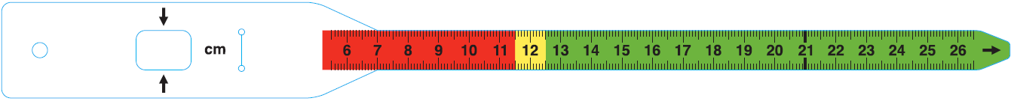

MUAC Referral, Admission and Discharge

For children 6-59 months:
RED | SAM | MUAC < 115 mm and/or bilateral pitting oedema
YELLOW | MAM | MUAC > 115 mm and < 125 mm
GREEN | Normal | MUAC > 125 mm

- There is recent growing evidence on the use of MUAC to identify nutrition vulnerability in infants under 6 months. However, a classification cutoff for this age group has not yet been established. Countries and programmes are encouraged to collect MUAC data for infants under 6 months to help build the evidence base for cutoffs and case management.
- MUAC is recommended as the best tool for effective CMAM services. The World Health Organisation (WHO 2013) has recommended the use of MUAC as an independent criterion for identification, admission, and discharge from treatment services for severe acute malnutrition (SAM). However, national guidelines may also require the use of weight-for-height (WFH) in addition to MUAC.
- MUAC < 115 mm indicates severe wasting in children age 6–59 months. MUAC ≥ 115 mm and < 125 mm indicates moderate wasting.
- Children age 6–59 months who are referred from the community with a red MUAC (<115 mm) are automatically admitted to outpatient care if they have an appetite and no medical complications.
- In some situations, cutoffs may be adjusted to accommodate available resources.

Screening, Admission, and Discharge Using MUAC
- MUAC is simple, quick, accurate and inexpensive, and colour-coded tapes are suitable to be used by people who are illiterate/innumerate but trained.
- Identifying acute malnutrition with MUAC tapes can help mothers, family members, and other people in the community better recognize which children need treatment.
- MUAC automatically selects younger children, those who are most at risk.

- MUAC is a better indicator of mortality risk associated with undernutrition than WFH.
- MUAC involves only one measurement, while WFH requires two measurements and one calculation. As a result, there are fewer chances for error with MUAC and the process takes less time.
- MUAC-only admission reduces the chance that children will be rejected at an outpatient care site or programs for the management of MAM because a referral based on MUAC is an automatic entitlement for admission.
- Children admitted using MUAC should be discharged using the same anthropometric criterion (i.e., MUAC)

Considerations in Using MUAC
- MUAC and WFH will identify slightly different groups of children as having SAM or MAM. For example, some children with MUAC < 115 mm can have a WFH z-score > -3 (WHO standards) and vice versa.
- Health care providers, community health workers, mothers, and family members must be trained and regularly monitored for the standardisation of MUAC measurements.

Handout 1.7 CMAM Components and How They Work Together


Core Components: Community-Based Management of Acute Malnutrition
Community Outreach

Outpatient care for management of SAM WITHOUT medical complications
Inpatient care for mgmt of SAM WITH medical complications
Management
of
MAM
Other nutrition and health interventions, food security, social protection and WASH, to prevent undernutrition

1. Community Outreach involves:
Community assessment and mobilisation
- Active case-finding to ensure early detection, early presentation and referral
- Education and sensitisation of the community so that they know how and where to bring their children for screening and treatment
- Case follow-up

To establish the most effective outreach, CMAM makes it a priority to:
Understand local barriers to access and service uptake
- Explain acute malnutrition and the objectives of the services in readily understandable local terms
- Engage a broad array of local institutions and community outreach systems, programmes, services, and initiatives

2. Outpatient Care is provided to children 6-59 months with severe acute malnutrition (SAM) and appetite but no medical complications. Medical assessment, anthropometric monitoring, and treatment are based on simple protocols. The following services are provided through outpatient care follow-on sessions to the health centre:
Medical assessment and anthropometric monitoring
- Nutrition rehabilitation with ready-to-use therapeutic food (RUTF)
- Basic medical treatment

Outpatient care is also provided to at-risk mothers and infants under 6 months who are nutritionally vulnerable with no medical complications (i.e., moderate nutrition risk). Feeding assessment, medical assessment, anthropometric monitoring, and treatment are based on the Community-Based Management of At-Risk Mothers and Infants under 6 Months (C-MAMI) Tool Version 2.0 (see details in Handout 4.13). The following services are provided to at-risk mothers and infants under 6 months through the outpatient care follow-on session:
Feeding monitoring
- Medical assessment and anthropometric monitoring
- Counselling and feeding support

3. Inpatient Care is provided to nutritionally vulnerable infants under 6 months of age, and children 6 – 59 months with SAM and medical complications:
Medical and nutrition care and treatment are provided according to World Health Organisation (WHO) and/or national protocols
- Infants under 6 months and children 6–59 months return to outpatient care when the medical complication is resolved and appetite returns

  - Management of Moderate Acute Malnutrition (MAM) can occur through supplementary feeding programmes or other services or programmes to manage MAM. Where such services do not exist, linkages can be created with other prevention and treatment programmes, such as community nutrition programmes.

Referrals to and between CMAM components
Referrals to CMAM services are fuelled by strong community outreach resulting in active case-finding and self-referrals by community members. Admission criteria determine which service component a child is admitted to initially.

Referrals between CMAM service components follow established criteria. Infants and children initially admitted to inpatient care will move to outpatient care as soon as their medical complication is resolved and their appetite returns. After discharge from outpatient care, the children are referred to nutrition programmes in the community (e.g., growth monitoring and promotion [GMP], PD Hearth, and infant and young child feeding [IYCF] support).

Referrals to and Between CMAM Service Components
Community outreach resulting in active case-finding and mother self-referrals |  | Inpatient care | Worsening condition  Improving condition
 |  | Outpatient care | Worsening condition  Improving condition
 |  | Programmes for management of moderate acute malnutrition | Worsening condition  Improving condition

Effective and smooth referrals between the components are essential. This is facilitated by:
The action protocol
- The use of referral slips, which ensure that full information on the child—including reason for referral—is available
- Good communication between staff in inpatient care and outpatient care
- Follow-up of referrals by community volunteers when required
Handout 1.8 Case Studies

Case Study 1: Life-saving intervention in Niger
(NGO-implemented, sustainability not a stated goal)

In 2005, working at a scale unthinkable five years ago, Médecins Sans Frontières (MSF) reached over 60,000 children with acute malnutrition in Niger through a mobile outpatient care programme and use of ready-to-use therapeutic food (RUTF). Children requiring inpatient care were transported to the inpatient care site. The intervention achieved good results (mortality < 5 percent) in six to 12 months. This intervention saved many lives, but was focused on the emergency response rather than the capacity to treat severe acute malnutrition (SAM) in the long term, as it was not integrated into the health system. In addition, the programme did not incorporate active case-finding; the service was promoted by reputation. MSF’s CMAM approach was a component within MSF’s emergency health and nutrition response model.

Case Study 2: CMAM integration in Zambia
In 2005, based on experiences in Ethiopia and Malawi, Valid International worked with the district Ministry of Health (MOH) in Lusaka, Zambia, to design and develop an integrated programme for management of SAM. The MOH implemented the programme directly from the outset, with Valid providing technical and managerial support. MOH health facility staff were trained to provide outpatient care alongside other primary health care (PHC) activities at health facilities. Hospital staff were trained to discharge children to outpatient care after they stabilised and regained appetite. Community volunteers were recruited for outreach activities and assistance with outpatient care days.

At the time of setup, some nongovernmental organisations (NGOs) were running supplementary feeding programmes (SFPs) in some health centres. The outpatient care linked directly with the SFPs in these centres, referring discharged cases to the SFP, while the SFP referred severe cases to outpatient care. The programme opened in a phased approach, slowly expanding from 5 to 13 health centres across Lusaka. The district MOH's commitment to the programme was crucial to its implementation and integration. The MOH created a position on its district staff for leading CMAM activities. This person is involved in daily implementation, supervision and planning, with technical support from Valid International.

While the programme operates at health centres, there are challenges in the implementation, including:
- Establishing low-cost local production of RUTF
- Ensuring links between hospitals with inpatient care and health facilities with outpatient care
- Keeping community volunteers motivated in the absence of monetary incentives
- Limited nursing and nutrition staff availability on outpatient care days due to overall staff shortages
- Ensuring sustained funding for service delivery.

Note: It is recognised that integration from the onset is a much more sustainable way to develop a CMAM programme. However, experience demonstrates that the process of integration and the provision of technical, logistical and, in some cases, managerial support to strengthen capacity for sustainable long-term service provision takes years; this must be considered during the planning stage.

Case Study 3: Emergency and transition in Ethiopia
(NGO start-up with plan to transfer most responsibility to MOH and integrate into health system)

Concern Worldwide’s community-based therapeutic care (CTC) programme in Wollo, Ethiopia, began in 2003 as a high-input response to emergency levels of general acute malnutrition (GAM) and SAM. The programme was established in health clinics and hospitals with existing staff. The MOH began assuming responsibility for certain activities in 2004. Concern Worldwide and the MOH established a plan in which Concern Worldwide would continue its support but in a more supervisory and mentoring role, and would facilitate supply of RUTF, when necessary, over time. Recognising the need to strengthen the MOH’s health services in Wollo so that it could take on the outpatient care programme, Concern Worldwide also supported the primary health care (PHC) activities. Published data through May 2005 indicated that recovery and coverage rates remained high even after the transition. Similar results were achieved in Malawi, where the MOH had taken on many activities and programme outcomes still exceeded Sphere Standards two years after the peak of the emergency. Concern Worldwide continued to assist with financial and logistical support for the procurement and delivery of RUTF, training, and low-level supervision/mentoring. Eventually, the CMAM services were fully transitioned to the MOH and are now part of routine health system interventions.

The experience in Ethiopia showed that the MOH’s post-emergency takeover of programme activities will be smoother if the MOH is involved in initial planning and activities, and supervision and monitoring systems are integrated into the MOH system from the beginning. The experience also showed that the hand-over is a gradual process that requires an effective, functioning health system in which to integrate activities and a reliable source of RUTF.

Handout 1.9 Implementing CMAM in Different Contexts

Emergency and Post-Emergency Settings
CMAM services have been implemented in emergency settings since 2001 and, since 2006, the management of acute malnutrition has been implemented in non-emergency and in high HIV prevalence settings.
- For CMAM programmes that were started by nongovernmental organisations (NGOs) in an emergency context and handed over to the Ministry of Health (MOH), initial performance results after hand-over are encouraging and gradually improving with continued technical support to the MOH.
- In an emergency, CMAM interventions follow a hierarchy of interventions. The needs of the greatest number should be a priority. In practice, this means ensuring food security, which includes ensuring that securing a general ration for the whole population takes priority over setting up services for target groups within the population.
- In an emergency, large numbers of children can be reached through decentralised and/or mobile outpatient care sites.
- To date, there are three scenarios for emergency CMAM interventions:
- Short-term, life-saving intervention with little or no attempt to hand over CMAM services to the MOH or integrate them into routine health services (Handout 1.9 Case Study 1)
- Integrated CMAM services in a development context (Handout 1.9 Case Study 2)
- Emergency CMAM intervention that evolves into post-emergency services that are handed over to the MOH and integrated into routine health services (Handout 1.9 Case Study 3)
- External agencies often start their involvement during a crisis but ideally will continue to support the health system during the post-crisis transition to establish basic CMAM capacity. This will prepare the local health services for future seasonal or sudden increases in acute malnutrition, and if another crisis occurs, the country will require fewer external resources because local capacity will have been maintained.

Handout 1.10 Factors to Consider in Seeking to Provide Services for the Management of SAM

Leadership and Governance for CMAM
- Effective Ministry of Health leadership and coordination mechanisms are essential to ensure that various agencies, including government and nongovernmental organisations (NGOs) running programmes for children with acute malnutrition, collaborate at national and sub-national levels.
- A Ministry of Health technical leadership and support system for national and sub-national capacity strengthening, including academic and training institutions should be put in place. Prevention of undernutrition should be the first policy priority, but treatment is needed for children with acute malnutrition because they have a high mortality risk.
- CMAM should be integrated into national health and nutrition policies and strategic plans. This will include integration into a basic package of health services and free treatment for children with SAM.
- National guidelines must be in place to standardise treatment protocols and monitoring tools. The guidelines should describe the community-based approach to manage acute malnutrition that builds upon and links with existing inpatient care, nutrition programmes, and primary health care (PHC).
- Free treatment for malnourished children must be ensured.
- Contingency planning for emergencies to strengthen the CMAM workforce, case management, procurement of essential CMAM supplies, and integration with IYCF should be developed at the national and sub-national levels.
- There should be ongoing advocacy for management of acute malnutrition

Health Financing for CMAM
- CMAM services should be planned for and resources allocated at the national and sub-national levels.
- Long-term and sustainable budgetary and funding mechanisms should be identified and assured.

Health Workforce for CMAM
- Opportunities to integrate pre-service training for CMAM should be maximised.
- In-service training for improved management of acute malnutrition must be provided to health care providers at all levels (i.e., district health managers, health care providers at health facilities, community outreach workers) so there is an effective integrated approach that links management and supervision, inpatient care, outpatient care, programmes for management of MAM and other health services with one another.
- In-service training and support must be provided to community outreach workers (e.g., community health workers [CHWs], volunteers) who identify and refer children with acute malnutrition in the communities.
- Internships at learning sites and learning visits provide real-time learning and rapid transfer of skills.
- CMAM should become part of health care providers’ roles, responsibilities, and job descriptions, and health care providers should be accountable for meeting those responsibilities.
- A positive work and learning environment should be cultivated to empower and motivate health care providers (control workload).
- Capacity development strategies should account for high staff turnover.

Knowledge and Information Systems for CMAM
- Baseline analysis of the health system capacity and performance
- Evaluation of coverage, barriers to accessing care and service uptake
- Supportive supervision, mentoring and coaching of health care providers, community health workers and volunteers
- Monitoring of individual care and case management
- Monitoring of performance of service
- Sharing of information and experiences with peers and experts, which is essential for continually learning good practices (This includes having a document repository and promoting interactive learning forums.)
- Formative research, which is critical for improving the effectiveness of services, promoting good practices, learning lessons, and fostering programme integration and scale-up
- Standardised monitoring and evaluation systems and tools that are integrated in the national health management information system (HMIS) and/or nutrition surveillance systems
- Links with other national and global initiatives

Infrastructure, Equipment, and Products for CMAM
- Efficient system for planning CMAM supplies including ensuring buffer stock
- Adequate resources and supplies for effective management of acute malnutrition must be procured and provided to all health facilities. This includes ready-to-use therapeutic food (RUTF), F75, F100, ReSoMal, essential drugs, mid-upper arm circumference (MUAC) tapes, scales and height boards, treatment cards, and monitoring cards.
- Integration and management of CMAM supplies and equipment through the MOH logistics management system
- Establishment of national and local production capacity for RUTF and UNICEF certification

CMAM Service Delivery
- Initial implementation of learning sites or centres of excellence
- Integration of CMAM into the basic health care package
- Gradual geographical scale-up of CMAM to priority areas
- Qualified health care providers (i.e., qualified to perform a medical assessment, refer or treat children with acute malnutrition) must be available in adequate numbers.
- Community outreach for community assessment, community mobilisation, and active case-finding and referral in line with existing formal and informal health and community outreach systems and initiatives
- Establishment of outpatient care at decentralised health facilities: One health care provider can manage 10–15 children a day in outpatient care as part of routine health services. In emergencies, services could be further decentralised in the community and provided by mobile teams. Outpatient care sites should be set up within a day’s walk from a settlement.
- Establishment of inpatient care in health facilities providing 24-hour care
- Decentralised community or health facilities for the management of moderate acute malnutrition (MAM)
- Triage and referral system between inpatient, outpatient, and routine child health services
- Establish or ensure adequate referral and linkage with other health and nutrition interventions for prevention of acute malnutrition with infant and young child feeding interventions; growth monitoring and promotion; water, sanitation, and hygiene; integrated management of childhood illness [IMCI]; and HIV testing and counselling
- Links with informal health care providers such as traditional healers, traditional birth attendants, and religious societies and leaders.
- Links with other community services and programmes should be made as necessary (e.g., with food security, agriculture, and livelihood programmes to ensure increased access to high-quality foods).
- Adherence to standardize treatment protocols
- Continuous quality improvement to strengthen the systems and process for management of CMAM
- Development, access, and use of standardised tools (e.g., training materials, job aids, planning and implementation tools)
- Individual and group counselling, health and nutrition education, and social behaviour change communication

Handout 1.11 Integrating CMAM into Routine Health Services at the District Level

- Existing health services and initiatives should be mapped and the programme planned with the relevant authorities and agencies to prevent duplication, build upon and strengthen existing structures and systems, and ensure that referral pathways, roles and responsibilities are clear.
- Health facilities with existing inpatient care for severe acute malnutrition (SAM) (e.g., therapeutic feeding centre [TFC], nutrition rehabilitation unit [NRU], hospital ward) can be adapted to also establish outpatient care for the management of SAM without medical complications in their outpatient department (OPD). This takes the burden off the inpatient care staff, which will continue to treat children with SAM and medical complications until they are stabilised and can be referred to outpatient care.
- Good communication between health care providers managing inpatient care and outpatient care is important for strong links and referral between those services.
- Existing community outreach networks can provide a platform for the community outreach work required for successful CMAM implementation. Assessing what is already in place and identifying potential links to those services are key to making the best use of resources available.
- CMAM can be integrated into child health and nutrition services at first-level health facilities. Bilateral pitting oedema and mid-upper arm circumference (MUAC) checks can be added to IMCI diagnostic tools and to growth monitoring and promotion activities so that children with acute malnutrition can be identified at any contact point within the health care system and be referred for appropriate treatment.
- CMAM can also be linked with other health services such as malaria prevention, HIV testing and counselling, family planning, and provision of relevant information, social behaviour change and communication.

Handout 1.12 Essentials of CMAM

Essentials of CMAM
- Acute malnutrition is a significant public health concern. In 2017, the World Health Organisation (WHO), United Nations Children’s Fund (UNICEF), and the World Bank estimated that wasting, a form of acute malnutrition, affects the lives of approximately 50.5 million children under 5 years of age globally. It is also estimated that 16.4 million children around the world suffer from severe wasting. Children suffering from severe wasting have an increased mortality risk. Current estimates suggest that severe wasting contributes to about 516,000 deaths of children under 5 every year.

- The principles of CMAM are maximum coverage and access (reaching as many children with acute malnutrition as possible), timeliness (early identification and referral before medical complications develop) and appropriate care (outpatient care for children with SAM without medical complications as long as needed and inpatient care only for those with SAM and medical complications). Evidence from emergency contexts has shown that about 80 percent of children with SAM can be treated as outpatients.

- To reach the maximum number of children with acute malnutrition, trained health care providers (and trained mothers and family members) must be able to reach the majority of these children in their communities, where they can access health facilities as outpatients and continue treatment in their homes. Coverage and access are achieved by providing CMAM outpatient care in decentralised health facilities or by establishing mobile outpatient care sites (in the case of emergencies).

- The following innovations make CMAM possible:
- Ready-to-use therapeutic food (RUTF), which can be used safely at home without refrigeration and in areas where hygiene conditions are not optimal, meaning children can be treated at home
- Using an acute malnutrition classification that divides SAM into two categories--SAM with medical complications and SAM without medical complications--to determine treatment (see below)
- Screening, admission, and discharge using mid-upper arm circumference (MUAC) which is simple, accurate and inexpensive, and makes active case-finding, referral and admission transparent

- Treatment for SAM differentiates between SAM with medical complications and SAM without medical complications:
- Children with SAM without appetite or with medical complications are treated in inpatient care
- Children with SAM and appetite and no medical complications are treated in outpatient care
- Children with moderate acute malnutrition (MAM) with appetite and no medical complications are treated in services or programmes that manage MAM, such as supplementary feeding programmes, if available.

- Infants under 6 months who are nutritionally vulnerable without medical complications (i.e., moderate nutrition risk) are treated in outpatient care. Infants under 6 months who are nutritionally vulnerable with medical complications (i.e., high nutrition risk) are treated in inpatient care.

- CMAM has four essential components: community outreach, outpatient care for children with SAM without medical complications, inpatient care for children with SAM with medical complications, and programmes for the management of MAM (e.g., supplementary feeding and others depending on the context). Effective and smooth referral among the components is essential. Using an action protocol helps health care providers determine which children require inpatient care and follow-up at home.

- CMAM can be implemented in a variety of contexts (e.g., emergency, non-emergency, high HIV prevalence). The CMAM components should complement existing services.

- CMAM should be integrated into existing health facilities and run as a component of primary health care (PHC) as much as possible. Linkages can be made to other child health services (e.g., integrated management of childhood illness [IMCI], community case management, HIV services, prevention services).
Additionally, CMAM should be linked with nutrition-sensitive interventions that address underlying causes of malnutrition. These include agriculture and food security, education, gender, and social protection interventions.

- In recent years, there have been several key developments and commitments at the global level regarding the acceptance of CMAM.

Handout 1.13 Field Visit Checklist

Complete the following activities during the CMAM field visit.

Observe the following activities, if possible:
Admission of at-risk mothers and infants under 6 months who are nutritionally vulnerable without medical complications in outpatient care
Discharge of at-risk mothers and infants under 6 months of age from outpatient care
Outpatient care follow-on sessions:
- Anthropometric measurement
- Feeding assessment of infants under 6 months of age
- Medical assessment
- Supply of ready-to-use therapeutic food (RUTF)
- Counselling and feeding support for infants under 6 months
Discuss with staff the following:
What do they like and dislike about the CMAM service?
How does this programme affect their overall workload?
What shortcomings or problems do they see with the service?
How do they work with volunteers?
How do they link with other health services (e.g., expanded programme of immunisation [EPI], HIV testing and counselling?
What type of support is provided to the child’s family after the child is discharged (e.g., social protection including cash transfers, agricultural support, IYCF counselling)?
Discuss with mothers/caregivers the following:
How did they find out about the service?
What do they like and dislike about the service?

Handout 1.14 PowerPoint Presentation Slide Images
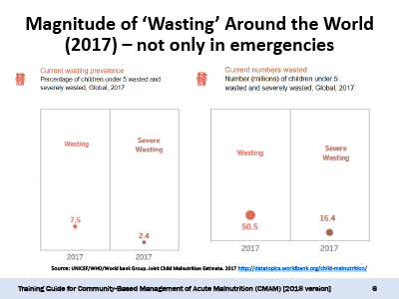
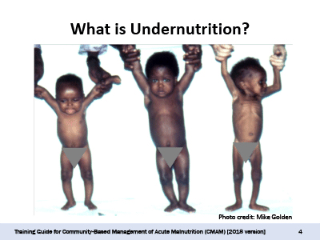
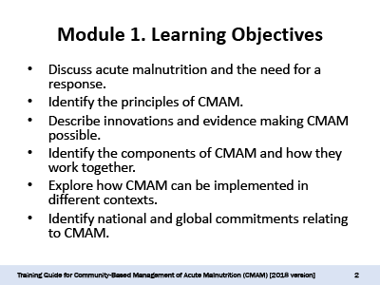
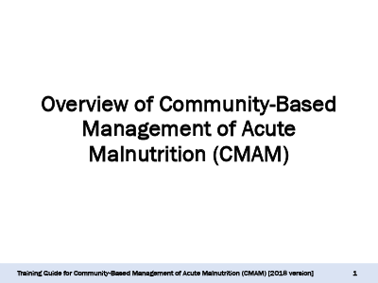

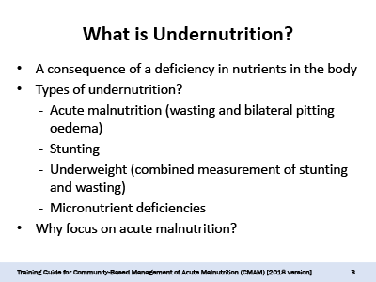

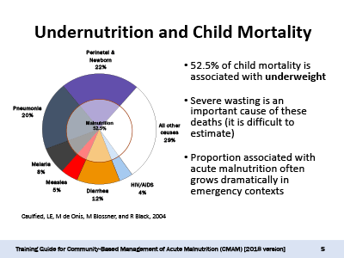

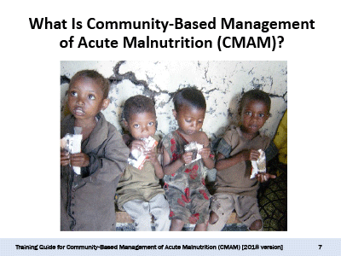
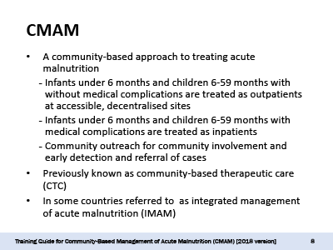
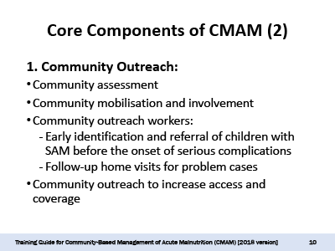
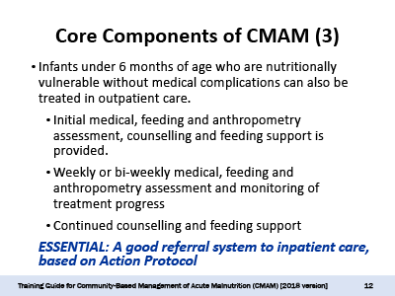
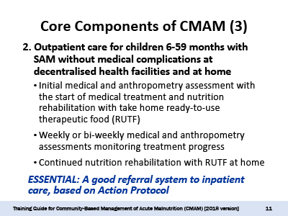

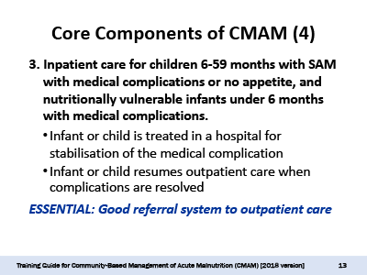
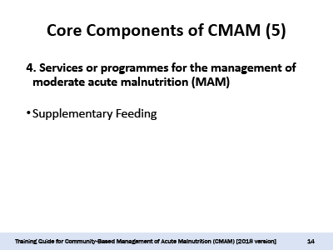

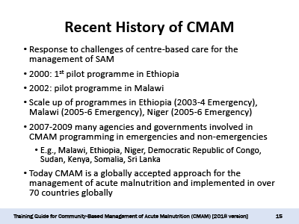
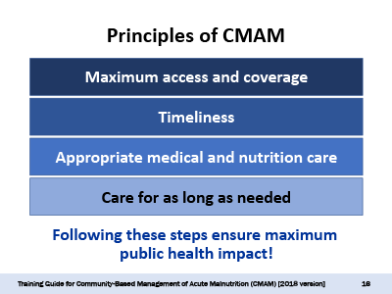

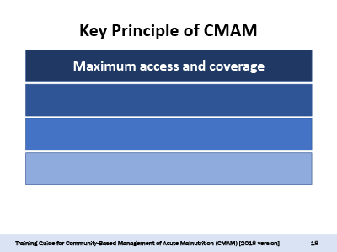
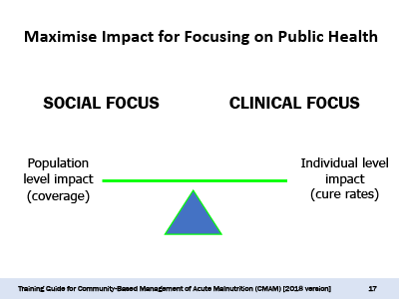

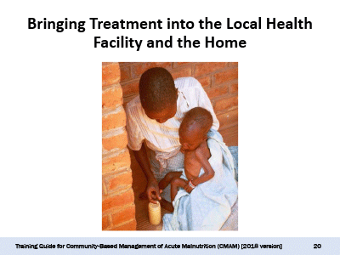
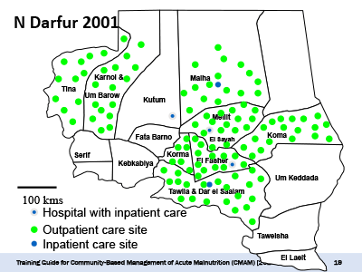
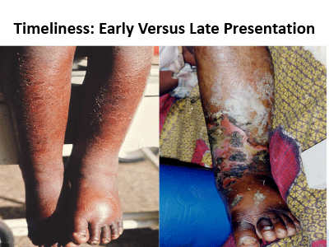
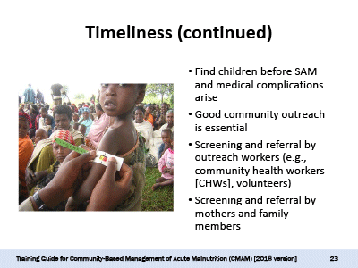

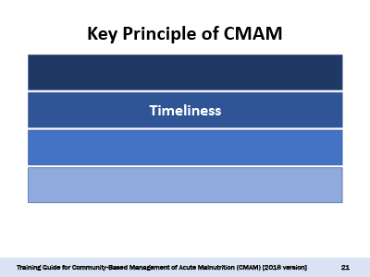

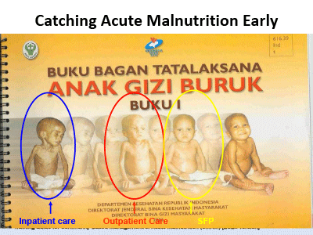

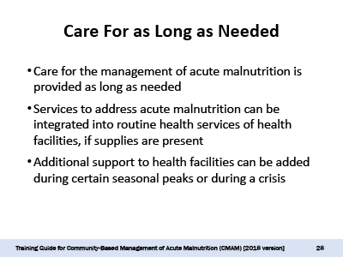
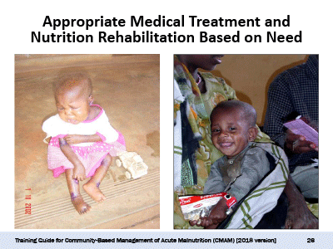
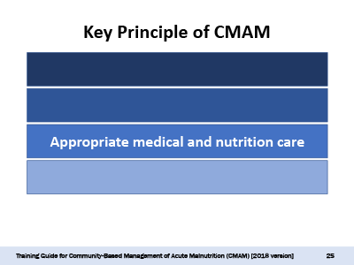
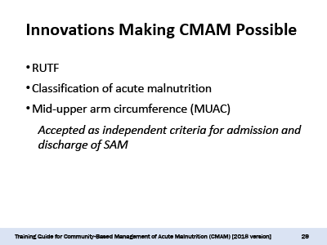
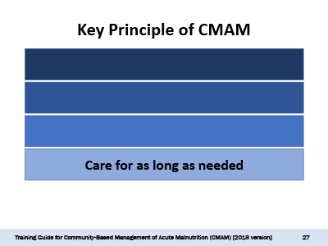
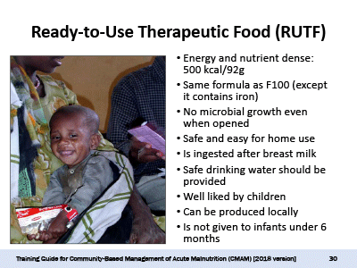

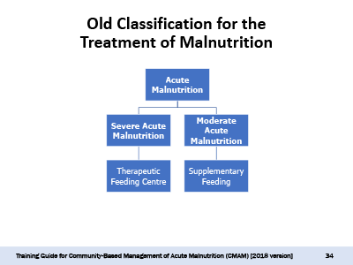
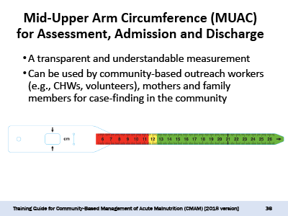
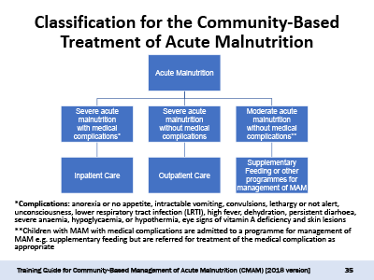
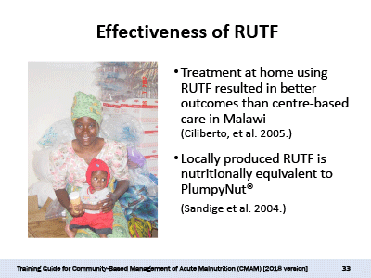
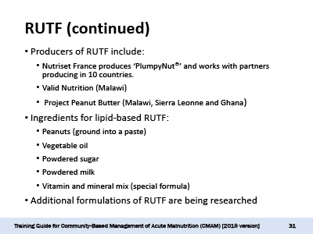
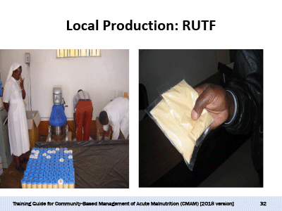

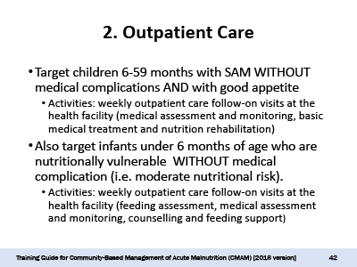
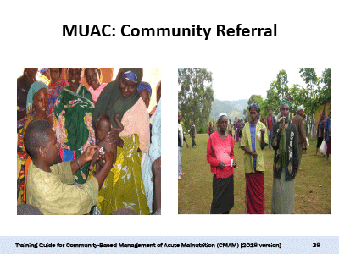
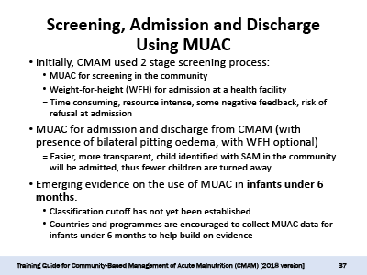
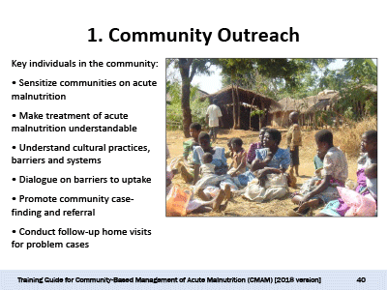
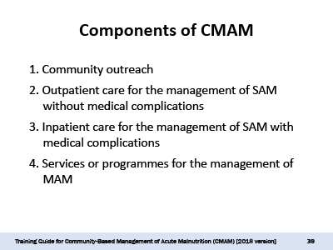
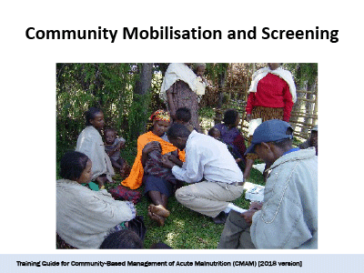

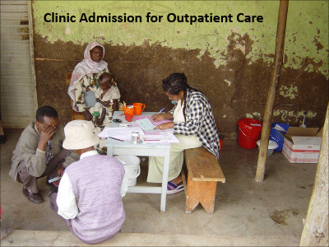
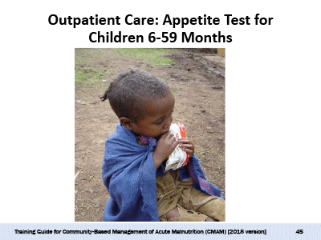
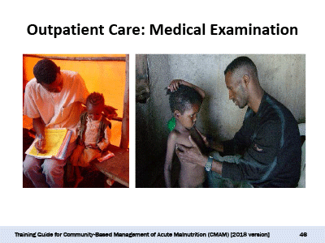
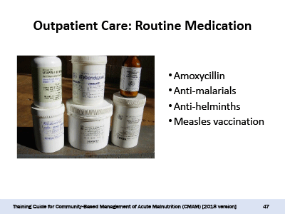
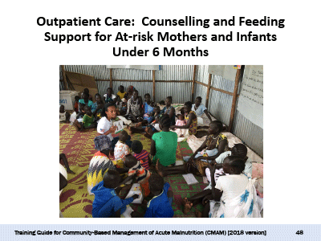
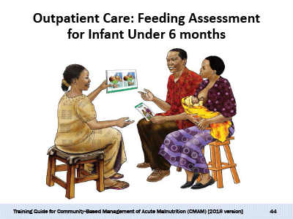

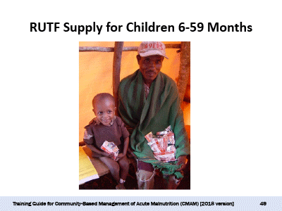
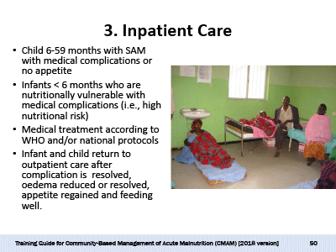
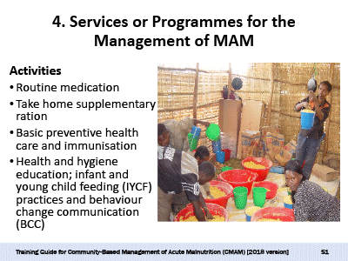
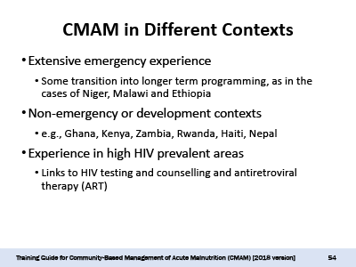
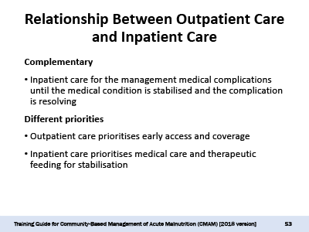

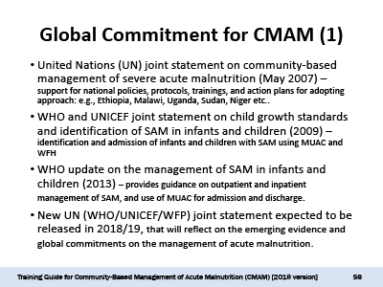
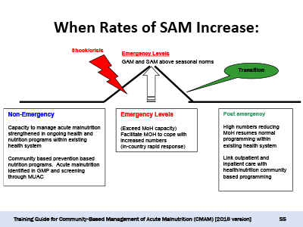

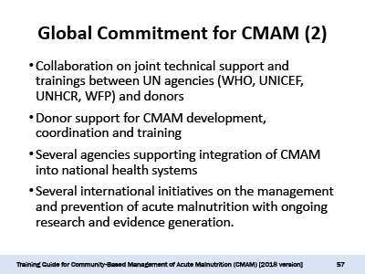

Module Two: Defining and Measuring Acute Malnutrition

Module Overview
This module reviews common nutrition and anthropometric terms and the causes of undernutrition and provides practical skills on how to measure acute malnutrition, and nutrition vulnerability in at-risk mothers and infants under 6 months of age.
The module will give field implementers an overview of methods used to determine the nutritional status of an infant or child: testing for bilateral pitting oedema; using mid-upper arm circumference (MUAC), weight, height, and age as measures; and assessing feeding in infants under 6 months. Proficiency in these skills is critical for identifying infants and children who might be eligible for management. Hands-on practice using these methods will be provided in the field visits to outpatient care sites in Module Four.

Learning Objectives | Duration | Handouts and Exercises
1. Discuss Causes and Consequences of Undernutrition and Undernutrition Terminology | 30 minutes | Handout 2.1 Causal Framework of Undernutrition  Handout 2.2 Undernutrition Definitions, Indices, Indicators, and Indicator Cutoffs
2. Identify the Clinical Signs of Acute Malnutrition | 15 minutes | Handout 2.3 Clinical Manifestations of Acute Malnutrition
3. Measure, Calculate, and Classify Acute Malnutrition | 1 hour, 15 minutes  (1¼ hours) | Handout 2.4 Assessing Age, Bilateral Pitting Oedema, MUAC, Weight, and Height  Handout 2.5 Weight-for-Height/Length Tables for Field Use  Exercise 2.1 Grades of Bilateral Pitting Oedema  Exercise 2.2 Calculating WFH/WFL and Classifying Acute Malnutrition
4. Assess and Classify Nutritional Vulnerability in At-Risk Mothers and Infants Under 6 Months of Age | 45 minutes | Handout 2.6 C-MAMI Tool Version 2.0
Wrap-Up and Module Evaluation | 15 minutes

Module Duration: 3 hours
Note: Depending on the needs of their audiences, trainers may choose to skip or spend more or less time on certain learning objectives and activities. The module duration is an estimate of the time it takes to complete all the learning objectives and activities.

Reference Resources
- Emergency Nutrition Network (ENN). 2018. C-MAMI Tool Version 2.0. Available at https://www.ennonline.net/c-mami.
- Food and Nutrition Technical Assistance III Project (FANTA). 2018. Anthropometry Pocket References for Children and Adolescents. Available at: https://www.fantaproject.org/tools/anthropometry-pocket-reference.
- Cashin, K. and Oot, L. 2018. Guide to Anthropometry: A Practical Tool for Program Planners, Managers, and Implementers—Module 6: Protocols and Equipment. Washington, DC: FANTA/FHI 360. (For reference material on weight and height equipment and on where to purchase equipment and available kits.) Available at: https://www.fantaproject.org/sites/default/files/resources/MODULE-6-FANTA-Anthropometry-Guide-May2018.pdf.
- Food and Agriculture Organisation (FAO). 2008. Guidelines for Estimating the Month and Year of Birth of Young Children. Available at: http://www.fao.org/docrep/pdf/011/aj984e/aj984e00.pdf
- World Health Organisation (WHO). 2006. WHO Child Growth Standards. Available at: http://www.who.int/childgrowth/standards/.

Further Reading Resources
- Council of Research & Technical Advice on Acute Malnutrition (CORTASAM). 2018. A Research Agenda for Acute Malnutrition. Available at: https://static1.squarespace.com/static/58da81cdd1758e39ca705526/t/5a5cbfcdf9619a9a191c6f34/1516027854696/NoWastedLives_Research_Agenda_2018.pdf.
- Briend, A.; Mwangome, M.K.; and Berkley, J.A. 2017. “Using Mid-Upper Arm Circumference to Detect High-Risk Malnourished Patients in Need of Treatment.” Preedy, V.R. and Patel, V.B. (eds.). Handbook of Famine, Starvation, and Nutrient Deprivation. DOI 10.1007/978-3-319-40007-5_11-1.
- Lelijveld, N. et al. 2017. A Review of Methods to Detect Cases of Severely Malnourished Infants Less than 6 Months for Their Admission into Therapeutic Care. Emergency Nutrition Network. Available at: https://www.ennonline.net/mamicasedetectionreview.
- Tang, A.M. 2016. Determining a Global Mid-Upper Arm Circumference Cutoff to Assess Malnutrition in Pregnant Women. Washington, DC: FHI 360/FANTA. Available at: https://www.fantaproject.org/sites/default/files/resources/FANTA-MUAC-cutoffs-pregnant-women-June2016.pdf.
- Blackwell, N. et al. 2015. “Mothers Understand and Can Do It (MUAC): A Comparison of Mothers and Community Health Workers Determining Mid-Upper Arm Circumference in 103 Children Aged from 6 Months to 5 Years.” Archives of Public Health. Available at: https://archpublichealth.biomedcentral.com/articles/10.1186/s13690-015-0074-z.
- WHO and UNICEF. 2009. WHO Child Growth Standards and the Identification of SAM in Infants and Children: A Joint Statement. Available at: http://www.who.int/nutrition/publications/severemalnutrition/9789241598163/en/.
- UNICEF. Nutrition in Emergencies. Available at: https://www.unicef.org/nutrition/training/list.html.
- WHO Department of Health and Development. 2002. Training Course on the Management of Severe Malnutrition. Geneva: WHO. Module 2.
- WHO. 1983. Measuring Change in Nutritional Status. Geneva: WHO.
- WHO. 2000. Management of Nutrition in Major Emergencies. Geneva: WHO.
- Young, H. and Jaspars, S. 2006. The Meaning and Measurement of Acute Malnutrition in Emergencies: A Primer for Decision-Makers. Overseas Development Institute (ODI), Humanitarian Practice Network Paper No. 56, November.

Handout 2.1 Causal Framework of Undernutrition

Causes of Undernutrition
The United Nations Children’s Fund (UNICEF) has developed a framework showing the immediate, underlying, and basic causes of undernutrition and how they contribute to and influence one another. The framework can be used at national, district and local levels for assessment and analysis to gain a better understanding of causes of undernutrition. This can help improve nutrition and reduce infant and child mortality and disability.

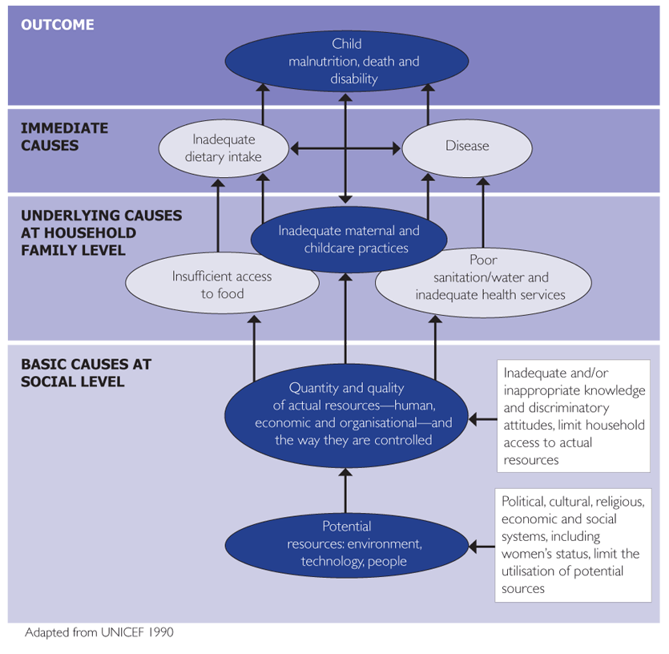
Handout 2.2 Undernutrition Definitions, Indices, Indicators, and Indicator Cutoffs

UNDERNUTRITION
There are four forms of undernutrition:
- Acute malnutrition
- Stunting
- Underweight
- Micronutrient deficiency
Undernutrition is defined based on anthropometric indicators, clinical signs and clinical tests. The four forms often overlap in one child or in a population. The training modules focus on acute malnutrition, and nutrition vulnerability in at-risk mothers and infants under 6 months of age.

ACUTE MALNUTRITION
Acute malnutrition is caused by a decrease in food consumption and/or illness resulting in bilateral pitting oedema or sudden weight loss. It is defined by the presence of bilateral pitting oedema or by wasting.
  - Severe acute malnutrition (SAM) is defined by the presence of bilateral pitting oedema or severe wasting. A child with SAM is highly vulnerable and has a high mortality risk.
Note: SAM can also be used as a population-based indicator defined by the prevalence of bilateral pitting oedema and severe wasting (based on the weight-for-height [WFH]/ weight-for-length [WFL] indicator using the World Health Organisation [WHO] standards. The prevalence of wasting based on mid-upper arm circumference (MUAC) is useful for estimating case load.
  - Moderate acute malnutrition (MAM) is defined by moderate wasting.
Note: MAM can also be used as a population-level indicator defined by moderate wasting (based on the WFH/WFL indicator using the WHO standards).

Indices
When body measurements are compared to a reference value, they are called nutrition indices. Three commonly used nutrition indices are WFH or WFL, which is used to assess wasting; height-for-age (HFA) or length-for-age (LFA), which is used to assess stunting; and weight-for-age (WFA), which is used to assess underweight.

The WFH/WFL index is used to assess wasting, a clinical manifestation of acute malnutrition. It shows how an infant’s or child’s weight compares to the weight of an infant or child of the same height and sex in the WHO standards. The index reflects the infant’s or child’s current nutritional status.

Indicators
Nutrition indicators are an interpretation of nutrition indices based on cutoff points. Nutrition indicators measure the clinical phenomena of malnutrition and are used for making a judgement or assessment. A good nutrition indicator detects as many people at risk as possible (sensitivity) without including too many people who are not at risk (specificity). A good nutrition indicator should also be functionally meaningful (i.e., related to the risk of morbidity and mortality), and be sensitive to change.
Standard cutoff points are used internationally to define undernutrition in infants and children. The cutoff points for nutrition indicators for this age-group are derived from the WHO child growth standard population (WHO standards). For infants under 6 months, anthropometric indicators are limited due to a lack of evidence; there is ongoing research to determine indicators and cutoffs that can help identify infants under 6 months of age who are nutritionally vulnerable and at the most risk of mortality.
Note: Cutoffs may vary according to the context, agency and national guidelines.

Bilateral Pitting Oedema
Bilateral pitting oedema is a clinical manifestation of acute malnutrition caused by an abnormal infiltration and excess accumulation of serous fluid in connective tissue or in a serous cavity. Bilateral pitting oedema (also called kwashiorkor) is verified when thumb pressure applied on top of both feet for three seconds leaves a pit (indentation) in the foot after the thumb is lifted.

MUAC Indicator
Low MUAC is an indicator for wasting. MUAC is relatively easy to measure and can be done by mothers and other family members in the community; it involves measuring the circumference of a child’s mid-upper arm. MUAC is a better indicator of mortality risk associated with undernutrition than WFH. Due to its ability to identify children with high risk of mortality, MUAC is used for the identification, admission, and discharge of children 6–59 months of age with acute malnutrition in the community. A MUAC < 115 mm for children 6–59 months indicates SAM. MUAC ≥ 115 mm and < 125 mm for children 6–59 months indicates MAM.
There is recent growing evidence on the use of MUAC to identify nutrition vulnerability and mortality risk in infants under 6 months. However, classification cutoffs have not yet been established. Countries and programmes are encouraged to collect MUAC data for infants under 6 months to help build the evidence to inform the case management.
In pregnant and lactating women, a MUAC < 190 mm is used to indicate SAM, and a MUAC ≥ 190 mm and < 230 mm indicates MAM. Note that countries may have different cutoffs for pregnant and lactating women based on context and national guidelines.

WFH/WFL Indicator
Low WFH/WFL is an indicator for wasting. A WFH/WFL standard deviation (SD) below -2 z-score of the median (WFH/WFL < -2 z-score) of the WHO standards indicate wasting. Severe wasting is indicated by a WFH/WFL < -3 z-score (WHO standards). Moderate wasting is indicated by a WFH/WFL ≥ -3 and < -2 z-score (WHO standards).
Note: The current WFL z- score standards do not include infants who are less than 45 cm in length.

Summary Tables: Indicators for Acute Malnutrition with Cutoffs for SAM and MAM

A. Indicators of acute malnutrition in children under 6–59 months
 | Bilateral pitting oedema | MUAC | WFH/WFL z-score
SAM | Present | < 115 mm or red | < -3
MAM | Not present | ≥ 115 mm and < 125 mm or yellow | ≥ -3 and < -2

B. Indicators of acute malnutrition in pregnant and lactating women
 | Bilateral pitting oedema | MUAC
SAM | Present | < 190 mm
MAM | Not present | ≥ 190 mm and < 230 mm

NUTRITION VULNERABILITY IN AT-RISK MOTHERS AND INFANTS UNDER 6 MONTHS OF AGE
Nutrition vulnerability is assessed in infants under 6 months and their mothers and is used to determine the type of intervention needed. Nutrition vulnerability includes acute malnutrition and/or underweight or growth faltering combined with ability to feed; medical condition; and maternal mental, nutrition, health, and social circumstances. The infant’s well-being is determined by the mother’s well-being; therefore, the mother and infant are considered a “mother-infant” pair.

WFA Indicator
Low WFA is an indicator for poor weight gain in relation to the infant’s or child’s age. A WFA standard deviation (SD) below -2 z-score of the median (WFA < -2 z-score) of the WHO standards indicates underweight. Severe underweight is indicated by a WFA < -3 z-score (WHO standards). Moderate underweight is indicated by a WFA ≥ -3 and < -2 z-score (WHO standards). Recent evidence has shown that WFA can help identify underweight infants who are nutritionally vulnerable and at high risk of mortality. WFA is therefore suggested as an admission criterion for nutritionally vulnerable infants under 6 months.

Handout 2.3 Clinical Manifestations of Acute Malnutrition

Acute malnutrition is defined by the presence of bilateral pitting oedema and wasting (defined by low mid-upper arm circumference [MUAC]) or weight-for-height [WFH]/ weight-for-length [WFL]). Acute malnutrition is caused by a decrease in food consumption and/or illness.

- The following terms are used to describe the clinical manifestations of severe acute malnutrition (SAM):
- Marasmus (severe wasting)
- Kwashiorkor (bilateral pitting oedema)
- Marasmic kwashiorkor (bilateral pitting oedema and severe wasting)
- Familiarity with these clinical signs will help health care providers triage cases efficiently – even before measurements are made.
- In most cases the anthropometric measurements will confirm these clinical diagnoses, but in a few cases there might be clinical but no anthropometric confirmation (e.g., observing that the skin on the buttocks has a “baggy pants” look.)

Clinical Signs | Picture | Indicator
A child with marasmus might have these characteristics:  - Thin appearance, “old man” face  - Apathy: the child is very quiet and does not cry  - The ribs and bones are easily seen  - The skin under the upper arms appears loose  - On the back, the ribs and shoulder bones are easily seen  - In extreme cases of wasting, the skin on the buttocks has a “baggy pants” look  - No bilateral pitting oedema  These children have lost fat and muscle and will weigh less than other children of similar height. | 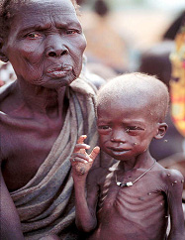 | Severe wasting:  - MUAC < 115 mm in children 6-59 months  - Z-score < -3
A child with kwashiorkor (bilateral pitting oedema) might have  these characteristics:  - “Moon face”  - Dermatosis: flaky skin or patches of abnormally light or dark skin (in severe cases)  - Apathy, little energy  - Loss of appetite  - Hair changes  - Irritable, cries easily | 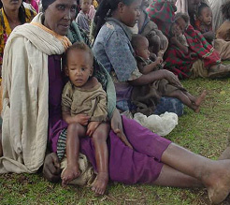 | Bilateral pitting oedema
A child with marasmic kwashiorkor has these characteristics:  - Bilateral pitting oedema  - Severe wasting | 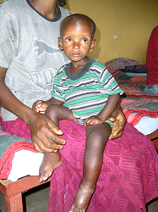 | Bilateral pitting oedema  AND Severe Wasting:  - MUAC < 115 mm in children 6–59 months  - Z-score < -3

Handout 2.4 Assessing Age, Bilateral Pitting Oedema, MUAC, Weight, and Height

1. Age
Estimating an infant’s or child’s age is relevant for a number of reasons. Infants under 6 months and children 6–59 months and older will require different management while in outpatient care. And measuring height for weight-for-height (WFH) calculations, which is carried out differently for children under the age of two years (for these children, length is measured instead of height).
If birth dates are not recorded on a child health card (CHC) or immunisation card and it is necessary to determine the age, the recall of the mother/caregiver is used to estimate the child’s age. Age may be easier to estimate for younger infants and children but is often difficult to determine for older children.
Other methods of estimating age include:
- Asking the mother/caregiver if the child was born before or after certain major local events until a fairly accurate age is pinpointed. It might be helpful to develop a local event calendar. The World Health Organisation (WHO) Child Age Calculator, a rotating disk mounted on a calendar, has been developed as a job aid for health workers to calculate a child’s age. The calculators might be available at regional WHO offices. Also, the Food and Agriculture Organisation of the United Nations (FAO) has developed guidelines to estimate the month and year of birth (2008), available here: http://www.fao.org/docrep/pdf/011/aj984e/aj984e00.pdf
- Estimating age based on height. The standard international height proxy for children 59 months is 110 cm. Note that while the standard international height proxy for children 6 months is 65 cm, it is not recommended to use this height cutoff in stunted populations. The mother/caregiver’s recall is much more accurate in these cases.

2. Bilateral Pitting Oedema
Bilateral pitting oedema, or kwashiorkor, can be verified when thumb pressure applied on top of both feet for three seconds leaves a pit (indentation) in the foot after the thumb is lifted. The pit will remain in both feet for several seconds. Bilateral pitting oedema usually starts in the feet and ankles. It is important to test both feet; if the pitting is not bilateral, the oedema is not of nutritional origin. The presence of bilateral pitting oedema should be confirmed by a second person who repeats the test.
To assess for bilateral pitting oedema, follow these steps:
Step 1. Hold the child’s feet and press thumbs on top of both feet. Count to 3 and then lift your thumbs. If no pit shows or if a pit only shows in one foot, the child does not have bilateral pitting oedema. If a pit shows in both feet, go to Step 2.
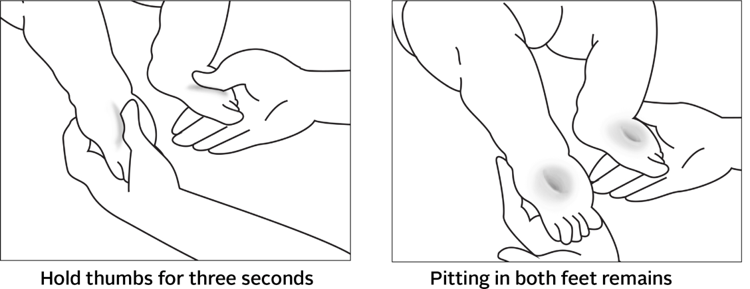

Step 2. Continue the same test on the lower legs, hands, and lower arms. If no pitting appears in these areas, then the child is said to have Grade +, or mild, bilateral pitting oedema. Mild bilateral pitting oedema only shows in the feet. If pitting appears in these other areas, go to Step 3.
Step 3: Look for swelling in the face, especially around the eyes. If no swelling appears in the face, then the child is said to have Grade ++, or moderate, bilateral pitting oedema. If swelling appears in the face, the child is said to have Grade +++, or severe, bilateral pitting oedema
Step 4: Have a second person repeat the test to confirm results.

Bilateral Pitting Oedema Grades | Definition
Absent | Absent
Grade + | Mild: Both feet/ankles
Grade ++ | Moderate: Both feet, plus lower legs, hands, or lower arms
Grade +++ | Severe: Generalised bilateral pitting oedema, including both feet, legs, arms, and face

3. MUAC
MUAC is the preferred indicator for identification, diagnosis, and treatment of children with acute malnutrition because of its ability to identify children who are at most risk of mortality due to acute malnutrition. MUAC should be measured while the arm is hanging down the side of the body and relaxed. The tape should be placed at the midpoint between the shoulder and the tip of the elbow. It is recommended to use a string instead of the MUAC tape to find the midpoint.

To measure MUAC, follow the steps below:
- Measure the length of the child’s upper arm, between the bone at the top of the shoulder [2] and the tip of the elbow [3] (the child’s arm should be bent to easily locate the tip).
- Find the midpoint of the upper arm by placing the tape from the top of the shoulder [4] to the tip of the elbow [5], mark it [6]. It is easier to use a string instead of the MUAC tape to find the midpoint.
- The child’s arm should then be relaxed, falling alongside his or her body.
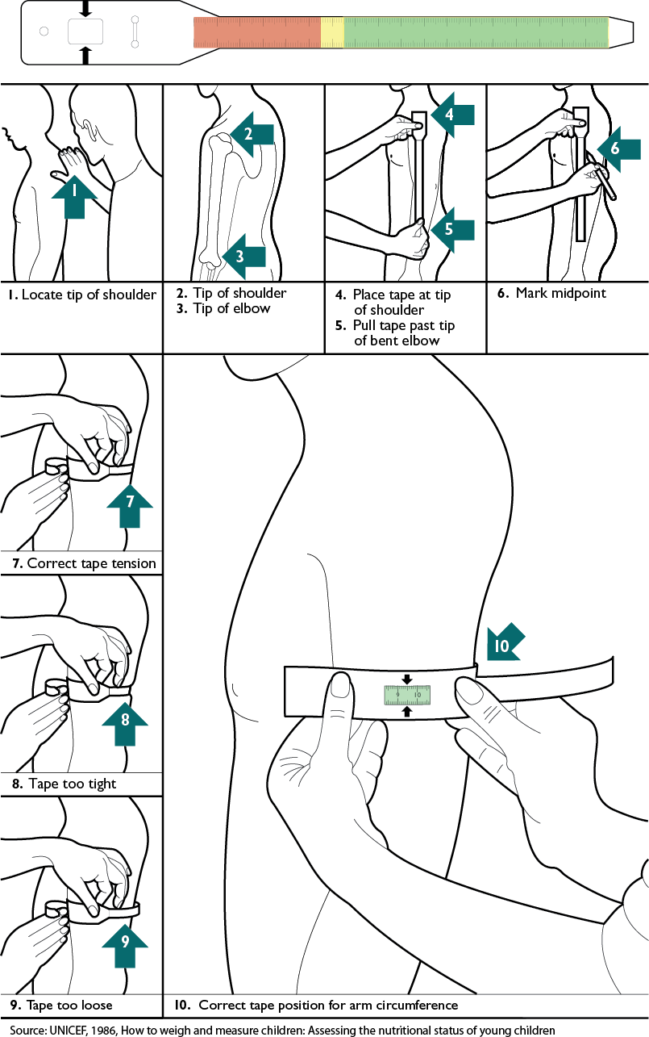
- Wrap the MUAC tape around the child’s midpoint so that all of it is in contact with the child’s skin [7]. The tape should be neither too tight [8] nor too loose [9].
- Feed the end of the tape through the first opening and then through the second opening. The measurement is read from the window where the arrows point inward [10].
- Record the MUAC reading with a precision of 1mm (0.1cm).

4. Weight
To increase accuracy and precision, two people are always needed to measure weight. Weight may be measured using a Salter-type hanging spring scale (as is commonly found in the health facilities and communities) or an electronic scale such as the United Nations Children’s Fund (UNICEF) UNISCALE, which is more precise and allows a child to be measured in the mother/caregiver’s arms. It is recommended that children be weighed with a scale with the following features:
- Solidly built and durable
- Electronic (digital reading)
- Measures up to 150 kg
- Measures to a precision of 0.1 kg (100 g)
- Allows tared weighing
‘Tared weighing’ means that the scale can be reset to zero (‘tared’) with the person who was just weighed still on it. Thus, a mother can stand on the scale, be weighed, and the scale tared. She then remains on the scale as her child is given to her to hold, and the child’s weight alone appears on the scale.
Tared weighing has two clear advantages:
- There is no need to subtract weights to determine the child’s weight alone (reducing the risk of error).
- The child is likely to remain calm when held in the mother’s arms for weighing.
Note: Infants under 6 months should be weighed using an infant scale with a precision of 10 g or 20 g.

Weigh Using a Spring (Salter) Scale
A 25-kg hanging spring scale, graduated by 0.100 kg, is most commonly used. In the community setting, the scale is hooked to a tree, a tripod or a stick held by two people. In a clinic, it is attached to the ceiling or a stand.
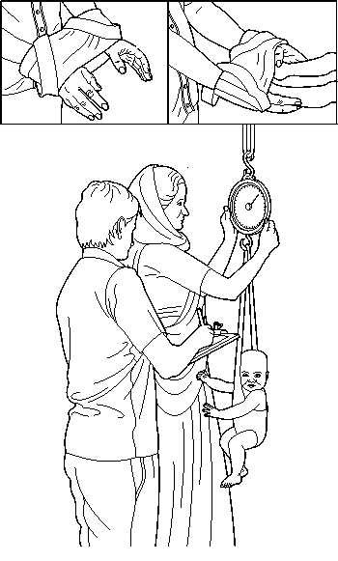
Weighing pants (or a weighing hammock for smaller infants) are attached to the scale. However, culturally adapted solutions, such as a mother’s wrap, basin or grass basket, are preferable to use to weigh the child; these are suspended from the lower hook of the scale, and the scale is readjusted to zero. The child's clothes are removed, and the child is placed in the weighing pants (or alternative). The scale should be read at eye level.
Considerations:
- Make sure the child is safely in the weighing pants or hammock with one arm in front and one arm behind to help maintain balance.
- In cold climates or in certain cultures, it might be impossible or impractical to undress a child completely. The average weight of the clothes should be estimated and deducted from the measure. It is helpful to retain similar clothing for girls and boys during weighing to help to standardize the weight deductions.
- When the child is steady and settled, the weight is recorded to the nearest 100 grams. If the child is moving and the needle does not stabilise, the weight should be estimated by recording the value at the midpoint of the range of oscillations. The measurer announces the value read from the scale, the assistant repeats it for verification and records it on the clinic form or CHC. The child is then dressed.
- The scale should be checked daily against a known weight. To do this, set the scale to zero and weigh objects of known weight (e.g., 5, 10 or 15 kg). If the measure does not match the weight to within 10 grams, the scale should be replaced or the springs must be changed.

Weigh the Child under 2 Years of Age Using an Electronic Scale (e.g., UNISCALE)
If the child is under 2 years of age or is unable to stand, you will do tared weighing.
Explain the tared weighing procedure to the mother as follows. Stress that the mother must stay on the scale until her child has been weighed in her arms.

Be sure that the scale is placed on a flat, hard, even surface. It should not be placed on a loose carpet or rug, but a firm carpet that is glued down is acceptable. Since the scale is solar-powered, there must be enough light to operate the scale.

- To turn on the scale, cover the solar panel for a second. When the number 0.0 appears, the scale is ready [1].

- Check to see that the mother has removed her shoes. You or someone else should hold the naked infant or child wrapped in a blanket.
- Ask the mother to stand in the middle of the scale, feet slightly apart (on the footprints, if marked), and remain still [2]. The mother’s clothing must not cover the display or solar panel.

- Remind her to stay on the scale even after her weight appears, until the child has been weighed in her arms.

- With the mother still on the scale and her weight displayed, tare the scale by covering the solar panel for a second. The scale is tared when it displays a figure of a mother and child and the number 0.0 [3].
- Gently hand the naked child to the mother and ask her to remain still [4].

- The child’s weight will appear on the display. Record this weight [5].

- Be careful to read the numbers in the correct order (as though you were viewing while standing on the scale rather than upside down).

Weigh the Child over 2 Years of Age using an Electronic Scale (e.g., UNISCALE)
If the child is 2 years or older, you will weigh the child alone if the child will stand still.
Explain that the child will need to step on the scale alone and stand very still. Undress the child. Explain that child needs to remove outer clothing in order to obtain an accurate weight. A wet diaper or shoes and jeans can weigh more than 0.5 kg. Older children should remove all but minimal clothing, such as their underclothes.

Standardise Scales
Standardise scales daily or whenever they are moved.

- Set the scale to zero.

- Weigh three objects of known weight (e.g., 5, 10, and 15 kg) and record the measured weights. (A container filled with stones and sealed may be used if its weight is accurately known.)

- Repeat the weighing of these objects and record the weights again.

- If there is a difference of 0.01 kg or more between duplicate weighings or if a measured weight differs by 0.01 kg or more from the known standard, check the scales and adjust or replace them if necessary.

5. Length and Height
Depending on the infant’s or child’s age and ability to stand, measure the length or height. The infant’s or child’s length is measured while he or she is lying down (recumbent). Height is measured while the child is standing upright.

- If the infant or child is under 2 years of age or is less than 87 cm tall and his or her age is not known, measure length. Use the Weight-for-Height/Length Reference Table in Annex B.
- If the child is 2 years or older or is 87 cm or taller and his or her age is not known, measure standing height. If a child 2 years or older or 87 cm or taller is unable to stand, measure recumbent length and subtract 0.7 cm from the length to arrive at a comparable height. Use the Weight-for-Height/Length Reference Table in Annex B.

Whether measuring length or height, the mother should be nearby to soothe and comfort the infant or child.

Use a Length Board to Measure the Infant’s or Child’s Length
Use a length board to measure length for an infant or child who is under 2 years of age, less than 87 cm tall when the infant’s or child’s age is not known, or 2 years or older or 87 cm or taller and is unable to stand.

- Place the length board on the ground and remove the infant’s or child’s shoes.

- Place the infant or child on his or her back in the middle of board, head facing straight up, arms at the infant or child’s sides, and feet at 90 degree angles to board. [2, 3]

- While holding the infant or child’s ankles or knees, move the sliding board up against the bottom of the child’s feet. [3]

- Ask an assistant [5] to hold the infant or child’s head in place [2].
- Take measurement to nearest 0.1 cm and read out loud. Have the assistant repeat the measurement for verification.

- Record the length measurement immediately to the nearest 0.1 cm. [6]

Note: If the child is 2 years old or older or is 87 cm or greater while standing up, be sure to subtract 0.7 cm from measurement.

Use a Height Board to Measure the Child’s Height

Use a height board to measure the height of a child 2 years or older or at 87 cm or taller who is able to stand.

- Remove the child’s shoes and place him or her on the height board, standing upright in the middle of the board with arms at his or her sides [1].

- Make sure that the child’s feet are close together with heels and soles touching the bottom of the board (that is, not standing tiptoe) [2].

- The back of the child’s ankles and knees should be firmly pressed toward the board [3].

- The child should stand straight, with heels, back of legs, buttocks, shoulder blades, and head touching the back of the board [3, 4, 5].

- Hold the child’s head straight [6]. The child’s line of vision should be parallel to the floor [5].

- Have an assistant hold the child’s legs and feet [7].
- Read measurement out loud to nearest 0.1 cm. Have the assistant repeat the measurement for verification.

- Record the height to the last completed 0.1 cm immediately [8].

Standardise Length/Height Board
Once a month, measure rods of known length on the measuring board and length/height board. For the measuring board, measure rods of 50 cm and 100 cm. For the length/height board, measure rods of 100 cm and 150 cm.

If there is 0.3 cm or more difference between the rod's known length and the measured length, recalibration may be needed. Get a second person to recheck your measurements before recalibrating. Also check that:
- The measuring tape is flat on the board, not buckled, in the correct position, and reading 0 cm at headboard end.
- The sliding foot piece is not too loose on the board (less than 0.2 cm wobble).
- The base of the board is not warped and that runners are straight and secure.

Handout 2.5 Weight-for-Height/Length Tables For Field Use

WHO sex-specific child growth standards (2006), expressed as z-score (SD) assessed supine from 45.0 cm up to 86.9 cm (length) and standing from 87.0 cm (height)

WHO 2006 Child Growth Standards: Length is measured for infants and children under 2 years or less than 87 cm height. For children 2 years or older or 87 cm height or greater, height is measured. Recumbent length is, on average, 0.7 cm greater than standing height; although the difference is of no importance to individual children, a correction may be made by subtracting 0.7 cm from all lengths above 86.9 cm if standing height cannot be measured. Note that the tables do not include reference for infants less than 45 cm.

 | Boys' weight (kg) |  |  |  | Length | Girls' weight (kg)
 | -3 SD | -2 SD | -1 SD | Median | (cm) | Median | -1 SD | -2 SD | -3 SD
 | 1.9 | 2.0 | 2.2 | 2.4 | 45 | 2.5 | 2.3 | 2.1 | 1.9
 | 2.0 | 2.2 | 2.4 | 2.6 | 46 | 2.6 | 2.4 | 2.2 | 2.0
 | 2.1 | 2.3 | 2.5 | 2.8 | 47 | 2.8 | 2.6 | 2.4 | 2.2
 | 2.3 | 2.5 | 2.7 | 2.9 | 48 | 3.0 | 2.7 | 2.5 | 2.3
 | 2.4 | 2.6 | 2.9 | 3.1 | 49 | 3.2 | 2.9 | 2.6 | 2.4
 | 2.6 | 2.8 | 3.0 | 3.3 | 50 | 3.4 | 3.1 | 2.8 | 2.6
 | 2.7 | 3.0 | 3.2 | 3.5 | 51 | 3.6 | 3.3 | 3.0 | 2.8
 | 2.9 | 3.2 | 3.5 | 3.8 | 52 | 3.8 | 3.5 | 3.2 | 2.9
 | 3.1 | 3.4 | 3.7 | 4.0 | 53 | 4.0 | 3.7 | 3.4 | 3.1
 | 3.3 | 3.6 | 3.9 | 4.3 | 54 | 4.3 | 3.9 | 3.6 | 3.3
 | 3.6 | 3.8 | 4.2 | 4.5 | 55 | 4.5 | 4.2 | 3.8 | 3.5
 | 3.8 | 4.1 | 4.4 | 4.8 | 56 | 4.8 | 4.4 | 4.0 | 3.7
 | 4.0 | 4.3 | 4.7 | 5.1 | 57 | 5.1 | 4.6 | 4.3 | 3.9
 | 4.3 | 4.6 | 5.0 | 5.4 | 58 | 5.4 | 4.9 | 4.5 | 4.1
 | 4.5 | 4.8 | 5.3 | 5.7 | 59 | 5.6 | 5.1 | 4.7 | 4.3
 | 4.7 | 5.1 | 5.5 | 6.0 | 60 | 5.9 | 5.4 | 4.9 | 4.5
 | 4.9 | 5.3 | 5.8 | 6.3 | 61 | 6.1 | 5.6 | 5.1 | 4.7
 | 5.1 | 5.6 | 6.0 | 6.5 | 62 | 6.4 | 5.8 | 5.3 | 4.9
 | 5.3 | 5.8 | 6.2 | 6.8 | 63 | 6.6 | 6.0 | 5.5 | 5.1
 | 5.5 | 6.0 | 6.5 | 7.0 | 64 | 6.9 | 6.3 | 5.7 | 5.3
 | 5.7 | 6.2 | 6.7 | 7.3 | 65 | 7.1 | 6.5 | 5.9 | 5.5
 | 5.9 | 6.4 | 6.9 | 7.5 | 66 | 7.3 | 6.7 | 6.1 | 5.6
 | 6.1 | 6.6 | 7.1 | 7.7 | 67 | 7.5 | 6.9 | 6.3 | 5.8
 | 6.3 | 6.8 | 7.3 | 8.0 | 68 | 7.7 | 7.1 | 6.5 | 6.0
 | 6.5 | 7.0 | 7.6 | 8.2 | 69 | 8.0 | 7.3 | 6.7 | 6.1
 | 6.6 | 7.2 | 7.8 | 8.4 | 70 | 8.2 | 7.5 | 6.9 | 6.3
 | 6.8 | 7.4 | 8.0 | 8.6 | 71 | 8.4 | 7.7 | 7.0 | 6.5
 | 7.0 | 7.6 | 8.2 | 8.9 | 72 | 8.6 | 7.8 | 7.2 | 6.6
 | 7.2 | 7.7 | 8.4 | 9.1 | 73 | 8.8 | 8.0 | 7.4 | 6.8
 | 7.3 | 7.9 | 8.6 | 9.3 | 74 | 9.0 | 8.2 | 7.5 | 6.9
 | 7.5 | 8.1 | 8.8 | 9.5 | 75 | 9.1 | 8.4 | 7.7 | 7.1
 | 7.6 | 8.3 | 8.9 | 9.7 | 76 | 9.3 | 8.5 | 7.8 | 7.2
 | 7.8 | 8.4 | 9.1 | 9.9 | 77 | 9.5 | 8.7 | 8.0 | 7.4
 | 7.9 | 8.6 | 9.3 | 10.1 | 78 | 9.7 | 8.9 | 8.2 | 7.5
 | 8.1 | 8.7 | 9.5 | 10.3 | 79 | 9.9 | 9.1 | 8.3 | 7.7
 | 8.2 | 8.9 | 9.6 | 10.4 | 80 | 10.1 | 9.2 | 8.5 | 7.8
 | 8.4 | 9.1 | 9.8 | 10.6 | 81 | 10.3 | 9.4 | 8.7 | 8.0
 | 8.5 | 9.2 | 10.0 | 10.8 | 82 | 10.5 | 9.6 | 8.8 | 8.1
 | 8.7 | 9.4 | 10.2 | 11.0 | 83 | 10.7 | 9.8 | 9.0 | 8.3
 | 8.9 | 9.6 | 10.4 | 11.3 | 84 | 11.0 | 10.1 | 9.2 | 8.5
 | 9.1 | 9.8 | 10.6 | 11.5 | 85 | 11.2 | 10.3 | 9.4 | 8.7
 | 9.3 | 10.0 | 10.8 | 11.7 | 86 | 11.5 | 10.5 | 9.7 | 8.9
 | 9.5 | 10.2 | 11.1 | 12.0 | 87 | 11.7 | 10.7 | 9.9 | 9.1
 | 9.7 | 10.5 | 11.3 | 12.2 | 88 | 12.0 | 11.0 | 10.1 | 9.3
 | 9.9 | 10.7 | 11.5 | 12.5 | 89 | 12.2 | 11.2 | 10.3 | 9.5
 | 10.1 | 10.9 | 11.8 | 12.7 | 90 | 12.5 | 11.4 | 10.5 | 9.7
 | 10.3 | 11.1 | 12.0 | 13.0 | 91 | 12.7 | 11.7 | 10.7 | 9.9
 | 10.5 | 11.3 | 12.2 | 13.2 | 92 | 13.0 | 11.9 | 10.9 | 10.1
 | 10.7 | 11.5 | 12.4 | 13.4 | 93 | 13.2 | 12.1 | 11.1 | 10.2
 | 10.8 | 11.7 | 12.6 | 13.7 | 94 | 13.5 | 12.3 | 11.3 | 10.4
 | 11.0 | 11.9 | 12.8 | 13.9 | 95 | 13.7 | 12.6 | 11.5 | 10.6
 | 11.2 | 12.1 | 13.1 | 14.1 | 96 | 14.0 | 12.8 | 11.7 | 10.8
 | 11.4 | 12.3 | 13.3 | 14.4 | 97 | 14.2 | 13.0 | 12.0 | 11.0
 | 11.6 | 12.5 | 13.5 | 14.6 | 98 | 14.5 | 13.3 | 12.2 | 11.2
 | 11.8 | 12.7 | 13.7 | 14.9 | 99 | 14.8 | 13.5 | 12.4 | 11.4
 | 12.0 | 12.9 | 14.0 | 15.2 | 100 | 15.0 | 13.7 | 12.6 | 11.6

*

WHO 2006 Child Growth Standards: Length is measured for infants and children under 2 years or less than 87 cm height. For children 2 years or older or 87 cm height or more, height is measured. Recumbent length is, on average, 0.7 cm greater than standing height; although the difference is of no importance to individual children, a correction may be made by subtracting 0.7 cm from all lengths greater than 86.9 cm if standing height cannot be measured. Note that the tables do not include reference for infants less than 45 cm.

 | Boys' weight (kg) |  |  |  | Length | Girls' weight (kg)
 | -3 SD | -2 SD | -1 SD | Median | (cm) | Median | -1 SD | -2 SD | -3 SD
 | 5.9 | 6.3 | 6.9 | 7.4 | 65 | 7.2 | 6.6 | 6.1 | 5.6
 | 6.1 | 6.5 | 7.1 | 7.7 | 66 | 7.5 | 6.8 | 6.3 | 5.8
 | 6.2 | 6.7 | 7.3 | 7.9 | 67 | 7.7 | 7.0 | 6.4 | 5.9
 | 6.4 | 6.9 | 7.5 | 8.1 | 68 | 7.9 | 7.2 | 6.6 | 6.1
 | 6.6 | 7.1 | 7.7 | 8.4 | 69 | 8.1 | 7.4 | 6.8 | 6.3
 | 6.8 | 7.3 | 7.9 | 8.6 | 70 | 8.3 | 7.6 | 7.0 | 6.4
 | 6.9 | 7.5 | 8.1 | 8.8 | 71 | 8.5 | 7.8 | 7.1 | 6.6
 | 7.1 | 7.7 | 8.3 | 9.0 | 72 | 8.7 | 8.0 | 7.3 | 6.7
 | 7.3 | 7.9 | 8.5 | 9.2 | 73 | 8.9 | 8.1 | 7.5 | 6.9
 | 7.4 | 8.0 | 8.7 | 9.4 | 74 | 9.1 | 8.3 | 7.6 | 7.0
 | 7.6 | 8.2 | 8.9 | 9.6 | 75 | 9.3 | 8.5 | 7.8 | 7.2
 | 7.7 | 8.4 | 9.1 | 9.8 | 76 | 9.5 | 8.7 | 8.0 | 7.3
 | 7.9 | 8.5 | 9.2 | 10.0 | 77 | 9.6 | 8.8 | 8.1 | 7.5
 | 8.0 | 8.7 | 9.4 | 10.2 | 78 | 9.8 | 9.0 | 8.3 | 7.6
 | 8.2 | 8.8 | 9.6 | 10.4 | 79 | 10.0 | 9.2 | 8.4 | 7.8
 | 8.3 | 9.0 | 9.7 | 10.6 | 80 | 10.2 | 9.4 | 8.6 | 7.9
 | 8.5 | 9.2 | 9.9 | 10.8 | 81 | 10.4 | 9.6 | 8.8 | 8.1
 | 8.7 | 9.3 | 10.1 | 11.0 | 82 | 10.7 | 9.8 | 9.0 | 8.3
 | 8.8 | 9.5 | 10.3 | 11.2 | 83 | 10.9 | 10.0 | 9.2 | 8.5
 | 9.0 | 9.7 | 10.5 | 11.4 | 84 | 11.1 | 10.2 | 9.4 | 8.6
 | 9.2 | 10.0 | 10.8 | 11.7 | 85 | 11.4 | 10.4 | 9.6 | 8.8
 | 9.4 | 10.2 | 11.0 | 11.9 | 86 | 11.6 | 10.7 | 9.8 | 9.0
 | 9.6 | 10.4 | 11.2 | 12.2 | 87 | 11.9 | 10.9 | 10.0 | 9.2
 | 9.8 | 10.6 | 11.5 | 12.4 | 88 | 12.1 | 11.1 | 10.2 | 9.4
 | 10.0 | 10.8 | 11.7 | 12.6 | 89 | 12.4 | 11.4 | 10.4 | 9.6
 | 10.2 | 11.0 | 11.9 | 12.9 | 90 | 12.6 | 11.6 | 10.6 | 9.8
 | 10.4 | 11.2 | 12.1 | 13.1 | 91 | 12.9 | 11.8 | 10.9 | 10.0
 | 10.6 | 11.4 | 12.3 | 13.4 | 92 | 13.1 | 12.0 | 11.1 | 10.2
 | 10.8 | 11.6 | 12.6 | 13.6 | 93 | 13.4 | 12.3 | 11.3 | 10.4
 | 11.0 | 11.8 | 12.8 | 13.8 | 94 | 13.6 | 12.5 | 11.5 | 10.6
 | 11.1 | 12.0 | 13.0 | 14.1 | 95 | 13.9 | 12.7 | 11.7 | 10.8
 | 11.3 | 12.2 | 13.2 | 14.3 | 96 | 14.1 | 12.9 | 11.9 | 10.9
 | 11.5 | 12.4 | 13.4 | 14.6 | 97 | 14.4 | 13.2 | 12.1 | 11.1
 | 11.7 | 12.6 | 13.7 | 14.8 | 98 | 14.7 | 13.4 | 12.3 | 11.3
 | 11.9 | 12.9 | 13.9 | 15.1 | 99 | 14.9 | 13.7 | 12.5 | 11.5
 | 12.1 | 13.1 | 14.2 | 15.4 | 100 | 15.2 | 13.9 | 12.8 | 11.7
 | 12.3 | 13.3 | 14.4 | 15.6 | 101 | 15.5 | 14.2 | 13.0 | 12.0
 | 12.5 | 13.6 | 14.7 | 15.9 | 102 | 15.8 | 14.5 | 13.3 | 12.2
 | 12.8 | 13.8 | 14.9 | 16.2 | 103 | 16.1 | 14.7 | 13.5 | 12.4
 | 13.0 | 14.0 | 15.2 | 16.5 | 104 | 16.4 | 15.0 | 13.8 | 12.6
 | 13.2 | 14.3 | 15.5 | 16.8 | 105 | 16.8 | 15.3 | 14.0 | 12.9
 | 13.4 | 14.5 | 15.8 | 17.2 | 106 | 17.1 | 15.6 | 14.3 | 13.1
 | 13.7 | 14.8 | 16.1 | 17.5 | 107 | 17.5 | 15.9 | 14.6 | 13.4
 | 13.9 | 15.1 | 16.4 | 17.8 | 108 | 17.8 | 16.3 | 14.9 | 13.7
 | 14.1 | 15.3 | 16.7 | 18.2 | 109 | 18.2 | 16.6 | 15.2 | 13.9
 | 14.4 | 15.6 | 17.0 | 18.5 | 110 | 18.6 | 17.0 | 15.5 | 14.2
 | 14.6 | 15.9 | 17.3 | 18.9 | 111 | 19.0 | 17.3 | 15.8 | 14.5
 | 14.9 | 16.2 | 17.6 | 19.2 | 112 | 19.4 | 17.7 | 16.2 | 14.8
 | 15.2 | 16.5 | 18.0 | 19.6 | 113 | 19.8 | 18.0 | 16.5 | 15.1
 | 15.4 | 16.8 | 18.3 | 20.0 | 114 | 20.2 | 18.4 | 16.8 | 15.4
 | 15.7 | 17.1 | 18.6 | 20.4 | 115 | 20.7 | 18.8 | 17.2 | 15.7
 | 16.0 | 17.4 | 19.0 | 20.8 | 116 | 21.1 | 19.2 | 17.5 | 16.0
 | 16.2 | 17.7 | 19.3 | 21.2 | 117 | 21.5 | 19.6 | 17.8 | 16.3
 | 16.5 | 18.0 | 19.7 | 21.6 | 118 | 22.0 | 19.9 | 18.2 | 16.6
 | 16.8 | 18.3 | 20.0 | 22.0 | 119 | 22.4 | 20.3 | 18.5 | 16.9
 | 17.1 | 18.6 | 20.4 | 22.4 | 120 | 22.8 | 20.7 | 18.9 | 17.3

Handout 2.6 C-MAMI Tool Version 2.0
- TRIAGE: CHECK FOR SIGNS AND SYMPTOMS FOR REFERRAL TO INPATIENT CARE
ASSESS | CLASSIFY |  | ACT (MANAGE)
Infant CHECK for General Danger Signs | INFANT/MOTHER: NUTRITIONALLY VULNERABLE WITH MEDICAL COMPLICATIONS - HIGH NUTRITIONAL RISK OR VERY SEVERE DISEASE |  | URGENT referral to Inpatient Care
Ask /Listen /Look /Feel  - Ask: Is the infant able to drink or breastfeed?  - Ask: Does the infant vomit everything?  - Ask: Has the infant had convulsions?  - Look: Is the infant convulsing now?  - Look: Is the infant lethargic or unconscious? | If any of the following are present for Infant:  General Danger Signs  - Unable to feed  - Vomits everything |  | Pre-referral actions: Infant  - Provide any appropriate pre-referral treatment  - Show the mother how to keep the infant warm on the way to the hospital or clinic  - Provide skin-to-skin contact  OR  - Keep the infant clothed or covered as much as possible all of the time. Dress the young infant with extra clothing including hat, gloves, socks and wrap the infant in a soft dry cloth and cover with a blanket  - If child is very hot, ask mother to remove outer clothing and leave infant in underwear  - For breastfed infant, encourage breastfeeding before transfer and on the way if infant has an appetite  - For non-breastfed infant, ensure the mother has appropriate feeding supplies and encourage to feed before transfer and on the way if the infant has appetite
 | - Had fit (convulsions) | - Fitting now (convulsions)
 | - Movement only when stimulated (lethargic) | - No movement (unconscious)
- Look and count the breaths in one minute.  - Look: Does infant have lower chest wall in-drawing? | Difficulty breathing  - Fast breathing  - infant 0-1 months: ≥60 breaths/min  - infant 2-5 months: ≥50 breaths/min  - Lower chest wall in-drawing  - Grunting
- Ask: Does the infant have diarrhoea?  - Look: Does the infant have sunken eyes?  - Ask: Are infant’s eyes recently sunken or look worse than yesterday?  - Pinch the skin of the abdomen. Does it go back: Very slowly (longer than 2 seconds) | Diarrhoea  - Has diarrhoea  - Sunken eyes  - Skin pinch goes back very slowly (>2 sec.)
- Feel: Does the infant have a fever (hot)? Does the infant have low body temperature (feels cool)?  - Measure temperature under the armpit if you have a thermometer | Fever  - Feels hot: ≥37.5○C  - Feels cold: <35.5○C
Infant: Check for jaundice  - Look for jaundice. Does the infant have yellow eyes or skin?  - Look at the young infant's palms and soles. Are they yellow? | Jaundice  - Age <24 hours: any jaundice  - Age >24 hours: jaundice hands & feet
Infant: Check for severe pallor/anaemia  - Look infant’s hands. Are the palms very pale/white? | Severe pallor/anaemia  - Very pale or white palms
Mother: Check at for pallor/anaemia  - Test for Hb via Hemocue or similar  - Look at mother’s hands: Are her palms very pale/white?  - Look at eyes: Are inside of eyelids pale? | Mother: Anaemia  - Hemocue or similar test indicates anaemia  - Very pale or white palms  - Pale inside of eyelids (conjunctiva)
Infant:  Check for complications that make feeding difficult (see 2nd Column) | If Infant has any of the following that make feeding difficult  - Cleft lip or palate (feel inside mouth to check palate)  - Tongue tie  - Abnormal tone or posture  - Excessively open/clenched jaw  - Unable to support head or poor trunk control  - When held, infant’s arms and legs fall to the sides  - Infant’s body stiﬀ, hard to move  - Coughing and eye tearing while feeding (signs of unsafe swallowing) |  | - Specialist referral for more detailed assessment and treatment of any structural or disability problem that should include special feeding support
Infant: Anthropometric/Nutritional Assessment  - Look for pitting oedema of both feet  - Measure weight and length and determine weight-for-age (WFA) and weight-for-length (WFL) where calculable  - Record Mid Upper Arm Circumference (MUAC) for all infants (to help build evidence)  - Ask & Listen: Have you noticed your infant losing weight? For how long? | Infant  - < -2 WFA OR  - < -2 WFL  - Bilateral pitting oedema +, ++ and +++  OR  - Failure to respond to previous outpatient-based nutritional care (infant or mother)  AND any one of the following  - Recent severe weight loss (within 1 week)  - Prolonged (weeks) failure to gain weight  - Sharp drop across growth chart centile line  MUAC: ______mm (record to help build evidence
Mother: Anthropometric/ Nutritional Assessment  - Look for pitting oedema of both feet (if mother not pregnant)  - Measure MUAC (always) | Mother  - MUAC: <190 mm  MUAC: _____ mm (record to help build evidence)  OR  - Bilateral pitting oedema (if mother not pregnant)

ASSESS | CLASSIFY | ACT (MANAGE)
MOTHER | MOTHER: SEVERE DEPRESSION
Mother: Maternal Mental Health  Observe the mother’s responses and behaviours  - Listen & Look: Does it appear that mother is out of touch with reality or what is happening in the assessment (e.g. not responding appropriately during the assessment)?  - Listen & Look: Does the infant appear to be at risk from the mother's behaviour? (for example: mother shows no concern for infant, or wilful neglect of infant, such as prolonged period of no eye contact or no physical contact with infant)  There are many daily tasks a mother does to care for her infant and family (for example: washing, cooking).  - Ask & Listen: What are some of the most important things you do for your infant and family?  - Ask & Listen: Do you ever find it difficult to do all these tasks? If Yes: Why is that?  Sometimes a mother finds it difficult to do daily tasks because she is feels sad or worried.  - Ask & Listen: In the last few weeks, have you been feeling:  Sad? If Yes (listen for): little/some/much/most of the time?  Worried? If Yes (listen for): little/some/much/most of the time?  - Ask & Listen: Are there times you experience so much pain that it interferes with your ability to carry out daily tasks?  - Ask & Listen: If Yes (listen for): Does this happen rarely/some/often/most of the time?  If mother answers yes to either of questions above, then ask:  - Ask & Listen: What are the problems that you are feeling sad or worried about?  Sometimes when a person feels sad or worried she may have thoughts of harming herself or her infant.  - Ask & Listen: Do you have any thoughts like that?  Sometimes a person feels very sad or worried because her husband/partner (or someone else in the family) is hitting or beating her.  - Ask & Listen: Is that happening to you? | Any of the following:  - Mother appears to be out of touch with reality or with what is happening in the assessment  OR  - Infant appears to be at risk from the mother’s behaviour.  [Mother may have a severe mental, neurological or substance use disorder]  OR  - Mother finds it difficult to carry out daily tasks necessary to care for her infant  OR  - Mother feels body pain most of time  OR  - Mother feels very sad or worried much of time  List problems mother is feeling sad or worried about:  __________________________________________  __________________________________________  [Mother is severely anxious, depressed, traumatised, or otherwise in emotional crisis]  - Mother has thoughts of harming herself or infant  OR  - Mother expresses fear of physical harm to herself or infant from her partner or another person  OR  - Mother or infant has experienced physical harm from her partner or another person  [Mother and/or infant are at risk of harm from mother herself or other individual] | - Explain to supervisor that you are concerned about the mother / infant’s safety and want to connect mother with the best care available  - Assess safety of family situation and link with other potential caregivers for immediate care of mother and infant  - Supervisors identify priority actions in partnership with Mental Health and Psychosocial Support (MHPSS) services and Child Protection services as appropriate  - Follow up on referral to ensure safety and potential of enrolment in C-MAMI upon amelioration of symptoms

2. FEEDING ASSESSMENT
ASSESS | CLASSIFY |  | ACT (MANAGE) |  |  | CLASSIFY |  | ACT (MANAGE)
Breastfed Infant and Mother | Moderate Feeding Problem: C-MAMI criteria |  | C-MAMI Enrolment (Outpatient): Infant-Mother Pair |  |  | No Feeding Problem: C-MAMI criteria |  | Home Care
Breastfed Infant  - 👁️ Look: Is the infant well attached?  - Mouth wide open  - Lower lip turned outwards  - Chin touching breast  - More areola above than below nipple  - Look: Is the infant suckling effectively?  - Slow deep sucks  - Pausing  - Audible swallowing  - Ask & Listen: Find out how many breastfeeds in 24 hours  - Ask & Listen: Does the infant receives plain water, other liquids or foods?  - Ask & Listen: Does the infant refuse to breastfeed?  - Look for thrush in infant’s mouth | Any of the following  - Not well attached to the breast  - Not suckling effectively  - <8 breastfeeds in 24 hours  - Receives plain water, other liquids or foods  - Refuses to breastfeed  - Oral thrush (candida) |  | Refer to Breastfeeding Counselling and Support Actions  - Attachment: Section A: 1  - Effectively suckling: Section A: 2  - Frequency of breastfeeds: Section A: 3  - Exclusive breastfeeding: Section A: 4  - Oral thrush (candida): Section A: 11  AND  - Plot and examine growth chart to monitor progress, including birth weight, if available |  |  | Well Attached: all the following  - Mouth wide open  - Lower lip turned outwards  - Chin touching breast  - More areola above than below nipple  AND  Suckling well: all the following  - Slow deep sucks  - Pausing  - Audible swallowing  AND  Frequent breastfeeds  - ≥8 in 24 hours  AND  - No plain water/ liquids/foods  AND  - No thrush in infant’s mouth |  | - Praise, support, reassure  - General advice / counselling on:  - general age-appropriate feeding and nutrition recommendations  - routine healthcare services e.g. vaccinations, growth monitoring  - Advise to return if new problem develops
Mother  - Listen: Find out if the mother thinks she hasn’t enough breast milk  - Listen: Find out if the mother lacks confidence about feeding  Breast Condition: identify any of the following  - Ask & Look: Engorgement  - Ask & Look: Sore & cracked nipples  - Ask & Look: Plugged ducts  - Ask & Look: Mastitis  - Ask & Look: Flat, inverted, large or long nipples  - Ask & Look: Itching of nipples or breasts (thrush)  Other concerns: any of the following  - Ask & Listen: Do you think your infant was born too early? or too small?  - Ask & Listen: How do you feel about your infant’s weight gain/growth?  - Ask & Listen: Are you working away from infant or separated from him/her?  - Ask & Listen: Do you have concerns about your own diet?  - Ask & Listen: Other (dealing with different feeding practices of mother-in-law, father, family)?  - Ask & Listen: Any other problem or concern? | Mother: either of the following  - Perception of not having enough breast milk  - Lack of confidence about feeding  OR  Breast Condition: any of the following  - Engorgement  - Sore & cracked nipples  - Plugged ducts  - Mastitis  - Flat, inverted, large or long nipples  - Itching of nipples or breasts (thrush)  OR  Other concerns: any of the following  - Preterm or low birth weight  - Lack of confidence about infant weight gain/growth  - Working away or separated from infant  - Concerns about own diet  - Other (dealing with different feeding practices of mother-in-law, father, family)  - Note problem/concern: ____________________ |  | Mother  - Perception of not having enough breast milk: Section A: 5  - Lack of confidence about feeding: Section A: 6  Breast Condition  - Engorgement: Section A: 7  - Sore & cracked nipples: Section A: 8  - Plugged ducts: Section A: 9  - Mastitis: Section A: 9  - Flat, inverted, large or long nipples: Section A: 10  - Thrush: Section A: 12  Other concerns  - Preterm or low birth weight: Section A: 13  - Lack of confidence about infant weight gain/growth: Section A: 14  - Working away from her infant: Section A: 15-16  - Concerns about her diet: Section A: 18 |  |  | Mother  - Confident about infant condition, and breastfeeding  - Reports no breastfeeding problem and no concern |  | - Praise, support, reassure  - General advice / counselling on:  - general age-appropriate feeding and nutrition recommendations  - routine healthcare services  - Advise to return if new problem develops
Non-breastfed Infant-Mother/Caregiver | Moderate Feeding Problem: C-MAMI criteria |  | C-MAMI Enrolment (Outpatient): Infant-Mother Pair |  |  | No Feeding Problem: C-MAMI criteria |  | Home Care
- Ask & Listen: Is mother the main caregiver for infant?  - Ask & Listen: Did mother ever breastfed? When did she stop and why?  - Ask & Listen: Is mother interested in relactating?  - Ask & Listen: Is caregiver interested in wet nursing?  - Ask & Listen: What is the type/source of breast milk substitute (BMS) used?  - Ask & Listen: How do you prepare the BMS used?  - Ask & Listen: How much BMS is consumed per 24 hours?  - Ask & Listen: Is infant refusing feeds?  - Ask & Listen: Does infant receive other drinks or foods in addition to BMS?  - Ask & Listen: What feeding utensils does infant use?  - Ask & Listen: Any problems or concerns?  - Ask & Listen: Do you have the fuel/equipment available to clean and sterilize? | In non-breastfed infant: any of the following  - If appropriate note why the mother stopped breastfeeding  _____________________  - Mother present and interested in relactating  - Mother absent but caregiver interested in relactation or wet nursing  - Inappropriate breast milk substitute (BMS) being used  - Consumes less than 500ml of BMS per 24 hours  - Refusing feeds  - Receives other drinks or foods in addition to BMS  - Feeding bottle used  - Does not practice good hygiene in feed preparation  - Note problem/concern ____________________ |  | In non-breastfed infant  - Non-breastfeeding counselling and support actions: Section C: 1-4  - Interest in relactating: Section C: 1-4  - Supplementary suckling support: Section B  - Preparing infant formula: Section C: 3-4 |  |  | In non-breastfed infant:  - Mother relactating  OR  - Infant fed by wet nurse  OR: all the following for infant fed with BMS  - Appropriate breast milk substitute (BMS) being used  AND  - Consumes at least 500ml of BMS per 24 hours  AND  - Feeds well  AND  - Receives only BMS  AND  - Practices good hygiene  Mother/Caregiver  - Confident about infant condition, feeding and home management  - Reports no feeding problem and no concern |  | - Praise, support, reassure  - General advice / counselling on:  - general age-appropriate feeding and nutrition recommendations  - routine healthcare services  - Advise to return if new problem develops
Underlying clinical problems or issues that may affect feeding  - Is this infant a twin?  - What is mother’s age?  - Has the mother or prospective wet nurse or infant had an HIV test?  - If tested HIV positive and breastfeeding: is the mother and infant on anti-retroviral treatment (ART)? | Infant: any of the following  - Twin birth  - Adolescent mother (<19 years)  - Tested HIV positive  - On ART  Mother or prospective wet nurse: any of the following  - Tested HIV positive  - On ART  - Note problem or concern: ____________________ |  | Infant  - Twin birth: Section A: 19  - Adolescent mother (<19 years): Section A: 20  - Tested HIV positive: investigate and treat as per national / local guidelines: Section A: 21  Mother/Wet-nurse  - Tested HIV positive: investigate and treat as per national / local guidelines  - Ensure mother/wet-nurse is referred for or receiving appropriate treatment (antiretroviral drugs for HIV)  - Emphasise importance of adherence to ART for mother/wet-nurse’s health and to reduce HIV transmission risk to infant |  |  |  |  | - Praise, support, reassure  - General advice / counselling on:  - general age-appropriate feeding and nutrition recommendations  - routine healthcare services  - Advise to return if new problem develops
- 3. ANTHROPOMETRIC / NUTRITIONAL ASSESSMENT
ASSESS |  | CLASSIFY |  | ACT (MANAGE) | CLASSIFY |  | ACT (MANAGE)
Infant/Mother |  | INFANT: NUTRITIONALLY VULNERABLE INFANTS WITHOUT MEDICAL COMPLICATIONS  (MODERATE NUTRITIONAL RISK) OR MOTHER: MODERATE NUTRITIONAL RISK |  | C-MAMI outpatient enrolment: Infant-Mother Pair | INFANT AND MOTHER  LOW NUTRITIONAL RISK |  | No C-MAMI enrolment for Infant-Mother Pair
Infant  - Obtain infant age (in completed months). Measure weight and length and determine weight-for-age z-score (WFA) and weight-for-length z-score (WFL) where calculable.  - NOTE: clinical assessment for visible wasting is not a reliable substitute for anthropometry and will result in cases being missed. It should only be done where length is <45cm and WFL cannot be calculated.  - Record Mid Upper Arm Circumference (MUAC) for all infants (to help build evidence) |  | Infant:  Both  - Clinically well  - Alert  AND  One of the following  - < -2 WFA OR  - < -2 WFL  OR: any of the following  - Moderate weight loss (within a few days)  - Recent (days-weeks) failure to gain weight  - Moderate drop across growth chart centile lines  MUAC: ______ mm (record to help build evidence) |  | - Assess underlying cause(s) of malnutrition and discuss action(s) to address these  - Plot & examine growth chart to monitor progress including  - Birth weight if available  - Gestation age at birth if available  - Growth trend if previous data available  - Provide age- and status-appropriate nutrition/feeding advice  - Provide course of broad-spectrum oral antibiotic, such as amoxicillin (for infant) – check local guidelines  Follow-up  - Provide follow-up in 1 week to monitor for change in nutritional status | Infant:  Both  - Clinically well  - Alert  AND  - ≥-2 WFA OR  - ≥-2 WFL  AND  - Infant gaining weight  MUAC: ____ mm (record to help build evidence) |  | No C-MAMI enrolment for Infant-Mother Pair  - Praise, support, reassure  - General advice / counselling on:  - age- and status-appropriate feeding and nutrition recommendations  - routine healthcare services e.g. vaccinations, growth monitoring  - Advise to return if new problem develops
Mother  - Measure MUAC (always) |  | OR  Mother  Anthropometry assessment  - MUAC ≥ 190mm and <230 mm  MUAC: ______ mm (record to help build evidence) |  | - Provide follow-up in 1 week | AND  Mother  Anthropometry assessment  - MUAC ≥230 mm  MUAC: ____ mm (record to help build evidence) |  | No C-MAMI enrolment for Infant-Mother Pair  - Praise, support, reassure  - General advice / counselling on:  - age- and status-appropriate feeding and nutrition recommendations  - routine healthcare services  - Advise to return if new problem develops

- MATERNAL MOTHER MENTAL HEALTH ASSESSSMENT
ASSESS | CLASSIFY | ACT (MANAGE) | CLASSIFY | ACT (MANAGE)
Mother | MOTHER: MODERATE  MATERNAL MENTAL DEPRESSION/ANXIETY/DISTRESS | C-MAMI outpatient enrolment: Infant-Mother Pair | MOTHER: NO MATERNAL  MENTAL DEPRESSION/  ANXIETY/ DISTRESS | No C-MAMI enrolment for Infant-Mother Pair
On some or most days in the last 2 weeks:  - Ask & Listen: Have you felt unable to stop worrying or thinking too much?  - Ask & Listen: Have you been sad or worried? | If mother answers yes to 1-2 of the questions, then enrol in C-MAMI  - Mother felt unable to stop worrying or thinking too much  - Mother has been sad or worried  (Mother has symptoms of anxiety, depression, or stress that impacts daily functions) | - Ask mothers about their concerns  - Listen to mothers and help them feel calm  - Help mothers to find solutions and link to resources to address basic needs  - Help connect mothers to information / help to prevent further harm | - Mother has limited / no symptoms of anxiety, depression, or stress that impacts daily functions | - Praise, support, reassure  - General advice / counselling on:  - care and nutrition recommendations during pregnancy, lactation and adolescence  - routine healthcare services  - Advise to return if new problem develops
Social support  - Ask & Listen: Do you have enough food to feed your family daily? If No: Are you registered in any food-related services: general food distribution (GFD), supplementary feeding programme (SFP), targeted cash/voucher schemes, social protection schemes, etc.?  - Ask & Listen: Have you attended health services when you felt you needed to or have been referred?  - Ask & Listen: Do you attend health education sessions, support groups in your community or facility or receive education through community outreach workers? | Lack of care and social support  - Not enough food to feed family  - Not registered in any food-related services: GFD, SFP, targeted cash/voucher schemes, social protection schemes, etc.  OR  - Does not attend the health services when needed or referred  OR  - Does not attend health education sessions, support groups in community or facility or receive education through community outreach workers | - Link and refer with appropriate institutional care / services (e.g. Health facility, Mental Health of Psychosocial support program, Protection programs / GBV response programs)  - If not attending health services or education sessions refer to Support during breastfeeding or for non-breastfeeding mother: Section C: 1-4/caregiver: Section D: 1-4  - Organise meetings at which caregivers can discuss their lives, share problem-solving and support one another in caring effectively for their infants  - Group support:  - Family support: Section D: 1-2page #  - Partner support: Section D: 3  - Community support: Section D: 4  - Identify local human resources (e.g. community leaders, elders, health workers, teachers, women’s group)  - In follow up visits, attempt to meet with people who have been named and ask if they can help  - When local support systems are weak, consider establishing support groups linking MAMI mothers ("current" and "graduated") | Adequate care and social support  - Existing social support / cohesion / belonging  - Registered in food-related services: GFD, SFP, targeted cash/voucher schemes, social protection schemes, etc.  - Attends the health services when needed or referred  - Attends health education sessions or support groups in community or facility
Source: C-MAMI Tool, v2.0 (2018). www.ennonline.net//c-mami

EXERCISES

Exercise 2.1 Grades of Bilateral Pitting Oedema

PHOTO 1 | 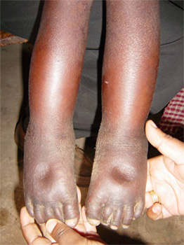
PHOTO 2 | 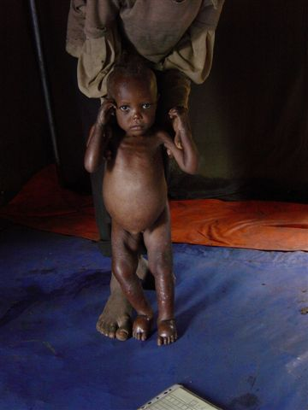
PHOTO 3 | 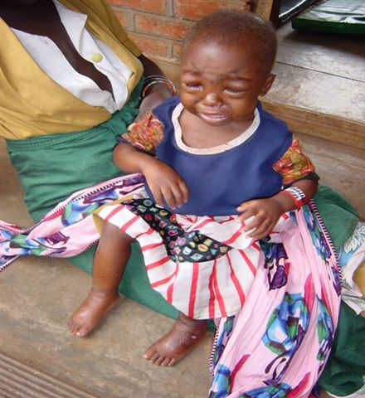

Exercise 2.2 Calculating WFL/WFH and Classifying Acute Malnutrition

PART A. WFH/WFL Z-Score

Child Name | Sex | Age  (in years unless noted) | Bilateral  Pitting Oedema | MUAC  (mm or colour) | Height  (cm) | Weight  (kg) | WFH/WFL Z-Score?
Child 1 | F | 3 |  | Green | 98.2 | 12.5
Child 2 | M | 5 |  | 123 | 110.0 | 14.8
Child 3 | M | 5 | ++ | Yellow | 102.2 | 13.5
Child 4 | F | 4 |  | 110 | 91.1 | 9.3
Child 5 | M | 9 months |  | 125 | 69.9 (Length) | 6.7
Child 6 | F | 4 | +++ | Yellow | 105.2 | 18.0
Child 7 | F | 8 months | + | 105 | 68.2  (Length) | 5.0
Child 8 | M | 1 |  | Red | 84.3  (Length) | 8.9
Child 9 | F | 2 |  | 109 | 97.2 | 11.0
Child 10 | M | 1.5 | + | Green | 89.7 | 12.9

Part B. Bilateral Pitting Oedema and MUAC

Child Name | Age  (in years unless noted) | Bilateral  Pitting Oedema | MUAC  (mm or colour) | Classification?
Child 1 | 3 |  | Green
Child 2 | 5 |  | 123
Child 3 | 5 | ++ | Yellow
Child 4 | 4 |  | 115
Child 5 | 9 months |  | 125
Child 6 | 4 | +++ | Yellow
Child 7 | 8 months | + | 105
Child 8 | 1 |  | Red
Child 9 | 2 |  | 114
Child 10 | 1.5 | + | Green

PART C. Bilateral Pitting Oedema, MUAC, and WFH/WFL Z-Score

Child Name | Sex | Age  (in years unless noted) | Bilateral  Pitting Oedema | MUAC  (mm or colour) | Height  (cm) | Weight  (kg) | WFH Z-Score | Classification?
Child 1 | F | 3 |  | Green | 98.2 | 12.5 | < -1 and  > -2
Child 2 | M | 5 |  | 123 | 110.0 | 14.8 | < -2 and  > -3
Child 3 | M | 5 | ++ | Yellow | 102.2 | 13.5 | < -2 and  > -3
Child 4 | F | 4 |  | 115 | 91.1 | 9.3 | < -3
Child 5 | M | 9 months |  | 125 | 69.9 | 6.7 | < -2 and  > -3
Child 6 | F | 4 | +++ | Yellow | 105.2 | 18 | > median
Child 7 | F | 8 months | + | 105 | 68.2 | 5.0 | < -3
Child 8 | M | 1 |  | Red | 84.3 | 8.9 | = -3 z
Child 9 | F | 2 |  | 114 | 97.2 | 11 | < -2 and  > -3
Child 10 | M | 1.5 | + | Green | 89.7 | 12.9 | = median

Module THREE: Community Outreach

Module Overview
This module explains why community outreach is an indispensable component of community-based management of acute malnutrition (CMAM). The module also explains why community outreach should be approached systematically and well in advance of actual CMAM start-up.
Community outreach is not a new concept within the health sector. It is important to emphasise that all efforts should be made to assess the existing health outreach systems and actors and that community outreach for CMAM should build upon and further strengthen these existing systems.
The suggested activities and methods explain what community outreach is, address what the barriers are to accessing CMAM-type services, and what preparations are needed to effectively reach communities with malnourished children. The module reviews the elements in and components of mobilising community outreach with the goal of maximising CMAM services, empowering communities, minimising the number of defaulters, and ultimately reducing deaths due to acute malnutrition.
The module provides participants with information, tools, and skills to plan their own CMAM community outreach activities and an opportunity to practice these skills in the field. During the field visit, participants will go through all the steps needed to develop a community outreach strategy and an action plan.
To strengthen infant and young child feeding (IYCF) practices in target communities and households, this training module should be complemented with the training course on Integration of IYCF support into CMAM, available at https://www.ennonline.net/integrationiycfintocmam. This two-day training helps to build the knowledge and skills of health care providers and community health workers involved with CMAM service delivery in the following areas:
- Identifying gaps between actual and recommended IYCF practices in the CMAM communities
- Discussing the recommended IYCF practices with mothers and caregivers
- Supporting mothers and caregivers to optimally feed their infants and young children less than 2 years of age

Learning Objectives | Duration | Handouts and Exercises
- Explain the Importance of Community Outreach to CMAM Outcomes | 30 minutes | Handout 3.1 Principles of Community Outreach in the Context of CMAM  Exercise 3.1 Barriers to Access Role-Play  Exercise 3.2 Overcoming Obstacles to Community Participation in CMAM
- Identify Key Elements of a Community Assessment | 45 minutes | Handout 3.2 Community Assessments  Handout 3.3 Community Assessment Steps and Methods
- Identify Key Steps in Developing a CMAM Outreach Strategy | 45 minutes | Handout 3.4 Community Outreach: From Assessment to Strategy  Handout 3.5 Community Outreach Strategy  Handout 3.6 Example: Selection of Candidates for House-to-House Case-Finding  Exercise 3.3 Comparison of Case-Finding Models  Exercise 3.4 Worksheet: Selection of Candidates for Community Outreach
- Discuss Considerations for Developing and Using CMAM Messages | 30 minutes | Handout 3.7 Developing Simple and Standardised CMAM Messages  Handout 3.8 Reference: Handbill Messages  Handout 3.9 Reference: Visual Communication Tools
- Discuss Preparations for Community Mobilisation and Training | 45 minutes | Handout 3.10 Key Actions in Community Mobilisation and Training  Handout 3.11 Planning and Implementing a Mass Training Campaign for Mothers and Family Members
Wrap-Up and Module Evaluation | 15 minutes | Handout 3.12 Elements and Sequencing of CMAM Community Outreach
Field Visit for Community Outreach | 1 day | Interview guide developed and provided by trainer  Handout 3.4 Community Outreach: From Assessment to Strategy  Handout 3.8 Reference: Handbill Messages  Handout 3.13 Team Checklist for Community Outreach Field Visit

Module Duration: Three and half hours (3½ hours) in classroom followed by one-day site visit
Note: Depending on the needs of their audience(s), trainers may choose to skip or spend more or less time on certain learning objectives and activities. The module duration is an estimate of the time it takes to complete all the learning objectives and activities.

Reference Resources
- Alliance for International Medical Action (ALIMA). 2016. Mother-MUAC: Teaching Mothers to Screen for Malnutrition—Guidelines for Training Mothers. Available at: https://www.alima-ngo.org/uploads/b5cb311474e9a36f414a69bd64d39596.pdf
- Dessie, M. et al. 2015. Community Engagement for CMAM. Coverage Monitoring Network. Available at: http://www.coverage-monitoring.org/wp-content/uploads/2015/07/Technical-brief-Community-Engagement-for-CMAM-20151.pdf.
- Kittle, B. 2013. A Practical Guide to Conducting a Barrier Analysis. New York, NY: Helen Keller International. Available at: https://pdf.usaid.gov/pdf_docs/PA00JMZW.pdf.
- Emergency Nutrition Network (ENN). 2009. Integration of IYCF Support into CMAM. Available at: https://www.ennonline.net/integrationiycfintocmam.
- Valid International. 2006. Community-based Therapeutic Care (CTC) A Field Manual. Oxford: Valid International. Available at: https://www.fantaproject.org/sites/default/files/resources/CTC-Field-Manual-Oct2006-508.pdf.
- Catholic Relief Services (CRS). 1999. Rapid Rural Appraisal and Participatory Rural Appraisal: A Manual for CRS Field Workers and Partners. Available at: https://www.crs.org/sites/default/files/tools-research/rapid-rural-appraisal-and-participatory-rural-appraisal.pdf.

Further Reading Resources
- Alvarez Moran, J.L. et al. 2018. “Quality of Care for Treatment of Uncomplicated Severe Acute Malnutrition Delivered by Community Health Workers in a Rural Area of Mali.” Maternal & Child Nutrition. Jan.:14(1). doi: 10.1111/mcn.12449. Available at: https://www.ncbi.nlm.nih.gov/pubmed/28378463.
- Rogers, E. et al. 2018. “Cost-Effectiveness of the Treatment of Uncomplicated Severe Acute Malnutrition by Community Health Workers Compared to Treatment Provided at an Outpatient Facility in Rural Mali.” Human Resources for Health. 16:12. Available at: https://human-resources-health.biomedcentral.com/articles/10.1186/s12960-018-0273-0.
- Franck, G.B. et al. “Mothers Screening for Malnutrition by Mid-Upper Arm Circumference Is Non-Inferior to Community Health Workers: Results from a Large-Scale Pragmatic Trial in Rural Niger.” Archives of Public Health: The Official Journal of the Belgian Public Health Association. 2016. 74:38. Available at: https://doi.org/10.1186/s13690-016-0149-5.
- Blackwell, N. et al. 2015. “Mothers Understand and Can Do It (Mid-Upper Arm Circumference [MUAC]): A Comparison of Mothers and Community Health Workers Determining Mid-Upper Arm Circumference in 103 Children Aged from 6 Months to 5 Years.” Archives of Public Health. Available at: https://archpublichealth.biomedcentral.com/articles/10.1186/s13690-015-0074-z.
- Puett, C.; Hauenstein Swan, S.; and Guerrero, S. 2013. Access for All, Volume 2: What Factors Influence Access to Community-Based Treatment of Severe Acute Malnutrition? (Coverage Monitoring Network, London, November 2013). Available at: https://www.actionagainsthunger.org/sites/default/files/publications/Access_For_All_Volume_2_11.2013.pdf.
- Forsythe, V. et al. 2010. Community Outreach for Community-Based Management of Acute Malnutrition in Sudan: A Review of Experiences and the Development of a Strategy. Washington, DC: FHI 360: Food and Nutrition Technical Assistance Project (FANTA). Available at: https://www.fantaproject.org/sites/default/files/resources/Sudan_Community_Outreach_CMAM_Dec2010.pdf.

Handout 3.1 Principles of Community Outreach in the Context of CMAM

Community outreach is an essential component of CMAM. It helps to ensure that nutritionally vulnerable infants and children who are acutely malnourished are detected early—before the onset of medical complications—and referred for treatment, leading to better clinical outcomes and decreased strain on inpatient services. Community outreach is vital to CMAM in any context, whether it is implemented by nongovernmental organisations (NGOs) or the Ministry of Health (MOH) and whether the context is a nutrition emergency or a stable development setting.

Once CMAM has begun, community outreach is characterised by:
Community mobilisation: It should be continuous with the aim of raising awareness on the signs, treatment, and prevention of acute malnutrition. Community mobilisation should also promote understanding of the services available and where to access them and should ensure community ownership of the services/programme.

Active case-finding for early detection and referral: For CMAM to function effectively and for coverage to reach acceptable levels, nutritionally vulnerable infants and children who are acutely malnourished should be identified early, usually through active case-finding.

Home visits and follow-up for high-risk cases: In a minority of cases, outpatient care protocols will trigger a follow-up home visit to:
- Check on an infant or child who is not thriving or responding well to the treatment
- Learn why an infant or child was absent from an outpatient care follow-on session
Learn why an infant or child defaulted (defined as missing three outpatient care follow-on sessions in a row)
Linkages with other community services, programmes, and initiatives: To prevent relapse, families with nutritionally vulnerable infants and children who are acutely malnourished should be targeted by community initiatives that improve their home environment and promote access to an improved quality diet.

The following steps are required to establish the above four components of community outreach effectively:
- Community Assessment
- Formulation of Community Outreach Strategy
- Development of Messages and Materials
Community Mobilisation and Training
These steps allow CMAM health care providers to understand and anticipate challenges and constraints to community and mothers’ participation and service access and uptake, without which CMAM is ineffective. They also help involve and empower communities. With proper preparation, community outreach can generate a cycle of positive feedback in the community so that mothers/caregivers refer each other to the services, increasing coverage. Without these steps, service or programme miscalculations can generate negative feedback and reduce participation. Without good service access and uptake, even the best-run outpatient care sites will have only limited impact.

The Need for Balance
- In both development and emergency settings, a key objective is to identify how to find nutritionally vulnerable infants under 6 months, and children 6-59 months who are acutely malnourished with the least inconvenience to the population. People might be more willing to put up with inconveniences to receive assistance during nutrition emergencies, but here too there are hazards. An overly broad mobilisation—one in which many people are screened but few end up being admitted—can backfire by alienating the community and diminishing further participation.
- The overall challenge is to regulate access to CMAM in the most effective way. There is always a compromise or balance to be struck: as CMAM is initiated, ineligible infants and children should be discouraged from coming while as many eligible ones as possible must be encouraged to come. If this balance can be found, a cycle of positive feedback is generated as mothers/caregivers return home from the outpatient care site with positive news.
- By getting this balance wrong or ignoring it, CMAM can quickly get off on the wrong foot and, especially in emergency settings, overwhelm health care providers with large crowds, giving CMAM a reputation of being a waste of precious time.

Involving the Right Actors
- It is easier to strike this balance when CMAM is being implemented by people with some familiarity with the region, e.g., the local MOH or an NGO with existing health or development programmes in the area. This is the case in both development settings and emergencies.
- Community outreach is not new to the health sector. All efforts should be made to assess the existing health outreach systems and actors, and community outreach for CMAM should build on and further strengthen these systems.
- Appointing a dedicated staff member to run the community outreach activities will enhance the success of all CMAM services.
- Preparation for CMAM will usually begin with discussion among members of the MOH district health management team (DHMT) and its local partners.
- Staff with experience with local health-seeking practices are likely to know the community gatekeepers who can help or hinder acceptance of the CMAM services. They usually have some means of sharing and receiving information from the community.
- People who usually are involved in the first exploratory discussions include:
- District medical officer
- District nutritionist
- District maternal and child health (MCH) coordinator
- Supervisor of community health workers (CHWs, if other than MCH coordinator)
- Staff of community-based organisations (CBOs) and/or NGOs with strong community links
- Civil society or religious leaders with good knowledge of local health-seeking practices

Handout 3.2 Community Assessments

A community assessment is the first step in preparation for CMAM community outreach.

A. Why Do a Community Assessment?

Community assessments are the learning part of community outreach preparation.

The role-play and preceding group discussion on the role of the community assessment showed that there are obstacles to service access and uptake and community participation in CMAM. The community assessment is an opportunity to consider these in a systematic way in a specific implementation context.

Well before CMAM is established, potential barriers and boosters to service access and uptake must be identified. To do this, planners must have a sense of how the community is organised, how undernutrition is viewed there, how the new service is likely to be received, how it complements other community outreach activities, and how the community can best support the outreach component.

The answers to many of these questions might seem apparent if CMAM is being delivered by the Ministry of Health (MOH) or a nongovernmental organisation (NGO) with longstanding experience in the community. However, even MOH staff could be outsiders and might not be fully conversant in the local language.

It is important that the community assessment be used as an opportunity to identify and acknowledge the limits of staff knowledge of the local community.

B. What Do Community Assessments Consist of?
One way to think of the assessment is in terms of supply and demand. Two major questions must be answered:
- What factors are likely to create and affect demand for CMAM locally?
How can community outreach be organised to meet and increase this demand most effectively (supply)?
Understanding demand involves spending time at the community level and interviewing community members about local perceptions and practices to develop a sense of where the demand-inhibitors might lie. Areas of investigation might include:
- Local disease classification for acute malnutrition; health problems might be treated as something other than a nutritional problem, requiring special communication
- Attitudes toward formal health services, which involves identifying what other services are offered through the existing government health services and how they are perceived by the population; a perception of poor service could affect uptake of CMAM
- Other paths to treatment (e.g., pharmacies, traditional healers) might have a role equal to or greater than MOH health services
- Community homogeneity/heterogeneity: various identity designators (e.g., language, ethnicity, religion, politics) can divide communities, making it necessary to provide information and services in an even-handed manner or to make special efforts to reach excluded or marginalised groups
- Barriers to access, including:
- Poor awareness of acute malnutrition
- Poor awareness of CMAM service within the community being served
- Community mobilisation has been overly broad, resulting in too many ineligible cases arriving and being rejected
- Referral and admission criteria are not aligned (e.g., mid-upper arm circumference [MUAC] is used for community screenings but final admission at site is based on weight-for-height [WFH]), leading to rejection of referred individuals at the site and hurting the programme’s reputation
- People might be aware that there is a new nutrition service, but local medico-cultural traditions do not connect advanced wasting or swelling with undernutrition, as awareness of traditional medicines might be stronger
- There might be stigma in the community that is associated with acute malnutrition
- The influence of peers or family members might serve as a disincentive
- Community mobilisation might have overlooked important community gatekeepers or opinion-makers
- Other services at the primary health care (PHC) facility are poorly regarded by the community (e.g., because medicines are not available, because hours are irregular, because staff are overworked, because treatment requires long waits), and as a result, when CMAM is established at the PHC facility, it is viewed negatively by association
- The location of outpatient care sites might require an unreasonable amount of travel time for target communities or make the sites inaccessible due to barriers like seasonal flooding
- Participation is interrupted by seasonal labour patterns beyond the control of the service, such as temporary relocation of families from homes to more remote farms during the weeding or harvesting seasons

- Boosters to service/program access, including:
- Engagement with the local opinion leaders including traditional leaders
- Community health workers and health care providers that are respected and have a good relationship with the communities, including families, mothers, and caregivers of children under 5 years
- Availability of functioning local communication channels through community leaders, religious leaders, and community-based organisations
- Family members such as grandmothers and aunts that have an active positive role in the care and well-being of children under 5 years of age

Understanding supply also involves some community-level discussion (usually done at the same time as investigation of demand) but requires the assessors to also consider institutional and organisational factors at the facility and district level. Questions to be answered typically include:

- Who are the likely candidates for case-finding? Can these be identified from existing networks of outreach workers (e.g., community health workers [CHWs], health extension workers [HEWs], health educators, contraceptive distributors, home-based care [HBC] providers)? Are there other extension workers (e.g., agricultural, social welfare) or local community-based organisations (CBOs) who could also take on this role? Can mothers and family members be trained to identify acute malnutrition? Which of these seem to be most valued and respected by the community?
- Where is the supervision of case-finding best situated? How and to whom do existing outreach workers currently report? How reliable is this contact? What are the channels of communication and coordination between facilities and the outreach workers? Is there active monitoring from the nutritionist, the maternal and child health (MCH) nurse, or other members of a management team? How will MUAC tapes, referral forms, and other job aids for case-finding be supplied?
- If volunteers will be used, what are the local limits to voluntarism? Are there other forms of incentive besides payment that could help motivate them? How heavy is the volunteer workload—are there other competing priorities? How will acute malnutrition be integrated with other existing activities? Do those activities have other competing priorities?
- If mothers or family members will be trained to screen for acute malnutrition and nutrition vulnerability, how will the monitoring be conducted? Are there adequate community health workers to train, monitor, and follow up with the mothers and families?
- How strong/reliable are the links between health facilities and the community? How can these be utilised or improved to establish a sense of community ownership of CMAM activities?
- What leaders/gatekeepers must be involved to gain full access to the community (i.e. for selection of volunteers, for house-to-house case-finding, for communicating the purpose of CMAM)?
- What channels exist for spreading information about CMAM, and what risks and advantages are associated with each? For example, while local health educators might be an effective way to pass information to households, they might not be the best channel to use if they have a reputation for simply repeating un-actionable messages (e.g., urging families to boil water when wood for fuel is scarce, urging families to wash clothes when soap is unaffordable). In this case, other influential people (e.g., traditional healers, clan leaders, religious figures) might be an important additional channel.

Handout 3.3 Community Assessment Steps and Methods

Step | Method | Area of investigation/Questions to be answered | Time Required
1: Defining the parameters of the CMAM programme | Briefing to confirm CMAM objectives | - Is this a short-term intervention to address a nutrition emergency or will it be a permanent part of PHC services?  - Will this be NGO-assisted or run independently by the MOH? If NGOs are to be involved, what will their role be?  - To what degree will the program be integrated into the existing health system?  - Is community case-finding needed only at startup, or will it be conducted indefinitely? | 1-3 hours
2: District- level review to understand the local context | District-based discussions with NGO/MOH/civil society key informants at the district level | - Local health-seeking practices  - Breastfeeding practices (see Table 1 on the next page for details)  - Community coherence/difference  - Broad patterns of undernutrition (e.g., seasonal, spatial, and geographical accessibility of services for communities)  - Available networks of extension staff and volunteers  - Potential allies (e.g., civil society, political leadership, private health sector) | 1-2 days but might require additional time to contact and make arrangements with resource persons
2: District- level review to understand the local context | Secondary data review of health and nutrition situation | - Data and information from Standardized Monitoring and Assessment of Relief and Transitions (SMART) survey; knowledge, attitude, and practice (KAP) surveys; past coverage surveys; barrier assessments; and health systems strengthening assessments.  - Data and information on infant and young child feeding (IYCF) practices  - Existing information on community networks, gender dynamics, social structures and cultural practices | 1 day
3: Community- level review to complete information gathered at district level | Community-level discussions  to fill gaps that could not be answered at district level | - Further information on above topics is gathered in community using Rapid Rural Appraisal (RRA)/ Participatory Rural Appraisal (PRA) approaches with separate groups of:  - Community leaders  - Mothers and caregivers  - Other family members  - Community extension workers and volunteers  - Special attention is given to finding information on issues related to excluded groups and cultural barriers, (e.g., cases where women are not allowed to travel without a male relative) | Varies greatly, depending on size and homogeneity of project area; plan for at least 1 day in the catchment of each outpatient care site but also factor in time required to plan, make appointments and conduct the discussions with community groups.
4: Beneficiary- level discussions to determine perspectives, knowledge, vocabulary of acute malnutrition | Interviews with mothers/ caregivers to fill gaps | - Visual aids depicting acute malnutrition are used in RRA/PRA approaches with community mothers/caregivers, individually or in groups to gather more detailed information on:  - Disease names and presumed causes  - Clues as to who might see (and therefore refer) these infants and children  - Attitudes toward existing extension networks | 2-4 days depending on cultural homogeneity and ease of access; it is possible to have discussions with mothers/caregivers at local MCH clinic, but better information often is obtained when discussion takes place in the community, away from the clinic

Table 1. Breastfeeding Practices Matrix

Breastfeeding Practice | Ideal Practice | Current Practice | Appeals/  Motivators | Barriers | Feasible  Practice | Possible Messages
Initiation of breastfeeding | Within the 1st hour of birth
Giving colostrum (local name) | Within the 1st hour of birth
Duration of exclusive breastfeeding | From birth until baby is 6 months of age (no other drink, water, or food)
Frequency of breastfeeding | On demand (or cue) day and night
Duration of breastfeeding | Until baby releases both breasts
Expressing breast milk
Giving water | No water during first 6 months
Breastfeeding during illness | More frequent during & after illness
Cessation of breastfeeding | 2 years of age or older

Source: Module 1 of the Training Course on Integration of IYCF Support in CMAM: https://www.ennonline.net/integrationiycfintocmam.

Handout 3.4 Community Outreach: From Assessment to Strategy

Example from Ethiopia
 | Key Findings | Implications for Strategy
1. | Locally, a variety of causes are thought to underlie swelling and wasting, and not all are food-related. Presumed causes include breastfeeding while pregnant, exposure to bright sunlight, malevolent spirits, and displeasure of ancestors. | Include a communications component that uses local disease terms for acute malnutrition, particularly for swelling and wasting.  Explore a range of local treatments and try to involve healers in referral to CMAM.
2. | Local churches are often the first recourse for families with sick children, as they borrow funds for treatment. | Churches and mosques should be the first stop in a campaign to inform civil society partners about CMAM. Ultimately, they might refer potential clients in need.
3. | All parts of the community are uncertain about the relationship between proposed CMAM and pre-existing anthropometric screening for the targeted general ration. | Immediately take steps to prevent the outpatient care services or programmes from receiving large numbers of ineligible self-referrals.
4. | A cadre of unpaid community health workers (CHWs) are already conducting house-to-house health education regularly, but only literate workers receive regular training. | Use these CHWs for house-to-house case finding, but put priority on re-energising the group of illiterate volunteers with mid-upper arm circumference (MUAC) training.  There is also an opportunity of using the trained CHWs to train mothers and family members how to measure the MUAC of their children.

Handout 3.5 Community Outreach Strategy

Formulating an outreach strategy is the second step in preparation for CMAM community outreach.

A. List and discuss key insights from the community assessment
A community outreach strategy is determined by the outcomes of the community assessment. The assessment will have clarified the overarching questions about the objectives and nature of the CMAM service as well as both barriers and opportunities affecting participation in the community.

Other questions will remain, such as determining who should be involved and how efforts should be prioritized to achieve maximum service access and uptake. To answer these questions, insights from the assessment should be reviewed and their implications for the outreach strategy should be considered.

The product of this strategy discussion should be a list of key insights and their implications for the CMAM service. This list does not need to be elaborate or complicated. It can usually be done point by point on a single piece of paper.

B. Determine the most appropriate method of case-finding
An essential aspect of outreach strategy involves deciding how case-finding will be conducted. Considerations include: 1) whether or not a campaign-style mass screening is needed at start-up, either to gauge levels of acute malnutrition or to establish awareness of CMAM; 2) how and when to transfer active case-finding from such campaign-style efforts to routine systems of primary health care (PHC) outreach; 3) where active case-finding can most likely be sustained with a minimum of external inputs.

Case-finding methods normally fall into the following three models:
- House-to-house case-finding. In this approach, roaming outreach workers (e.g., community health workers [CHWs], volunteers) periodically perform the bilateral pitting oedema and mid-upper arm circumference (MUAC) checks in the home. This approach is sometimes necessary at startup to ensure that pockets of the community are not overlooked and that all families are aware of CMAM. However, if admission numbers are high enough to demonstrate the benefits of CMAM, families will usually begin to self-refer, allowing for a shift to less-active forms of case-finding.
- Community case-finding. In this approach, the bilateral pitting oedema and MUAC checks are performed in the community or neighbourhood, bringing infants and children from different households together. This can be done either by CHWs performing regular scheduled outreach (e.g., maternal and child health [MCH] visits, growth monitoring and promotion [GMP] sessions) or by specially recruited volunteers. Other community-based service providers such as teachers, home-based care (HBC) group members, and local healers can also be trained to screen children for acute malnutrition. Unscheduled community case-finding can also be performed at formal and informal community activities and gatherings, market days, and other settings where children are present. This approach is used in many nutrition emergencies.
- Mother and family case-finding. In this approach, CHWs train mothers and other family members such as grandmothers, aunts, and fathers on how to use a MUAC tape to measure MUAC and how to identify bilateral pitting oedema. The mothers and family members are encouraged to screen their infants and children, which helps with early identification of acute malnutrition and promotes the families’ involvement in the health and well-being of their child.

The appropriate model to use (or sequence or combination to use) in a given setting depends on a variety of factors including:

- The level of acute malnutrition in the community
- Community awareness of the signs of acute malnutrition
- Accessibility of homes and whether they are clustered together or widely dispersed
- Existing networks of outreach workers and whether the workloads will allow for taking on active case-finding duties
- Time and resources available for training outreach workers involved in case-finding
- Whether active case-finding is envisioned as permanent or temporary

Handout 3.6 Example: Selecting Candidates for House-to-House Case-Finding

Example from the Southern Nations, Nationalities, and People’s Region (SNNPR), Ethiopia

Type of Outreach Worker | Job Description  (including supervision) | Proximity  to Cases | Breadth  of Coverage | Accessible/ Amenable to Training | Can Accept Additional Work | Capable of Use of MUAC | Accepted in all Parts of the Community
Health Extension Worker (HEW) | Community health worker (CHW) supervised by health centre staff | XX | X | XX | X | XXX | X
Community Health Promoter (CHP) | Volunteer mobiliser  supervised by HEW | XXX | XXX | XXX | XXX | XXX | XXX
Community Care Coalition (CCC)  Members | HIV/AIDS home-based care (HBC) volunteers (not established in all parts of district) | XX | XX | XXX | XX | XX | XXX

XXX = high
XX = medium
X = low

Handout 3.7 Developing Simple and Standardised CMAM Messages

Development of messages and materials is the third step in preparation for CMAM community outreach.

A. Standardise CMAM Messages
The start of any new service is a time of great interest and speculation for community members, and unless the information vacuum surrounding CMAM is filled with accurate information, it will be filled with rumours which can hurt community participation and service access and uptake.

Health facilities in low-literacy environments typically rely on word-of-mouth communication with the surrounding community, and messages to health committees and community leaders might be passed through many people before they reach their intended recipients.

Key messages, expressed simply and explaining admission and practical aspects of inpatient and outpatient care must be developed, standardised and disseminated rapidly to avoid confusion and service access and uptake problems.

It is important to note that the purpose of the key messages is not to change underlying behaviours or practices but to clarify how and to whom CMAM is offered and how linkages can be made to other ongoing sensitisation activities.

Standard CMAM messages should:
- Describe the target infants and children using the local disease terms for poor feeding, wasting, and swelling collected during assessment
- Explain the benefits of CMAM, noting that children 6–59 months with severe acute malnutrition (SAM) without medical complications can be treated in outpatient care once a week in the community with ready-to-use therapeutic food (RUTF) at home. Infants under 6 months of age who are nutritionally vulnerable without medical complications will also be treated in outpatient care once a week in the community with counselling and feeding support for the mother-and-infant pair.
- State the time and date of outpatient care sessions at the closest outpatient care site; as much as possible, use local date identifiers such as religious days and market days.
- Give the price and duration: The treatment is free and last several weeks.
- Explain the referral process, noting that the infant or child is assessed (measured) and supported near home.
- Explain (if appropriate) that families can also self-refer infants and children who meet the criteria by going to the nearest outpatient care site or health facility with CMAM services.
- Explain that an infant or child can be re-assessed (re-measured) at different intervals to monitor his/her nutritional status and be admitted if s/he has deteriorated.
- Introduce RUTF not as a food but as a medicine and avoid referring to it in ways that are associated with food. For example, promote a local name for RUTF that does not refer to food (and avoid calling it “biscuit” in the local language) and say that children will “take” RUTF instead of “eat” RUTF. .

- If there are services or programmes for the management of children with MAM, explain to the mothers and caregivers what programmes exist and where they can access the services.
- Reflect the findings of the assessment and address concerns directly.

B. Create a Handbill Using Simple, Non-Technical Language
Once standard CMAM messages have been developed in simple, non-technical terms, it is important to print them in the local language(s) so that every reader is receiving the exact same information regardless of possible language barriers.

Creating a handbill is not costly; it normally just takes the use of a photocopier and paper. However, it does require a dedicated effort to think through the concerns and issues that emerged from the assessment and to address them directly with a set of core CMAM messages. It might take several attempts to boil these issues down to their simplest form, but it is worthwhile. It should take about a day to refine the messages and then arrange for them to be translated into the language(s) used in the homes of mothers/caregivers. The translated versions should then be back-translated to ensure accuracy by someone who did not translate the original into the local language(s). After dissemination, a record of any misconceptions arising from the handbill should be kept so that it can be revised periodically.

C. How to Make the Best Use of the Handbill
- Use the handbill in information meetings with district and community leaders. Ask them to make announcements through their networks. Give them sufficient copies so that the handbill can be read aloud in the community. This should be done before active case-finding is initiated.
- Take the handbill to meetings with civil society partners (e.g., community-based organisations [CBOs], churches, mosques) and ask them to disseminate it.
- Create a separate handbill for significant minority language groups in the area.
- Tailor the handbill to address special concerns as they arise (e.g., confusion over whether referral constitutes admission).
- Where appropriate, pair with photographs of kwashiorkor and marasmus to help identify target children.
- Give copies to literate outreach workers so they can share the information accurately. They can use the handbill to make announcements at formal or informal gatherings (e.g., funerals, marketplace, water points, community government or committee meetings).
- Consider using radio and SMS messaging, which has been a useful means of disseminating CMAM messages in several countries (e.g., Niger, Nigeria, Ethiopia, DRC, Malawi, and Tanzania).

Handout 3.8 Reference: Handbill Messages

1. Example from Lusaka, Zambia

HELP IS NOW AVAILABLE FOR FAMILIES WITH VERY THIN OR SWOLLEN CHILDREN

The New Treatment

A new treatment is now available at the health facility for children under 5 years old who are severely malnourished. Children who are very thin or whose feet have begun to swell but have no medical complications no longer need to spend a long time in the hospital. A new treatment is being offered for these children. Families can use it to rehabilitate their children at home.

How to Know Whether Your Child Needs this Treatment

To find out whether a child is eligible for this treatment, the child’s arm is measured and his/her feet are checked. The arm measurement is taken with a tape similar to the cloth tape that tailors use in the marketplace. It is a fast, painless check that does not involve taking blood or injecting the child. Different people are being trained in this community in how to use the tape, so that in some cases the measurement may be taken by a person the child or family knows.

If you know a child who is very thin or whose feet have started to swell, tell his/her parents or guardians about this new treatment. They can ask in their neighbourhood for the name of a person trained to take the arm measurement, or they can go direct to the health centre.

Important Points to Remember

- The treatment will be offered every _________ morning at _________ clinic.
- Even very sick children can be helped with this treatment. Since the child remains at home, the parents/guardians can care for him/her at the same time as other children. However, the treatment is only for the very thin child and should not be shared.
The treatment consists of medicines and a medicinal paste made from groundnuts, so children normally have no trouble eating it. The results are usually very rapid.
(Note: The following paragraph should be adapted to the context.)
- In different communities, the diseases of thin and swollen children go by different names. It is common nowadays to speak of njala, but in some places, a child might be said to have njisi (anyonkela), matufya, kalyondeyonde, midulo, kulowewa, or kulozedwa. Or the child might be said to be osila or dayonda. Families who suspect these diseases should also ask for their children’s arms and feet to be checked, since the new treatment might also help these children.

2. Examples from Ghana

A. Sensitisation Letter to Civil Society Groups/Leaders in Agona District (includes key messages)

Date:
Postal Address/Name of Institution:

Dear Sir/Madam,

RE: NEW TREATMENT FOR CHILDREN WITH SEVERE ACUTE MALNUTRITION (VERY THIN OR SWOLLEN)

A new treatment is now available at Swedru hospital, Kwanyako, Abodom, Duakwa and Nsaba health centres under Agona District Health Directorate for children who are very thin or swollen (showing signs of severe acute malnutrition, or SAM). These children need a specific medical treatment and nutrition rehabilitation and must be referred to the health centre. If a child with SAM has good appetite and no medical complication, the child does not have to go to the hospital; s/he can be treated at home and followed up through weekly health centre visits. If a child with SAM has no appetite or has a medical complication, then s/he will be admitted to the hospital for a short time until the complication is resolved and then will receive further treatment at the health centre and at home. Children under 6 months who are very thin or have swelling will need specialised care in the hospital.

To determine whether a child is eligible for this treatment, his/her arm is measured in the community to see if s/he is too thin and both feet are checked for swelling. If the child is referred to the health centre, s/he is measured again at the centre and receives a medical check. If the child is too thin or has swelling but has good appetite and no medical complications, s/he receives a medical treatment and a weekly supply of the medicinal food free of charge. All small children with SAM and older children with SAM with medical complications will be referred to Swedru hospital for inpatient care. The arm measurement is taken with a tape similar to the cloth tape tailors use in the marketplace and can be taken by many types of persons. Community health workers or volunteers are being trained in communities around the above-mentioned health facilities to take the measurement, so that it may be taken by a person the child or his/her family knows.

If you know a child who is very thin or whose feet are swollen, tell the parents or guardians about this new treatment. They can ask around their neighbourhood for a community health worker or volunteer or someone else trained to take the arm measurement, or they can go directly to these health facilities.

We are confident that this new treatment will significantly improve the District’s ability to support the recovery of malnourished children, and we look forward to your cooperation. Please do not hesitate to contact me for more information or clarification.

Yours faithfully,

DISTRICT DIRECTOR OF HEALTH

B. Sensitisation Letter to Private Clinics in Agona District (includes key messages)

Date:
Postal Address:

Dear Sir/Madam,

Re: Community-Based Management of Acute Malnutrition (CMAM)
As part of its mandate to improve the quality and accessibility of health services in Agona District, the Ghana Health Services (GHS) has introduced a new treatment for children under 5 years with a severe form of acute malnutrition (bilateral pitting oedema or severe wasting). The service is called Community-Based Management of Acute Malnutrition (CMAM). It brings the treatment of children with severe acute malnutrition (SAM) much closer to the family, making it possible for children and their mothers/caregivers to avoid the long stays at the Paediatric Ward or the Nutrition Rehabilitation Centre, which customarily have been necessary for treating undernutrition.

Children with SAM need a specific programme containing both medical treatment and nutrition rehabilitation, and must be referred to the health centre. If a child with SAM has good appetite and no medical complications, s/he can be treated at home and followed up through weekly health centre visits. If a child with SAM has no appetite or has a medical complication, then s/he will be admitted to inpatient care at Swedru Hospital for a short time until the medical complication is resolved and then receive further treatment at the health centre and at home. Children under 6 months who are very thin or have swelling will need specialised care in inpatient care at the hospital.

The treatment, which is free of charge, provides antibiotic, antihelminth and malaria drug treatment, vitamin A supplementation and a ready-to-use therapeutic food (RUTF) called Plumpy’nut® at the health centre level, which the families of eligible children can take home. Early detection of cases and referral for treatment is essential to avoid medical complications.

Children in the communities and the health facilities are checked for bilateral pitting oedema and screened for severe wasting based on a mid-upper arm circumference (MUAC) measurement with a specially marked tape (MUAC tape) for referral and admission to the CMAM service at the health centre.

We would like to involve a variety of health practitioners and service providers, including private clinics, to help us identify children with SAM so that they can be treated at an early stage. Currently the services are provided in five sites (Swedru Hospital and Kwanyako, Abodom, Duakwa and Nsaba Health Centres) under Agona District Health Directorate, but it is hoped that the services will be extended to other health centres in Agona District. We are writing therefore to kindly request that your facility brief all staff members, especially those in the Out-Patient Department (OPD), and have them refer children with bilateral pitting oedema and severe wasting to any of the above-mentioned health centres for treatment. The GHS SAM team would be pleased to provide your clinic with these tapes and train your staff in identifying children with bilateral pitting oedema and severe wasting.

We are confident that the CMAM services will significantly improve the District’s ability to support the recovery of malnourished children, and we look forward to your cooperation. Please do not hesitate to contact us for more information or clarification.

Yours faithfully,

DISTRICT DIRECTOR OF HEALTH

3. Sensitisation Basic Messages - Public Address or Peer System Version in Agona District

Message to All Mothers/Caregivers with Children between 6 Months and 5 Years of Age from Ghana Health Services

A new treatment is now available for children under 5 years with severe acute malnutrition (SAM, very thin or swollen). These children need a specific treatment and must be referred to the health centre. If a child with SAM has good appetite and no medical complications, s/he can be treated at home and followed up through weekly health centre visits. These children do not have to go to the hospital but can be rehabilitated while staying at home with their families. If the child with SAM has no appetite or has developed a medical complication, then s/he will be admitted to hospital for a short time until the complication is resolved and then receive further treatment at the health centre and at home. Children under 6 months who are very thin or have swelling will need specialised care in inpatient care in Swedru Hospital.

How to know whether your child needs this treatment
Some people within your communities have been trained to take an arm measurement of children with a small tape and check if both feet are swollen.

The treatment
All children found to be thin or swollen are referred to the health centre, where the arm measurement and swelling are checked again. If the children have appetite and are clinically well, they are given a medical treatment and a weekly supply of the medicinal paste called Plumpy’nut®. Children who are very small or very ill will need referral to inpatient care.

If you know a child who appears to be very thin or whose feet are swollen, tell his/her parents or guardians about this new treatment. They can ask around their neighbourhood for a community health worker, volunteer, or someone else trained to take the arm measurement. Or, they can go directly to the following health centres to have their child measured any day. Follow-up service days are:

- Swedru Hospital on Monday
- Kwanyako Health Centre on Wednesday
- Abodom Health Centre on Wednesday
- Nsaba Health Centre on Friday
- Duakwa Health Centre on Friday

Handout 3.9 Reference: Visual Communication Tools

Example from Nigeria

A. Screening and Referral at the Community Level
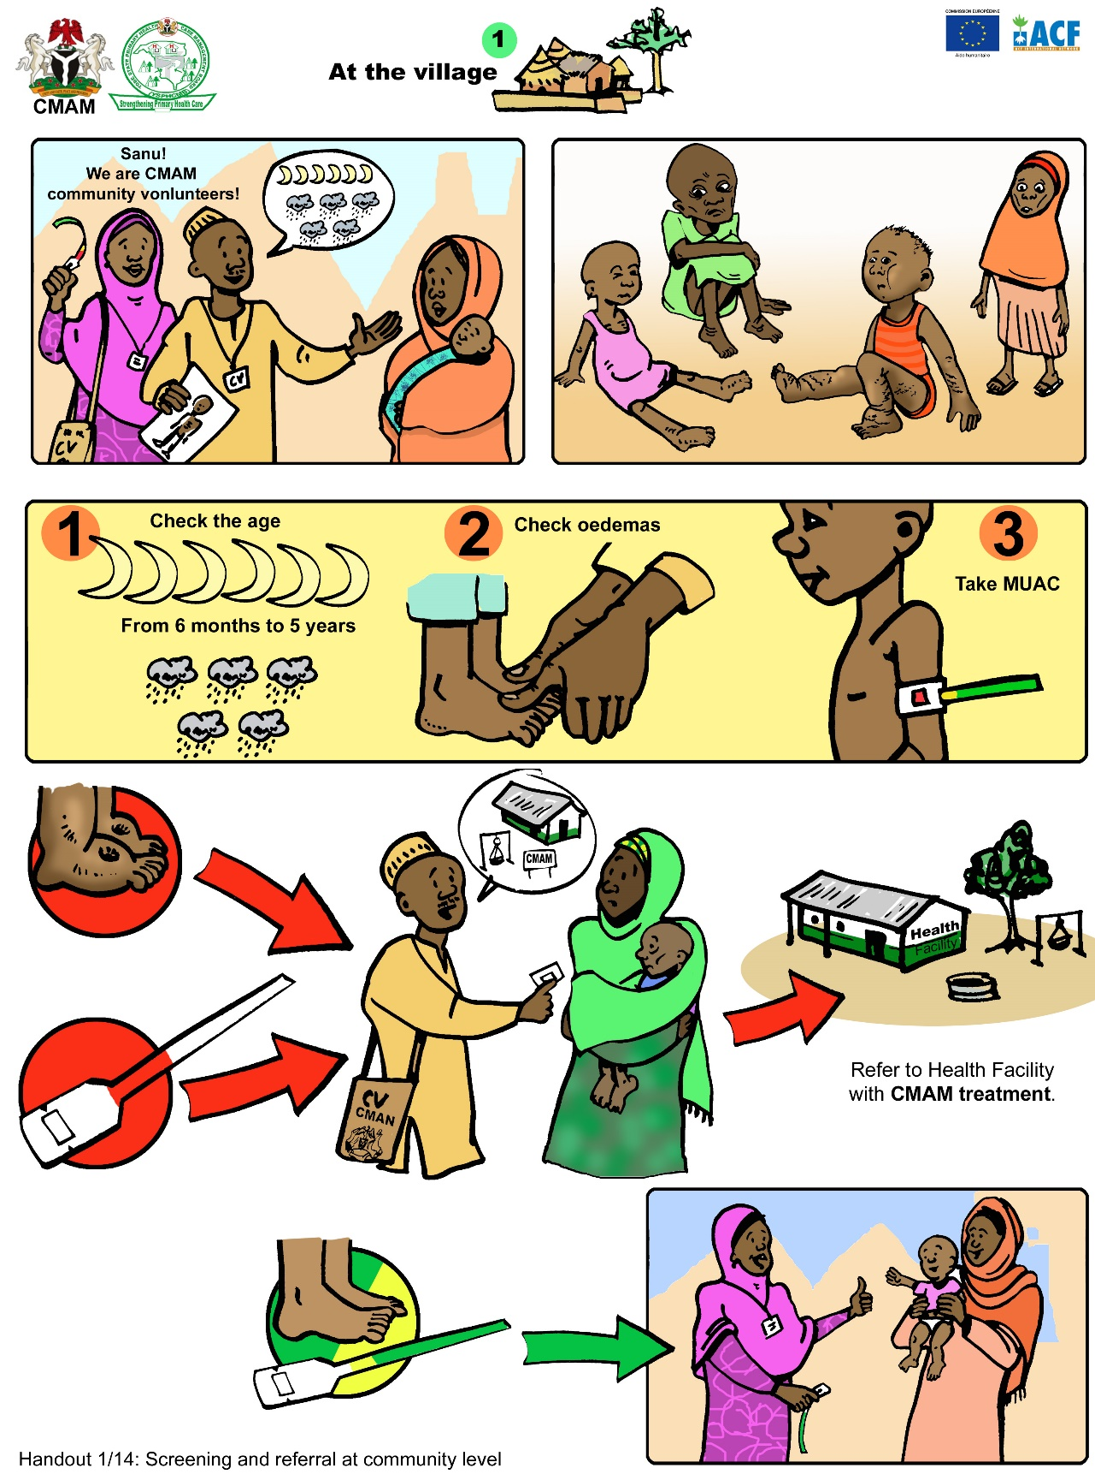

B. Sensitisation Messages on Treatment at the Health Facility Level
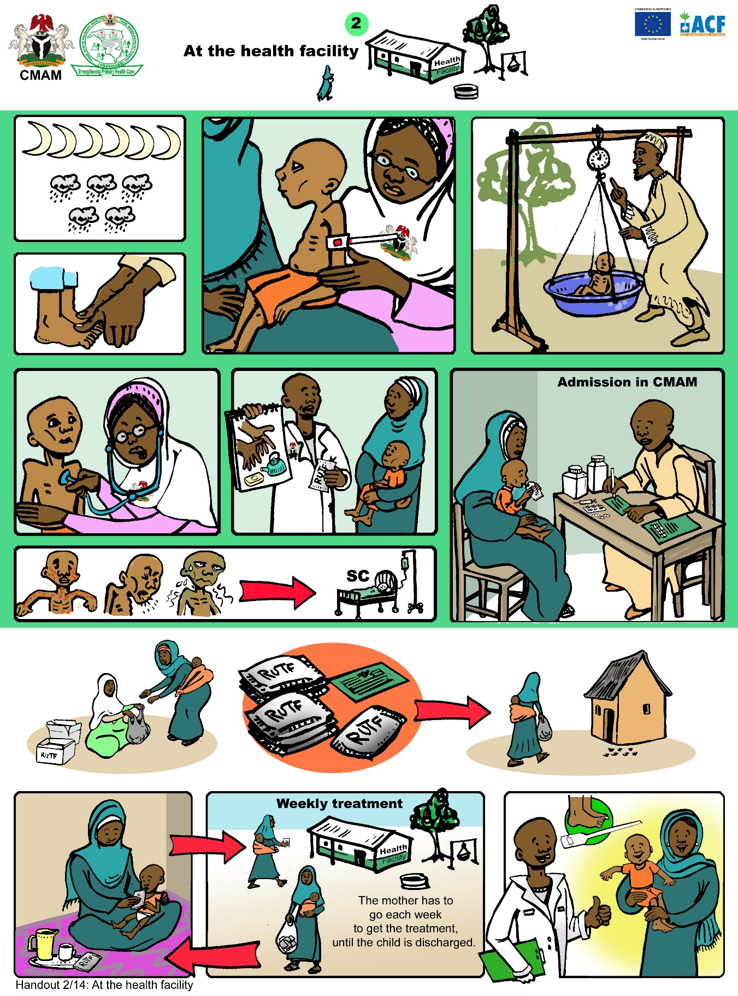

C. Sensitisation Messages for CMAM Beneficiaries: Treatment for Acute Malnutrition

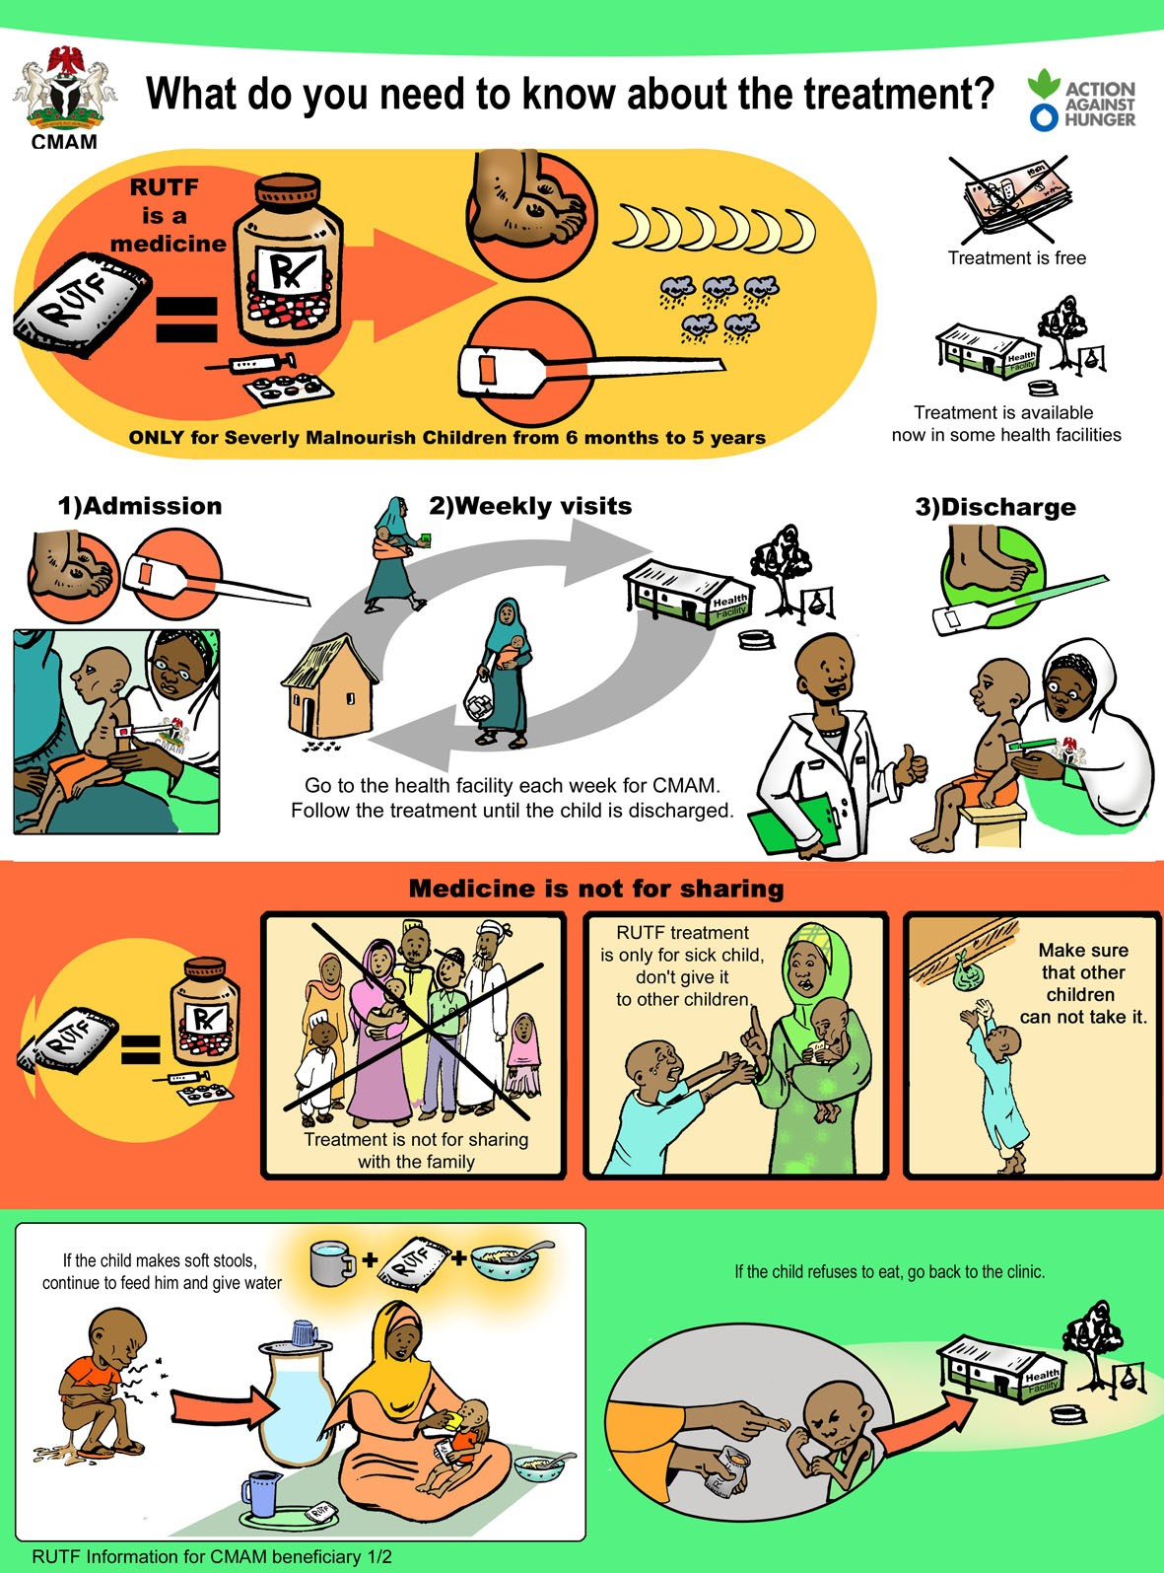

D. Sensitisation Messages for CMAM Beneficiaries: How to Use RUTF

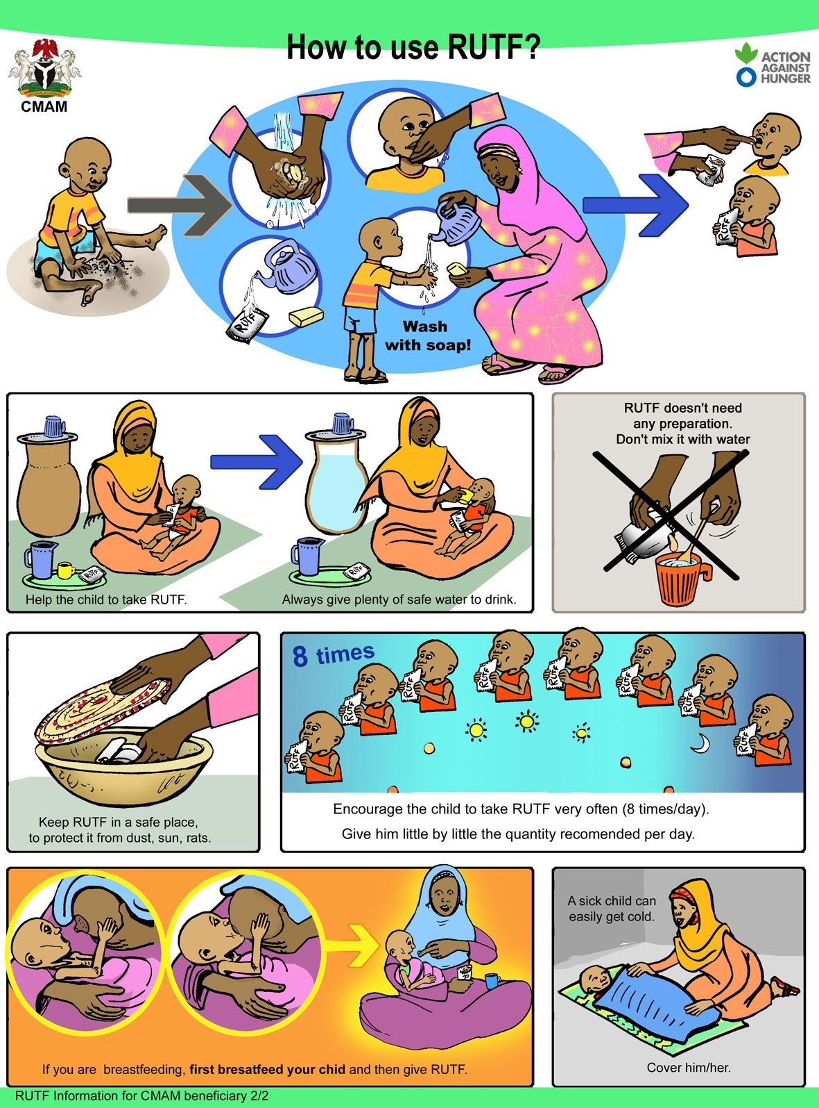

Handout 3.10 Key Actions in Community Mobilisation and Training

What? | Why? | How?
Establish reliable communication between health care providers, the community, mothers, and families | CMAM implementation relies on good relations between service providers and the community, mothers, and families both at the start, when CMAM is explained, and later on.  At the start, agreements must be made with the community concerning joint responsibilities (e.g., outpatient care day activities, volunteer case-finding, case follow-up).  Issues and challenges that arise later (e.g., defaulting) will require the community’s advice on correctives and assistance with implementing solutions. | - Conduct orientation meetings before startup that explain the purpose of CMAM.  - Seek the advice and involvement of standard health sector partners but also other gatekeepers, (e.g., administrative officials, political officials, religious officials).  - Look for ways to disseminate messages rapidly and without cost, such as at regular gatherings of political or traditional leaders.  - Make full use of the handbill, and adjust content as necessary.  - Take advantage of existing mechanisms for engaging community leaders on local health issues.
Help communities select outreach workers when necessary | If volunteers will be used for active case-finding, it helps to be part of the selection process, not to control who is selected but to ensure that volunteers understand what they are volunteering for.  If extension workers will be used, it helps to be involved so that community leadership has a good sense of what is needed. | - Spell out the level of effort expected of outreach workers.  - Explain that the need for house-to-house case-finding will diminish after startup.  - Try to recruit outreach workers who:  - Are accepted in the homes of all community members  - Feel secure walking within and between communities  - Are trusted to deal with all families fairly  - Are prepared to assist at the outpatient care site if needed  - Have the confidence to learn, if not literate
Train outreach workers (e.g., CHWs, volunteers) to perform active case-finding | Accurate assessment of bilateral pitting oedema and use of mid-upper arm circumference (MUAC) tape requires basic training.  Giving good quality training to large numbers of outreach workers can be challenging, since considerable individual practice with MUAC is required.  These trainings are often also the first real opportunity outreach workers have to learn about their new responsibilities. | - Conduct training at or near a maternal and child health (MCH) clinic or other location where many children under 5 are available for practicing. Make arrangements beforehand with mothers/caregivers and offer a bar of soap or other token as thanks.  - Try to ensure that referral criteria used by outreach workers are identical to admission criteria at outpatient care sites to minimise the number of referrals rejected.  - Be sure to allocate sufficient time for both the bilateral pitting oedema and MUAC practise and discussion. The topics should include:  - Explanation of outpatient care and CMAM  - Proposed role of outreach workers  - Probable workload  - MUAC measurement  - Identification of bilateral pitting oedema  - Referral procedure  - Questions to confirm understanding of training
Train mothers and family members to regularly screen their children for acute malnutrition | If trained, mothers and family members can play a vital role in the screening their children for acute malnutrition. This has potential to increase coverage of CMAM services and encourages early identification and treatment of acute malnutrition. | - Community health workers (CHW) train mothers and family members (e.g., aunts, grandmothers, and fathers) how to use MUAC and identify bilateral pitting oedema.  - The training should be simple using the local language. Short presentations, videos, and drawings or pictures should be used to describe malnutrition diagnosis and treatment.  - Demonstrate and practice the screening techniques.  - Trainings can be done for individual mothers or in group sessions integrating with existing health and nutrition interventions.  - Be sure to monitor and evaluate the effectiveness of the training and screening capability of mothers by:  - Random tests in homes several weeks after the initial training.  - Comparing the colour reported by the mother on arrival at the health centre and the measurement taken by a health care provider  - Reminders about screening through media (e.g. radio, text messages, handbills, and other forms of public announcements)
Engage civil society partners | Reaching out beyond the health sector can help identify and address gaps in community participation or service access and uptake. | - Brief the leadership of churches, mosques and community-based organisations (CBOs) about CMAM objectives and procedures.  - Look for opportunities in their activities to identify nutritionally vulnerable infants and children who are acutely malnourished. Train outreach workers from their organisations.  - Leave handbills so they can use a consistent message when passing information through their hierarchies.
Monitoring and evaluation | Routine monitoring of community outreach activities helps with tracking referrals against the actual number of cases admitted for treatment and helps to determine whether the outreach and referral system is working properly.  A coverage survey can help with the in-depth analysis on how well the service or programme is reaching the expected cases with acute malnutrition and help identify barriers and boosters to accessing the service. | - Review the community referrals against admissions register.  - Conduct supervision to review coordination, mobilisation, active-case finding, and follow-up activities.  - Conduct consultations with communities including families, mothers, caregivers, and opinion leaders.  - Conduct a coverage survey using the Semi-Quantitative Evaluation of Access and Coverage (SQUEAC)/Simplified Lot Quality Assurance Sampling Evaluation of Access and Coverage (SLEAC) (also see additional details in Module 8).

Handout 3.11 Planning and Implementing a Mass Training Campaign for Mothers and Family Members

Source: Alliance for International Medical Action (ALIMA) 2016. Mother-MUAC: Teaching Mothers to Screen for Malnutrition—Guidelines for Training of Trainers.

Step 1: Determining Your Coverage Area
When Mother-MUAC is first introduced to a community, covering an entire health catchment area will help ensure maximum impact. For this, you will need to define your population and evaluate population density:
- Have a comprehensive list of all villages in the health area with recent population estimates
- Identify village focal points who will be responsible for conducting training and following up with mothers
- Identify opportunities to train mothers (e.g., when, where, and how)
- Identify ways to regularly disseminate messages about routine screening activities (e.g., reminders via radio advertisements, SMS, social media, handbills, and posters)

Step 2: Determining the Human Resources Needed for a Mass Training Campaign
The number of MUAC trainers needed will vary based on population density. Below is an example for an entire health zone in Mirriah District, Niger in 2013:
- Anticipate one trainer per 50–60 people per day (or 100–120 people with a team of two trainers).
- In more densely populated areas, anticipate one trainer per 100–120 people per day (or 200–240 with a team of two trainers).
- Anticipate covering one village per half-day unless villages are very close together.
- Avoid scheduling training sessions on market days.
- Organise 1 or 2 days for return visits to villages to make the training available to mothers who could not attend the initial training.

Step 3: Determining the Budget
Based on ALIMA’s experience in Niger, it costs approximately US$1.00 per child per year to implement the Mother-MUAC activities (mass training, monitoring, and follow-up). The Mother-MUAC screening was less costly than the community health worker (CHW)-based screening strategy. However, the Mother-MUAC strategy requires a higher initial investment. Below is a breakdown of the cost:
- US$5,000: Initial training of trainers and mass Mother-MUAC campaign
- 75%: Per diems for 16 trainers
- 10%: Transport for trainers
- 15%: Supervision and evaluation of the initial training
- US$2,000: Occasional supervision from community manager and per diem for the District Supervisor (1 supervisor for 16 trainers)
- US$1,750: MUAC tapes estimated at US$0.14/tape distributed to 12,900 mothers and family members

Step 4: What to Prepare for Trainers

To organize a training of trainers, you will need to:
- Calculate the number of MUAC tapes needed per trainer
- Provide a set of training materials per trainer (e.g., visuals, oedema mock-up, key messages, tally sheet to count participants, number of MUAC tapes to distribute)
- Develop a timeline that runs from the pre-training visits to explain the purpose of the training to the post-training follow-up visits to train mothers who were unavailable during the training sessions and to supervise training quality.
- Plan transportation and determine daily salaries.
- Prepare pictures and drawings for the presentation.

To run group sessions in villages, trainers will need to:
- Limit groups to 20–25 mothers and family members.
- Expect each session to last 20–30 minutes.
- Allow for some extra time to do individual follow-up.

Step 5: Developing Training Sessions
Messages should be clear and simple, delivered in the local language. The agenda for a 20- to 30-minute training session should cover the following:
- Welcome the mothers and explain the objectives of Mother-MUAC
- What is malnutrition?
- What is the difference between wasting and oedematous malnutrition?
- How to recognize the early signs of malnutrition
- Advantages of Mother-MUAC
- How to check MUAC (followed by a practical demonstration)
- When to use MUAC and check for bilateral pitting oedema
- Thank the mothers for their participation

Step 6: Follow Up with the Mothers

Follow-up and tracking the effectiveness of the trainings is as important as the trainings themselves. Monitoring at the health centre can include the following questions during triage:
- Have you previously been trained to check your child’s MUAC status?
- If yes: Did you check your child’s MUAC/oedema at home before coming to health centre?
- If yes: Document the colour/oedema status reported by the mother and compare with the measurement by the health care provider. If the readings are different, the health care provider can do a practical demonstration with the mother.
Handout 3.12 Elements and Sequencing of CMAM Community Outreach

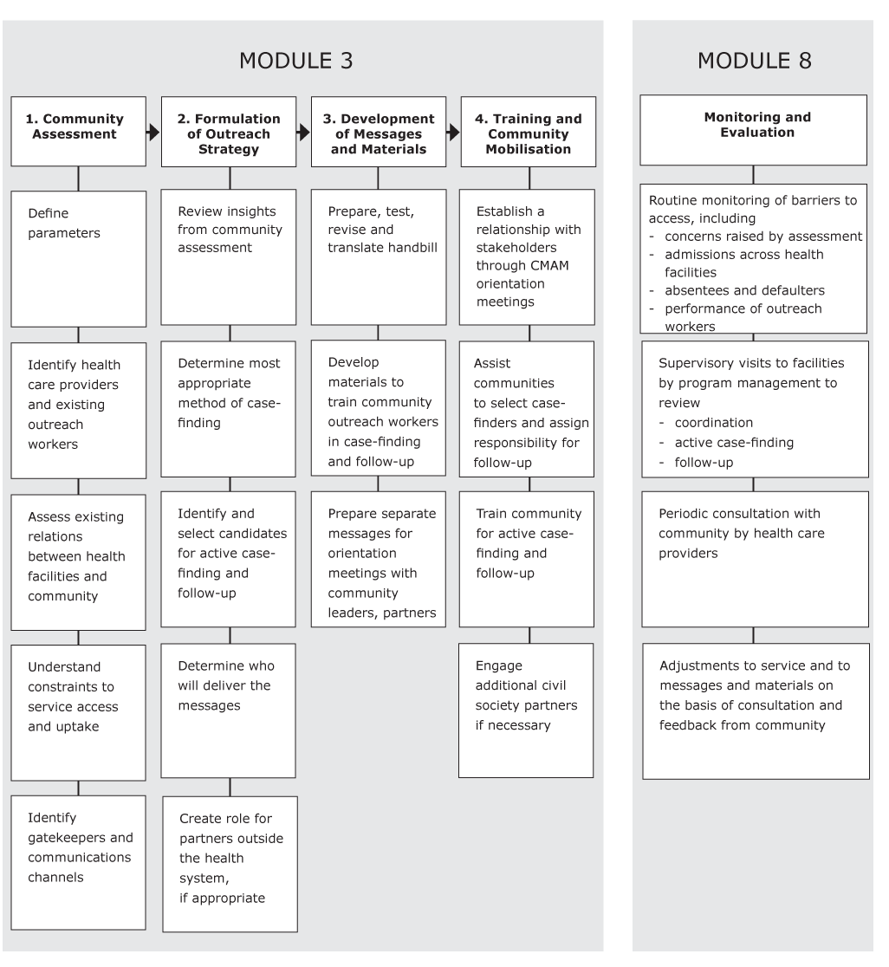

Handout 3.13 Team Checklist for Community Outreach Field Visit

COMMUNITY INTERVIEWS
Courteous treatment of community members
Clarity of instruction/explanation to informants
Efficient use of community time and maximum use of opportunities
Ability to employ variety of tactics to prompt discussion
Good written record of the discussion
INTERVIEW QUESTIONS – Based on interview guide developed by trainers
POST-INTERVIEW DISCUSSION, PLANNING
Content gaps are recognised by team
Team is able to distil useful insights from raw material of interview
Team can identify changes and improvements needed to interview guides and process
Team can draw practical operational conclusions from interview insights
Team can determine priority messages and package them in the simplest, most appropriate form
Team can demonstrate a grasp of the necessary next steps by devising an action plan for the mobilisation phase

EXERCISES

Exercise 3.2 Overcoming Obstacles to Community Participation in CMAM

Obstacles | Who Needs to be Involved
Poor awareness of acute malnutrition
Poor awareness of CMAM
Community mobilisation has been overly broad
Referral and admission criteria are not aligned
Local medico-cultural traditions do not connect advanced wasting or swelling with undernutrition
Stigma of acute malnutrition in the community or the influence of peers or family members
Important community gatekeepers or opinion-makers to CMAM
Primary health care (PHC) facilities are poorly regarded
Location of outpatient care sites
Interruption of seasonal labour patterns

Exercise 3.3 Comparison of Case-finding Models

Model | Suitable for | Strengths | Weaknesses
House-to-house case-finding
Community case-finding
Mother and family case-finding

Exercise 3.4 Worksheet: Selecting Candidates for Community Outreach
Job Description  (including supervised by) | Proximity  to Cases (sees children < 2 yrs) | Breadth  of Coverage (exist in every community or catchment area) | Accessible/ Amenable to Training | Can Accept Additional Work | Can Learn Mid-Upper Arm Circumference (MUAC) | Requires Little/No Extra Payment | Accepted in All Parts of the Community (for  house-to-house)
- Outreach workers (e.g., community health workers [CHWs], health extension workers [HEWs], volunteers)
- Other extension workers and volunteers
- Important community figures

MODULE FOUR: Outpatient Care for the Management of SAM Without Medical Complications

Module Overview
This module introduces participants to the concepts and protocols used in outpatient care for children with severe acute malnutrition (SAM) without medical complications. It provides an overview of admission and discharge processes and criteria, medical treatment and nutrition rehabilitation in outpatient care. Emphasis is placed on the use of an action protocol, which helps health care providers determine which children require referral to inpatient care and which children require follow-up at home.
To align with the 2013 World Health Organisation (WHO) guidance on the management of SAM in infants and children, this module has also been updated to provide guidance on the management of at-risk mothers and infants under 6 months of age (MAMI) without medical complications in outpatient care.
The module complements the WHO 2013 updates on the management of SAM in infants and children and the WHO training modules for the inpatient management of SAM with medical complications. It is intended to be used alongside national guidelines and national treatment protocols for the management of SAM.
The module also includes a field visit where participants will practice assessing and admitting at-risk mothers and infants under 6 months as pairs and children 6–59 months with SAM without medical complications to outpatient care. The field visit will also enable participants to practice managing infants and children in an outpatient care follow-on session. Participants will also have the opportunity during this field visit to practice the skills covered in Module 2. Defining and Measuring Acute Malnutrition.

Learning Objectives | Duration | Handouts and Exercises
- Describe Outpatient Care for the Management of SAM Without Medical Complications | 15 minutes | PowerPoint: Overview of CMAM from Module 1 (optional)
- Describe Admission Criteria in Outpatient Care (Infants Under 6 Months and Children 6–59 Months) | 45 minutes | Handout 4.1 Admission Criteria and Entry Categories for CMAM  Handout 4.2 Outpatient Care: Admission Criteria for Infants Under 6 Months and Children 6–59 Months  Exercise 4.1 Outpatient Care Admission for Infants Under 6 Months and Children 6–59 Months
- Describe the Process for Admissions and Outpatient Care Follow-On Sessions for Children 6–59 Months | 1 ½ hours | Handout 4.3 Outpatient Care: Admission Process for Children 6–59 Months  Handout 4.4 Outpatient Care Treatment Card for Children 6–59 Months  Handout 4.5 RUTF Ration Card for Children 6–59 Months  Handout 4.6 Using Outpatient Care Treatment Card and RUTF Ration Card for Children 6–59 Months  Exercise 4.2 Outpatient Care Treatment Card and RUTF Ration Card for Children 6–59 Months
- Explain Medical Treatment for the Management of Children With SAM Without Medical Complications in Outpatient Care | 1 hour | Handout 4.7 Medical Treatment for the Management of SAM in Outpatient Care  Handout 4.8 Routine Medicines for SAM in Outpatient Care  Handout 4.9 Supplemental Medicines for SAM in Outpatient Care  Handout 4.10 Medicine Protocol Rationale for Outpatient Care (Reference)
- Explain Nutrition Rehabilitation for the Management of SAM Without Medical Complications in Outpatient Care (Children 6–59 Months) | 30 minutes | Handout 4.11 Nutrition Rehabilitation and RUTF for Children 6–59 Months
- Describe the Key Messages for Mothers/Caregivers of Children 6–59 Months Used in Outpatient Care | 30 minutes | Handout 4.12 Key Messages for Individual Counselling for Mothers/Caregivers of Children 6–59 Months in Outpatient Care
- Explain the Management of At-Risk Mothers and Infants under 6 Months of Age Without Medical Complications in Outpatient Care | 1 hour | Handout 4.13 C-MAMI Tool Version 2.0: Breastfeeding Counselling and Support Actions  Handout 4.14 Outpatient Care: Admission Process for At-Risk Mothers and Infants Under 6 Months  Handout 4.15 Outpatient Care Treatment Card for At-Risk Mothers and Infants Under 6 Months
- Recognising When Further Action Is Needed: Referral to Inpatient Care and Follow-Up Home Visits | 45 minutes | Handout 4.16 Outpatient Care Action Protocol for Infants Under 6 Months and Children 6–59 Months  Handout 4.17 Referral to Inpatient Care or Follow-Up Home Visits for Infants Under 6 Months and Children 6–59 Months  Handout 4.18 Referral Slip for Infants Under 6 Months and Children 6–59 Months  Exercise 4.3 Identifying Infants Under 6 Months and Children 6–59 Months Who May Need Follow-Up Home Visits or Referral to Inpatient Care
- Explain Discharge Criteria and Procedures for At-Risk Mothers and Infants Under 6 Months and Children 6–59 Months | 30 minutes | Handout 4.19 Outpatient Care: Discharge Criteria for At-risk Mothers and Infants Under 6 Months and Children 6–59 Months  Handout 4.20 Discharge Criteria and Exit Categories for CMAM  Exercise 4.4 Partially Completed Outpatient Care Treatment Cards
- Describe Linkages Between Outpatient Care and Other Services, Programmes, and Initiatives | 30 minutes | Handout 1.11 Integrating CMAM into Routine Health Services at the District Level
Wrap-Up and Module Evaluation | 15 minutes  (additional 15–20 minutes for the optional exercise) | Handout 4.21 Essentials of Outpatient Care for SAM Without Medical Complications  Optional Exercise 4.5 Outpatient Care Admissions Role Play
Field Visit for Outpatient Care | 3 days | Handout 4.22 Outpatient Care Field Practice Checklist

Module Duration: Eight hours in classroom; three-day field practice
Note: Depending on the needs of their audience(s), trainers may choose to skip or spend more or less time on certain learning objectives and activities. The module duration is an estimate of the time it takes to complete all the learning objectives and activities.

Reference Resources
- National guidelines for CMAM
- World Health Organisation (WHO). 2013. Guideline: Updates on the Management of Severe Acute Malnutrition in Infants and Children. Geneva: WHO. Available at: http://www.who.int/nutrition/publications/guidelines/updates_management_SAM_infantandchildren/en/.
- WHO. 2014. Integrated Management of Childhood Illnesses (IMCI) Chart Booklet. Available at: http://www.who.int/maternal_child_adolescent/documents/IMCI_chartbooklet/en/.
- Emergency Nutrition Network (ENN). 2018. C-MAMI Tool Version 2.0. Available at https://www.ennonline.net/c-mami.
- Core Group. 2015. Essential Nutrition Actions and Essential Hygiene Actions Framework. Available at: http://coregroup.nonprofitsoapbox.com/resources/488-essential-nutrition-actions-and-essential-hygiene-actions-framework.
- Emergency Nutrition Network (ENN). 2009. Integration of IYCF Support into CMAM. Available at: https://www.ennonline.net/integrationiycfintocmam.
- Valid International. 2006. Community-based Therapeutic Care (CTC): A Field Manual. Oxford: Valid International. Available at: https://www.fantaproject.org/sites/default/files/resources/CTC-Field-Manual-Oct2006-508.pdf

Further Reading Resources
- National guidelines for integrated management of childhood illness (IMCI)

- WHO. 2013. Pocket Book of Hospital Care for Children: Guidelines for Management of Common Childhood Illnesses. 2nd Edition. Available at: http://www.who.int/maternal_child_adolescent/documents/child_hospital_care/en/.

- Lelijveld, N. et al. 2017. A Review of Methods to Detect Cases of Severely Malnourished Infants Less than 6 Months for Their Admission into Therapeutic Care. Emergency Nutrition Network. Available at: https://www.ennonline.net/mamicasedetectionreview.
- Bailey, J. et al. 2016. Combined Protocol for SAM/MAM Treatment: The ComPAS study. Available at: https://www.ennonline.net/fex/53/thecompasstudy.

- Maust, A. et al. 2015. “Severe and Moderate Acute Malnutrition Can Be Successfully Managed with an Integrated Protocol in Sierra Leone.” Journal of Nutrition. Available at: https://pdfs.semanticscholar.org/d5c2/e4bed4e18d6cdfa6d6b3b31f69d0ee347d54.pdf.

- Philip, T.J. et al. 2015. “Low-Dose RUTF Protocol and Improved Service Delivery Lead to Good Programme Outcomes in the Treatment of Uncomplicated SAM: A Programme Report from Myanmar.” Maternal & Child Nutrition. 11(4):859–69. doi: 10.1111/mcn.12192. Epub 2015 Apr 7. Available at: https://www.ncbi.nlm.nih.gov/pmc/articles/PMC4672709/pdf/mcn0011-0859.pdf.

Handout 4.1 Admission Criteria and Entry Categories for CMAM

A. Admission Criteria for Management of At-Risk Mothers and Infants Under 6 Months of Age

*Note on the admission criteria for infants under 6 months of age:
MUAC: There is recent growing evidence on the use of MUAC to identify nutrition vulnerability in infants under 6 months. However, a classification cutoff for this age group has not yet been established. Countries and programmes are encouraged to collect MUAC data for infants under 6 months to help build the evidence base for cutoffs and case management.
WFA: A recent review has shown that WFA can help identify underweight infants who are nutritionally vulnerable and at higher risk of mortality. WFA is therefore used as a criterion for enrolment of nutritionally vulnerable infants under 6 months. A cutoff of WFA <-2 is used for consistency with WFL cutoffs.
Weight loss: In many settings, it can be difficult for a health worker or mother to detect acute weight loss in an infant. Where reported or detected, weight loss in infants should be interpreted alongside the general clinical condition.

**On the admission criteria for lactating women:
MUAC: Countries may have different cutoffs based on context and national guidelines.
Adolescent lactating mothers: To facilitate support and close monitoring, it is recommended that adolescents who are lactating mothers be enrolled in programmes for the management of acute malnutrition irrespective of their MUAC measurement.
Pregnant adolescents: To facilitate support and close monitoring, it is recommended that pregnant adolescents be enrolled in programmes for the management of acute malnutrition irrespective of their MUAC measurement.

INPATIENT CARE | OUTPATIENT CARE
Management of nutritionally vulnerable infants  with medical complications (HIGH NUTRITIONAL RISK) | Management of nutritionally vulnerable infants  without medical complications (MODERATE NUTRITIONAL RISK)
*ADMISSION CRITERIA FOR INFANTS UNDER 6 MONTHS
Bilateral pitting oedema +, ++, and +++  OR WFA <-2 z score or  WFL < -2 z-score or  MUAC: TBD (record measure to help build evidence)  OR any of the following:  - Recent severe weight loss (within 1 week)  - Prolonged failure to gain weight (weeks, months)  - Sharp drop across the infant’s growth line  WITH any of the following medical complications:  - Unable to feed - Intractable vomiting  - Convulsions - Lethargy, not alert  - Unconsciousness - High fever  - Lower respiratory tract infection (LRTI)  - Dehydration - Persistent diarrhoea  - Severe anaemia - Hypoglycaemia  - Hypothermia - Severe skin lesions  - Eye signs of vitamin A deficiency  OR WITH any of the following additional complications:  - Cleft lip or palate (feel inside mouth to check for palate)  - Abnormal tone or posture  - Excessively open or clenched jaw  - Unable to support head or control trunk  - When held, infant’s arms and legs fall to the sides  - Infant’s body still, hard to move  - Not willing or able to suckle at the breast or feed by cup or bottle  - Coughing and eye tearing (signs of unsafe swallowing) while feeding  OR Referred from outpatient care according to action protocol | NO bilateral oedema  OR WFA <-2 z score or  WFL < -2 z-score or  MUAC: TBD (record measure to help build evidence)  OR any of the following:  Moderate weight loss (within a few days)  Recent (days, weeks) failure to gain weight  Moderate drop across the infant’s growth line  OR Moderate feeding problem with underlying causes listed below for breastfed and non-breastfed infants:  Breastfed infant:  Not well attached to the breast  OR Not suckling eﬀectively  OR Less than 8 breastfeeds in 24 hours  OR Receives other foods or drinks  OR Refusing to breastfeed  Non-breastfed infant:  Inappropriate breast milk substitute (BMS) being used  OR Consuming less than 500 ml of BMS per 24 hours  OR Refusing feeds  OR Receives other foods or drinks in addition to BMS  OR Mother absent  AND mother-infant pair is clinically well and alert  OR Referred from inpatient care after stabilisation
**ADMISSION CRITERIA FOR LACTATING MOTHERS OF INFANTS UNDER 6 MONTHS OF AGE
Bilateral pitting oedema (only in non-pregnant mother)  OR MUAC: <190 mm  OR Severe anaemia  OR Severe depression | MUAC: 190 to <230 mm  OR Moderate or mild anaemia  OR Breastfeeding assessment: Perception of not having  enough breast milk  OR Breast conditions—Any of the following:  - Engorgement - Sore and cracked nipples  - Plugged ducts - Mastitis  - Flat, inverted, large, or long nipples  OR Lack of social support

B. Admission Criteria for Children 6-59 Months and Pregnant Women

*Note on the admission criteria for children 6–59 months:
MUAC is the preferred primary indicator for detection and diagnosis of acute malnutrition and discharge from treatment for this age group because it identifies children who are at high risk of mortality.
The same anthropometric indicator that is used to identify and confirm SAM on admission should be used to determine recovery and discharge from treatment. However, if a child is admitted based only bilateral pitting oedema, discharge and recovery should be based on whichever anthropometric indicator MUAC or WFH/WFL routinely used. The child should also have no bilateral pitting oedema for at least two consecutive sessions.
**Note on the admission criteria for pregnant women:
MUAC: Countries may have different cutoffs based on context and national guidelines.
Pregnant adolescents: To facilitate support and close monitoring, it is recommended that pregnant adolescents be enrolled in programmes for the management of acute malnutrition irrespective of their MUAC measurement

INPATIENT CARE  for the Management of SAM with Medical Complications | OUTPATIENT CARE  for the Management of SAM without Medical Complications | Management of Moderate Acute Malnutrition (MAM) (e.g., Supplementary Feeding)
ADMISSION CRITERIA FOR CHILDREN 6–59 MONTHS
Bilateral pitting oedema +++  OR Marasmic kwashiorkor: any grade of bilateral pitting oedema with severe wasting (MUAC < 115 mm or WFH/WFL < -3 z-score)  OR Bilateral pitting oedema + or ++ or  MUAC < 115 mm or  WFH/WFL < -3 z-score  WITH any of the following medical  complications:  - Anorexia, no appetite  - Intractable vomiting  - Convulsions  - Lethargy, not alert  - Unconsciousness  - Lower respiratory tract infection (LRTI)  - High fever  - Dehydration  - Persistent diarrhoea  - Severe anaemia  - Hypoglycaemia  - Hypothermia  - Eye signs of vitamin A deficiency  - Skin lesions  OR Referred from outpatient care  according to action protocol | Bilateral pitting oedema + and ++  OR MUAC < 115 mm  OR WFH/WFL < -3 z-score  AND  Appetite  Clinically well  Alert  OR Referred from inpatient care after stabilisation | MUAC ≥ 115 mm and < 125 mm  OR WFH/WFL ≥ -3 and < -2 z-score  AND  Appetite  Clinically well  Alert
ADMISSION CRITERIA FOR PREGNANT WOMEN
Pregnant women
MUAC <230 mm

C. Entry Categories for CMAM
INPATIENT CARE | OUTPATIENT CARE | MANAGEMENT of MAM (e.g., Supplementary Feeding)
ENTRY CATEGORY: NEW ADMISSIONS OF INFANTS UNDER 6 MONTHS OF AGE
New cases of infants under 6 months who meet admission criteria—including relapse after cure | New cases of infants under 6 months who meet admission criteria—including relapse after cure | Not applicable for infant under 6 months of age
ENTRY CATEGORY: NEW ADMISSIONS OF CHILDREN 6—59 MONTHS
New SAM cases of children 6-59 months who meet admission criteria—including relapse after cure | New SAM cases of children 6-59 months who meet admission criteria—including relapse after cure | New MAM cases of children 6-59 months who meet admission criteria—including relapse after cure and referral from outpatient care
ENTRY CATEGORY: OTHER NEW ADMISSIONS
New SAM cases of children ≥ 5 years, adolescents, or adults who need treatment of SAM in inpatient care | New SAM cases of children ≥ 5 years, adolescents, or adults who need treatment of SAM in outpatient care | New MAM cases of children ≥ 5 years, adolescents, or adults who need treatment of MAM
ENTRY CATEGORY: OLD CASES—REFERRAL FROM OUTPATIENT CARE AND INPATIENT CARE
- Referral from outpatient care: Infant’s or child’s health condition deteriorated in outpatient care (according to action protocol) and child needs inpatient care  - Returned after defaulting  - Moved in from other inpatient care site | - Referral from inpatient care: Infant’s or child’s health condition improved in inpatient care and child continues treatment in outpatient care  - Returned after defaulting  - Moved in from other outpatient care site | - Returned after defaulting  - Moved in from other supplementary feeding site

Handout 4.2 Outpatient Care: Admission Criteria Infants Under 6 Months and Children 6–59 Months

Who Should Be Admitted to Outpatient Care
- Infants under 6 months of age who are nutritionally vulnerable with no medical complications (i.e., moderate nutrition risk), no bilateral pitting oedema, an appetite (i.e., able to feed), OR whose caregiver declines admission to inpatient care.
- Infant whose mother/caregiver declines admission to inpatient care will require follow-up home visits and very close monitoring while in outpatient care.
- Infants under 6 months referred from inpatient care will continue to receive feeding support and monitoring in outpatient care.
- Infants under 6 months who return after defaulting (absent for three consecutive sessions) and need to continue with feeding support and monitoring.
- Children age 6–59 months who have severe acute malnutrition (SAM), an appetite (ability to eat ready-to-use therapeutic food [RUTF], passing the appetite test) and no medical complications
- Children whose mother/caregiver refuses inpatient care despite advice; the child will require follow-up home visits and close monitoring while in outpatient care
- Children who a health care provider has determined should be admitted, such as children over 5 years old with bilateral pitting oedema or who are severely wasted
- Infants and children referred from inpatient care to complete the treatment according to the protocol
- Infants and children who return after defaulting (absent for three consecutive sessions) and who need to continue the treatment

Who Is Not Admitted to Outpatient Care?
- Infants under 6 months who are nutritionally vulnerable (i.e., high nutritional risk) with medical complications, have any grade of bilateral pitting oedema, have no appetite (refusing or unable to feed), or failed to respond to management in outpatient care should be referred to inpatient care.
- Children 6–59 months with SAM and medical complications, including no appetite, should be referred to inpatient care.
- Children 6–59 months with moderate acute malnutrition (MAM) should be referred to supplementary feeding or other treatment services for MAM, as available.
- Children who are sick but do not have SAM should be referred to other appropriate health services.

Note:

Infants and children with HIV/AIDS and SAM should follow the SAM treatment protocol as children with SAM and not with HIV/AIDS.

Twins under 6 months: If one twin meets the admission criteria, then both twins are admitted to ensure that the mother can support feeding of both infants. The objective is to ensure that the care of the healthy infant is not compromised by the increased attention to the nutritionally vulnerable twin.

Twins 6–59 months: If the first twin meets CMAM admission criteria and the second does not, the second twin is not admitted. However, the second twin receives a weekly RUTF ration because ration sharing must be assumed. An RUTF ration card for the second twin is filled out and stapled to the RUTF ration card of the admitted first twin.

Adults and adolescents: In recent years, several countries (e.g., Malawi, Zambia, Mozambique, and Tanzania) have adapted the treatment of adolescents and adults with SAM in outpatient care based on context and national guidelines.

Handout 4.3 Outpatient Care: Admission Process for Children 6–59 Months

A. Overview of Outpatient Care Admission Process

Admission Process for Child with SAM
Referred To or Presented At the Health Facility with Outpatient Care
(Outpatient Care Follow-On Sessions: Steps 1-15 [except 6] are repeated)
1. Sugar water given
2. Bilateral pitting oedema checked
3. Anthropometry checked: MUAC measured
- Weight measured
- Length or height measured; WFH/WFL verified*
4. Nutritional status recorded
5. DECISION whether child IS ADMITTED FOR SAM or REFERRED FOR MAM OR OTHER (In outpatient care follow-on sessions: progress of nutritional status monitored)
6. Registration number provided
7. Medical assessment: Medical history taken and physical examination conducted, all recorded on outpatient care treatment card
8. Appetite tested (including breastfeeding status for children 6–23 months)
9. Decision WHETHER CHILD IS admitted to outpatient care or referred to inpatient care (based on admission criteria) (In outpatient care follow-on sessions: decision whether child continues treatment in outpatient care, is referred to inpatient care or tertiary care [based on outpatient care action protocol], needs a follow-up home visit, or is ready for discharge [based on discharge criteria]
Child Receives Treatment in Outpatient Care | Child is Referred to Inpatient Care
Routine medication given upon admission (In outpatient care follow-on sessions: medication following treatment protocol given)  Weekly supply of RUTF given  RUTF ration card filled out and RUTF given (Soap provided if available)  Counselling on how to give RUTF (key messages) and antibiotics given upon admission (In outpatient care follow-on sessions: counselling on progress, and health and nutrition education given)  Explanation of outpatient care schedule and when to return for outpatient care follow-on sessions, and linkage with outreach worker (e.g., CHW, volunteer) given  15. Links with other services, programmes and initiatives made | 10. First-dose antibiotic given and recorded in the referral slip.  11. Referral slip provided  (Arrange transportation where possible)
* Note: In countries where bilateral pitting oedema and mid-upper arm circumference (MUAC) are used for admission, adjust chart and remove length or height measurement and weight-for-height (WFH)/ weight-for-length (WFL) information.

B. Important Considerations in the Admission Process
- Shade and toilets should be provided if mothers/caregivers and children have to wait outside. Organise the flow of patients and the waiting area so that mothers/caregivers have somewhere to sit, and health care providers can see patients and take measurements in an orderly manner.
- Children waiting for admission can be given clean, safe water to drink. Where possible, sugar water should be given to help prevent hypoglycaemia.
- Children in a severe condition should be triaged and treated first.
- Water and clean cups should be available for children who eat the ready-to-use therapeutic food (RUTF) during the appetite test and during the waiting period.
- Soap and water should be available for hand-washing.

C. Steps for Admission
- Children are checked for bilateral pitting oedema, their MUAC is taken, they are weighed and their length or height is measured.
- If a child meets the admission criteria for severe acute malnutrition (SAM), the health care provider takes a medical history and conducts a physical examination. The medical history includes information on bilateral pitting oedema, diarrhoea, vomiting, cough, appetite, frequency of stools and urine, bilateral pitting oedema duration, and breastfeeding status. The physical examination includes measurement of respiratory rate, chest retraction and body temperature, and observations of the eyes, ears, lymph nodes, skin, mouth and extremities (see Handout 4.7 Medical Treatment for Management of SAM in Outpatient Care for more information).
- All information is recorded on the child’s outpatient care treatment card, which is kept on file at the outpatient care site. The health care provider should complete an outpatient care treatment card for all children admitted at the outpatient care site, even those that will be referred to inpatient care. Each child has a unique registration number noted on the outpatient care treatment card.
- The appetite is tested; RUTF is given to the mother/caregiver to give to the child for an observed appetite test. The child’s appetite is graded by the health care provider. See Section D below for detailed information on the appetite test.
- Based on the appetite test and the medical assessment (i.e. anthropometry, medical history, physical examination), the health care provider determines whether the child should be referred to inpatient care or admitted into outpatient care.
- Routine medication is provided based on the treatment protocol.
- The child will receive a ration of RUTF, and the amount is marked on the outpatient care treatment card and on an RUTF ration card that is given to the mother/caregiver.
- The health care provider counsels the mother/caregiver with key messages on how to feed the child RUTF, how to give the medicines to the child, when to return to outpatient care, and to bring the child to the health facility immediately if his/her condition deteriorates.
- Note: Outpatient care includes individual counselling, health and nutrition education, and behaviour change communication (BCC) at each session. It is important that the initial counselling session focus only on the messages above so that the mother/caregiver clearly understands the practices that are essential to the successful treatment of SAM. As the child’s condition improves, other messages should be given. These messages will be discussed more fully under Learning Objective 6.
- The mother/caretaker receives explanation on the outpatient care schedule and when to return for outpatient care follow-on sessions. S/he is also linked with the responsible outreach worker for his/her community (i.e., name of the community health worker [CHW] or volunteer, how to reach the outreach worker if the introduction was not made during the screening or admission).
- Linkages are made with other services, programs or initiatives as appropriate (e.g., HIV testing and counselling [HCT], expanded programme of immunisation [EPI], reproductive health clinic, food security initiatives).
- The same anthropometric indicator that is used to identify and confirm SAM on admission should be used to determine recovery and discharge from treatment. However, if a child is admitted based only bilateral pitting oedema, discharge and recovery should be based on whichever anthropometric indicator MUAC or WFH/WFL routinely used. The child should also have no bilateral pitting oedema for at least two consecutive sessions.

D. Appetite Test to Determine Whether Child Should Be Treated in Outpatient Care with RUTF
- Appetite is essential for a child to be admitted to and remain in outpatient care. If a child has no appetite, s/he will not be able to eat RUTF at home and therefore needs referral for specialized care in inpatient care for the management of SAM with medical complications.
- An appetite test is given to children ages 6 months and above to determine whether the child can eat the RUTF. The test shows whether the child has appetite, accepts the RUTF’s taste and consistency and can swallow (e.g., child is old enough to swallow solids, child has no lesions that prevent him/her from eating). Anorexia, or absence of appetite, is considered to reflect a severe disturbance of the metabolism.
- Children with SAM who pass the test and have no medical complications are treated in outpatient care. Those who do not pass are referred to inpatient care.
The appetite test is repeated at every outpatient care follow-on session. For children who are used to the RUTF, there is flexibility on when the repeat test can be done (e.g., with supervision in a group, during the waiting time).
- Children who have other medical complications that require referral to inpatient care do not need to take the appetite test at the outpatient care site.

- The Appetite Test
- The child is given a packet of RUTF to eat.
- The child should eat at least one third of a packet to pass the test.
- The health care provider observes the child eating the RUTF and decides whether the child passes or fails.
- If the child passes, s/he can be sent home and continues treatment in outpatient care. If the child fails, referral procedures to inpatient care are started.
- The health care provider notes on the outpatient care treatment card whether the child “passed” or “failed” the appetite test.

Note: Many children will eat the RUTF enthusiastically straight away while others might refuse initially. These children should sit quietly with their mothers/caregivers in a secluded place and be given time to become accustomed to the RUTF.

E. Steps for Outpatient Care Follow-On Sessions
- Depending on the outpatient care site’s schedule and the ability of the mother/caregiver to bring in the child, weekly or bi-weekly outpatient care follow-on sessions are scheduled.
- The mother/caregiver is asked to return for each outpatient care follow-on session, and the importance of compliance with this is explained: returning for outpatient care follow-on sessions is critical for the child’s treatment as receiving the needed RUTF is vital for the child’s nutrition rehabilitation.
- At each outpatient care follow-on session, the child receives a comprehensive evaluation that includes:
- Anthropometry, medical history, and physical examination
- Breastfeeding status for children 6–23 months
- An appetite test
- Monitoring the progress of the child’s nutritional status
- Decision making for referral to inpatient care or tertiary care depending on the outpatient care action protocol, for a follow-up home visit, or for discharge
- Continuation of drug treatment protocol
- Adequate supply of RUTF
- Individual counselling, and group health and nutrition education.
- Verifying and excluding the presence of medical complications
- The mother/caretaker is linked with services, programmes, and initiatives as appropriate.

Handout 4.4 Outpatient Care Treatment Card for Children 6–59 Months
ADMISSION DETAILS: OUTPATIENT CARE Treatment Card
Name |  |  |  |  |  |  | Reg. Nº | / /
Age (months) |  |  | Sex |  | M | F | Date of admission
Administrative Unit |  |  |  |  |  |  | Time to travel to site
Community |  |  |  |  |  |  | Father Alive
House details / landmarks |  |  |  |  |  |  | Mother Alive
Name of Caregiver |  |  |  |  |  | Total number in household
Admission (circle) |  | self referral | outreach referral |  | inpatient care referral | health facility referral | Twin |  | yes | no
Re-Admission (relapse) |  | No | Yes |  | Additional information
Admission Anthropometry
Bilateral pitting oedema |  | + ++ +++
MUAC (mm) |  |  | Weight (kg) |  |  | Height/length (cm) |  | Weight for height/length (WFL)
Admission criteria |  | Bilateral pitting oedema | MUAC |  | Weight for height | Other:
History
Diarrhoea |  | yes | no |  | # Stools/day |  |  | 1-3 | 4-5 | >5
Vomiting |  | yes | no |  |  |  |  | Passing urine | yes | no
Cough |  | yes | no |  |  | If bilateral pitting oedema, how long swollen?
Appetite | good | poor | none |  |  | Breastfeeding status (children 6 to 23 months) |  |  | yes | no
Additional information
Physical examination
Respir. rate (# min) |  | <30 | 30 – 39 |  | 40 - 49 | 50+ | Chest Indrawing |  | yes | no
Temperature ⁰C |  |  |  |  |  |  |  | Conjunctiva | normal | pale
Eyes |  | normal | sunken |  | discharge |  | Dehydration | none | moderate | severe
Ears |  | normal | discharge |  |  |  | Mouth | normal | sores | candida
Enlarged lymph nodes |  | none | neck |  | axilla | groin | Hands & feet |  | normal | cold
Skin changes |  | none | scabies |  | peeling | ulcers / abscesses |  | Disability | yes | no
Additional information
Routine medication: admission
ADMISSION: Drug |  | date | dosage |  |  |  | Drug | date | dosage
Amoxycillin
 |  |  |  |  |  | Measles immunisation |  | No yes | date:
Malaria treatment |  | yes | no |  | date | Fully immunised |  | no yes
2nd VISIT: drug |  | date | dosage
Mebendazole
Other medication
Drug |  | Date | Dosage |  |  |  | Drug | Date | Dosage

FOLLOW UP: OUTPATIENT CARE

NAME |  |  |  |  |  |  |  |  |  | REG.Nº |  | / /
Week |  | ADM  (=0) | 1 | 2 | 3 | 4 | 5 | 6 | 7 | 8 | 9 | 10 | 11 | 12 | 13 | 14 | 15 | 16
Date
Anthropometry
Bilateral Pitting Oedema
(+ ++ +++)
MUAC (mm)
Weight (kg) |  |  |  |  | * |  | *
Weight loss * (Y/N)
Height/length (cm)
Weight for Height/length
* If below admission weight on week 3 refer for home visit; If no weight gain by week 5 refer to inpatient care
History
Diarrhoea (# days)
Vomiting (# days)
Fever (# days)
Cough (# days)
Physical examination
Temperature (⁰C)
Respiratory rate (# /min)
Dehydrated (Y/N)
Anaemia / palmar pallor (Y/N)
Skin infection (Y/N)
Appetite check / feeding
RUTF test (Passed/Failed)
RUTF (# units given)
 | Breastfeeding (Y/N)
Action / follow up
ACTION NEEDED (Y/N)
Other medication (see front of card)
Name of examiner
VISIT OUTCOME
OK=Continue A=Absent D=Defaulted for 3 visits R=Referral RR=Refused referral C=Cured NR=Non-recovered HV= Home visit X=Died
Action taken during follow-up (include date)
Name of outreach worker:

Handout 4.5 RUTF Ration Card for Children 6–59 Months

Front of card:
OUTPATIENT CARE RUTF RATION CARD |  |  |  | Registration Nº
Site |  |  |  | Community
Name of Child |  |  |  | Age |  |  | Sex
Target Weight (kg) |  |  |  | CRITERIA FOR ADMISSION:
Date | Bilateral pitting oedema | MUAC (mm) | Height (cm) |  | Weight (kg) | WFH/  WFL |  | RUTF ration
Notes:

OUTCOME: Cured Died Defaulted Non-Recovered Referred

Back of card:
Date | Bilateral pitting oedema | MUAC (mm) | Height (cm) | Weight (cm) | WFH/  WFL | RUTF ration
Notes / Follow-Up Home Visits (date/signature by outreach worker)
Handout 4.6 Using Outpatient Care Treatment Card and RUTF Ration Card for Children 6–59 Months

A. Outpatient Care Treatment Card
- The outpatient care treatment card is completed for all children admitted to CMAM at the outpatient care site, including those being referred to inpatient care.
- Each child admitted to CMAM is given a unique registration number, which is noted on the outpatient care treatment card. The numbering system starts with the first child admitted at that site e.g., 001/OC/XXX (OC for “outpatient care” and XXX as the code for the health facility). This number remains the same even if the child is referred to inpatient care. The number must appear on referral slips. The hospital or agency running inpatient care should use this number on the slip when the child is returned from inpatient care to outpatient care. The same numbering system applies to programmes that manage moderate acute malnutrition (MAM). Note: If a mother/caregiver presents a child directly to inpatient care and the child is admitted, then the inpatient care code is used.
- The outpatient care treatment card filing system is a simple data repository system that maintains the most detailed monitoring information of individual treatment. Outpatient care treatment cards are kept in a simple file on site. The file should have dividers with separate sections for defaulters, deaths, recovered (cured children who were discharged) and referrals. This system makes it easy to organise, find the right cards and fill out reports weekly and monthly.
- If a child is referred to inpatient care, the outpatient care treatment card is filed under “referrals to inpatient care” until the child returns to the outpatient care site. Cards in the referral section should be checked weekly, and health care providers should discuss the referral status of the children with the outreach workers (e.g., community health workers [CHWs], volunteers) to be sure that each child returns from inpatient care. If a child dies in inpatient care, the outpatient care treatment card is filed under deaths.
- For health facilities that require registration to meet follow-up and reporting requirements, a simplified registration system using registration books can be useful. The health care provider records the child’s number, name, place of origin, admission date, nutrition indicators upon admission (i.e. bilateral pitting oedema, mid-upper arm circumference [MUAC], weight, height, weight-for-height [WFH]/ height, weight-for-length [WFL]), date of discharge, and nutrition indicators upon discharge. In stand-alone CMAM services, outpatient care treatment cards can also serve as registration records and no registration book would be required.

B. Ready-to-Use Therapeutic Food (RUTF) Ration Card
- Information provided on RUTF ration cards include:
- Name of Child
- Age
- Sex
- Community
- Registration number
- Health facility with outpatient care site
- Target weight
- Criteria for admission
- Date and nutrition indicators: bilateral pitting oedema assessments, measurements of MUAC, height, weight, WFH/WFL
- Sizes of rations and dates given
- Notes
- Follow-up home visits
- Outcome (e.g., referred, defaulted)
- The mother/caregiver keeps the RUTF ration card until discharge.
- The amount of RUTF given is determined according to the child’s weight and visit frequency, and is recorded on the RUTF ration card.
- At the time of discharge, date and discharge criteria are recorded on the RUTF ration card.

Note: Monitoring of individual children is based on the outpatient care treatment cards, which feed information into the monitoring system of the services (see Module 8: Monitoring and Evaluation of CMAM). Individual and service data collection must be adapted to the existing monitoring system of individual cases at the health facility and the health management information system (HMIS) at the district level. The existing systems should be reviewed first to determine how to best integrate the CMAM outpatient care treatment cards into an HMIS that is already in place.

Handout 4.7 Medical Treatment for Management of SAM in Outpatient Care

A. Evaluation of the Health and Nutrition Status
- When a child with severe acute malnutrition (SAM) first presents at the health facility, the health care provider assesses the nutritional status: bilateral pitting oedema is checked and anthropometry is measured.
- The medical assessment includes a medical history and physical examination, and determines whether the child with SAM has any medical complications, including Integrated Management of Childhood Illness (IMCI) danger signs, that might require inpatient care. The medical assessment includes: asking the mother/caregiver about the child’s general condition in the past week (e.g., diarrhoea, vomiting, cough, appetite, passing stools and urine, oedema, breast feeding); examining the eyes, ears, lymph nodes, mouth, extremities and skin; checking for bilateral pitting oedema, fever, anaemia and superficial infections; checking respiration rate and chest retraction, alertness and hydration status.
- In areas where HIV prevalence is high, universal testing of children with SAM and moderate acute malnutrition (MAM) should be encouraged if status is unknown. HIV testing procedures should follow the national guidelines.
- At every outpatient care follow-on session, a health care provider evaluates the child’s nutritional status and medical condition. The medical assessment determines the severity of the case and serves as the basis for deciding whether to continue the course of treatment, refer to inpatient care or perform a follow-up home visit to monitor the child’s progress.
- A health care provider, educator or trained volunteer counsels mothers/caregivers individually on the child’s nutritional and medical status and progress, and provides health and nutrition education, including guidance on optimal infant and young child feeding (IYCF) practices, among other health topics.

B. Routine Medical Treatment in Outpatient Care
- Routine medicines are given to all children admitted to outpatient care whether or not they show symptoms because ill children with SAM might have suppressed immune systems and not show symptoms until they begin to recover from SAM.
- Treatment is based on World Health Organisation (WHO) guidelines for the treatment of SAM and should be adapted to national treatment protocols and based on the national Essential Drugs List (EDL).
- The recommended first-line antibiotic is amoxicillin. The child’s mother/caregiver gives the first dose of amoxicillin at admission to outpatient care, under the guidance of the health care provider. The health care provider should clearly explain how to continue treatment of antibiotics at home and should ask the mother/caregiver to repeat the instructions to make sure they were understood.
- Vitamin A: Ready-to-use therapeutic food (RUTF) contains vitamin A. Children with SAM do not require a high dose of vitamin A as a supplement if they are receiving therapeutic food (RUTF) that complies with WHO specifications. A high dose of Vitamin A should be given on admission only if the therapeutic foods given are not fortified as recommended in WHO specifications and if vitamin A is not part of other daily supplements and was not given to the child in the past one month.
- A high dose (50,000 IU, 100,000 IU or 200,000 IU, depending on age) of vitamin A should be given on day 1 to all children with SAM and eye signs of vitamin A deficiency (e.g., night blindness, Bitot’s spots, corneal ulceration) and to all children with SAM and recent measles (now or in the past 3 months). The second and third doses should be given on day 2 and day 15, irrespective of the type of therapeutic food they are receiving.
- Deworming: Mebendazole (or albendazole) is provided as a single dose at the second visit. This ensures that the child does not take too many medications on the first day and increases the effectiveness of the medications by reducing the likelihood of vomiting. By the second session, the antibiotics will have taken effect and absorption of the deworming medication will be higher.
- Iron and folic acid are not given routinely. RUTF contains iron and folic acid; if anaemia is identified, it should be treated according to IMCI guidelines, and treatment should begin after 14 days in the CMAM service. Cases of severe anaemia should be referred for treatment in inpatient care. Malaria testing and treatment should be done before the iron and folic acid treatment is given.
- In areas where malaria is endemic, malaria testing and/or treatment should be given to all children on admission. Rapid malaria tests (e.g., Paracheck) are conducted systematically in malaria-endemic areas to verify the presence of malaria. In the absence of malaria tests, treatment should be done based on the national treatment guidelines.
- The child’s vaccination status is checked upon admission. If the child has not been vaccinated for measles, the vaccination is given to the child on the fourth session. If the child’s vaccinations are incomplete, arrangements should be made to complete them, and the vaccination status is recorded on the outpatient care treatment card and the vaccination card.

C. Supplemental Medicines
- Supplemental medicines are given based on the clinical diagnosis of individual children upon admission or during the medical assessment. Second-line antibiotics might be required if a child continues to have signs of infection after the first-line routine antibiotic is given. Some children might need additional treatment for conditions such as skin lesions, mouth infection and parasitic infections.

Handout 4.8 Routine Medicines for SAM in Outpatient Care
Name of Medication | When to Give | Age/Weight | Prescription | Dose
AMOXICILLIN | On admission for the presumptive treatment of infections | 0–59 months | Under 6 months: 40–45 mg/kg/day  6- 59 months: 45–90 mg/kg/day | Under 6 months: 15 mg/kg, every 12 hours, for 5 days, orally  6–59 months: 15-30 mg/kg, every 8 hours, for 5 days, orally
ANTIMALARIAL  (follow national protocol) | On admission in malarial areas | All beneficiaries > 2 months old  and > 2 kg | See national protocol | Follow national protocol
Sugar water (10% sucrose) | On admission for the prevention of hypoglycaemia | All ages | Sugar water is obtained by dissolving 1 teaspoon of sugar in 3 tablespoons of water | 50 ml orally once
ALBENDAZOLE  or  MEBENDAZOLE | After 1 week  for the presumptive treatment of worms | ≥ 12 months | 1–2 years:  Albendazole 200 mg  Mebendazole 300 mg  > 2 years:  Albendazole 400 mg  Mebendazole 600 mg | Albendazole:  1–2 years: 200 mg single dose  > 2 years: 400 mg single dose  Mebendazole:  1–2 years: 300 mg single dose  > 2 years: 600 mg single dose
MEASLES VACCINE | Give measles vaccine if child > 9 months and has not yet received the measles vaccine. If the child is <9 months of age at discharge, make an appointment to receive a repeat vaccination after the age of 12 months. | > 9 months | Refer to national EPI guidelines
OTHER VACCINES | Update all vaccinations according to the national immunization schedule. | All ages | Refer to national EPI guidelines
Other preventive actions:
- Advise mother/caregiver to keep the child warm: Cover the child; apply kangaroo technique if needed; put a hat on the child.
- Use insecticide-treated bed nets in malaria endemic areas.
Vitamin A:
- If the RUTF the child is receiving complies with WHO specifications, vitamin A is not given as the daily dose of RUTF contains sufficient vitamin A (daily dose provides minimum 5,000 IU of vitamin A and up to a double preventive vitamin A dose for a completed RUTF treatment).
- If the child has eye signs of vitamin A deficiency or had recent measles (now or in past 3 months), vitamin A should be given on Day 1, Day 2, and Day 15 as follows: 50,000 IU for under 6 months, 100,000 IU for 6–11 months of age, 200,000 IU for ≥12 months of age.
Folic acid and iron: The child on a RUTF diet should not receive folic acid or iron as the daily dose of RUTF contains sufficient folic acid (210 µg/100 g or 500 kcal) and iron (10 mg/100 g or 500 kcal).
Zinc: Zinc is not given in case of diarrhoea, as the daily dose of RUTF contains sufficient zinc (daily dose provides 30–45 mg of elemental zinc).
Always consult the national treatment protocols and adapt (e.g., IMCI, malaria protocols, other relevant protocols).

Handout 4.9 Supplemental Medicines for SAM in Outpatient Care*
Name of Medication | When to Give | Prescription and Dose | Special Instructions
SECOND-LINE ANTIBIOTIC | For SAM without medical complications after first-line antibiotic | Refer to the national antibiotic treatment protocols | Use as second-line antibiotic to treat confirmed minor infections, in the absence of IMCI danger signs (referral to hospital).
ANTI-MALARIAL | Refer to the national guidelines for first-line treatment and whether presumptive malaria treatment is given and criteria for referral to hospital. | Refer to the national guidelines | For treatment of malaria in case of SAM, do not use quinine. Note: Iron and folic acid should never be provided together with a malaria treatment; malaria is treated first.
ANTI-RETROVIRAL THERAPY (ART) and COTRIMOXAZOLE | For treatment of HIV infection, start (or continue) ART and cotrimoxazole in addition to the antibiotic treatment for SAM. See national guidelines. | Refer to the national guidelines
ANTI-TB and PYRIDOXINE SUPPLEMENTATION | For treatment of tuberculosis with isoniazid treatment, give pyridoxine supplement. | Refer to the national guidelines;  Pyridoxine supplementation 5-10 mg single daily dose
TETRACYCLINE EYE OINTMENT  or  CHLORAMPHENICOL EYE DROPS | For treatment of eye infection | 1 drop, 2 times per day  1 drop, 4 times per day | Wash hands before and after use; wash eyes before application; continue for 2 days after disappearance of signs of infection.
NYSTATIN | For treatment of candidiasis | 100,000 units (1 ml)  4 times per day after food, for 7 days | Use dropper and show caregiver how to use it.
BENZYL BENZOATE | For topical treatment of scabies | Apply over whole body; repeat without bathing on following day; wash off 24 hours later | Avoid eye contact; do not use on broken or secondary infected skin.
WHITFIELDS | For topical treatment of ringworm, taenia, or fungal infections of the skin | Apply 2 times per day | Continue treatment until condition has completely resolved.
GENTIAN VIOLET | For topical treatment of minor abrasions or fungal infections of the skin | Apply on lesion once a day | Can be repeated; continue until condition has resolved.

*Not listed: Medicine protocols for treating other infections and infestations; refer to the national treatment protocols.

Handout 4.10 Medicine Protocol Rationale for Outpatient Care (Reference)

Vitamin A
Children with SAM require about 5,000 IU of vitamin A daily, as part of therapeutic foods or a multi-micronutrient formulation. A high dose of vitamin A should not be given if they are receiving RUTF that complies with WHO specifications. A high dose of vitamin A should be given on admission only if the therapeutic foods given are not fortified as recommended under WHO specifications and if vitamin A is not part of other daily supplements and was not given to the child in the past one month.

A high dose (50,000 IU, 100,000 IU, or 200,000 IU, depending on age) of vitamin A should be given on day 1 to all children with SAM and eye signs of vitamin A deficiency (e.g., night blindness, Bitot’s spots, corneal ulceration) and to all children with SAM and recent measles (now or in the past 3 months). The second and third doses should be given on day 2 and day 15, irrespective of the type of therapeutic food they are receiving.

Amoxicillin
Amoxicillin is given routinely on admission to treat underlying infections that might be masked due to immunosuppression, which limits response such as fever. Amoxicillin is also effective in reducing the overgrowth of bacteria in the gastrointestinal (GI) tract (Meyers et al. 2001), which is commonly associated with severe acute malnutrition (SAM). Amoxicillin can cross the wall of the GI tract into the bloodstream passively and does not rely on active transport mechanisms that might be inefficient in severely malnourished individuals. If signs and symptoms of infection continue beyond the initial treatment, a second-line antibiotic should be started.

Additional Antibiotics
Antibiotics other than those mentioned above should be given only when specifically indicated by the presence of an infection and should be given according to the drug protocol and in consideration of national drug protocols. In cases where severe infections require referral to an inpatient unit, second-line antibiotics may be added to amoxicillin according to guidance provided in the 2013 WHO update on the management of SAM in infants and children. National protocols or local antibiotic resistance information will indicate which additional antibiotics to use.

Measles Vaccination
Evidence shows that an early two-dose strategy from the age of 6 months is very effective. All children entering inpatient care (except those in shock or those with evidence of previous vaccination) should be given the vaccination immediately and again on discharge from outpatient care. This should be coordinated with the expanded programme of immunisation (EPI) where applicable. The first vaccination in the inpatient setting is to ameliorate the severity of both incubating measles and the episode if the child is exposed to measles in inpatient care. However, the first vaccination does not provide adequate immunity in many children requiring inpatient care due to insufficient antibody response, so the second injection is needed for future protection.

In outpatient care, children are at less risk of exposure to active measles cases and are less severely affected by undernutrition. It is recommended that they receive one measles vaccination only after they have sufficiently recovered from their undernutrition to ensure a sufficient antibody response to produce immunity (i.e., on week four).

Outpatient care also can provide an opportunity for referring the children’s siblings for measles vaccination, which can reduce the mortality of household members who are unvaccinated.

Antimalarial Therapy
National protocols should guide the antimalarial therapy used. Systematically screen all children for malaria in endemic areas on admission regardless of their body temperature. If in clinical doubt of symptoms, repeat the malaria test in the weeks following the initial test. If no diagnostic test is available but malaria symptoms are diagnosed, treat the child. Treat malaria according to the national treatment protocol and in compliance with Integrated Management of Childhood Illness (IMCI) treatment guidelines. This guidance is designed to prevent overuse of the antimalarial therapy, which could cause the malarial parasite to become resistant to the drug regimen.

Folic Acid
The folic acid in RUTF and F75 is sufficient for a malnourished child. Folic acid should be given only to children showing signs of anaemia. However, if these children receive Fansidar as part of the malaria therapy on admission, they should not be given folic acid until the second session at outpatient care. Giving folic acid within seven days of Fansidar can make the antimalarial ineffective as the malarial parasite can use folic acid to overcome the effect of Fansidar (Wang et al. 1999). Because folic acid is present in RUTF, priority is given to treating life-threatening malaria.

Iron
High-dose iron tablets should not be given to children with SAM because they can increase the risk of severe infections. The presence of free iron in the blood is often a limiting substrate to infective organisms. In a normal functioning liver, the enzyme transferrin can “mop up” this free iron. In the severely malnourished, poor liver function and the reduced levels of transferrin allow iron to remain free for use by the infective organisms. Although there is some iron content in RUTF, the levels are lower than in high-dose tablets and insufficient to allow the formation of free iron in the same way. RUTF is given only to those with an appetite. However, good appetite correlates with good liver function and consequently with transferrin activity.

Where moderate anaemia is identified according to Integrated Management of Childhood Illness (IMCI) guidelines, treatment should be provided according to WHO guidelines (INACG 1998) after day 14 in the CMAM service. Where anaemia is severe, the child should be referred for treatment in inpatient care according to the action protocol.

Mebendazole/Albendazole
Mebendazole/albendazole is actively absorbed from the intestine and, because it is more effective when the GI tract is free of other infections, is given on the second session. Indications are that mebendazole/albendazole is metabolised efficiently by children over 12 months (Montresor et al. 2003), so routine treatment should be given only to those children. Worm infection is less common in infants due to reduced exposure to potential contaminants (e.g., soil).

IMPORTANT NOTE ON ORAL REHYDRATION SALTS
The pathophysiology of SAM causes an inability to regulate and excrete sodium normally that can lead to bilateral pitting oedema, fluid retention, and heart failure. This deterioration can happen very quickly. Oral rehydration salts (ORS) are therefore contraindicated for all children with SAM.

Children with SAM and dehydration are treated in inpatient care with an oral rehydration solution of electrolytes and minerals called ReSoMal (Rehydration Solution for Malnutrition). Children with SAM are deficient in potassium and need a solution that contains less sodium and more potassium. These children are usually also deficient in other minerals like magnesium, copper and zinc. ReSoMal, which should be taken orally, is composed of:
Glucose 125 mmol/l
Sodium 45 mmol/l
Potassium 40 mmol/l
Chloride 70 mmol/l
Magnesium 3 mmol/l
Zinc 0.3 mmol/l
Copper 0.045 mmol/l
Citrate 7 mmol/l

ReSoMal should not be given if children are suspected of having cholera or have profuse watery diarrhoea; in this case, standard WHO low-osmolarity ORS diluted normally should be used.

Management of HIV-Infected Children in Outpatient Care
Treatment of HIV-infected children with acute malnutrition should follow national HIV protocols. In high prevalence areas, universal testing of children with severe acute malnutrition (SAM) and moderate acute malnutrition (MAM) should be encouraged if HIV status is unknown. If a child is failing to respond to treatment of SAM or MAM and HIV status is unknown, it is important that the child be tested for HIV as part of routine treatment. The 2013 WHO updates on management of SAM in infants and children make the following recommendations for HIV-infected children:
- Children with SAM who are HIV-infected and qualify for antiretroviral therapy (ART) should be started on treatment as soon as possible after stabilization.
- HIV-infected children with SAM should be given the same ART treatment regimens, in the same doses, as children with HIV who do not have SAM.
- HIV-infected children with SAM who are started on ART treatment should be monitored closely in inpatient and outpatient care 6–8 weeks following initiation of ART.
- Children with SAM who are HIV-infected should be managed in outpatient care using the same therapeutic foods (F-75, F-100, or RUTF) as children with SAM who are not HIV-infected.
- Children with SAM who are HIV-infected should follow the same guidance for micronutrient supplementation including Vitamin A, iron, folic Acid and zinc for diarrhoea management as children with SAM who are not HIV-infected.
- HIV-infected children with SAM in whom persistent diarrhoea does not resolve with standard management should be investigated to exclude carbohydrate intolerance and infective causes, which may require different management, such as modification of fluid and feed intake, or antibiotics.

Handout 4.11 Nutrition Rehabilitation and RUTF for Children 6– 59 Months

Ready-to-Use Therapeutic Food (RUTF)
- RUTF is high-energy, nutrient-dense food used for nutrition rehabilitation in outpatient care in combination with systematic medical treatment. It should not be used alone to treat severe acute malnutrition (SAM).
- Some characteristics of RUTF:
- Similar in composition to F100 (except RUTF contains iron and is about five times more energy-nutrient dense)
- Soft lipid-based paste (e.g., Plumpy’nut®)
- Ideal for outpatient care because it does not need to be cooked or mixed with water, which prevents growth of bacteria
- Easy to distribute and carry
- Easy to store (in a clean dry place) and can be kept for some time even when opened
- Available locally through either imports or local production

- Lipid-based RUTF is most commonly used in outpatient care. It has a caloric value of 545 kilocalories (kcal) per 100 g of product. The ration given is 200 kcal per kg per day on average.
1 packet of Plumpy’nut® = 92 g = 500 kcal
1 packet of locally produced RUTF = 100 g = 545 kcal

- Lipid-based RUTF is composed of:
25% peanut butter
26% milk powder
27% sugar
20% oil
2% combined mineral and vitamin mix (CMV)
- RUTF’s low water content means that children should be offered clean water when eating it.
- In the first weeks of nutrition rehabilitation, the child should not be offered any food other than breastfeeding and RUTF.
- RUTF should be eaten after breastfeeding and before any other food.
- Allergic reactions to RUTF in children with SAM who are immunosuppressed have not been recorded.

Procedures for Nutrition Rehabilitation
- The health care provider asks the mother/caregiver of a child returning for the outpatient care follow-on session how many packets the child has eaten in the past week and how many are untouched at home. The health care provider then subtracts the number of untouched packets from this week’s ration. This is to make sure the child is eating well at home. If the child is not eating well, the health care provider discusses this with the mother/caregiver and reinforces the importance of RUTF. If needed, the health care provider performs a follow-up home visit to investigate the reduced RUTF intake.
Note: If the child has not gained weight in the past week (approximately 5g/kg/day can be expected), it is very likely that the child did not consume the required amount of RUTF.
- Key messages should be given to the mother/caregiver on how to use the RUTF, including the importance of regular feeding in small amounts. These messages are important. The mother/caregiver should repeat the key messages so the health care provider can be sure they are understood.
- The health care provider fills out an RUTF ration card and gives it to the mother/caregiver.
- Mothers/caregivers are asked to return empty packets of RUTF. This is to avoid littering and help discourage the sale of the RUTF. This measure is not intended to be a means to control how much is eaten.

Considerations in Providing RUTF and Other Rations in Outpatient Care
- If a twin is admitted to outpatient care and the other is not, sharing is assumed. The twin without SAM should be given an equal amount of RUTF ration.
- To prevent sharing of the RUTF, a family ration of fortified blended food (FBF) can be provided to the mother/caregiver of a child admitted to outpatient care. This might be possible during periods of high food insecurity when supplementary feeding is available.
- The mother should be encouraged to continue breastfeeding especially if the child is 2 years old or younger.
- The child should complete the daily ration of RUTF before being given any other foods (except for breast milk).
- On discharge from outpatient care, each child receives seven packets of RUTF to help transition the child to family food.

RUTF Ration
- The number of packets of RUTF the child eats in a day is determined by the child’s weight.
- The number of packets of RUTF provided is determined by the child’s weight and the frequency of the child’s session to the health facility.

RUTF Rations* in Outpatient Care (92 g packets containing 500 kcal)
Weight of Child (kg) | Packets per Day | Packets per Week
3.5 - 3.9 | 1.5 | 11
4.0 – 5.4 | 2 | 14
5.5 – 6.9 | 2.5 | 18
7.0 – 8.4 | 3 | 21
8.5 – 9.4 | 3.5 | 25
9.5 – 10.4 | 4 | 28
10.5 – 11.9 | 4.5 | 32
≥ 12 | 5 | 35
*Based on average nutrition rehabilitation ration of 200 kcals/kg/day

RUTF Rations* in Outpatient Care (100g packets containing 545 kcal)
Weight of Child (kg) | Packets per Day | Packets per Week
3.5 - 3.9 | 1.3 | 9
4.0 – 5.4 | 1.5 | 11
5.5 – 6.9 | 2 | 15
7.0 – 8.4 | 2.5 | 18
8.5 – 9.4 | 3 | 22
9.5 – 10.4 | 3.5 | 25
10.5 – 11.9 | 4 | 28
≥ 12 | 4.5 | 32
*Based on average nutrition rehabilitation ration of 200 kcals/kg/day

NOTE: There is ongoing research through the combined protocol Severe Acute Malnutrition (SAM) and Moderate Acute Malnutrition (MAM) treatment to test alternative treatment protocols by reducing the RUTF doses.
Evidence: Sierra Leone (Maust, A. et al. 2015)
Washington University in St. Louis conducted a cluster randomised control trial to test the efficacy of an integrated protocol for the treatment of SAM and MAM using one product (RUTF) at different doses— 175 kcal/kg/day for SAM and 75 kcal/kg/day for MAM—against the standard protocol of outpatient care with RUTF and SFP with corn-soy blend (CSB) ++. Children were discharged at a MUAC of 125mm with a package of preventive health care and infant and young child feeding (IYCF) support. Results from the trial indicate the integrated program had a reduced caseload of SAM due to earlier treatment as MAM, a higher overall recovery rate (83% vs. 79%, p= 0.0005), and a higher coverage rate (71% vs. 55%). The integrated treatment of acute malnutrition provided an acceptable alternative to standard management with greater coverage and similar recovery rate.
Details on the combined protocol for SAM and MAM treatment will be covered in Module 6: Management of MAM in the context of CMAM

Handout 4.12 Key Messages for Individual Counselling for Caregivers/Mothers of Children 6–59 Months in Outpatient Care

Key messages should explain to mothers/caregivers:
- How to feed ready-to-use therapeutic food (RUTF) to the child
- When and how to give the medicines to the child
- When to return to outpatient care
- That the child should be brought to the health facility immediately if his/her condition deteriorates

The health care provider should ask the mother/caregiver to repeat the messages to be sure they were understood. Key messages include:
- RUTF is a food and medicine for very thin children only. It should not be shared.
- Sick children often do not like to eat. Give small regular meals of RUTF and encourage the child to eat often (if possible eight meals a day). Your child should have ___ packets a day.
- RUTF is the only food sick and/or thin children need to recover during their time in outpatient care. However, breastfeeding should continue, when applicable.
- For young children, continue to breastfeed regularly.
- Always offer the child plenty of clean water to drink or breast milk while he or she is eating RUTF.
- Wash children’s hands and face with soap before feeding if possible.
- Keep food clean and covered.
- Sick children get cold quickly. Always keep the child covered and warm.
- When a child has diarrhoea, never stop feeding. Continue to feed RUTF and (if applicable) breast milk.
These key messages can be supplemented with more detail and more messages if time allows.

NOTE: In some circumstances, mothers/caregivers are given a ration of supplementary food for the other children in the family to prevent sharing of the RUTF. The health care provider should make it clear that the supplementary food is for the other children in the family and that the child with severe acute malnutrition should only eat RUTF (preceded by breast milk, when applicable).

As soon as the child is improving and has increased appetite, mothers/caregivers can start giving the child other nutritious locally available foods in addition to — but after — breast milk and the RUTF.

Health and Nutrition Education
Individual counselling and group sessions on health and nutrition education are essential. In some contexts, existing messages can be adapted (e.g., Essential Nutrition Actions [ENA]). Every attempt should be made to use the same or similar messages disseminated in other programmes.

Messages must be reinforced by practice. They should focus on:
- Basic hygiene
- Continuation of recommended breastfeeding behaviours, especially with infants and young children age 6-23 months
- The importance of frequent and active feeding
- What local foods to give young children, while reinforcing that the child in outpatient care MUST finish eating all the RUTF BEFORE other foods (except breast milk) are given
- Identifying undernutrition (recognising when to bring children to outpatient care)
- Managing diarrhoea and fever
- Recognising danger signs
The outreach workers (e.g., community health workers [CHWs], volunteers) should be encouraged to give the same health and nutrition education messages to the communities.

Handout 4.13 C-MAMI Tool Version 2.0: Breastfeeding Counselling and Support Actions
Image | Symptoms/signs/indicators of practice | Counselling and Support Actions
- Good Attachment
Observe breastfeeding:  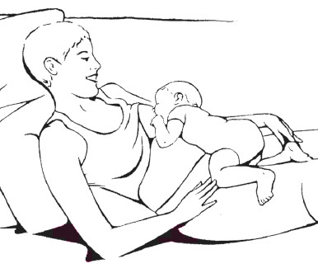 | Attachment  - Infant’s mouth wide open  - Lower lip turned outwards  - Chin touching breast  - More darker skin (areola) visible above than below the mouth  Positioning  - Infant’s body should be straight, not bent or twisted  - Infant’s body should be facing the breast  - Infant should be held close to mother  - Mother should support the infant’s whole body, not just neck and shoulders (for tummy down or reclining position: assisted by gravity, with baby’s full weight resting on mother’s body during the period the infant is learning to breastfeed; works with cesarean sections) | Note on Natural Breastfeeding  Every newborn has a series of responses designed by Mother Nature to make infant an active breastfeeding partner.  - When newborn lies tummy down on mother, anchored by gravity, the baby’s innate reflexes kick in. This position helps the baby move toward the breast, resulting in attachment and suckling.  - If infant not alert/doesn’t open mouth, hand express drops of milk and apply on infant’s lips to stimulate mouth opening  - Good attachment helps to ensure that your baby suckles well and helps you to produce a good supply of breast milk  - Good attachment helps to prevent sore and cracked nipples  See videos:  - http://breastfeedingtoday-llli.org/position-to-breastfeed/  - Breastfeeding attachment: https://globalhealthmedia.org/portfolio-items/attaching-your-baby-at-the-breast/?portfolioID=10861  Note: there is no ONE right position for all mothers. No matter the position (from cradle to tummy down), there are commonalities that assist a deep latch.  See videos:  - Breastfeeding positions: https://globalhealthmedia.org/portfolio-items/positions-for-breastfeeding/?portfolioID=10861  - Breastfeeding in the first hours after birth: https://globalhealthmedia.org/portfolio-items/breastfeeding-in-the-first-hours-after-birth/?portfolioID=10861

- Effective Suckling
Ask about and observe: | - Slow deep suckles, sometimes pausing  - Audible or visible swallowing  - Infant’s jaw will drop distinctly as he or she swallows  - Infant’s cheeks are rounded and not dimpled or indrawn  - Mother responds with satisfaction and self-confidence. | - Counsel on the same actions as above for good attachment  - If infant is not suckling, hand express drops of milk into infant’s mouth to encourage suckling  See video:  Effective suckling and breastfeeding frequency: https://globalhealthmedia.org/portfolio-items/is-your-baby-getting-enough-milk/?portfolioID=10861
- Frequency of breastfeeds
Ask how many times the infant breastfeeds in 24 hours | Breastfeeding pattern  - On demand (on cue) breastfeeding, day and night  - Infant releases one breast before switching to the other  - Infant breastfeeds 8 – 12 times in 24 hours | If < 8 breastfeeds in 24 hours  - Increase frequency of breastfeeds by alerting and stimulating infant to breastfeed  - Breastfeed as often and as long as the infant wants, day and night  - Let infant release one breast before offering the other  If > 12 breastfeeds in 24 hours  - Assess length of each breastfeed  - Assess if infant is getting milk at each feed: refer ‘Not enough breastmilk’ page #  - Check attachment and effective suckling  Note: Infants <2 months sometimes breastfeed every 2 hours because they have very small stomachs. Breastfeeding more frequently helps to establish breastfeeding/breast milk flow.

- Receives other liquids or foods
Ask if infant receives water, other liquids, semi-solids, or solids | Exclusive breastfeeding from 0 up to 6 months (no water, liquids, semi-solids or solids) | - Counsel mother on the importance of exclusive breastfeeding  - Address reason(s) for giving water, other drinks or foods including mother’s absence for work (see Breast milk expression page #)  - Counsel to increase breastfeeding frequency; and reduce other drinks and foods  - Assess the feeding realities and choices the mother is making and work with her to reduce the risk (e.g. from care and WASH practices page #)

Image | Symptoms/signs/indicators of practice | Counselling and Support Actions
- “Not enough” breastmilk
 | Real “Not enough” breastmilk production  - Infant is still passing black stools on Day-4 (after birth)  - Less than 6 “wets” or urine/ day after the first week  - Infant is not taking good deep suckles followed by a visible or audible swallow  - Infant not satisfied after breastfeeding  - Infant cries often after feeds  - Very frequent and long breastfeeds  - Infant refuses to breastfeed  - Infant has hard, dry, or green stools  - Infant has infrequent small stools  - Infant is not gaining weight: trend line on growth chart for infant less than 6 months is flat or slopes downward – weight gain less than 500 g/month | - Look for good attachment  - Look for effective suckling  - Ask about frequency of breastfeeds: 8 – 12 times in 24 hours  - Stop any supplements: infant should receive no water, other drinks or foods  - Look for illness or physical abnormality in the infant or mother  - Look for bonding or rejection  - Explain to mother that she and infant will be seen daily until infant begins gaining weight, and it may take 3-7 days for the infant to gain weight.  - Build mother’s confidence – reassure her that she can produce enough milk  - Explain what the difficulty may be – growth spurts (around 3 weeks, 6 weeks, 3 months) or cluster feeds (feeds are bunched closely together during certain times of the day)  - Explain: ‘The more an infant suckles and removes milk from the breast, the more milk the mother produces’  - Let infant come off the first breast by him/herself before mother offers the 2nd breast  - Avoid separation, and keep mother and infant skin-to-skin as much as possible  - Ensure mother gets enough to eat and drink  - If no improvement in weight gain after 7 days, refer mother and infant for supplementary suckling to in-patient care (See Supplementary Feeding Support page # )  See videos:  - Perception of ‘not enough’ breastmilk: https://globalhealthmedia.org/portfolio-items/increasing-your-milk-supply/?portfolioID=10861  - Is your baby getting enough milk: https://globalhealthmedia.org/portfolio-items/is-your-baby-getting-enough-milk/?portfolioID=10861
 | Mother thinks she has “not enough” breastmilk production but not “real”  - Mother thinks she does not have enough milk  - (Infant restless or unsatisfied)  First decide if the infant is getting enough breastmilk or not (weight, urine and stool output): see above | - Listen to mother’s concerns and why she thinks she does not have enough milk  - Check infant’s weight and urine and stool output (if poor weight gain, refer)  - Apply same counselling/actions as for real “not enough” breastmilk (above)
- Mother lacks confidence to breastfeed | Mother thinks she may be unable to breastfeed the infant | - Listen to mother’s concerns. If mother expresses concern about her diet/nutrition, refer to #19 in Counselling and Support Booklet  - Assess mother for any problem she thinks she may have; if appropriate, help mother address the issue  - Encourage her to enjoy skin-to-skin contact and to play with her infant face-to-face  - Build her confidence:  - Recognize and praise what she is doing right – including signs of milk flow  - Give relevant information in an encouraging way and correct misconceptions  - Provide mother with hands-on help to attach infant to breast and get breastfeeding established  - Help her to breastfeed near trusted companions, which helps relaxation

Image | Symptoms/signs/indicators of practice | Counselling and Support Actions
Breast condition: Breast Engorgement | - Occurs on both breasts  - Swelling  - Hard  - Tenderness  - Warmth  - Slight redness  - Pain  - Skin shiny, tight and nipple flattened and difficult to attach  - Can often occur on 3rd to 5th day after birth (when milk production increases dramatically and suckling not established) | - Look for good attachment  - Look for effective suckling  - Ask about frequency of breastfeeds: 8 – 12 times in 24 hours  - Stop any supplements: infant should receive no water, other drinks or foods  - Keep mother and infant together after birth  - Put infant skin-to-skin with mother  - Gently stroke breasts to help stimulate milk flow  - Press around areola to reduce swelling, to help infant to attach  - Offer both breasts  - Express milk to relieve pressure until infant can suckle  - Apply cold compresses to breasts to reduce swelling  - Apply warm compresses to help the milk flow before breastfeeding or expressing  Note: on the first day or two infants may only feed 2 to 3 times  See video:  - Breast engorgement: https://globalhealthmedia.org/portfolio-items/breast-engorgement/?portfolioID=10861
- Breast condition: Sore or Cracked Nipples | - Breast/nipple pain  - Cracks across top of nipple or around base  - Occasional bleeding  - May become infected | - Look for good attachment  - Look for effective suckling  - Ask about frequency of breastfeeds: 8 – 12 times in 24 hours  - Stop any supplements: infant should receive no water, other drinks or foods  - Do not stop breastfeeding  - Begin to breastfeed on the side that hurts less  - Change breastfeeding positions  - Let infant come off breast by him/herself  - Hand express to start the flow of milk before putting infant to breast  - Apply drops of breastmilk to nipples  - Do not use soap or cream on nipples  - Do not wait until the breast is full to breastfeed  - Do not use feeding bottles  - If sore is large and infected after applying these measures, refer to facility  - If mother is HIV positive she should not breastfeed from the breast with a cracked or bleeding nipple; she can express milk from damaged breast and discard until nipple heals, or heat-treat expressed breast milk  Note: If baby is known to be living with HIV, a mother with cracked nipples and mastitis still needs to heat-treat expressed breast milk to prevent re-infection.  See video:  - Nipple pain: https://globalhealthmedia.org/portfolio-items/what-to-do-about-nipple-pain/?portfolioID=10861
- Breast condition: Plugged Ducts and Mastitis | Plugged Ducts:  - Lump, tender, localized redness, feels well, no fever  Mastitis:  - Hard swelling  - Severe pain  - Redness in one area  - Generally, not feeling well  - Fever  - Sometimes, an infant refuses to feed as milk tastes more salty | - Look for good attachment  - Look for effective suckling  - Ask about frequency of breastfeeds: 8 – 12 times in 24 hours  - Stop any supplements: infant should receive no water, other drinks or foods  - Do not stop breastfeeding (if milk is not removed, risk of abscess increases; let infant feed as often as he or she wants)  - Apply warmth (water, hot towel)  - Hold infant in different positions, so that the infant’s tongue/chin is close to the site of the plugged duct/mastitis (the reddish area). The tongue/chin will massage the breast and release the milk from that part of the breast.  - Get support from the family to perform non-infant care chores  - Breastfeed on demand, and let infant finish/come off breast by him/herself  - Avoid holding the breast in scissors hold  - Avoid tight clothing  - For plugged ducts: apply gentle pressure to breast with flat of hand, rolling fingers towards nipple; then express milk or let infant feed every 2-3 hours day and night  - Rest (mother)  - Drink more liquids (mother)  - If no improvement in 24 hours, refer  - If mastitis: express if too painful to suckle; expressed breastmilk may be given to infant; If mastitis, seek treatment (mother may need antibiotics)  - If there is pus, discard by expressing and continue breastfeeding  See video:  - Breast pain: https://globalhealthmedia.org/portfolio-items/what-to-do-about-breast-pain/?portfolioID=10861
- Breast condition: Flat, inverted, large or long nipples  Inverted Nipple | Observe nipple appearance | Flat, inverted, large or long nipples are managed using the same techniques:  - Listen to the mother’s concerns  - Give extra help with attachment; make certain that as the mother is putting the infant on her breast she:  - gently touches the infant’s lips to encourage him/her to open widely and take a big mouthful of breast  - aims the infant’s lower lip well below her nipple, so that the nipple goes to the top of the infant’s mouth and the infant’s chin touches her breast (see additional information under ‘Good Attachment’ page #)  - for long nipples, place infant in a semi-sitting position to breastfeed  - Encourage mother to give the infant plenty of skin-to-skin contact near the breast, with frequent opportunities to find his or her own way of taking the breast into his/her mouth (mother should not force infant to take the breast, or force infant’s mouth open)  - Encourage mother to try different breastfeeding positions (e.g., lying down, holding infant in underarm position, or lying or leaning forward so that her breast falls towards the infant’s mouth  - Teach mother to express her milk at least 8 times a day and to feed the expressed milk to the infant with a cup (see ‘Breast Milk Expression, Cup Feeding, and storage of breastmilk’)  - Keep on trying. Most babies want to suckle, and they will find out how to open their mouths wide enough to take the nipple eventually. It may take a week or two.  - For an inverted nipple: If it is possible to get a 20 ml plastic syringe, it can be used to pull out an inverted nipple in the following way:  - Cut off the adaptor end, and put the plunger in backwards  - Put the smooth (uncut) end of the syringe over the nipple and draw out the plunger. This will stretch out the nipple  - Do this for half a minute to make the nipple stand out just before each breastfeed.  See video:  - Large breasted mothers: https://www.youtube.com/watch?v=584nv1oNxvw

Image | Symptoms/signs/indicators of practice | Counselling and Support Actions
- Oral thrush: Infant  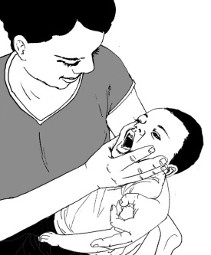 | Infant’s symptoms:  - white patches inside check or on tongue  - maybe rash on baby’s bottom  - baby repeatedly pulls off the breast or refuses to breastfeed | - Both counsellor and mother wash hands  - Teach the mother to identify and treat thrush at home:  - Show mother how to look for ulcers or white patches in the mouth of infant  - Explain to mother: it is necessary to carry out the treatment four times daily for 5 days after the thrush has cleared  - Explain to mother that the ulcers/white patches are the thrush, and teach her how to treat the thrush at home  - Give the mother an antifungal liquid (nystatin)  - Demonstrate to mother how to paint (part of the infant’s) mouth with nystatin using a soft cloth wrapped around the fingers  - Continue four times a day until five days after the thrush has cleared.  - Ask her if she has any questions, and have her show you how to paint the other part of the child’s mouth  - Ask mother to return after 2 days  Follow-up care:  After 2 days:  - Look for ulcers or white patches in the mouth. If thrush is worse, check that treatment is being given correctly  - Reassess infant’s feeding  - If infant has problems with attachment or suckling, refer to facility  See video:  - Thrush: https://globalhealthmedia.org/portfolio-items/thrush/?portfolioID=5638
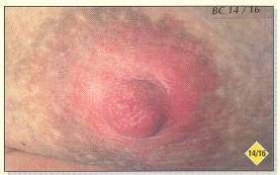  - Maternal Nipple Thrush | - Mother’s symptoms:  - sore nipples with pain continuing between feeds, pain like sharp needles going deep into the breast, which is not relieved by improved attachment  - there may be a red or flaky rash on the areola, with itching and de-pigmentation | - Examine the infant’s mouth for white spots, and the infant’s bottom for a spotty red rash. These are signs that the infant may have thrush, which is also affecting the mother’s nipples.  - Treat infant as explained above  - Treat mother: apply nystatin cream on mother’s nipples  - The mother can continue breastfeeding during the treatment; the medicine on her nipples will not harm the infant; do not use pacifiers or feeding bottles  - Discourage use of soap or ointments on the nipples. Use ordinary washing as for the rest of the body.

Image | Symptoms/signs/indicators of practice | Counselling and Support Actions
- Low Weight Infant
Cross-arm/cross-cradle  Under-arm  Kangaroo Mother Care | - Low weight for length  - Low weight for age | For ALL breastfeeding mothers with low weight infants:  - If not well attached or not suckling effectively, demonstrate and assist mother to correctly position and attach infant (specify cross-arm/cross-cradle hold), and identify signs of effective suckling  - If not able to attach well immediately, demonstrate breastmilk expression and feeding by a cup: #17, page #  - If attached but not suckling, hand-express drops of milk into infant’s mouth to stimulate suckling  - If breastfeeding less than 8 times in 24 hours, counsel to increase frequency of breastfeeding  - Counsel the mother to breastfeed as often and as long as the infant wants, day and night  - Counsel mother on establishing exclusive breastfeeding  - If infant is receiving water, other drinks or foods, counsel the mother about breastfeeding more, reducing water, other drinks or foods, and using a cup rather than a bottle if infant has been bottle-fed  - Low weight infants fatigue easily and may fall asleep after few minutes; try again after a break.  - Help mother to increase her breastmilk supply; see “Not enough” breastmilk page #  - Counsel mother to wait until the infant releases one breast before switching to the other breast  - Mother may need to spend more time feeding, perhaps at times with a cup using only expressed breastmilk  - Mother may need to share some of her other household duties with others for a month or two  - For the mother who has breastfed in the past and is interested in re-establishing breastfeeding: see Relactation #18, page #  - Show mother how to provide stimulation and play to make her infant more alert.  - Weigh each infant weekly until weight gain is established (at least 125 g/week, 500 g/month) and appetite improves.  - Give mother frequent reassurance, praise and help, to build her confidence  See video:  - Cup Feeding Your Small Baby: https://globalhealthmedia.org/portfolio-items/cup-feeding-your-small-baby/?portfolioID=13325  Kangaroo Mother Care improves breastfeeding  - Provide skin to skin contact as much as possible, day and night. For skin to skin contact, demonstrate Kangaroo Mother Care:  - Dress the infant in a warm shirt open at the front, a nappy, hat and socks.  - Place the infant in skin to skin contact on the mother's chest between her breasts. Keep the infant's head turned to one side.  - Cover the infant with mother's clothes (and an additional warm blanket in cold weather).  - When not in skin to skin contact, always keep the young infant clothed or covered. Dress the young infant with extra clothing including hat and socks, loosely wrap the young infant in a soft dry cloth and cover with a blanket.  - Keep the room warm (at least 25°C) with home heating device (if available) and make sure there is no draught of cold air  - Close windows/cover window spaces at night  - Avoid bathing the low weight infant. When washing or bathing, do it in a very warm room/at a warm time of the day with warm water, dry immediately and thoroughly after bathing and clothe the young infant immediately.  - Change clothes (e.g. nappies) whenever they are wet.  - Check frequently if the hands and feet are warm. If cold, re-warm the infant using skin to skin contact.  - Breastfeed the infant frequently (or give expressed breastmilk by cup).  - Give a hot drink to the adult providing Kangaroo Mother Care for relaxation and production of more body heat.
- Satisfactory Slow Weight Gain | - Gain in weight and length consistent and continuous although below growth chart lines  - Satisfactory slow weight gain has the following characteristics:  - Frequent feeds  - Active suckling and swallowing  - Mother experiences regular let-downs  - Pale urine: 6 or more diapers soaked daily  - Seedy or soft stools, frequency within normal ranges  - Infant is alert and active  - Appropriate developmental milestones met  - Good muscle tone and skin turgor | - Check attachment and breastfeeding positions  - Listen for deep suckles and audible swallowing  - Counsel mother to breastfeed frequently  - Encourage mother to continue to exclusively breastfeed  - Praise and reassure mother, build her confidence
- Mother expresses concerns about working or being away from her infant and her ability to breastfeed her infant | Mother is concerned about being away from her infant and her ability to feed her infant exclusively on breastmilk | - Listen to mother’s concerns  - Explain to mother: if she must be separated from her infant, she can express her breastmilk and leave it to be fed to her infant while she is absent  - Help mother to express her breastmilk and store it safely to feed the infant while she is away (see ‘Breast milk expression, cup feeding and storage of breastmilk’: #17, page #)  - Mother should allow infant to feed frequently at night and whenever she is at home.  - Mother who can keep her infant with her at the work site or go home to feed the infant should be encouraged to do so and to feed her infant frequently.  - Reassure mother that any amount of breastmilk will contribute to the infant’s health and development, even if she cannot practice exclusive breastfeeding.

Image | Symptoms/signs/indicators of practice | Counselling and Support Actions
- Breast milk expression, cup feeding and storage of breastmilk
 | If infant not able to attach immediately, demonstrate breastmilk expression, cup feeding and storage of breastmilk | Ask the mother to:  - Wash her hands thoroughly  - Make herself comfortable  - Hold a wide necked clean container under her nipple and areola  - Stimulate breast with light stroking or gentle circular motion around whole breast  - Place her thumb on top of her breast and the first 2 fingers on the underside of her breast so that they are opposite each other  - With thumb and fingers press back to chest wall, press and hold together (compress) and release  - Repeat the action: press back to chest wall, press and hold together and release. Note: this should not hurt  - Compress and release all the way around the breast, with thumb and fingers the same distance from the nipple. Be careful not to squeeze the nipple or to rub the skin or move thumb or finger on the skin  - Express one breast until the flow of milk is very slow; express the other breast  - Alternate between breasts 5 or 6 times, for at least 20 to 30 minutes  See video:  - How to express breastmilk: https://globalhealthmedia.org/portfolio-items/how-to-express-breastmilk/?portfolioID=10861
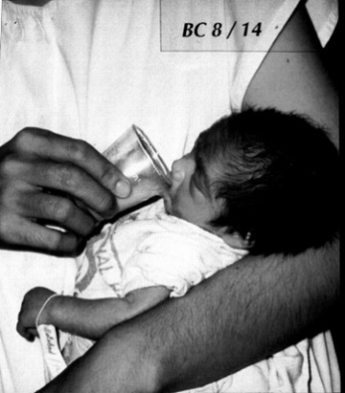 |  | Cup Feeding  Assess readiness for cup feeding: rest the cup against the infant's lips, with milk touching infant's top lip. Wait and watch for infant response. If no response, try at next feed. If no response after 2-3 trials, then refer to a facility where infant can be 'supported' to suckle.  Ask the mother or caregiver to:  - Put a cloth on the infant's front to protect his/her clothes as some milk can spill  - Hold the infant upright or semi-upright on the lap  - Put a measured amount of milk in the cup or pour only amount to be used at one feeding into the cup  - Hold the cup resting on the lower lip and tip the cup so that the milk touches the infant’s upper lip  - Wait for the infant to draw in or suckle in the milk  - Allow the infant to take the milk himself. DO NOT pour the milk into the infant's mouth  - Caregiver should pause and let infant rest after every few suckles  - Caregiver should pay attention to infant, look into infant’s eyes and be responsive to infant’s cues for feeding  - Do not reuse any milk the infant does not drink for another feeding  See video:  - Cup feeding: https://globalhealthmedia.org/portfolio-items/cup-feeding/?portfolioID=13325
Storage of breastmilk
Ask the mother to:
- Use a clean and covered glass or plastic container
- Store only enough for one feeding in each container
- Each container should be labelled with date and time
- Store breastmilk in the coolest possible place; breastmilk can be left in a room at room temperature (<26 °C, in the shade) for 6 to 8 hours.
- Store in refrigerator at back of lowest shelf for 5 days (if milk remains consistently cold)
- Store frozen for 2 weeks
- Use oldest milk first
- To warm the milk, put the container of milk in a bowl of warm water; don’t heat on the stove
- Use a cup to feed the infant expressed breastmilk
See video:
- Storing breastmilk safely: https://globalhealthmedia.org/portfolio-items/storing-breastmilk-safely/?portfolioID=10861
- Relactation
Mother/ wet nurse interested in re-establishing breastfeeding | Relactation: Mother/caregiver expresses interest in re-establishing breastfeeding after she has stopped, whether in the recent or distant past. | Note: Relactation can be started at home if there is no supplemental feeding involved.  Reassure the mother/wet nurse:  - Most women can re-establish breastfeeding. It will be easier if the mother/wet nurse has stopped breastfeeding recently and her infant still suckles occasionally, but relactation can still be accomplished, even by older and postmenopausal women who stopped breastfeeding a long time ago.  Prepare the mother/wet nurse:  - Discuss how her infant will be fed while she re-establishes her breastmilk production (expressed breastmilk or infant formula given by cup)  - To relactate, mother/wet nurse must be motivated and believe that relactation is possible  - Mother/wet nurse’s breasts must be stimulated frequently – ideally, by the infant’s suckling, and/or by hand-expressing breastmilk. Reassure her that she will receive the support that she needs from skilled helpers.  - Inform the mother/wet nurse how long it may take, and discuss the need for her to be patient and persistent  - If an infant has stopped breastfeeding, it may take 1 to 2 weeks or more before much breastmilk comes.  - It is easier for a mother/wet nurse to relactate if an infant is very young (less than 2 months) than if s/he is older. However, it is possible at any age.  - Discuss the importance of avoiding any practices that can interfere with breastfeeding:  - Periods of separation from the infant  - Feeding at fixed times, or using a pacifier or bottle (explain the need to feed on demand)  - Medicines that can reduce breastmilk production (e.g., oestrogen-containing contraception: provide a non-oestrogen method, if appropriate)  - If possible, introduce her to other women who have relactated and can encourage her  - Explain to the woman’s family and friends that she needs practical help and relief from other duties for a few weeks so that she can breastfeed often and take care of her infant: hold the infant close to her, sleep with the infant, and give skin-to-skin contact as often as possible.  - Ensure mother/wet-nurse gets enough to eat and drink  - Explain to the mother that resting can help her to breastfeed frequently  Starting relactation  Encourage the mother/wet nurse to:  - Stimulate her breasts with gentle breast massage  - Put the infant to the breast frequently, as often as s/he is willing (every 1-2 hours if possible, and at least 8-12 times every 24 hrs)  - Sleep with the infant so s/he can breastfeed at night  - Let the infant suckle on both breasts, and for as long as possible at each feed – at least 10-15 minutes on each breast  - Offer each breast more than once if the infant is willing to continue suckling  - Make sure that the infant is well attached to the breast

Image | Symptoms/signs/indicators of practice | Counselling and Support Actions
- Mother expresses concerns about her diet | - Mother thinks her diet affects her ability to produce enough good quality breastmilk  - Enrolled in Supplementary Feeding Programme (SFP) and/or similar food-related/social protection services if appropriate | - Listen to mother’s concerns about her diet and her ability to breastfeed  - Remind mother that breastmilk production is not affected by her diet:  - No one special food or diet is required to provide adequate quantity or quality of breastmilk  - No foods are forbidden  - Mother should limit alcohol and avoid smoking  - Encourage mother to eat more food to maintain her own health:  - Eat two extra small meals or ‘snacks’ each day  - Continue eating a variety of foods  - Use iodized salt  - ‘Drink to satisfy thirst’  - Consume local dietary sources of vitamin A  - Attend nutrition education (family, child; cooking demonstrations)  - In some communities, certain drinks are said to help ‘make milk’; these drinks usually have a relaxing effect on the mother and can be taken (but are not necessary)  - Link pregnant and lactating women with registration for other service such as general food distribution (GFD), SFP, targeted cash/voucher schemes, social protection schemes, etc.  - The additional rations distributed to breastfeeding women contribute to mother’s own nutrition while she continues to breastfeed
- Twin delivery | A mother can exclusively breastfeed both infants | - The more an infant suckles and removes milk from the breast, the more milk the mother produces  - Mothers of twins produce enough milk to feed both infants if the infants breastfeed frequently and are well attached  - The twins need to start breastfeeding as soon as possible after birth – if they cannot suckle immediately, help the mother to express and cup feed. Build up the milk supply from very early to ensure that breasts make enough for two infants  - Explain different positions – cross cradle, one under arm, one across, feed one by one etc. Help mother to find what suits her  Responsive Feeding and Care Practices  - Pay attention to infant(s): look at infant(s); look into infant’s eyes; respond to infant
- Adolescent mother | Extra care, more food and more rest than an older mother | - Adolescent mothers need extra care, more food and more rest than an older mother  - Adolescent mothers need to nourish their own bodies, which are still growing, as well as their growing infant’s  - Adolescent mothers need calcium. Note: as calcium is not present in the multiple micronutrient (MMN) supplement, 1g of Calcium/day should be added to the 1 tablet MMN/day (or IFA), needed to promote continuation of growth (especially pelvis bones) during pregnancy  - All pregnant and lactating adolescents (< 19 years) should receive food supplements regardless of their anthropometry for better foetal and maternal outcomes
- Mother tested positive for HIV |  | - Mother and infant should be counselled & treated according to national guidelines  - Breastfeed and take ARVs  Mother who tests negative or mother of unknown status:  - Exclusively breastfeed for up to 6 months, add complementary foods at 6 months and continue breastfeeding for 2 years and beyond with periodic re-testing (test & re-test & re-test & re-test for as long as a mother’s results are negative and she is breastfeeding)  Mother living with HIV whose infant tests HIV negative or is of unknown HIV status:  - Exclusively breastfeed from birth up to 6 months together with ART for the mother (the infant will receive ARVs regardless of feeding method); add complementary foods at 6 months and continue breastfeeding for 2 years  - Breastfeeding and ART should continue until 12 months and may continue up to 24 months or longer (similar to the general population)  Mother living with HIV whose infant is tested and also found to be living with HIV:  - Treatment for the infant should be initiated immediately  - Exclusively breastfeed for up to 6 months, add complementary foods at 6 months and continue breastfeeding for 2 years and beyond

Community and Family Support for Infant U6m-Mother Pair
Image | Counselling and Support Actions
Health Education/information and Social Support
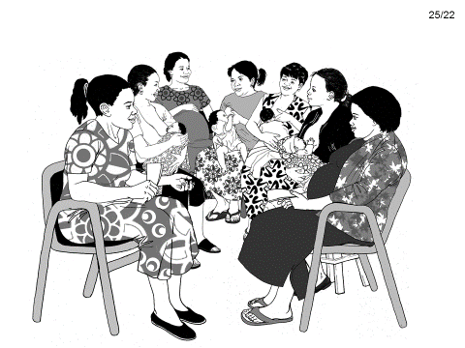 | - Health education sessions (beyond infant feeding)  - Nutrition education (family, infant, child; cooking demonstrations)  - Mother’s own health: basic information about STDs and HIV, reproductive health  - Early childhood development: including importance of play and psychosocial stimulation to child development)  - Effects of poor hygiene and pollution  - What to do when child becomes ill
Group Support (or organised support)
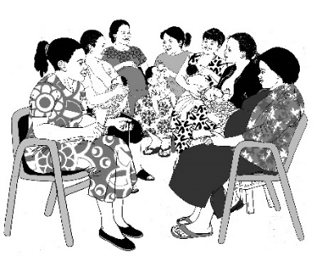  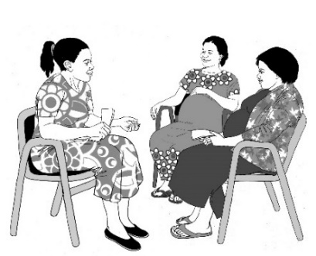 | - The group is facilitated by an experienced and trained facilitator/mother who listens and guides the discussion  - A safe environment of respect, attention, trust, sincerity, and empathy is created  - Group participants share their experiences, information and provide mutual support  - ‘Confidentiality’ is a key principle of a Support Group: “what is said in the group stays in the group”.  - The facilitator guides the discussion, but the discussion is not directed only to the facilitator, but among the participants (“cross-talk”)  - The sitting arrangement allows all participants to have eye-to-eye contact  - The group size varies from 3 to 12  - The facilitator and the participants decide the length and frequency of the meetings (number per month)
Family/Partner Support
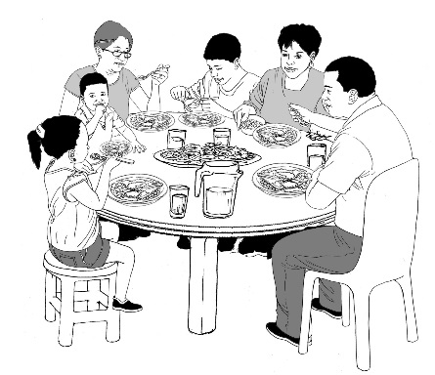  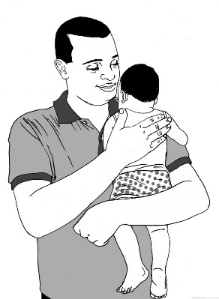 | During pregnancy:  - Accompany expectant mother to antenatal clinics (ANC)  - Remind her to take her iron/folate tablets  - Provide extra food during pregnancy and lactation  During labour and delivery:  - Make sure there is a trained birth attendant  - Make arrangements for safe transportation to facility for birth  - Encourage breastfeeding immediately after birth and skin-to-skin contact  After birth:  - Help with non-infant household chores, and caring for other children  - Make sure the infant exclusively breastfeeds for the first 6 months  - Support the mother so that she has time to breastfeed  - Pay attention to infant: look at infant; look into infant’s eyes; respond to infant’s responses; asks: what is infant thinking?  - Pay attention to/observe the signs/cues of hunger and learn to respond to the infant/young child: smile, go to infant, talk to infant to encourage infant to communicate his/her wishes, show infant that you/mother are preparing to feed  - Discuss child spacing with wife/partner  - Accompany wife/partner to the health facility when infant/child is sick, for infant/child's Growth Monitoring Promotion (GMP) and immunisations  - Provide bed-nets for family in endemic malaria areas  An adolescent pregnant woman/lactating mother: needs extra care, more food and more rest than an older mother. The adolescent pregnant woman/lactating mother needs to nourish her own body, which is still growing, as well as her growing infant’s.
Community Support
Mothers of acutely malnourished infants can receive support from the following community institutions/programmes:
  - Trained Birth Attendants: at every contact with a pregnant woman in the community, and at delivery
  - During postpartum and/or family planning sessions in the community
  - At immunisation sessions (immunisation during health days in the community)
  - During well baby community sessions (Community Growth Monitoring Promotion – GMP)
  - At every contact with mothers or caregivers of a sick infant/child
- Therapeutic feeding centres (TFCs)
- Supplementary feeding programmes (SFPs)
- Agriculture: food diversification, food security, women’s farmers clubs
  - Micro-Credits
  - Community Nutrition
  - Sanitation
  - During general ration distribution (GRD) or general food distribution (GFD)
  - Churches/mosques; government offices
  - Schools

Supplementary Suckling Support: Information for the Community Worker to help explain to the mother of of an acutely malnourished/nutritionally vulnerable infant with medical complications/failure to respond to outpatient care, the process she may experience when admitted to a facility for inpatient treatment. Supplementary suckling is not implemented in community settings.

Image | Symptoms/signs/indicators of practice | Counselling and Support Actions
4.1 Supplementary Suckling to help mother relactate (inpatient care only, this is not a C-MAMI intervention)
A breastfeeding supplementer consists of a tube which leads from a cup of supplement (expressed breastmilk or formula) to the breast, and which goes along the nipple and into the infant’s mouth. | - Avoids using feeding bottles or pacifiers  - For infants who are not willing to suckle at the breast, mother uses the supplementary suckling technique  - Whenever the infant wants to suckle, he or she does so from the breast | While encouraging the infant to resume breastfeeding, ask the mother to:  - Go to the health facility for supervision of practice.  - Explain that the infant suckles and stimulates the breast at the same time drawing the supplement (expressed breastmilk or formula) through the tube and is thereby nourished and satisfied. A fine nasogastric tube (gauge 8) or other fine plastic tubing should be used.  - The mother can express her breastmilk into the infant’s mouth, touching the infant’s lips to simulate the rooting reflex and encourage the infant to open his or her mouth wider.  - Mother controls the flow by raising or lowering the cup so that the infant suckles for about 30 minutes at each feed.  - If the tube is wide, a knot can be tied in it, or it can be pinched.  - The cup and tube should be cleaned and sterilized each time mother uses them.  - Encourage the mother to let the infant suckle on the breast at any time that he or she is willing – not just when she is giving the supplement.

Non-breastfeeding Counselling and Support Actions
Image | Symptoms/signs/indicators of practice | Counselling and Support Actions
- Mother absent
 | - Designated carer for infant  - Wet nurse identified OR  - Established supply of appropriate BMS where wet nurse is not available | Establish the reasons for an absent mother:  - Temporary (at work, minding other children, minor illness)  - Permanent (seriously ill, maternal death)  - Identify and support a wet nurse: this is especially a priority for young infants (e.g. <2 months of age)  - Relactation: #18, page # support if necessary  - Where a wet nurse is not available, provide the necessary supports for using an appropriate breastmilk substitute (see below)
- Use infant formula as breastmilk substitute (BMS)
 | - Availability:  - sustained source and required amount of infant formula  - cooking and feeding equipment  - staff to help mother  - Access to adequate water, sanitation and hygiene | Refer to Infant Feeding in Emergencies (IFE) Module 2, Chapter 9: When infants are not breastfed (see Key Additional Material, p3).
- Preparing infant formula
 | - Clean hands and utensils  - Boiling water used to clean utensils  - Cooled, boiled water to prepare infant formula  - Follows instructions on formula tin  - Feeds infant by cup*  - Safe storage of formula  - No mixed feeding (water, other fluids, foods)  - No under or over dilution of formula  - If ready to use infant formula (liquid, requires no dilution) is used, practice good hygiene, safe storage and follow instructions. | Ask the mother or caregiver to:  - Wash hands with soap and water before preparing formula and feeding infant.  - Wash the utensils with clean water and soap, and then boil them to kill the remaining germs.  - Discuss cost/availability with mother of infant formula: an infant needs about 40 tins of 500g in formula for the first 6 months**  - Always read and follow the instructions that are printed on the tin very carefully. Ask for more explanation if she does not understand.  - Use clean water to mix with the infant formula. If possible, prepare the water that is needed for the whole day. Bring the water to a rolling boil for at least 2 minutes and then pour into a flask or clean covered container specially reserved for boiled water.  - Keep or carry boiled water and infant formula powder separately to mix for the next feeds, if the mother is working away from home and infant accompanies her, or for night feeds.  - Use only a clean cup to feed the infant. Even a newborn infant learns quickly how to drink from a cup. Avoid using bottles, teats or spouted cups as they are much more difficult to clean.  - Store the formula tin in a safe clean place.  - Only prepare enough infant formula for one feed at a time and use the formula within one hour of preparation.  - Refer to health facility if infant has diarrhoea or other illness or mother has difficulty obtaining sufficient formula.
- Cup-feeding
Ask about and observe: | Mother/caregiver feeds infant with cup, and does not use bottles, teats, or spouted cups* | Assess readiness for cup feeding: rest the cup against the infant's lips, with milk touching infant's top lip. Wait and watch for infant response. If no response, try at next feed. If no response after 2-3 trials, then refer to a facility where infant can be 'supported' to suckle.  Ask the mother or caregiver to:  - Put a cloth on the infant's front to protect his clothes as some milk can spill.  - Hold the infant upright or semi-upright on the lap.  - Put a measured amount of milk in the cup.  - Hold the cup resting on the lower lip and tip the cup so that the milk touches the infant’s upper lip.  - Wait for the infant to draw in or suck in the milk.  - Allow the infant to take the milk himself. DO NOT pour the milk into the infant's mouth.  - Caregiver should pause and let infant rest after every few sucks.  - Caregiver should pay attention to infant, look into infant’s eyes and be responsive to infant’s cues for feeding.  - Do not reuse any milk the infant does not drink for another feeding.
*Note: If bottle feeding is practised, provide specific advice and support on hygiene and feeding practice. See Infant Feeding in Emergencies (IFE) Module 2, Chapter 9, When infants are not breastfed (see Key Additional Material, p3). www.ennonline.net//ifemodule2
**Note: Amount of milk calculated - 150ml/kg body weight/day

Credits for Images
The images come from the following:
- WHO/UNICEF Infant and Young Child Feeding Counselling: an Integrated Course (The source for redrawn B&W images is work submitted for the revision to the ‘Integrated Course’).
- Laid-Back Breastfeeding or Biological Nurturing: La Leche League International.
- The ‘breast problem’ images and ‘cup-feeding’ image came originally from the WHO/UNICEF Breastfeeding Counselling: a Training Course, but were used also in the ‘Integrated Course’ and in the UNICEF Community IYCF Counselling Package.
- The ‘grey-scale’ images (more African in appearance) come from the UNICEF Community IYCF Counselling Package.
- Oral thrush image: Infant and Young Child Feeding: a Community-Focused Approach. CARE & URC/CHS. 2007.
- Supplementary suckling image: Infant and young child feeding: model chapter for textbooks for medical students and allied health professionals. World Health Organization, 2009.

Handout 4.14 Outpatient Care: Admission Process for At-Risk Mothers and Infants Under 6 Months

Admission Process for At-Risk Mothers and Infants Under 6 months of Age Who Are Nutritionally Vulnerable Without Complications Referred to or Presented at the Health Facility with Outpatient Care
(Outpatient Care Follow-On Sessions: Steps 1–18 [except 5] are repeated)

- Triage the infant to check for general danger signs or signs of general disease
- Bilateral pitting oedema checked for the infant and mother
- Anthropometry checked:
- MUAC of infant and mother measured
- Weight of the infant measured
- Weight-for-age (WFA) of infant verified
- Length of infant measured; weight-for-length (WFL) verified*

- Infant’s weight history is taken to check for weight loss or failure to gain weight and period of weight faltering
- Infant’s birth history including weight at birth is taken
- Infant’s feeding history and current feeding status is assessed according to the C-MAMI Tool version 2.0
- Mother and infant’s clinical assessment is conducted according to the C-MAMI Tool version 2.0
- Mother assessed for depression, anxiety, and distress
- Information is recorded
- DECISION On whether MOTHER-INFANT PAIR IS ADMITTED FOR MANAGEMENT (In outpatient care follow-on sessions: progress of nutritional status monitored)
- Registration number provided
- Medical assessment: history taken and physical examination conducted, all recorded on outpatient care treatment card
- Decision ON WHETHER MOTHER-INFANT Pair IS admitted to outpatient care or referred to inpatient care (based on admission criteria) (In outpatient care follow-on sessions: decision on whether mother-infant pair continues treatment in outpatient care, is referred to inpatient care or tertiary care [based on outpatient care action protocol], needs a follow-up home visit, or is ready for discharge [based on discharge criteria])
Mother-Infant Pair Managed in Outpatient Care | Mother-Infant Pair Referred to Inpatient Care
- Counselling and support provided (In outpatient care follow-on sessions: progress is monitored and support provided to the mother on breastfeeding, non-breastfeeding, maternal nutrition, family and community support) | 17. Initial management according to the national IMCI, neonatal or post-natal protocols  18. Referral slip provided (Arrange transportation where possible)
- Explanation of outpatient care schedule and when to return for outpatient care follow-on sessions, and linkage with outreach worker (e.g., CHW, volunteer) given
- Links provided with other services, programmes, and initiatives that provide IYCF support (e.g., growth monitoring, mother support groups, mental health services, other)
* Note: The chart may be adjusted to remove length measurement and weight-for-height (WFH) information.

Handout 4.15 Outpatient Care Treatment Card for At-Risk Mothers and Infant Under 6 Months
Admission Details: Community-Based Management of At-Risk Mothers and Infants under 6 Months (C-MAMI)
Name (first, last/family)
Age (completed months) |  |  |  |  |  |  | Sex | M |  |  | F | Date of birth (DOB) |  |  |  |  |  |  | Date of admission
Administrative unit |  |  |  |  |  |  |  |  |  |  |  |  |  |  |  |  |  | Time to travel to site
Community |  |  |  |  |  |  |  |  |  |  |  |  |  |  |  |  |  | Father alive |  |  |  |  | Yes |  |  |  | No | Mother alive |  |  |  |  |  |  |  |  | Yes |  |  |  | No
House details/landmarks |  |  |  |  |  |  |  |  |  |  |  |  |  |  |  |  |  | Father’s Age |  |  |  |  |  |  |  |  |  | Mother’s age
Caregiver (first, last/family) |  |  |  |  |  |  |  |  |  |  |  |  |  |  |  |  |  | Total number in household
Contact phone #1 |  |  |  |  |  |  |  |  |  |  |  |  |  |  |  |  |  | Contact phone #2
Admission (circle) |  |  |  | Self-referral |  |  | Outreach referral |  |  |  | Inpatient care referral |  |  | Inpatient care refusal |  |  |  | Health facility referral |  |  |  |  | Readmission/  relapse |  |  |  |  | Yes |  |  |  | No |  |  |  |  | If yes, when?
Twin/multiple births |  |  |  | Yes |  |  | No | Infant’s birth weight (kg) |  |  |  |  |  |  |  |  |  | Premature |  |  | Y | N | Orphan/  mother absent |  |  |  |  | Yes |  |  | No |  | Mother sick |  |  |  |  |  |  | Yes |  | No
Additional information
Admission Anthropometry (Infant)
Weight (kg) |  |  |  |  |  | Length(cm) |  |  |  |  |  |  | Weight-for-length (WFL) z-score |  |  |  |  |  |  |  | Weight-for-age (WFA)  z-score |  |  |  |  |  |  |  |  | MUAC (mm)
Bilateral pitting oedema |  |  |  |  | 0 + ++ +++
Admission Anthropometry (Mother)
Bilateral pitting oedema |  |  |  | 0 + ++ +++ |  |  |  |  |  |  |  |  | MUAC (mm) |  |  |  |  |  |  |  |  |  |  |  |  | Height (cm)
Medical History (Infant)
IMCI Danger Signs  Signs | Unable to drink/breastfeed |  |  | Yes |  |  | No |  |  |  |  |  | Symptoms |  |  | Respiration rate (#min) |  |  |  |  |  |  |  |  | <30 |  |  |  | 30 – 39 |  |  |  |  |  | 40 - 49 |  |  |  | 50+
IMCI Danger Signs  Signs | Vomits everything |  |  | Yes |  |  | No |  |  |  |  |  |  |  |  | Chest in-drawing |  |  |  |  |  |  |  |  |  |  |  | Yes |  |  |  |  |  |  |  |  | No
IMCI Danger Signs  Signs | Any convulsions |  |  | Yes |  |  | No |  |  |  |  |  |  |  |  | Cough |  |  |  |  |  |  |  |  |  |  |  | Yes |  |  |  |  |  |  |  |  | No
IMCI Danger Signs  Signs | Lethargic/  unconscious |  |  | Yes |  |  | No |  |  |  |  |  |  |  |  | Abnormally loose/watery stools in infant > 1 mo. (Diarrhoea) |  |  |  |  |  |  |  |  |  |  |  | Yes |  |  |  |  |  |  |  |  | No
IMCI Danger Signs  Signs |  |  |  |  |  |  |  |  |  |  |  |  |  |  |  | Stools/day |  |  |  |  |  |  |  |  |  |  |  | <3 |  |  |  |  |  | 3-5 |  |  |  | >5
 |  |  |  |  |  |  |  |  |  |  |  |  |  |  |  | Temperature (⁰C)
Physical Examination (Infant)
Eyes |  |  |  | Normal |  |  | Sunken | Discharge |  |  |  |  |  |  |  |  |  |  |  |  |  |  | Conjunctiva |  |  |  |  | Normal |  |  |  |  |  |  |  |  | Pale
Ears |  |  |  | Normal |  |  | Discharge |  |  |  |  |  |  |  |  |  |  | Dehydration |  |  |  |  | None |  |  |  |  | Moderate |  |  |  |  |  |  |  |  | Severe
Lymph nodes |  |  |  | None |  |  | Neck | Axilla |  |  |  |  | Groin |  |  |  |  | Mouth |  |  |  |  | Normal |  |  |  |  | Sores |  |  |  |  |  |  |  |  | Candida
Skin problems |  |  |  | None |  |  | Scabies | Peeling |  |  |  |  | Ulcers/abscesses |  |  |  |  |  |  |  |  |  | Disability |  |  |  |  | Yes |  |  |  |  |  |  |  |  | No
Feeding Assessment
Breastfeeding |  |  |  | Yes |  |  | No | Non-breastfeeding |  |  |  |  | Yes |  |  | No |  | Receiving appropriate breast milk substitute (BMS) |  |  |  |  |  |  |  |  |  | Yes |  |  |  |  |  |  |  |  | No
Any plain water, other liquids or foods |  |  |  | Yes |  |  | No | If yes, describe: |  |  |  |  |  |  |  |  |  |  |  |  |  |  | Passing urine |  |  |  |  | Yes |  |  |  |  |  |  |  |  | No
Breastfeeding frequency (total times/24 hours) |  |  |  |  |  |  |  | If not breastfeeding, how long since you stopped?
 |  |  |  |  |  |  |  | If not breastfeeding, why did you stop?
Recommendations for Management (Circle)
Infant/  Mother |  | Orange |  | Breastfeeding counselling |  |  |  |  | Refer to C-MAMI counselling and support actions: Good attachment; effective suckling; frequency of breastfeeds; receives other liquids/foods; "not enough" breast milk; mother lacks confidence; breast conditions; thrush: infant, maternal nipple thrush; low-weight infant, keeping low-weight infant warm and kangaroo mother care (KMC); satisfactory slow weight gain; concerns about being away from infant; breast milk expression; cup feeding and storage of breast milk; re-lactation; other breastfeeding-related concerns: maternal diet concerns, twin delivery, adolescent mother, HIV-infected or exposed  Mother, family, and community counselling: Informal support, group support, family support, partner support, community support
 |  |  |  | Non-breastfeeding support |  |  |  |  | Non-breastfeeding support: Mother absent, use of appropriate BMS (e.g., infant formula), preparing infant formula, cup feeding  Mother, family, and community Counselling: Informal support, group support, family support, partner support, community support
INFANT in ORANGE: NUTRITIONALLY VULNERABLE WITHOUT MEDICAL COMPLICATIONS

WFA <-2 z score OR WFL < -2 z-score [MUAC: record measure to help build evidence] OR any of the following: Moderate weight loss (within a few days), recent (days, weeks) failure to gain weight, moderate drop across the infant’s growth line, moderate feeding problem with possible underlying causes (see below) AND clinically well and alert OR referred from inpatient care

BREASTFED INFANT: Not well attached to the breast OR not suckling effectively OR less than 8 breastfeeds in 24 hours OR receives other foods or drinks

NON-BREASTFED INFANT: Inappropriate BMS being used OR consuming less than 500 ml of BMS per 24 hrs OR refusing feedings OR receives other foods or drinks in addition to BMS OR mother absent

MOTHER in ORANGE: MODERATE RISK MUAC 190 to <230 mm (record actual measure to help build evidence) AND lack of social support
INFANT in PINK: NUTRITIONALLY VULNERABLE WITH MEDICAL COMPLICATIONS – refer for management in the inpatient care

MOTHER in PINK: HIGH RISK – refer for management in the inpatient care

Follow-Up: C-MAMI
Name |  |  |  |  |  |  |  |  |  |  | Date of Birth |  |  |  |  | Reg. N°
Visit (weeks) |  | Adm (0) | 1 |  | 2 | 3 | 4 |  | 5 |  |  | 6 | 7 |  | 8 |  | 9 |  | 10 | 11 | 12
Date
Anthropometry: Infant
Bilateral pitting oedema
MUAC (mm)
Weight (kg) |  |  |  |  |  | * |  |  |  |  |  | *
Weight gain? (Y/N) |  |  |  |  |  | * |  |  |  |  |  | *
WFA (z-score)
Length (cm)
WFL (z-score)
*WEIGHT CHANGES: If below admission weight on week 3, refer for home visit; if no weight gain by week 6 refer to inpatient care
Anthropometry: Mother
Bilateral pitting oedema
MUAC (mm)
Physical Examination: Infant
Temperature (C°)
Respiratory rate (#/min)
Dehydrated (Y/N)
Anaemia (Y/N)
Episode of sickness (Y/N)
Monitoring Feeding
Breastfeeding (Y/N)
Well attached? (Y/N)
Suckling effectively (Y/N)
At least 8 breastfeeds in 24 hrs. (Y/N)
Consume any of the following: water, other liquids or foods (Y/N)
Clinically well and alert (Y/N)
Mother is confident with infant condition & breastfeeding (Y/N)
If non-breastfed: receives appropriate breast milk substitutes (Y/N)
Counselling and Support
Breastfeeding counselling
Non-breastfeeding support
Mother, family, and community counselling
Name of examiner
Visit outcome
Codes for the visit outcome: OK=continue; A=absent; D=defaulted for 3 visits; R=referral; RR=refused referral; C=cured; NR=non-recovered;
HV=home visit; X=died
Before discharged cured, check to make sure the breastfed or non-breastfed infant meets the following criteria:
Breastfed infant:  - Breastfeeding=Yes  - Consumes any water, other liquids or foods=No  - Clinically well and alert=Yes  - Mother confident with infant condition and breastfeeding=Yes |  |  |  |  |  |  |  | Non-breastfed infant:  - Breastfeeding=No  - Receives appropriate quantity of breast milk substitutes=Yes  - Consumes any water, other liquids or foods=No  - Clinically well and alert=Yes  - Mother confident with infant condition and feeding=Yes
Follow-Up Actions
Date | Actions agreed upon during follow-up visits |  |  |  |  |  |  |  |  | Date |  |  | Actions agreed upon during follow-up visits
Name of outreach worker
C-MAMI Tool, v.2.0 (2018). https://www.ennonline.net/c-mami

Handout 4.16 Outpatient Care Action Protocol for Infants Under 6 Months and Children 6–59 Months

Sign | Referral to Inpatient Care | Follow-Up Home Visit
BILATERAL PITTING OEDEMA | Infants under 6 months: Grade +, ++, and +++  Children 6–59 months: Grade +++ | Child 6–59 months, bilateral pitting oedema not reducing by week 3
BILATERAL PITTING OEDEMA | Marasmic kwashiorkor
BILATERAL PITTING OEDEMA | Increase in, or development of, bilateral pitting oedema
APPETITE /  ANOREXIA | Infants under 6 months: For breastfed infants: refusing or unable to breastfeed, no suckling. For non-breastfed infants: refusing or unable to feed.  Children 6–59 months: No appetite or unable to eat, fail RUTF appetite test. | Child 6-59 months eats < 75% of the RUTF a week by  third session (6–59 months only)
VOMITING | Intractable | General medical deterioration
TEMPERATURE | Fever: > 39C | General medical deterioration
TEMPERATURE | Hypothermia: < 35 C | General medical deterioration
RESPIRATION RATE (rr) | ≥ 60 respirations/minute for under 2 months | General medical deterioration
RESPIRATION RATE (rr) | ≥ 50 respirations/minute from 2 to 12 months | General medical deterioration
RESPIRATION RATE (rr) | ≥ 40 respirations/minute from 1 year to 5 years | General medical deterioration
RESPIRATION RATE (rr) | ≥ 30 respirations/minute for over 5 years | General medical deterioration
RESPIRATION RATE (rr) | Any chest in-drawing | General medical deterioration
ANAEMIA | Very pale (severe palmer pallor), difficulty breathing | General medical deterioration
SUPERFICIAL  INFECTION | Extensive infection requiring intermuscular treatment | General medical deterioration
ALERTNESS | Very weak, apathetic, unconscious | General medical deterioration
ALERTNESS | Fitting/convulsions | General medical deterioration
HYDRATION  STATUS | Severe dehydration based primarily on recent history of diarrhoea, vomiting, fever or sweating and on recent appearance of clinical signs of dehydration as reported by the mother/caregiver | General medical deterioration
WEIGHT CHANGES |  | Below admission weight on week 3
WEIGHT CHANGES | Weight loss for 3 consecutive weighings | Weight loss for 2 consecutive weeks
WEIGHT CHANGES | Static weight for 5 consecutive weighings | Static weight for 3 consecutive weeks
GENERAL | Mother/caregiver requests inpatient care | Returned from inpatient care (first 2  weeks)
GENERAL | Mother/caregiver requests inpatient care | Refused referral to inpatient care
NOT RECOVERING | Child that is not recovering is referred to hospital for investigation.

Handout 4.17 Referral to Inpatient Care or Follow-Up Home Visits for Infants Under 6 Months and Children 6–59 Months

A. Referral to Inpatient Care

Referral system
- Close collaboration between inpatient and outpatient care is essential. Health care providers in inpatient facilities should receive an orientation on outpatient care treatment and visit the site and vice versa.
- Infants under 6 months and children 6–59 months who are referred to inpatient care are sent to the nearest inpatient care site linked to the referring outpatient care site.
- The mother/caregiver receives appropriate explanations and instructions on what to expect and what to do. If possible, arrangements should be made or facilitated for the mother/caregiver and beneficiary to travel to the health facility and stay for a certain time.
- If an infant under 6 months of age is referred to inpatient care, appropriate information should be given to the mother on supplementary suckling support and the process she will experience when admitted to inpatient care. Counselling and support information is provided in Handout 4.13 C-MAMI Tool Version 2.0: Breastfeeding Counselling and Support Actions.
- Mothers/caregivers might refuse to go to inpatient care for a number of reasons: fear that they will have to pay at the hospital, lack of transport, unwillingness to be separated from the family and other children, or a belief that the child might die on the way to or in the hospital. Instead, they choose to stay home. Where possible, these issues should be considered and a careful explanation given to the mother/caregiver. The mothers/caregivers will often need some time to tell the family that they must go to the hospital and to collect things they need. If after careful explanation the mother/caregiver still refuses to go to inpatient care, the child can stay in outpatient care and should receive follow-up home visits according to the outpatient care action protocol (refused referral to inpatient care).

Referral slip
- If infants or children are being referred to inpatient care from outpatient care, the mother/caregiver is given a referral slip with the unique registration number, medical history and information on treatment the infant or child has received. The purpose of the referral slip is to keep track of the infants and children between outpatient care and inpatient care. The referral slip should also include information on what medications were given and why to avoid giving children medicine that they have already been given.
- Using the infant’s or child’s unique registration number on referral slips helps ensure smooth referrals among services. When inpatient care sites use an already existing system for registration numbers, efforts should be made to use the unique CMAM registration number in addition.
- It is important to have effective tracking and reporting systems so that children do not get lost and defaulters and deaths do not go unreported.

Referral to tertiary care
- An infant or child might need to be sent from outpatient care to a higher-level referral centre for underlying medical complications. If the child 6–59 months has appetite, the child might be sent to the hospital with a supply of ready-to-use therapeutic food (RUTF) or an arrangement might be made to make sure the hospital has RUTF for children who are referred. Otherwise, F75 and instructions should be made available for inpatient care (in case the hospital does not have specific inpatient care for SAM). For infants under 6 months, breastfeeding support should continue during referral for tertiary care.

B. Follow-Up Home Visits
- The health care provider in collaboration with the outreach worker (e.g., community health worker [CHW], volunteer) should arrange for infants and children who are at risk based on the outpatient care action protocol to be followed up at home through an outreach visit.
- The follow-up home visit is used to assess what might be hindering the infant’s or child’s recovery and to support the family to help the infant or child recover through counselling, education and close monitoring of the infant or child’s progress.
- Follow-up home visits can be made by a health care provider or outreach worker.
- There must be communication channels in place between the health care provider and the outreach worker to ensure that infants and children receive necessary follow-up. Ideally, outreach workers will be present on an outpatient care day so they will know who needs follow-up. But having a communication system can help ensure that those who could not attend the outpatient care day are told which infants and children need follow-up and who is responsible for making the follow-up home visit.

Handout 4.18 Referral Slip for Infants Under 6 Months and Children 6–59 Months

Name of child |  |  |  |  | Community
Age |  |  |  |  | Sex
Date of admission
ADMISSION DATA |  |  |  |  | Site
Weight |  |  | MUAC |  | Referral to
Height |  |  | WFH/WFL |  | Registration No
Bilateral pitting oedema (circle) NONE + ++ +++
INFANTS UNDER 6 MONTHS OF AGE
Is infant exclusively breastfeeding? (circle) Y N
If not breastfeeding, is infant feeding well and exclusively on replacement feed? (circle) Y N
Date of referral
Criteria for referral

Treatment given

Comments

Handout 4.19 Outpatient Care Discharge Criteria for At-risk Mothers and Infants Under 6 Months and Children 6–59 Months

When Are Infants Under 6 Months of Age Discharged from Outpatient Care?
- An infant under 6 months of age can be discharged from outpatient care when effectively exclusively breastfeeding—or, for the non-breastfed infant, receiving exclusive, safe, and appropriate breast milk substitute—consistently gaining weight (the growth curve is going up), is clinically well and alert, and the mother is confident with feeding, care, and condition of the infant.
The decision to discharge the infant from management is based on the mother and infant’s clinical condition, feeding capability, and general well-being, and on the infant’s weight gain. As long as the infant is gaining adequate weight and growing progressively along the child growth line, the infant does not need to reach the absolute WFL ≥ -2 z-score and WFA ≥ -2 z-score at discharge.
The decision rules for discharge differ based on breastfed and non-breastfed infant as follows:
- The breastfed infant must spend a minimum of 2 months in management before being discharged. After 2 months, if the infant is effectively breastfeeding (good attachment, effective suckling, frequent breastfeeds, and not consuming water or other liquids and foods), has adequate weight gain, is clinically well and alert, and if the mother is confident with infant’s feeding, care, and condition and is linked with community-based support, the mother and infant may be discharged from outpatient care.
- The non-breastfed infant must spend a minimum of 2 months in management before being discharged. After 2 months, if the infant is feeding well on exclusive, safe, and appropriate breast milk substitutes, has adequate weight gain, is clinically well and alert, and the mother or caregiver is confident with infant’s feeding, care, and condition, has access to appropriate breast milk substitutes at home, and is linked with community-based support, the mother and infant may be discharged from outpatient care.

When Are Children 6–59 Months Discharged from Outpatient Care?
A child is discharged from outpatient care when s/he has recovered from bilateral pitting oedema or a low weight, and thus no longer has severe acute malnutrition (SAM).
The same anthropometric indicator that is used to identify and confirm SAM on admission should be used to determine recovery and discharge from treatment. Below are the decision rules for discharge from treatment:
- Children who were admitted for bilateral pitting oedema must have no bilateral pitting oedema for more than two consecutive outpatient care follow-on sessions before being discharged. If this condition is met, and the child is clinically well and alert, the child may be discharged from CMAM services after being checked to ensure that his/her mid-upper arm circumference (MUAC) ≥ 115 mm or weight-for-height (WFH)/ weight-for-length (WFL) ≥ -2 z-score.
- Children who were admitted based on a low MUAC must achieve a MUAC ≥ 125 mm for more than two consecutive outpatient care follow-on sessions. Once this condition is met, the child may be discharged if he or she has consistently gained weight, is clinically well and alert, and has been checked to ensure that s/he does not have bilateral pitting oedema.
- Children who were admitted based on a low WFH/WFL must achieve WFH/WFL ≥ -2 z-score for more than two consecutive outpatient care follow-on sessions. Once this condition is met, the child may be discharged if he or she has consistently gained weight, is clinically well and alert, and has been checked to ensure that s/he does not have bilateral pitting oedema.
- Children who were admitted with marasmic kwashiorkor (bilateral pitting oedema and severe wasting) must have no bilateral pitting oedema and no severe wasting for more than two consecutive outpatient care follow-on sessions, must have consistently gained weight, and must be clinically well and alert before being discharged. If they were admitted using MUAC, they must achieve a MUAC ≥ 125 mm for more than two consecutive outpatient care follow-on sessions. If they were admitted using WFH/WFL, they must achieve WFH/WFL ≥ -2 z-score for more than two consecutive outpatient care follow-on sessions.

Handout 4.20 Discharge Criteria and Exit Categories for CMAM

A. Discharge Criteria for At-Risk Mothers and Infants Under 6 Months of Age
It is important that the mother and infant’s clinical condition, feeding capability and general well-being, and the infant’s weight gain are used as the primary criteria to determine discharge from management. As long as the infant is gaining adequate weight and growing progressively along the child growth line, the infant does not need to reach the absolute WFL ≥ -2 z-score and WFA ≥ -2 z-score at discharge.
INPATIENT CARE  for the management of nutritionally vulnerable infants with medical complications  (HIGH NUTRITIONAL RISK) | OUTPATIENT CARE  for the management of nutritionally vulnerable infants without medical complications  (MODERATE NUTRITIONAL RISK)
*DISCHARGE CRITERIA FOR INFANTS UNDER 6 MONTHS
REFERRED TO OUTPATIENT CARE:  For Breastfed Infant:  Medical complications resolved  AND Bilateral pitting oedema resolved  AND Breastfeeding well, that is:  - Good attachment  - Effective suckling  - Frequency of more than 8 times in 24 hours  - Infant not given water, other liquids, or foods  AND  - Gaining weight on exclusive breastfeeding  - Mother is confident about the infant’s condition, feeding, and outpatient care management  AND  - Clinically well and alert  - Infant has been checked for immunization and other routine interventions  For Non-Breastfed Infant:  Medical complications resolved  AND Bilateral pitting oedema resolved  AND Feeding well on breast milk substitute  AND  - Gaining weight on the breast milk substitute  - Mother is confident about infant’s condition, feeding, and outpatient care management  - Mother has access to adequate amount of an appropriate breast milk substitute at home  AND Mother or caregiver is linked with needed community-based follow-up and support  AND  - Clinically well and alert  - Infant has been checked for immunization and other routine interventions | DISCHARGED CURED: Minimum of 2 months of management and meets feeding, clinical, weight gain, and support criteria below:  For Breastfed Infant:  - Good attachment  - Effective suckling  - Frequent breastfeeds: more than 8 times in 24 hours  - Infant not consuming water, other liquids, and foods  AND Adequate weight gain  AND Mother is confident about the infant’s condition, feeding and management at home  AND Mother or caregiver is linked with the needed community-based follow-up and support  AND  - Clinically well and alert  - Infant has been checked for immunization and other routine interventions  For Non-Breastfed infant:  Feeding well on breast milk substitute  AND Adequate weight gain  AND  - Mother or caregiver is confident about the infant’s condition, feeding and management at home  - Mother has access to an appropriate breast milk substitute at home  AND Mother or caregiver is linked with needed community-based follow-up and support  AND  - Clinically well and alert  - Infant has been checked for immunization and other routine interventions  NOTE: An infant may reach 6 months of age while in management of at-risk mothers and infants under 6 months of age (MAMI). MUAC or WFL should be re-measured at 6 months; if those measurements met the SAM or MAM criteria for children 6–59 months, the infant should be referred for appropriate management.
DISCHARGE CRITERIA FOR LACTATING MOTHERS OF INFANTS UNDER 6 MONTHS OF AGE
MUAC: ≥190 mm  AND Severe anaemia managed (i.e., does not require blood transfusion, and mother is on iron supplementation)  AND No bilateral pitting oedema  AND Severe depression managed, and mother is in stable condition | MUAC: ≥230 mm  AND Linked with the needed support

B. Discharge Criteria for Children 6–59 Months and Pregnant Women

*Note on the discharge criteria for children 6–59 months:
The same anthropometric indicator that is used to identify and confirm SAM on admission should be used to determine recovery and discharge from treatment. However, if a child is admitted based only bilateral pitting oedema, discharge and recovery should be based on whichever anthropometric indicator MUAC or WFH/WFL routinely used. The child should also have no bilateral pitting oedema for at least two consecutive sessions.

Children discharged from treatment of SAM should be followed up periodically to avoid relapse.

**Note on the discharge criteria for pregnant mothers:
MUAC: Countries may have different cutoffs based on context and national guidelines.

INPATIENT CARE  for the Management of SAM with Medical Complications | OUTPATIENT CARE  for the Management of SAM without Medical Complications | Management of Moderate Acute Malnutrition (MAM) (e.g., Supplementary Feeding)
*DISCHARGE CRITERIA FOR CHILDREN 6–59 MONTHS
REFERRED TO OUTPATIENT CARE:  Appetite returned (passed appetite test)  AND Medical complication resolving  AND Bilateral pitting oedema decreasing  AND Clinically well and alert  (If marasmic kwashiorkor admission: bilateral pitting oedema resolved) | DISCHARGED CURED:  If bilateral pitting oedema admission:  No bilateral pitting oedema for 2 consecutive sessions  AND MUAC ≥ 125 mm or WFH/WFL ≥ -2 z-score  AND Child clinically well and alert  If MUAC admission: MUAC ≥ 125 mm  AND No bilateral pitting oedema  AND Child clinically well and alert  If WFH/WFL admission: ≥ -2 z-score  AND No bilateral pitting oedema  AND Child clinically well and alert  If marasmic kwashiorkor admission:  No bilateral pitting oedema for 2 consecutive sessions  AND If MUAC admission: MUAC ≥ 125 mm for 2 consecutive sessions  AND If WFH/WFL admission: WFH/WFL ≥ -2 z-score for 2 consecutive sessions  AND Child clinically well and alert | DISCHARGED CURED:  If MUAC admission: MUAC ≥ 125 mm  If WFH/WFL admission:  WFH/WFL ≥ -2 z-score for 2 consecutive sessions
**DISCHARGE CRITERIA FOR PREGNANT WOMEN
 |  | MUAC ≥ 230 mm

C. Exit Categories for CMAM
INPATIENT CARE | OUTPATIENT CARE | Management of Moderate Acute Malnutrition (MAM) (e.g., Supplementary Feeding)
EXIT CATEGORY: CURED
Infant under 6 months, child 6–59 months or other (child ≥ 5 years, adolescent or adult) meets outpatient care discharge criteria | Infant under 6 months, child 6–59 months or other (child ≥ 5 years, adolescent or adult) meets discharge criteria | Child 6–59 months or other (child ≥ 5 years, adolescent or adult) meets discharge criteria
EXIT CATEGORY: DIED
Infant under 6 months, child 6–59 months or other (child ≥ 5 years, adolescent or adult) dies while in inpatient care | Infant under 6 months, child 6–59 months or other (child ≥ 5 years, adolescent or adult) dies while in outpatient care | Child 6–59 months or other (child ≥ 5 years, adolescent or adult) dies while in supplementary feeding
EXIT CATEGORY: DEFAULTED
Infant under 6 months, child 6–59 months or other (child ≥ 5 years, adolescent or adult) is absent for 2 days | Infant under 6 months, child 6–59 months or other (child ≥ 5 years, adolescent or adult) is absent for 3 consecutive sessions (e.g., 3 weeks) | Child 6–59 months or other (child ≥ 5 years, adolescent or adult) is absent for 3 consecutive sessions (e.g., 6 weeks)
EXIT CATEGORY: NON-RECOVERED
Infant under 6 months, child 6–59 months or other (child ≥ 5 years, adolescent or adult) does not reach discharge criteria after 4 months in treatment (medical investigation previously done) | Infant under 6 months, child 6–59 months or other (child ≥ 5 years, adolescent or adult) does not reach discharge criteria after 4 months in treatment (medical investigation previously done) | Child 6–59 months or other (child ≥ 5 years, adolescent or adult) does not reach discharge criteria after 4 months in treatment (medical investigation previously done)
EXIT CATEGORY: REFERRED TO OUTPATIENT OR INPATIENT CARE
Referred to Outpatient Care: Health condition of infant under 6 months, child 6–59 months or other (child ≥ 5 years, adolescent or adult) is improving and is referred to outpatient care to continue treatment | Referred to Inpatient Care: Health condition of infant under 6 months, child 6–59 months or other (child ≥ 5 years, adolescent or adult) is deteriorating and meets inpatient care admission criteria (action protocol) | Referred to Outpatient or Inpatient Care: Health condition of child 6–59 months or other (child ≥ 5 years, adolescent or adult) has deteriorated and meets outpatient or inpatient care admission criteria (action protocol)

Handout 4.21 Essentials of Outpatient Care for SAM Without Medical Complications

Essentials
- Children with severe acute malnutrition (SAM) who have an appetite and no medical complications are treated on an outpatient basis at a health facility that offers outpatient care for SAM without medical complications. These children do not have to be admitted to inpatient care at a hospital or health facility with beds. The majority of children with SAM (> 80%) can be treated on an outpatient basis.
- After the child is admitted to outpatient care, the mother/caregiver brings him/her to the health facility or outpatient care site every week or two weeks. At each of these outpatient care follow-on sessions, the health care provider assesses the child’s medical condition and nutritional status, provides additional medical treatment if necessary and gives the mother/caregiver the quantity of ready-to-use therapeutic food (RUTF) needed until the child’s next outpatient care follow-on session. The amount of RUTF given is determined by the child’s weight and frequency of sessions.
- Outpatient care is offered in as many health facilities or treatment points as possible in a given area or district. This ensures that as many infants and children as possible can access treatment.
- Outpatient care sites are run by health care providers such as a doctor or nurse (depending on the Ministry of Health’s [MOH’s] policy).
- Outpatient care should be incorporated into the routine health service for children under 5 years old. Depending on the size of the caseload, outpatient care might be offered once a week on a designated day or every day as part of the routine health service (ideally), with patients returning weekly or biweekly.
- Infants and children can be referred to CMAM services by outreach workers (e.g., community health workers [CHWs], community volunteers. They can also be self-referrals, meaning they are brought to the health facility or outpatient care without community referral. Other outpatient care admissions will include children discharged from inpatient care and those who have deteriorated in programmes to treat moderate acute malnutrition (MAM).
- Most of the children will first access CMAM services at the outpatient care site and will be examined and referred to inpatient care or MAM programmes as needed. Thus, the outpatient care sites are an access point for the majority of SAM cases.
- Infants and children are admitted to CMAM at any time if they present at the health facility. They should be treated when they present and asked to return on the designated outpatient care day, if applicable.
- Community outreach is an essential part of a community-based programme. This ensures that the community understands the services. Outreach workers (e.g., CHWs, volunteers) are used to find and refer children to CMAM services, which increases understanding and coverage. As much as possible, mothers/caregivers and family members should be trained to screen their infants and children using MUAC and bilateral pitting oedema.

Handout 4.22 Outpatient Care Field Practice Checklist

ANTHROPOMETRY
Assess for bilateral pitting oedema
Measure mid-upper arm circumference (MUAC), weight, height/length
Classify nutritional status
Record nutrition indicators on outpatient care treatment cards and on ready-to-use therapeutic food (RUTF) ration card
Assess the mother-infant (under 6 months) pair for nutritional vulnerability
Record mother-infant pair information on the C-MAMI outpatient care treatment card
NEW ADMISSIONS
Obtain registration details from mother/caregiver and record anthropometric measurement
Take medical history
Conduct physical examination
Test appetite and determine breastfeeding status for children 6 to 23 months
Decide if eligible for outpatient care or needs referral to inpatient care
Calculate doses and give routine medicines to child
Explain medical treatment to mother/caregiver
Calculate amount of RUTF for child and record and give the ration
Fill out RUTF ration card
Discuss key messages with mothers/caregivers
Ask mother/caregiver to repeat instructions on how to give medicine and RUTF
Link with outreach worker
outpatient care follow-on sessions
Take medical history
Conduct physical examination
Test appetite and determine breastfeeding status of children 6 to 23 months
Review information on outpatient care treatment card to date and interpret progress (Are they improving? Are they not improving? Why?)
Continue medical treatment as appropriate
Use action protocol to assess need for follow-up home visit and arrange if necessary
Use action protocol to assess need for referral and arrange if necessary
Discuss infant’s or child’s progress with mother/caregiver
Calculate amount of RUTF for child and record and provide the ration
Fill out RUTF ration card
Provide health and nutrition counselling
Inform mother/caregiver about linking with other services, programmes, and initiatives (e.g., expanded programme of immunisation [EPI], HIV testing and counselling, reproductive health)
MANAGEMENT OF AT-RISK MOTHERS AND INFANTS UNDER 6 MONTHS
Provide breastfeeding counselling and support
Recommend counselling and support actions for the mother and the community
DISCHARGES
Identify infants and children ready for discharge
Fill in the outpatient care treatment card upon discharge
Provide appropriate information to mother/caregiver about child’s discharge (e.g., when to bring the child back, danger signs)
Provide discharge ration of RUTF for children 6–59 months
Inform mother/caregiver about linking with other services, programmes, and initiatives, if appropriate (e.g., supplementary feeding programme [SFP])
ACCEPTING REFERRALS FROM INPATIENT CARE
Review referral slip from inpatient care and record relevant information on outpatient care treatment card (including medicines)
Review information and medications provided in inpatient care, confirm with mother/caregiver medicines received to date, and adjust outpatient care medicines for admission
Follow admission protocols (i.e., do anthropometry, take medical history, do physical examination, check breastfeeding status for children 6 to 23 months, test appetite, calculate RUTF ration, discuss key messages, fill out RUTF ration card, link with outreach worker)
DISCUSSION WITH MOTHERS/CAREGIVERS AT SITES
Where have you come from?
How long did it take to get here?
How did you hear about the service?
Why did you bring your child?

EXERCISES

Exercise 4.1 Outpatient Care Admission for Infants Under 6 Months and Children 6–59 Months

 | Age  (m) | Appetite | Bilateral pitting oedema | MUAC in mm | WFH/  WFL z-score | Other information | Admitted to outpatient care?
Child 1 | 7 | Yes | No | 102 | -3 ≤ to <-2
Child 2 | 24 | Yes | No | 117 | <-3
Child 3 | 20 | Yes | No | 108 | <-3
Child 4 | 16 | Yes | ++ | 117 | -3 ≤ to <-2
Child 5 | 36 | Yes | + | 118 | -3 ≤ to <-2
Child 6 | 12 | No | No | 95 | <-3
Child 7 | 50 | Yes | No | 112 | <-3
Child 8 | 45 | Yes | No | 116 | <-3
Child 9 | 7 | Yes | No | 107 | -3 ≤ to <-2
Child 10 | 5 | No, infant is refusing to breastfeed | No | 104 | -3 ≤ to <-2 | Recent failure to gain weight
Note: In countries where presence of bilateral pitting oedema and mid-upper arm circumference (MUAC) are used for admission, adjust chart to remove information on weight-for-height (WFH)/ weight-for-length (WFL) z-score.
Exercise 4.2 Outpatient Care Treatment Card and RUTF Ration Card for Children 6–59 Months

Below is all of the information needed to complete the front and back of an outpatient care treatment card and a ready-to-use therapeutic food (RUTF) ration card.

A child requiring admission to outpatient care

First section of admission details
- The next registration number available is 015. The outpatient care site code is GRG.
- The child’s name is Mohammed Ahmed.
- He lives in Lusaka District; his community is Bombali.
- Mohammed is 17 months old.
- He has come directly from his community after a community volunteer referred him to CMAM services.
- He lives in a house with his mother, father, grandfather and five brothers and sisters.
- It took 20 minutes for his mother to walk with him from their house to the outpatient care site.
- There is no general food distribution where he lives.

Admission anthropometry
- He weighs 7.9 kg.
- His height is 76 cm.
- His mid-upper arm circumference (MUAC) is 111 mm.
- He has no bilateral pitting oedema.
What are his admission criteria?

Medical history
- His mother says he has had diarrhoea for the past week and passes four to five loose stools every day.
- He does not vomit.
- He passes urine with no problem.
- He occasionally has a cough.
- His appetite is generally good.
- He no longer breastfeeds.
- She reports no other problems but says he has been getting thinner for some time.

Physical examination
- He has 38 respirations per minute, and there are no chest retractions.
- His temperature is 36.9° C.
- His conjunctiva is pink.
- His eyes are wet and have no discharge.
- Although his skin is saggy, he shows no apparent signs of dehydration.
- He has a discharge from his left ear.
- His mouth is clear, and there are no enlarged lymph glands.
- He has no apparent disabilities.
- His skin looks good.
- His hands and feet are warm.

Routine admission medication
His mother has his expanded programme of immunisation (EPI) card.
RUTF appetite test
By the time Mohammed is seen, he has already eaten half a packet of RUTF.

Exercise 4.3 Identifying Infants Under 6 Months and Children 6-59 Months Who May Need Referral to Inpatient Care or Follow-Up Home Visits

Child A
Child A is 2 years old, has a mid-upper arm circumference (MUAC) of 111 mm and has been referred by the community health worker (CHW) to CMAM services. On admission, the child refuses to eat the ready-to-use therapeutic food (RUTF) during the appetite test. You ask his mother to move to a quiet area and try again. After a half-hour, the child still refuses to eat the RUTF. During the medical assessment, you discover that the child has had vomiting for two days. What action is needed?

Child B
Child B is presented at the outpatient care site with bilateral pitting oedema + and a MUAC of 117 mm. The child has good appetite and no other signs of medical complications. What action is needed?

Child C
Child C was admitted to outpatient care with a MUAC of 109 mm and weight of 10 kg. The child did not gain any weight in the first three weeks, and by the fourth week has actually lost weight; the child now weighs 9.5 kg. What action is needed?

Child D
Child D is presented at the outpatient care site with bilateral pitting oedema ++ and a MUAC of 110 mm. What action is needed?

Child E
Childe E is a three-month-old girl. Her mother was ill with the flu and stopped breastfeeding one weeks ago. The infant is being fed tea and cow’s milk, appears not to be gaining weight, and is clinically well. What action is needed?

Child F
Child F is presented at the outpatient care site with bilateral pitting oedema +++. You want to refer the child to the hospital. Despite your best efforts to persuade the mother, her family refuses to let her take the child to the hospital. What action is needed?

Child G
Child G is above 6 months and was admitted with a MUAC of 109 mm and a weight of 5 kg. The child gained a little weight the first week but has not gained weight for the past two weeks. His medical assessment does not show any signs of illness or medical complications.

Child H
Infant H is a 2-week-old boy whose mother is breastfeeding. The infant has now regained his birth weight. The mother thinks she is not producing enough milk for him and wants to give him some diluted cow’s milk. What action is needed?

Exercise 4.4 Partially Completed Outpatient Care Treatment Cards (examples)

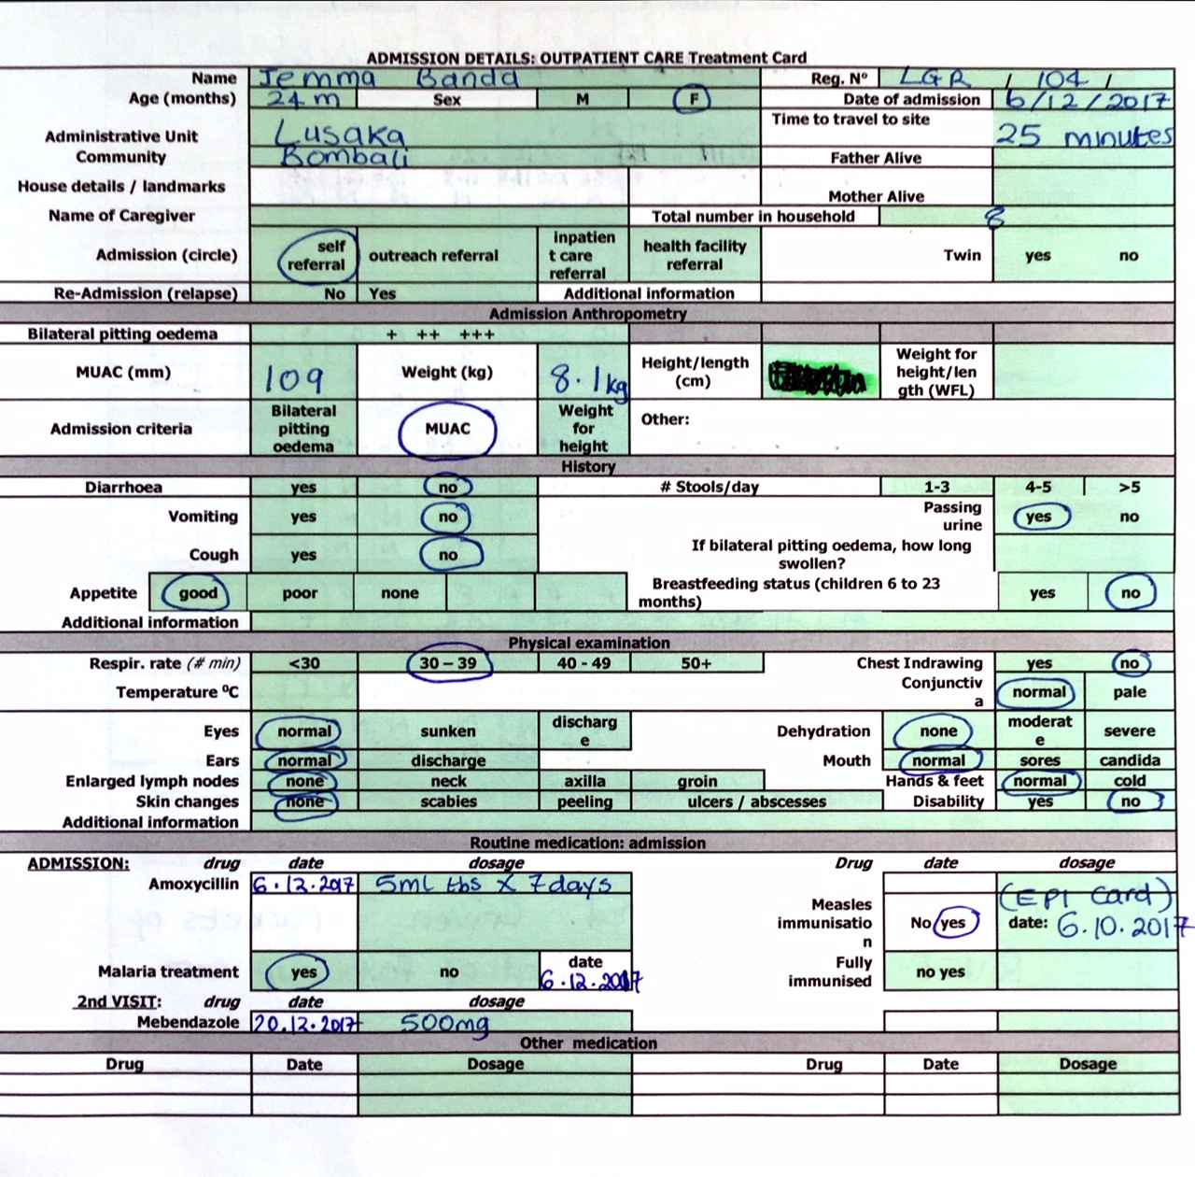
Example 1. Jemma Banda

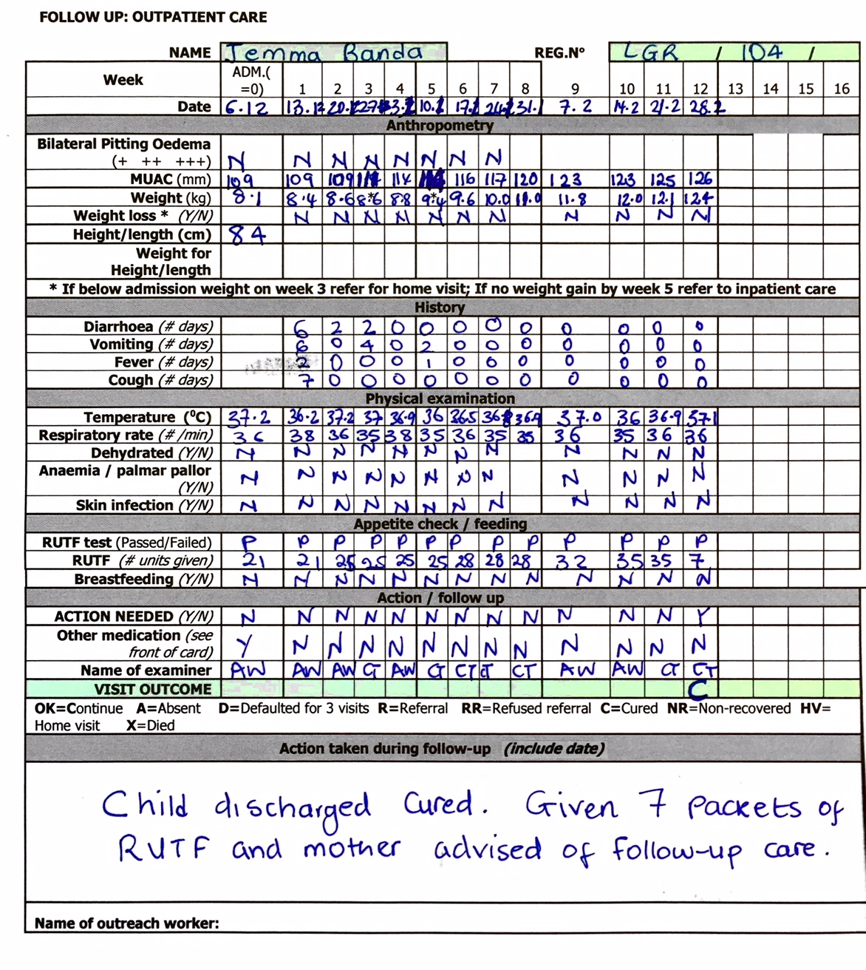

Example 2. Adam Ali
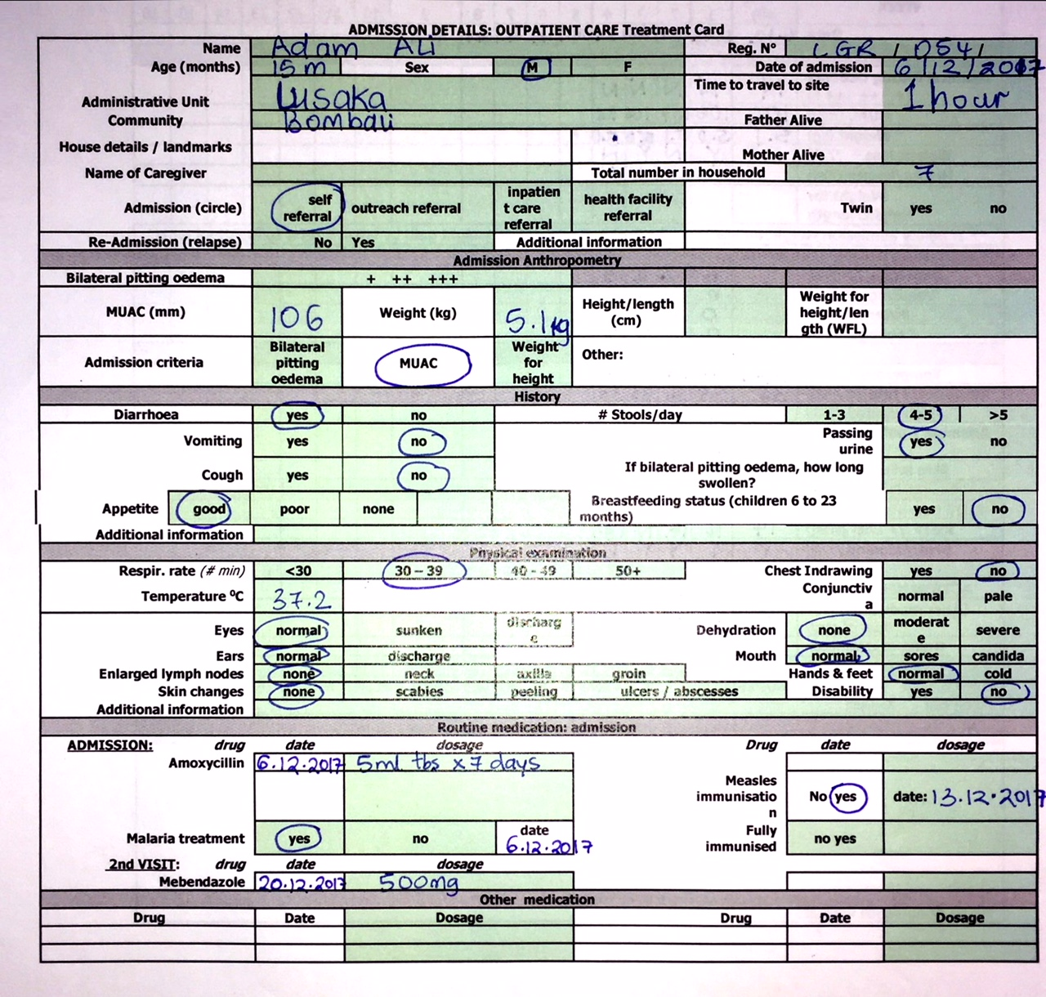

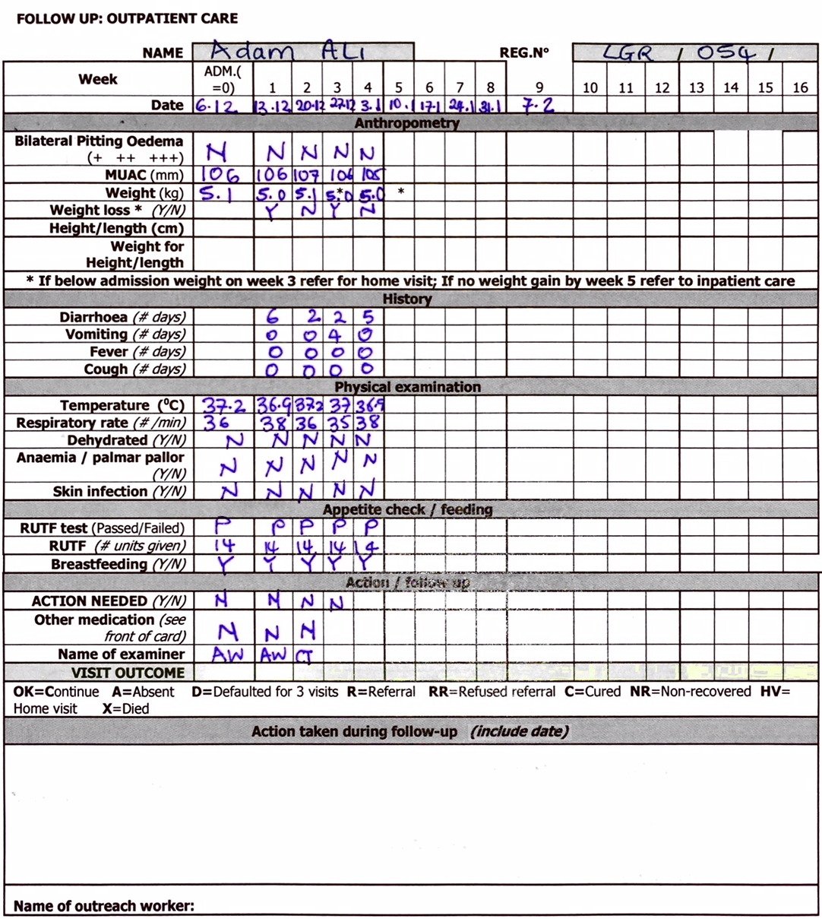

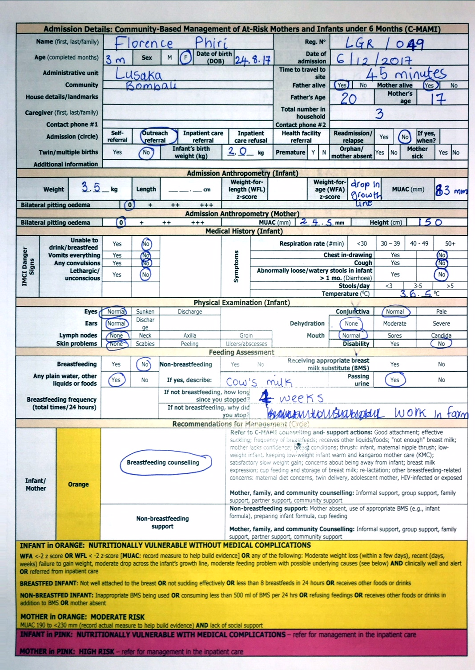

Example 3. Florence Phiri
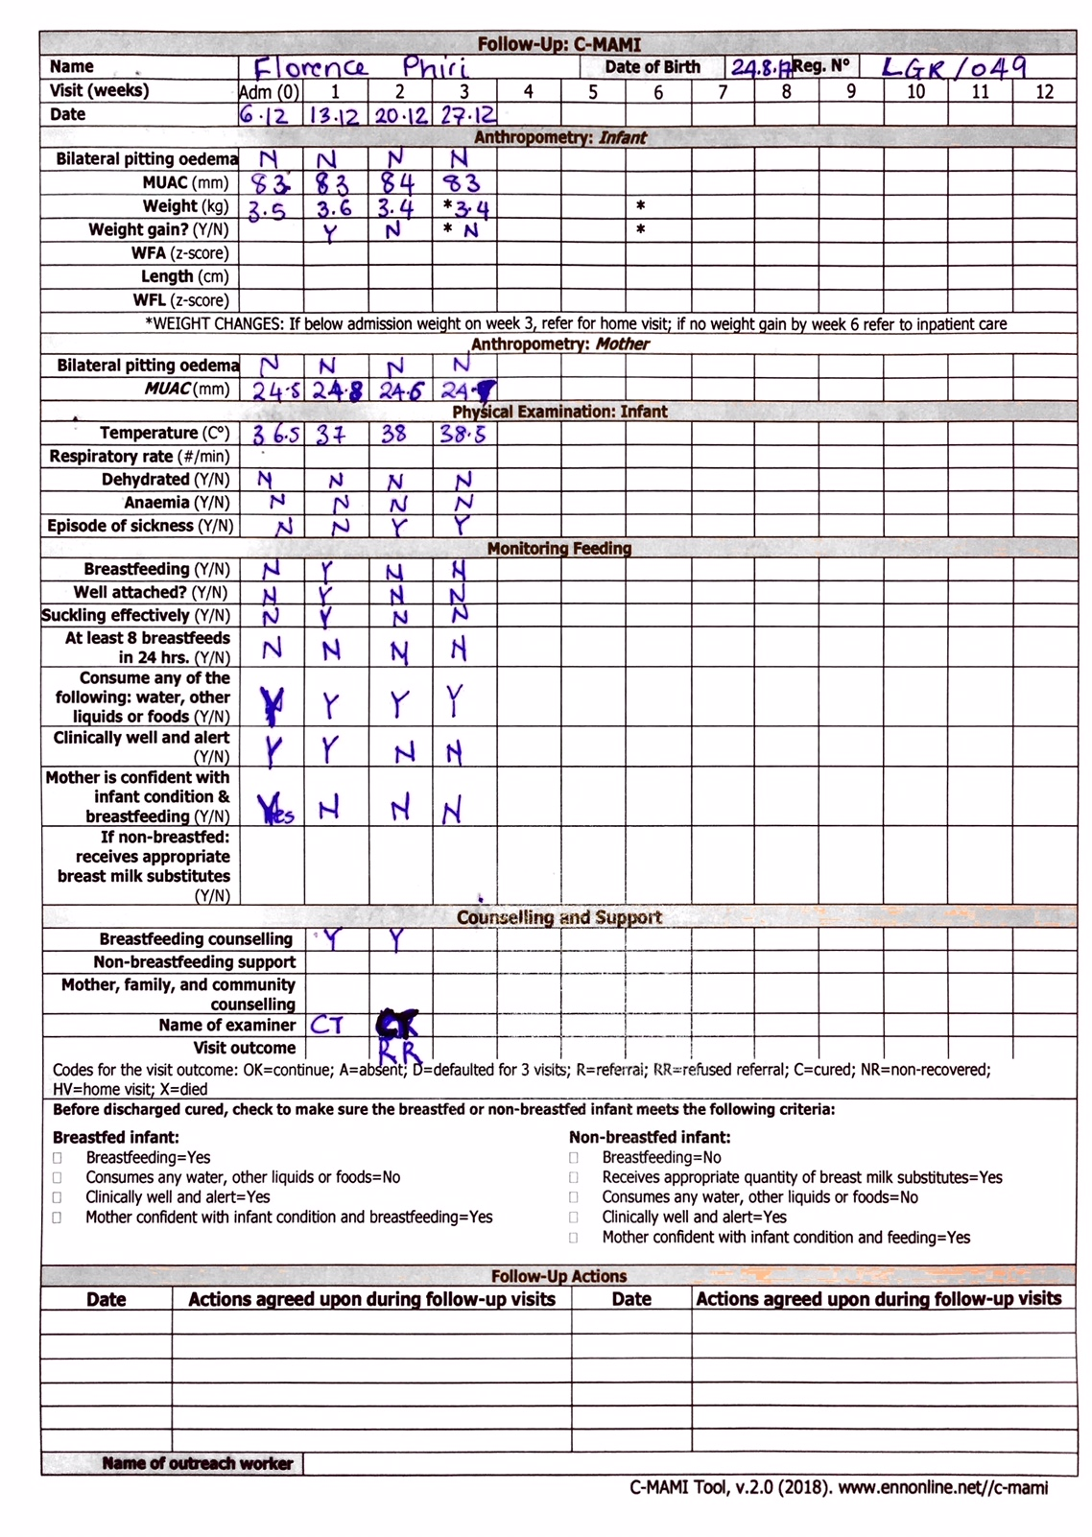

MODULE FIVE: Inpatient Care for the Management of SAM with Medical Complications in the Context of CMAM

Module Overview
This module provides an orientation of inpatient care for the management of severe acute malnutrition (SAM) with medical complications and notes the issues that should be considered. The module briefly outlines who should be admitted to inpatient care and why. It also covers admission and discharge processes and criteria as well as the basic principles of medical treatment and nutrition rehabilitation. Emphasis is placed on ensuring a smooth referral process between outpatient care and inpatient care, in both directions.
This module is NOT a guide to setting up or managing inpatient care. For this type of guidance, a separate seven-day World Health Organisation (WHO) training course has been designed for health care managers and health care providers who will be managing children with SAM with medical complications in inpatient care. However, participants in the training of this module will partake in a half-day site visit to an inpatient care site to give them a better understanding of CMAM, the comprehensive treatment of SAM, and the referral process between the inpatient and outpatient components.
This module is intended to be used alongside the WHO guidelines for the management of severe malnutrition (1999), the WHO update on the management of SAM in infants and children (2013), and national guidelines and treatment protocols.
Inpatient care is provided in a hospital or health facility with 24-hour care for children with SAM without appetite or with medical complications until their medical condition is stabilised and the complication is resolving. Treatment then continues in outpatient care until the child recovers sufficient weight. For certain cases, inpatient care sites can provide care for the management of SAM until the child is fully recovered.
Learning Objectives | Duration | Handouts and Exercises
1. Outline the Management of Children with SAM with Medical Complications in Inpatient Care | 15 minutes | Handout 5.1 Essentials of the Management of SAM With Medical Complications in Inpatient Care
2. Describe Admission and Discharge for the Management of SAM With Medical Complications in Inpatient Care | 30 minutes | Handout 5.2 Admission Procedures in Inpatient Care  Handout 5.3 Admission Criteria and Entry Categories for CMAM  Handout 5.4 Discharge Procedures in Inpatient Care  Handout 5.5 Discharge Criteria and Exit Categories for At-Risk Mothers and Infants Under 6 Months and Children 6–59 Months
3. Review Medical and Dietary Treatment in Inpatient Care | 30 minutes | Handout 5.6 Medical and Dietary Treatment of SAM With Medical Complications
4. Practice the Referral Process Between Inpatient Care and Outpatient Care | 30 minutes | Handout 5.5 Discharge Criteria and Exit Categories for At-Risk Mothers and Infants Under 6 Months and Children 6–59 Months  Handout 5.7 Practical Implications in Discharges From Inpatient Care  Exercise 5.1 Referral from Inpatient to Outpatient Care
Field Visit to Inpatient Care Site | ½ day | Handout 5.1 Essentials for the Management of SAM With Medical Complications in Inpatient Care  Handout 5.8 Inpatient Care Field Visit Checklist  Local Inpatient Care Treatment Card
Wrap-Up and Module Evaluation | 15 minutes

Duration: Two hours of classroom time followed by a half-day site visit
Note: Depending on the needs of their audience(s), trainers may choose to skip or spend more or less time on certain learning objectives and activities. The module duration is an estimate of the time it takes to complete all the learning objectives and activities.

Reference Resources
- World Health Organisation (WHO). 2002. Training Course on the Management of Severe Malnutrition. Geneva: WHO. (Note: Update expected to be published in 2018)
- WHO. 2013. Guideline: Updates on the Management of Severe Acute Malnutrition in Infants and Children. Available at: http://www.who.int/nutrition/publications/guidelines/updates_management_SAM_infantandchildren/en/
- WHO. 2013. Pocket Book of Hospital Care for Children: Guidelines for Management of Common Childhood Illnesses. 2nd Edition. Available at: http://www.who.int/maternal_child_adolescent/documents/child_hospital_care/en/.
- WHO. 2003. Guidelines for the Inpatient Treatment of Severely Malnourished Children. Geneva: WHO. Available at: http://www.who.int/nutrition/publications/severemalnutrition/9241546093/en/.
- WHO. 1999. Management of Severe Malnutrition: A Manual for Physicians and Other Senior Health Workers. Geneva: WHO. Available at: www.who.int/nut/publications.

Further Reading Resources
- National guidelines for CMAM
- National guidelines for integrated management of childhood illness (IMCI)
- Emergency Nutrition Network, International Baby Food Action Network, Terre des Hommes, United Nations High Commissioner for Refugees, UNICEF, World Food Programme, WHO. 2004. “The Young Severely Malnourished Infant” (chapter 8) in Infant Feeding in Emergencies, Module 2, Version 1.0 for Health and Nutrition Workers in Emergency Situations. Available at: http://www.unhcr.org/45f6cc4e2.pdf
- Woodruff, B. and Duffield, A. 2000. Adolescents: Assessment of Nutritional Status in Emergency Affected Populations. United Nations Administrative Committee on Coordination Sub-Committee on Nutrition (ACC/SCN). Available at: https://www.unscn.org/web/archives_resources/files/adolescentrnissup.pdf

Handout 5.1 Essentials for the Management of Infants and Children with Medical Complications in Inpatient Care

General
- Infants and children with medical complications face a high risk of mortality. They require 24-hour inpatient care until their condition stabilises, over a period usually spanning four to seven days.
- Inpatient care is the component of CMAM services that provides medical and dietary treatment for children 6–59 months with SAM with medical complications or no appetite. Once stabilised, the children continue treatment in outpatient care until they recover.
- Inpatient care is also needed for at-risk mothers and infants under 6 months of age who are nutritionally vulnerable with medical complications (i.e., high nutritional risk). Once stabilised, the infants should continue treatment in outpatient care until they recover.
- Inpatient care is provided in a hospital or health facility that offers 24-hour care by trained health care providers.
- Inpatient treatment for SAM with medical complications follows the initial steps listed in the World Health Organisation (WHO) treatment protocol and the 2013 WHO updates on management of SAM in infants and children.
- In certain cases, inpatient care sites can provide care for the management of SAM until weight recovery.
- Medical complications for children age 6-59 months with SAM include: anorexia or no appetite, intractable vomiting, convulsions, lethargy or not alert, unconsciousness, lower respiratory tract infections (LRTIs), high fever (> 39° C), dehydration, persistent diarrhoea, severe anaemia, hypoglycaemia, hypothermia (< 35° C), eye signs of vitamin A deficiency and skin lesions. Other conditions that require inpatient care include children with SAM in outpatient care who are losing weight or have static weight, following the outpatient care action protocol.
- Medical complications for nutritionally vulnerable at-risk mothers and infants under 6 months are the same as those stated above (no. 7) for children age 6–59 months. Additional complications that will also require inpatient care include:
  - Cleft lip or palate
  - Abnormal tone or posture
  - Excessively open or clenched jaw
  - Unable to support head or control trunk
  - When held, infant’s arms and legs fall to the sides
  - Infant’s body still, hard to move
  - Not willing or able to suckle at the breast or feed by cup or bottle
  - Coughing and eye tearing (signs of unsafe swallowing) while feeding
- The inpatient care component of CMAM is relatively small because most children 6–59 months are treated as outpatients. Generally, fewer than 20 percent of children 6–59 months with SAM have medical complications that require inpatient care. This will vary according to location and context and how frequently children are screened for acute malnutrition in the community.

- Inpatient care should be provided within existing health facilities with 24-hour care capacity wherever possible, using Ministry of Health (MOH) staff. Inpatient care for children with SAM often already exists in the paediatric units of hospitals and sometimes at clinics or nutrition rehabilitation units (NRUs). Hospitals should have health care providers on duty who have been trained in the WHO treatment protocols, including the management of SAM with medical complications.

- Treatment in inpatient care is provided according to national protocols and/or the WHO guidelines. Decisions about adapting medical treatment and nutrition rehabilitation protocols to account for outpatient care and about the location of sites must be made jointly with the MOH and should take into account existing capacity (e.g., staff, space, beds, supplies, storage).

- The number of admissions to inpatient care depends on the context:
- During an emergency, there will likely be a high influx to inpatient care at first, but this will decrease quickly as infants and children are stabilised and moved to outpatient care. A sudden population migration or an outbreak of diarrhoeal disease, acute respiratory infections (ARIs) or measles could also sharply increase the caseload.
- The inpatient care caseload will probably fluctuate according to the season. During peak hunger seasons, the caseload might increase significantly. This usually follows a pattern, therefore it is possible to plan for such periodic increases.
In contexts with high HIV and/or TB prevalence, the inpatient caseload might be high because of increased incidence of medical complications associated with HIV or TB.
- Medical officers and other health care providers at inpatient care sites should visit outpatient care sites and vice versa. This will help ensure a smooth referral process between the two components.

- Treatment supplies required for inpatient care are based on the WHO guidelines. The main required supplies for children 6–59 months are F75 and F100 therapeutic milks, ready-to-use therapeutic food (RUTF), essential medicines and medical equipment, ReSoMal, treatment protocols, and a reliable clean water source. RUTF is used to help transition children to an RUTF diet before his/her referral to outpatient care and for children with SAM who are admitted to inpatient care and have appetite. F100 is used for the transition and nutrition rehabilitation of children who remain in inpatient care and are unable to eat RUTF for specific medical reasons (e.g., intolerance, disability). For infants under 6 months, F100-diluted or F75 or an appropriate breast milk substitute (e.g., infant formula) is used for the nutrition rehabilitation or to supplement breast milk.

In addition, if appropriate and possible, inpatient care should make food available for the mother/caregiver, as well as provide soap. Other requirements include equipment for food preparation and distribution and insecticide-treated nets (ITNs) in malaria-endemic areas.
- Providing transportation to and from inpatient care should be considered. Lack of transportation and high transportation costs prohibit some mothers/caregivers from taking their children to inpatient care. It might be possible to establish a small fund through community health committees for local or short-distance transportation. Other alternatives such as a bicycle ambulance or donkeys might be considered. Infants and children should be kept warm during transportation.
Handout 5.2 Admission Process in Inpatient Care

Admission Process
- Infants and children admitted to inpatient care should be triaged, with the most urgent cases treated first. Sugar water (10 percent dilution) should be made available during transport and upon arrival to prevent hypoglycaemia. For infants under 6 months of age, encourage the mother to breastfeed the infant during transportation and upon arrival; if the infant is unable to breastfeed but is alert and can swallow, give the child expressed breast milk during transportation.
- The infant’s and child’s medical condition is assessed and life-saving treatment is started as soon as possible, followed by the routine World Health Organisation (WHO) treatment protocols for severe acute malnutrition (SAM) with medical complications.
- Health and nutrition information is recorded on the inpatient care treatment card: child information, medical history, physical examination, bilateral pitting oedema, and anthropometry (mid-upper arm circumference [MUAC], weight, and height/length), and assessment of feeding for infants under 6 months.
- Admission registration is completed using the registration number assigned by the referring outpatient care site if the child was referred. If the inpatient care site has an existing system for registration numbers, arrangements should be made to also include the unique CMAM registration number obtained in outpatient care.
- The mother/caregiver will receive counselling, including on the treatment of the infant or child, breastfeeding, good hygiene practices. The mother/caregiver should be given soap for hand-washing and general hygiene, and food during their stay in inpatient care.

Admission Criteria for Infants Under 6 Months
Nutritionally vulnerable with medical complications (i.e., high nutritional risk)
- Unable to feed,  - Intractable vomiting  - Convulsions  - Lethargy or not alert  - Unconscious | - Lower respiratory tract infections (LRTIs)  - High fever (> 39° C)  - Dehydration  - Persistent diarrhoea  - Severe anaemia | - Hypoglycaemia  - Hypothermia (< 35° C)  - Eye signs of vitamin A deficiency  - Skin lesions
With any of the following additional complications:
- Cleft lip or palate  - Abnormal tone or posture  - Excessively open or clenched jaw | - Unable to support head or control trunk  - When held, infant’s arms and legs fall to the sides  - Infant’s body still, hard to move | - Not willing or able to suckle at the breast or feed by cup or bottle  - Coughing and eye tearing (signs of unsafe swallowing) while feeding

Bilateral pitting oedema: Infants under 6 months of age should be referred for inpatient care if they have any grade of bilateral pitting oedema (+, ++, or +++). Bilateral pitting oedema is normally rare in infants, therefore further investigations should be done.

Other conditions requiring inpatient care: Infant has recent severe weight loss (within 1 week) or prolonged failure to gain weight (weeks, months), sharp drop across the infant’s growth line. Inpatient care also is required if the mother has severe depression, severe anaemia, is not pregnant and has bilateral pitting oedema, or is severely underweight.

Note on the use of MUAC and weight-for-age (WFA):
- There is recent growing evidence on the use of MUAC to identify nutrition vulnerability in infants under 6 months. However, a classification cutoff for this age group has not yet been established. Countries and programmes are encouraged to collect MUAC data for infants under 6 months to help build the evidence base for cutoffs and case management.
- A recent review has shown that WFA can help identify underweight infants who are nutritionally vulnerable and at higher risk of mortality. WFA is therefore used as a criterion for enrolment of nutritionally vulnerable infants under 6 months. A cutoff of WFA <-2 is used for consistency with WFL cutoffs.

Admission Criteria for Children 6–59 Months
- Anorexia or no appetite: Lack of appetite is a key indicator of the need to refer a child to inpatient care. Poor appetite is demonstrated by continued refusal to eat ready-to-use therapeutic food (RUTF, appetite test) and might be the result of poor liver and/or gut function due to SAM. Occasionally, some mothers/caregivers might try to force-feed their children RUTF because they would rather stay in outpatient care than go to inpatient care. Observation is needed to make sure this is not the case.
- Bilateral pitting oedema: Children with bilateral pitting oedema +++ have an increased mortality risk and must be referred to inpatient care.
- Marasmic kwashiorkor: Children with bilateral pitting oedema AND severe wasting (MUAC < 115 mm or weight-for-height [WFH]/ weight-for-length [WFL] < -3 z-score) must be referred to inpatient care. These children are at an increased risk of mortality and require careful treatment.
- SAM with medical complications: Anorexia or no appetite (also mentioned above), intractable vomiting, convulsions, lethargy or not alert, unconscious, lower respiratory tract infections (LRTIs), high fever (> 39° C), dehydration, persistent diarrhoea, severe anaemia, hypoglycaemia, hypothermia (< 35° C), eye signs of vitamin A deficiency and skin lesions.
Other medical conditions that require inpatient care include: Children with SAM in outpatient care with weight loss (3 weeks) or static weight (5 weeks), following the outpatient care action protocol.
- Other medical conditions that need referral to tertiary care: Underlying acute medical complications might require specialised diagnosis and treatment. These cases should be referred to the appropriate service at the hospital. The children should be referred while continuing their treatment for SAM (including receiving the therapeutic food) and should return to inpatient care or outpatient care for continued SAM treatment as soon as their treatment for the other medical complications is completed.
- Choice: Some mothers/caregivers might prefer inpatient care to outpatient care. This choice is a right and should be respected. However, practice has shown that it is more common for mothers/caregivers to refuse referral from outpatient care to inpatient care.
- HIV-positive children: Treatment of HIV-infected children with SAM should follow national HIV protocols. In high prevalence areas, universal testing of children with acute malnutrition should be encouraged if HIV status is unknown. If a child is failing to respond to SAM treatment and HIV status is unknown, it is important that the child be tested for HIV as part of routine treatment. The 2013 WHO updates on management of SAM in infants and children make the following recommendations for HIV-infected children:
- Children with SAM who are HIV-infected and qualify for antiretroviral therapy (ART) should be started on treatment as soon as possible after stabilization.
- HIV-infected children with SAM should be given the same ART treatment regimens, in the same doses, as children with HIV who do not have SAM.
- HIV-infected children with SAM who are started on ART treatment should be monitored closely in inpatient and outpatient care 6–8 weeks following initiation of ART.
- Children with SAM who are HIV-infected should be managed in outpatient care using the same therapeutic foods (F-75, F-100, or RUTF) as children with SAM who are not HIV-infected.
- Children with SAM who are HIV-infected should follow the same guidance for micronutrient supplementation including Vitamin A, iron, folic Acid and zinc for diarrhoea management as children with SAM who are not HIV-infected.
- HIV-infected children with SAM in whom persistent diarrhoea does not resolve with standard management should be investigated to exclude carbohydrate intolerance and infective causes, which may require different management, such as modification of fluid and feed intake, or antibiotics.

Other Target Groups
- Adults and adolescents: Criteria for admission to inpatient care for adults and adolescents are based on WHO treatment protocols (WHO 1999) and national protocols.
- HIV-positive adults: In several countries (e.g., Malawi, Zambia, Mozambique, and Tanzania), HIV-positive adults with SAM have been treated as inpatients using F75/F100 and as outpatients using RUTF. There are protocols available for HIV-positive adults, but the evidence is limited.

Handout 5.3 Admission Criteria and Entry Categories for CMAM

A. Admission Criteria for Management of At-Risk Mothers and Infants Under 6 Months of Age

*Note on the admission criteria for infants under 6 months of age:
MUAC: There is recent growing evidence on the use of MUAC to identify nutrition vulnerability in infants under 6 months. However, a classification cutoff for this age group has not yet been established. Countries and programmes are encouraged to collect MUAC data for infants under 6 months to help build the evidence base for cutoffs and case management.
WFA: A recent review has shown that WFA can help identify underweight infants who are nutritionally vulnerable and at higher risk of mortality. WFA is therefore used as a criterion for enrolment of nutritionally vulnerable infants under 6 months. A cutoff of WFA <-2 is used for consistency with WFL cutoffs.
Weight loss: In many settings, it can be difficult for a health worker or mother to detect acute weight loss in an infant. Where reported or detected, weight loss in infants should be interpreted alongside the general clinical condition.

**On the admission criteria for lactating women:
MUAC: Countries may have different cutoffs based on context and national guidelines.
Adolescent lactating mothers: To facilitate support and close monitoring, it is recommended that adolescents who are lactating mothers be enrolled in programmes for the management of acute malnutrition irrespective of their MUAC measurement.
Pregnant adolescents: To facilitate support and close monitoring, it is recommended that pregnant adolescents be enrolled in programmes for the management of acute malnutrition irrespective of their MUAC measurement.

INPATIENT CARE | OUTPATIENT CARE
Management of nutritionally vulnerable infants  with medical complications (HIGH NUTRITIONAL RISK) | Management of nutritionally vulnerable infants  without medical complications (MODERATE NUTRITIONAL RISK)
*ADMISSION CRITERIA FOR INFANTS UNDER 6 MONTHS
Bilateral pitting oedema +, ++, and +++  OR WFA <-2 z score or  WFL < -2 z-score or  MUAC: TBD (record measure to help build evidence)  OR any of the following:  - Recent severe weight loss (within 1 week)  - Prolonged failure to gain weight (weeks, months)  - Sharp drop across the infant’s growth line  WITH any of the following medical complications:  - Unable to feed - Intractable vomiting  - Convulsions - Lethargy, not alert  - Unconsciousness - High fever  - Lower respiratory tract infection (LRTI)  - Dehydration - Persistent diarrhoea  - Severe anaemia - Hypoglycaemia  - Hypothermia - Severe skin lesions  - Eye signs of vitamin A deficiency  OR WITH any of the following additional complications:  - Cleft lip or palate (feel inside mouth to check for palate)  - Abnormal tone or posture  - Excessively open or clenched jaw  - Unable to support head or control trunk  - When held, infant’s arms and legs fall to the sides  - Infant’s body still, hard to move  - Not willing or able to suckle at the breast or feed by cup or bottle  - Coughing and eye tearing (signs of unsafe swallowing) while feeding  OR Referred from outpatient care according to action protocol | NO bilateral oedema  OR WFA <-2 z score or  WFL < -2 z-score or  MUAC: TBD (record measure to help build evidence)  OR any of the following:  Moderate weight loss (within a few days)  Recent (days, weeks) failure to gain weight  Moderate drop across the infant’s growth line  OR Moderate feeding problem with underlying causes listed below for breastfed and non-breastfed infants:  Breastfed infant:  Not well attached to the breast  OR Not suckling eﬀectively  OR Less than 8 breastfeeds in 24 hours  OR Receives other foods or drinks  OR Refusing to breastfeed  Non-breastfed infant:  Inappropriate breast milk substitute (BMS) being used  OR Consuming less than 500 ml of BMS per 24 hours  OR Refusing feeds  OR Receives other foods or drinks in addition to BMS  OR Mother absent  AND mother-infant pair is clinically well and alert  OR Referred from inpatient care after stabilisation
**ADMISSION CRITERIA FOR LACTATING MOTHERS OF INFANTS UNDER 6 MONTHS OF AGE
Bilateral pitting oedema (only in non-pregnant mother)  OR MUAC: <190 mm  OR Severe anaemia  OR Severe depression | MUAC: 190 to <230 mm  OR Moderate or mild anaemia  OR Breastfeeding assessment: Perception of not having  enough breast milk  OR Breast conditions—Any of the following:  - Engorgement - Sore and cracked nipples  - Plugged ducts - Mastitis  - Flat, inverted, large, or long nipples  OR Lack of social support

B. Admission Criteria for Children 6-59 Months and Pregnant Women

*Note on the admission criteria for children 6–59 months:
MUAC is the preferred primary indicator for detection and diagnosis of acute malnutrition and discharge from treatment for this age group because it identifies children who are at high risk of mortality.
The same anthropometric indicator that is used to identify and confirm SAM on admission should be used to determine recovery and discharge from treatment. However, if a child is admitted based only bilateral pitting oedema, discharge and recovery should be based on whichever anthropometric indicator MUAC or WFH/WFL routinely used. The child should also have no bilateral pitting oedema for at least two consecutive sessions.
**Note on the admission criteria for pregnant women:
MUAC: Countries may have different cutoffs based on context and national guidelines.
Pregnant adolescents: To facilitate support and close monitoring, it is recommended that pregnant adolescents be enrolled in programmes for the management of acute malnutrition irrespective of their MUAC measurement

INPATIENT CARE  for the Management of SAM with Medical Complications | OUTPATIENT CARE  for the Management of SAM without Medical Complications | Management of Moderate Acute Malnutrition (MAM) (e.g., Supplementary Feeding)
ADMISSION CRITERIA FOR CHILDREN 6–59 MONTHS
Bilateral pitting oedema +++  OR Marasmic kwashiorkor: any grade of bilateral pitting oedema with severe wasting (MUAC < 115 mm or WFH/WFL < -3 z-score)  OR Bilateral pitting oedema + or ++ or  MUAC < 115 mm or  WFH/WFL < -3 z-score  WITH any of the following medical  complications:  - Anorexia, no appetite  - Intractable vomiting  - Convulsions  - Lethargy, not alert  - Unconsciousness  - Lower respiratory tract infection (LRTI)  - High fever  - Dehydration  - Persistent diarrhoea  - Severe anaemia  - Hypoglycaemia  - Hypothermia  - Eye signs of vitamin A deficiency  - Skin lesions  OR Referred from outpatient care  according to action protocol | Bilateral pitting oedema + and ++  OR MUAC < 115 mm  OR WFH/WFL < -3 z-score  AND  Appetite  Clinically well  Alert  OR Referred from inpatient care after stabilisation | MUAC ≥ 115 mm and < 125 mm  OR WFH/WFL ≥ -3 and < -2 z-score  AND  Appetite  Clinically well  Alert
ADMISSION CRITERIA FOR PREGNANT WOMEN
Pregnant women
MUAC <230 mm

C. Entry Categories for CMAM
INPATIENT CARE | OUTPATIENT CARE | MANAGEMENT of MAM (e.g., Supplementary Feeding)
ENTRY CATEGORY: NEW ADMISSIONS OF INFANTS UNDER 6 MONTHS OF AGE
New cases of infants under 6 months who meet admission criteria—including relapse after cure | New cases of infants under 6 months who meet admission criteria—including relapse after cure | Not applicable for infant under 6 months of age
ENTRY CATEGORY: NEW ADMISSIONS OF CHILDREN 6—59 MONTHS
New SAM cases of children 6-59 months who meet admission criteria—including relapse after cure | New SAM cases of children 6-59 months who meet admission criteria—including relapse after cure | New MAM cases of children 6-59 months who meet admission criteria—including relapse after cure and referral from outpatient care
ENTRY CATEGORY: OTHER NEW ADMISSIONS
New SAM cases of children ≥ 5 years, adolescents, or adults who need treatment of SAM in inpatient care | New SAM cases of children ≥ 5 years, adolescents, or adults who need treatment of SAM in outpatient care | New MAM cases of children ≥ 5 years, adolescents, or adults who need treatment of MAM
ENTRY CATEGORY: OLD CASES—REFERRAL FROM OUTPATIENT CARE AND INPATIENT CARE
- Referral from outpatient care: Infant’s or child’s health condition deteriorated in outpatient care (according to action protocol) and child needs inpatient care  - Returned after defaulting  - Moved in from other inpatient care site | - Referral from inpatient care: Infant’s or child’s health condition improved in inpatient care and child continues treatment in outpatient care  - Returned after defaulting  - Moved in from other outpatient care site | - Returned after defaulting  - Moved in from other supplementary feeding site

HANDOUT 5.4 Discharge Procedures in Inpatient Care

Discharge Procedures from Inpatient Care to Outpatient Care
- The referral slip to outpatient care is completed, including a summary section informing health care providers at the outpatient care site about the medical intervention and treatment (medicines are specified) given to the child.
- The mother/caregiver is informed where and on which day to go for outpatient care, at the health facility closest to her community, and is given sufficient RUTF to last until the next outpatient care follow-on session (usually one week’s worth).
- Key messages about the use of RUTF and basic hygiene are discussed again with the mother/caregiver of infants above 6 months of age. The mother/caregiver is also given any remaining medications and instructions on how to use them. S/he should repeat these instructions to the health care provider to make sure they were clearly understood and will be followed correctly.
- Discharge from inpatient care can occur on any day. Staff in the inpatient care facility should not retain children that are ready for outpatient care.
- The mother/caregiver is informed on what to do if the child’s condition deteriorates before the next outpatient care follow-on session.

Discharge Criteria for Infants Under 6 Months
- Infants under 6 months may be referred from inpatient care to outpatient care when medical complications and bilateral pitting oedema have resolved, infants are clinically well and alert, effective feeding is established, and weight gain on either exclusive breastfeeding or exclusive artificial feeding (i.e., breast milk substitute) is satisfactory, the infant has been checked for immunizations and other routine interventions, and the mother or caregiver is linked with needed community-based follow-up and support.

Discharge Criteria for Children 6–59 Months
- Children who have been referred to inpatient care because of medical complications may be discharged to outpatient care if they pass the RUTF appetite test, their medical complication is resolving, bilateral pitting oedema is decreasing, and they are clinically well and alert.
- Children who have been referred to inpatient care because of marasmic kwashiorkor may be discharged to outpatient care when their bilateral pitting oedema is resolved as long as they pass the RUTF appetite test, have no medical complications and are clinically well and alert.
- Children whose mothers/caregivers chose inpatient care over outpatient care, or whose medical condition required long hospitalisation, will stay in inpatient care until the mother/caregiver agrees to continue treatment in outpatient care or until the child has fully weight thus no longer suffering from severe acute malnutrition (SAM). The discharge criteria will be the same as those for outpatient care.

Handout 5.5 Discharge Criteria and Exit Categories for CMAM

A. Discharge Criteria for At-Risk Mothers and Infants Under 6 Months of Age
It is important that the mother and infant’s clinical condition, feeding capability and general well-being, and the infant’s weight gain are used as the primary criteria to determine discharge from management. As long as the infant is gaining adequate weight and growing progressively along the child growth line, the infant does not need to reach the absolute WFL ≥ -2 z-score and WFA ≥ -2 z-score at discharge.
INPATIENT CARE  for the management of nutritionally vulnerable infants with medical complications  (HIGH NUTRITIONAL RISK) | OUTPATIENT CARE  for the management of nutritionally vulnerable infants without medical complications  (MODERATE NUTRITIONAL RISK)
*DISCHARGE CRITERIA FOR INFANTS UNDER 6 MONTHS
REFERRED TO OUTPATIENT CARE:  For Breastfed Infant:  Medical complications resolved  AND Bilateral pitting oedema resolved  AND Breastfeeding well, that is:  - Good attachment  - Effective suckling  - Frequency of more than 8 times in 24 hours  - Infant not given water, other liquids, or foods  AND  - Gaining weight on exclusive breastfeeding  - Mother is confident about the infant’s condition, feeding, and outpatient care management  AND  - Clinically well and alert  - Infant has been checked for immunization and other routine interventions  For Non-Breastfed Infant:  Medical complications resolved  AND Bilateral pitting oedema resolved  AND Feeding well on breast milk substitute  AND  - Gaining weight on the breast milk substitute  - Mother is confident about infant’s condition, feeding, and outpatient care management  - Mother has access to adequate amount of an appropriate breast milk substitute at home  AND Mother or caregiver is linked with needed community-based follow-up and support  AND  - Clinically well and alert  - Infant has been checked for immunization and other routine interventions | DISCHARGED CURED: Minimum of 2 months of management and meets feeding, clinical, weight gain, and support criteria below:  For Breastfed Infant:  - Good attachment  - Effective suckling  - Frequent breastfeeds: more than 8 times in 24 hours  - Infant not consuming water, other liquids, and foods  AND Adequate weight gain  AND Mother is confident about the infant’s condition, feeding and management at home  AND Mother or caregiver is linked with the needed community-based follow-up and support  AND  - Clinically well and alert  - Infant has been checked for immunization and other routine interventions  For Non-Breastfed infant:  Feeding well on breast milk substitute  AND Adequate weight gain  AND  - Mother or caregiver is confident about the infant’s condition, feeding and management at home  - Mother has access to an appropriate breast milk substitute at home  AND Mother or caregiver is linked with needed community-based follow-up and support  AND  - Clinically well and alert  - Infant has been checked for immunization and other routine interventions  NOTE: An infant may reach 6 months of age while in management of at-risk mothers and infants under 6 months of age (MAMI). MUAC or WFL should be re-measured at 6 months; if those measurements met the SAM or MAM criteria for children 6–59 months, the infant should be referred for appropriate management.
DISCHARGE CRITERIA FOR LACTATING MOTHERS OF INFANTS UNDER 6 MONTHS OF AGE
MUAC: ≥190 mm  AND Severe anaemia managed (i.e., does not require blood transfusion, and mother is on iron supplementation)  AND No bilateral pitting oedema  AND Severe depression managed, and mother is in stable condition | MUAC: ≥230 mm  AND Linked with the needed support

B. Discharge Criteria for Children 6–59 Months and Pregnant Women

*Note on the discharge criteria for children 6–59 months:
The same anthropometric indicator that is used to identify and confirm SAM on admission should be used to determine recovery and discharge from treatment. However, if a child is admitted based only bilateral pitting oedema, discharge and recovery should be based on whichever anthropometric indicator MUAC or WFH/WFL routinely used. The child should also have no bilateral pitting oedema for at least two consecutive sessions.

Children discharged from treatment of SAM should be followed up periodically to avoid relapse.

**Note on the discharge criteria for pregnant mothers:
MUAC: Countries may have different cutoffs based on context and national guidelines.

INPATIENT CARE  for the Management of SAM with Medical Complications | OUTPATIENT CARE  for the Management of SAM without Medical Complications | Management of Moderate Acute Malnutrition (MAM) (e.g., Supplementary Feeding)
*DISCHARGE CRITERIA FOR CHILDREN 6–59 MONTHS
REFERRED TO OUTPATIENT CARE:  Appetite returned (passed appetite test)  AND Medical complication resolving  AND Bilateral pitting oedema decreasing  AND Clinically well and alert  (If marasmic kwashiorkor admission: bilateral pitting oedema resolved) | DISCHARGED CURED:  If bilateral pitting oedema admission:  No bilateral pitting oedema for 2 consecutive sessions  AND MUAC ≥ 125 mm or WFH/WFL ≥ -2 z-score  AND Child clinically well and alert  If MUAC admission: MUAC ≥ 125 mm  AND No bilateral pitting oedema  AND Child clinically well and alert  If WFH/WFL admission: ≥ -2 z-score  AND No bilateral pitting oedema  AND Child clinically well and alert  If marasmic kwashiorkor admission:  No bilateral pitting oedema for 2 consecutive sessions  AND If MUAC admission: MUAC ≥ 125 mm for 2 consecutive sessions  AND If WFH/WFL admission: WFH/WFL ≥ -2 z-score for 2 consecutive sessions  AND Child clinically well and alert | DISCHARGED CURED:  If MUAC admission: MUAC ≥ 125 mm  If WFH/WFL admission:  WFH/WFL ≥ -2 z-score for 2 consecutive sessions
**DISCHARGE CRITERIA FOR PREGNANT WOMEN
 |  | MUAC ≥ 230 mm

C. Exit Categories for CMAM
INPATIENT CARE | OUTPATIENT CARE | Management of Moderate Acute Malnutrition (MAM) (e.g., Supplementary Feeding)
EXIT CATEGORY: CURED
Infant under 6 months, child 6–59 months or other (child ≥ 5 years, adolescent or adult) meets outpatient care discharge criteria | Infant under 6 months, child 6–59 months or other (child ≥ 5 years, adolescent or adult) meets discharge criteria | Child 6–59 months or other (child ≥ 5 years, adolescent or adult) meets discharge criteria
EXIT CATEGORY: DIED
Infant under 6 months, child 6–59 months or other (child ≥ 5 years, adolescent or adult) dies while in inpatient care | Infant under 6 months, child 6–59 months or other (child ≥ 5 years, adolescent or adult) dies while in outpatient care | Child 6–59 months or other (child ≥ 5 years, adolescent or adult) dies while in supplementary feeding
EXIT CATEGORY: DEFAULTED
Infant under 6 months, child 6–59 months or other (child ≥ 5 years, adolescent or adult) is absent for 2 days | Infant under 6 months, child 6–59 months or other (child ≥ 5 years, adolescent or adult) is absent for 3 consecutive sessions (e.g., 3 weeks) | Child 6–59 months or other (child ≥ 5 years, adolescent or adult) is absent for 3 consecutive sessions (e.g., 6 weeks)
EXIT CATEGORY: NON-RECOVERED
Infant under 6 months, child 6–59 months or other (child ≥ 5 years, adolescent or adult) does not reach discharge criteria after 4 months in treatment (medical investigation previously done) | Infant under 6 months, child 6–59 months or other (child ≥ 5 years, adolescent or adult) does not reach discharge criteria after 4 months in treatment (medical investigation previously done) | Child 6–59 months or other (child ≥ 5 years, adolescent or adult) does not reach discharge criteria after 4 months in treatment (medical investigation previously done)
EXIT CATEGORY: REFERRED TO OUTPATIENT OR INPATIENT CARE
Referred to Outpatient Care: Health condition of infant under 6 months, child 6–59 months or other (child ≥ 5 years, adolescent or adult) is improving and is referred to outpatient care to continue treatment | Referred to Inpatient Care: Health condition of infant under 6 months, child 6–59 months or other (child ≥ 5 years, adolescent or adult) is deteriorating and meets inpatient care admission criteria (action protocol) | Referred to Outpatient or Inpatient Care: Health condition of child 6–59 months or other (child ≥ 5 years, adolescent or adult) has deteriorated and meets outpatient or inpatient care admission criteria (action protocol)

Handout 5.6 Medical and Dietary Treatment of SAM With Medical Complications
Medical and dietary treatment of children with severe acute malnutrition (SAM) and medical complications in inpatient care follows the World Health Organisation (WHO) protocols for the treatment of SAM (WHO 1999) and the updated 2013 WHO guidance on management of SAM in infants and children (WHO 2013). When the medical condition is stabilised and the medical complication is resolving, the infant or child is referred to outpatient care to continue the nutrition rehabilitation.

Treatment
- The WHO manual (WHO 1999), guidelines (WHO 2003) and the updated guidance (WHO 2013) provide detailed information on the treatment of infants and children with SAM.
- It usually takes about four to seven days of treatment for the medical complication to start resolving.

WHO 10-Steps Treatment of Children with SAM
1. | Treat/prevent hypoglycaemia by feeding the child.
2. | Treat/prevent hypothermia (which is often related to hypoglycaemia) by feeding the child, keeping the child warm, and treating infection.
3. | Treat/prevent dehydration using ReSoMal.
4. | Correct electrolyte imbalance (by giving feeds and ReSoMal prepared with mineral mix or combined mineral and vitamin mix [CMV]).
5. | Presume and treat infection with antibiotics.
6. | Correct micronutrient deficiencies (by providing feeds prepared with CMV or if CMV is not available, by providing mineral mix and, as needed, extra vitamins and folic acid).
7. | Start cautious feeding with F-75 to stabilise the child (usually 2−7 days).
8. | Rebuild wasted tissues through higher protein and calorie feeds (RUTF or F-100).
9. | Provide stimulation, play, and loving care.
10. | Prepare mothers for referral and follow-up in outpatient care to continue treatment (or proper feeding and stimulation after discharge if full recovery is attained in inpatient care).

Dietary Treatment for Children 6–59 Months
- Children receive F75 (100 kcal/kg/day) every two to three hours and are given routine or specific medication according to the medical complication and the WHO treatment protocol (Steps 1-7 above). When appetite has returned (child drinks F75 voluntarily), ready-to-use therapeutic food (RUTF) is gradually introduced (Step 8). The recommended energy intake during this period is 100–135 kcal/kg/day.
- There are two feeding options for transitioning children from F-75 to RUTF:
- Start feeding by providing the daily amount of RUTF prescribed for the transition phase. Let the child drink water freely. If the child does not take the daily prescribed amount of RUTF, then top up the feed with F-75. Increase the amount of RUTF over 2–3 days until the child takes the full requirement of the daily dosage.
- Give the child the prescribed daily amount of RUTF for the transition phase. Let the child drink water freely. If the child does not take at least half the prescribed amount of RUTF in the first 12 hours, then stop providing the RUTF and give the child F-75 again. Retry the same approach after another 1–2 days until the child takes the appropriate amount of RUTF to meet the daily energy needs.
- Children with SAM and medical complications in inpatient care can be given RUTF immediately if they have appetite and can eat the RUTF.
- Children who have been referred to inpatient care from outpatient care because of static weight for five consecutive weigh-ins or weight loss for more than three consecutive weeks also can be given RUTF if they have appetite.
- Encourage breastfeeding on demand for children 6–23 months or older.

Dietary Treatment of Infants Under 6 Months With SAM
Health care providers need special training in the management of SAM in infants under 6 months receiving inpatient care. Treatment can be very labour-intensive. Management of SAM in infants under 6 months generally requires the following:
If the mother is present:
- Nutrition rehabilitation should prioritize establishing, or re-establishing, effective exclusive breastfeeding.
- Provide a supplementary feed using the supplemental suckling technique (SST) using expressed breast milk, commercial (generic) infant formula, F-75, or F-100 diluted if the infant does not have bilateral pitting oedema. If the infant has bilateral pitting oedema, feed with an appropriate breast milk substitute (i.e., infant formula) or F-75. Undiluted F-100 should not be given to infants under 6 months.
- The physical and mental health status of mothers or caregivers should be assessed, and relevant treatment or support provided.
- Promotion and support for breastfeeding should be prioritised in all instances.

If the mother is not breastfeeding or is absent:
- Nutrition rehabilitation should prioritize establishing, or re-establishing, effective exclusive breastfeeding by the mother. If available and culturally accepted, nutrition rehabilitation should support the female caregiver with re-lactating.
- If feasible, provide a supplementary feed using SST. If SST is not feasible, feed with expressed breast milk, commercial (generic) infant formula, F-75, or F-100 diluted if the infant does not have bilateral pitting oedema. If the infant has bilateral pitting oedema, feed with infant formula or F-75.
- Undiluted F-100 should not be given to infants under 6 months.
- If there is no realistic prospect of the infant being breastfed, ensure supply of appropriate and adequate amounts of breast milk substitutes (i.e., infant formula), with relevant support to enable safe preparation and use at home.
Note: Infants under 6 months are never given RUTF, as they have not sufficiently developed the swallowing reflex for solid foods.
See WHO’s Guidelines for the Inpatient Treatment of Severely Malnourished Children (2003) and the 2013 WHO update on management of SAM in infants and children for more information on inpatient care.

Handout 5.7 Practical Implications in Discharges from Inpatient Care

A. Discharges from inpatient care to outpatient care
- Infants and children discharged from inpatient care are referred to the nearest outpatient care site to continue their treatment. The hospital or health facility with inpatient care should have a complete list of outpatient care sites in its catchment area, along with the sites’ service days, so they can refer the infant or child to the appropriate health facility closest to their community and on the right service day.
- If there is no outpatient care site, outpatient treatment should continue at the health facility’s outpatient department (OPD). Arrangements should be made for the mother/caregiver and child to have a temporary and safe living space near the health facility.
- A referral slip to the outpatient care site should be provided, including a summary section listing any medical interventions and medicines given to the child.
- Children discharged from inpatient care are considered a priority for follow-up home visits during their first week in outpatient care, according to the action protocol. Outreach workers (e.g., community health workers [CHWs], volunteers) should visit the child at home to be sure there are no problems with feeding and to refer the child to the nearest health facility with outpatient care if his/her condition deteriorates.
- On discharge, the mother/caregiver is given sufficient ready-to-use therapeutic food (RUTF) to last until the next outpatient care follow-on session. Key messages about the use of RUTF and basic hygiene are discussed again with the mother/caregiver.
- Infants under 6 months of age can be discharged from inpatient care to continue treatment in outpatient care when their medical complications and bilateral pitting oedema have resolved and they are gaining adequate weight on exclusive breastfeeding or artificial feeding. The infant and mother/caregiver should be referred to the nearest outpatient care for continued follow-up and support.
Note:
- Close collaboration and information sharing between inpatient and outpatient care are essential. Health care providers in health facilities with inpatient care should receive a full orientation at the outpatient care treatment site and vice versa.
- It is important to have effective tracking and reporting systems so that children do not get lost and defaulters and deaths do not go unreported. Using the child’s unique registration number on referral slips helps ensure smooth referrals among services. When inpatient care sites use an already existing system for registration numbers, efforts should be made to also use the child’s CMAM registration number.

B. Discharges from inpatient care that exit CMAM
- If the infant or child is absent from inpatient care for two days, the case is classified as a default.
- If the infant or child died while in inpatient care, the cause of death should be reported according to local regulations. If possible, transportation should be provided to take the mother/caregiver and the infant’s or child’s body home. The outpatient care treatment site where the infant or child entered CMAM should be notified.

C. Referral for tertiary care
- An infant or child in inpatient care might need to go to a higher-level referral hospital —or tertiary care—for underlying medical complications that cannot be treated at the inpatient care site. If a child 6–59 months has appetite, the child might be sent to the referral hospital with a supply of RUTF, (or F-100 if s/he has problems with swallowing), or an arrangement might be made with the referral hospital to make sure it has RUTF or F-100 for children with SAM who are referred. For children without appetite, F75 and instructions on how to use it should be made available. For infants under 6 months, breastfeeding support should continue during referral for tertiary care.

Handout 5.8 Inpatient Care Field Visit Checklist

Observe the following:
Registration
Admission criteria
Admission process
Discharge criteria
Discharge procedures
Preparation of therapeutic foods (e.g., F75, F100, F100 diluted)
Transitioning feeds with RUTF
Storage of therapeutic foods and drugs
Feeding of children with severe acute malnutrition (SAM)
Support to re-establish breastfeeding in infants under 6 months old (supplementary suckling technique)
Feeding routines
Inpatient care treatment card
Flow of activities within inpatient care
Referral process
Ask the staff:
How the referral between inpatient care and outpatient care is working
How the numbers/types of infants and children in inpatient care now compare with the numbers/types before outpatient care was available
What the challenges to managing the workload are

EXERCISES

Exercise 5.1 Referral from Inpatient to Outpatient Care

Fill out this referral card completely and accurately with the information provided.

Name of child |  |  |  |  | Community
Age |  |  |  |  | Sex
Date of admission
ADMISSION DATA |  |  |  |  | Site
Weight |  |  | MUAC |  | Referral to
Height |  |  | WFH/WFL |  | Registration No
Bilateral pitting oedema (circle) NONE + ++ +++
INFANTS UNDER 6 MONTHS OF AGE
Is infant exclusively breastfeeding? (circle) Y N
If not breastfeeding, is infant feeding well and exclusively on replacement feed? (circle) Y N
Date of referral
Criteria for referral

Treatment given

Comments

Module Six: Management of Moderate Acute Malnutrition (MAM) in the Context of CMAM

Module Overview
The module outlines the issues that should be considered when programmes or services for the management of moderate acute malnutrition (MAM) are part of community-based management of acute malnutrition (CMAM) services.
The module focuses on supplementary feeding. Because most experience in management of MAM in CMAM has been in emergency situations to date, particular focus is given to supplementary feeding programmes (SFPs) as an intervention for the management of MAM in emergencies. The module addresses who is admitted and briefly describes the types of medical treatment and nutrition rehabilitation that are provided. The module also describes how the management of MAM fits in as a component of CMAM services. Emphasis is placed on ensuring a smooth referral process among CMAM components (e.g., from supplementary feeding to outpatient care or inpatient care).
his module should be used alongside national guidelines for the management of MAM and the Management of Acute Malnutrition: A Decision Tool for Emergencies, available at http://nutritioncluster.net/?get=002086%7C2014/07/MAM-Decision-Tool-final-June-2014-corrected.pdf.
The module includes a half-day site visit to a supplementary feeding site.

Notes:
Programmes and services to manage MAM are evolving with ongoing research on effectiveness of treatment options, approaches, and methods to simplify and improve impact at the individual and population levels (see Reference Resources and Further Reading Resources below for more details). It is important that MAM services or programme design and approaches are tailored based on the context, underlying causes of malnutrition, and resources available. The MAM decision tool for emergencies noted above can be used to help identify the most appropriate and feasible programme to address MAM in a particular context.
Programmes and services to manage MAM should not be implemented in isolation. They should be part of a broader multisector nutrition programme including infant and young child feeding (IYCF) support in emergencies; livelihoods; food security; health; and water, sanitation, and hygiene (WASH) interventions.
In exceptional emergency settings where global acute malnutrition (GAM) is high (above 15 percent in the absence of aggravating factors or above 10 percent in the presence of aggravating factors) and there is no SFP and/or outpatient care for the management of severe acute malnutrition (SAM) without medical complications, guidance on the use of combined protocol for SAM and MAM treatment is provided (see Handout 6.1 Management of Moderate Acute Malnutrition [MAM] in Emergencies). Because research is ongoing on the combined protocol for SAM and MAM, guidance provided in this module is a temporary option for emergency settings. The guidance should be seen as a complement to national guidelines to support the treatment of children until full services/programmes are set up.

Learning Objectives | Duration | Handouts and Exercises
- Describe Some Types of Programmes to Manage MAM and How this Component Fits Within CMAM | 40 minutes | Handout 6.1 Management of Moderate Acute Malnutrition (MAM) in Emergencies  Handout 6.2 Principles of Supplementary Feeding for the Management of MAM
- Describe Admission to and Discharge from the Management of MAM | 25 minutes | Handout 6.3 Admission Procedures in Supplementary Feeding  Handout 6.4 Admission Criteria and Entry Categories for CMAM  Handout 6.5 Discharge Criteria and Exit Categories for CMAM  Handout 6.6 Classification of Acute Malnutrition for CMAM  Handout 6.7 Supplementary Feeding Treatment Card Cards
- Discuss Medical Treatment and Nutrition Rehabilitation for the management of MAM | 20 minutes | Handout 6.8 Medical Treatment Protocols for Management of MAM  Handout 6.9 Nutritional Rehabilitation Protocols for the Management of MAM  Handout 6.10 Food Commodities Used for the Management of Acute Malnutrition  Handout 6.11 Supplementary Feeding Ration Card
- Practice Making Referrals from Supplementary Feeding to Outpatient or Inpatient Care | 20 minutes | Handout 6.12 Referral Slip  Exercise 6.1 Referrals in CMAM
- Supplementary Feeding Field Visit | ½ day | Handout 6.2 Principles of Supplementary Feeding for the Management of MAM  Handout 6.4 Admission Criteria and Entry Categories for CMAM  Handout 6.5 Discharge Criteria and Exit Categories for CMAM  Handout 6.13 Supplementary Feeding Field Visit Checklist
Wrap-Up and Module Evaluation | 15 minutes

Module Duration: Two hours of classroom followed by a half-day site visit
Note: Depending on the needs of their audience(s), trainers may choose to skip or spend more or less time on certain learning objectives and activities. The module duration is an estimate of the time it takes to complete all the learning objectives and activities.

Reference Resources
- Global Nutrition Cluster. 2017. Moderate Acute Malnutrition: A Decision Tool for Emergencies. Available at: http://nutritioncluster.net/?get=002086%7C2014/07/MAM-Decision-Tool-final-June-2014-corrected.pdf.
- The Sphere Project. 2017 revision. Humanitarian Charter and Minimum Standards in Disaster Response.
- Global Nutrition Cluster, Emergency Nutrition Network (ENN) et al. 2010. Harmonised Training Package – Version 2. Module 12. Management of Moderate Acute Malnutrition. Available at: https://www.ennonline.net/htpv2module12.
- World Food Programme (WFP) and United Nations High Commissioner for Refugees (UNHCR). 2011. Guidelines for Selective Feeding: The Management of Malnutrition in Emergencies. Available at: https://cms.emergency.unhcr.org/documents/11982/32558/Guidelines+for+selective+feeding.+The+management+of+malnutrition+in+emergencies/117faa46-7fa4-446b-8104-10f5a4c763e1.
- ENN. 2009. Integration of IYCF Support into CMAM. Available at: https://www.ennonline.net/integrationiycfintocmam.
- UNHCR/UNICEF/WFP/WHO. 2003. Food and Nutrition Needs in Emergencies. http://apps.who.int/iris/bitstream/handle/10665/68660/a83743.pdf;jsessionid=807AFEFCE35FFF1AA581AFC85A0C4C15?sequence=1.

Further Reading Resources
- Bailey, J. et.al. 2016. Combined Protocol for SAM/MAM Treatment: The ComPAS study. Available at: https://www.ennonline.net/fex/53/thecompasstudy.
- Maust, A. et.al. 2015. “Severe and Moderate Acute Malnutrition Can Be Successfully Managed with an Integrated Protocol in Sierra Leone.” Journal of Nutrition. Available at: https://pdfs.semanticscholar.org/d5c2/e4bed4e18d6cdfa6d6b3b31f69d0ee347d54.pdf.
- USAID. 2016. Multi-Sectoral Nutrition Strategy—Technical Guidance Brief: Community-Based Management of Acute Malnutrition (CMAM). Available at: https://www.usaid.gov/sites/default/files/documents/1864/CMAM-technical-guidance-brief-508-revFeb2017.pdf.
- WHO. 2012. Technical Note: Supplementary Foods for the Management of Moderate Acute Malnutrition in Infants and Children 6–59 Months of Age. Available at: http://www.who.int/nutrition/publications/moderate_malnutrition/9789241504423/en/.

Handout 6.1 Management of Moderate Acute Malnutrition (MAM) in Emergencies

A. Purpose of Supplementary Feeding Programmes (SFPs)
Supplementary feeding implemented in an emergency context is known as an SFP. Its purpose is to treat moderate acute malnutrition (MAM) in children 6-59 months and other vulnerable groups, such as malnourished pregnant women and lactating women with infants under 6 months of age.

There are two types of supplementary feeding interventions in emergencies:

Blanket supplementary feeding: A supplementary ration is provided for everyone in an identified vulnerable group for a defined period. This might be all children under 2 or 5 years old and/or all pregnant and lactating women, regardless of their nutritional status. Anthropometric criteria are not used for admission. Blanket supplementary feeding is used when the prevalence of acute malnutrition is high, numbers of vulnerable people are very large and general food distributions are inadequate. It can also be used during certain peak seasons or shocks.
Targeted supplementary feeding: A supplementary ration is targeted to individuals with MAM in specific vulnerable groups. The vulnerable groups usually include children age 6 to 59 months and malnourished pregnant women and lactating women with infants under 6 months of age. Groups also might include individuals with special needs such as people living with HIV (PLHIV), people with tuberculosis (TB) and the elderly. Specific anthropometric criteria for entry and discharge are usually used.
The supplementary feeding discussed in this module as part of CMAM is a targeted SFP.

B. SFPs in the Context of CMAM
- SFP rations are meant to be consumed in addition to regular intake. In emergencies where the population depends on external food assistance, a general ration for the whole population is a priority to reach the maximum number of children. Normally, SFPs should not be set up before the general food insecurity situation is addressed; this may include ensuring that a general food ration is in place.
- SFPs involving take-home supplementary rations (dry feeding) are preferable in most situations to on-site (wet feeding) SFPs. Rations should always be energy-dense, micronutrient-rich, and culturally appropriate.
- An SFP is implemented through a large number of decentralised treatment sites. These are located at or near the sites chosen for outpatient care and should be within a day’s walk (round-trip) for the beneficiaries, which helps facilitate referrals between outpatient care and supplementary feeding.
- SFP programming should be done in as integrated manner as possible, with linkages to infant and young child feeding (IYCF) support and programming for water, sanitation, and hygiene (WASH); livelihoods; food security; and health where feasible and appropriate.
- When an SFP and outpatient care are provided at the same site, this can lead to very large crowds. Good organisation is necessary to ensure that the crowds do not interfere with ongoing health facility activities.
- Methods to manage MAM continue to evolve. Key areas include admission and discharge criteria, the types of food commodity used, and methods to improve overall quality, access, performance, and impact at individual and population level.

C. Objectives of an SFP and When to Start and Close an SFP
- The objectives of an SFP intervention should be measurable and, in most cases, achieved in a defined period. The precise objectives will depend on the context and resources available. The objectives might include:
- Reducing mortality among children under 5
- Treating and preventing deterioration in the nutritional status of children with MAM
- Preventing deterioration in the nutritional status of pregnant and lactating women

- The decision to start supplementary feeding in an emergency context is often based on a high prevalence of MAM and/or the presence of aggravating factors, such as a crude death rate above 1 in 10,000 per day, an epidemic of measles, high prevalence of respiratory or diarrhoeal disease, poor sanitation environment, inadequacy in the relief food basket and/or an unreliable food distribution system.
- Decision charts can be used as guidelines for when to open and close an SFP. They should be used only as a guide and when appropriate for the SFP’s context, precise objectives, and timeframe.
- The decision to close an SFP will depend on the SFP’s objectives. The decision to close ideally should be made after a nutrition survey has clearly shown a decrease in global acute malnutrition (GAM) in the population to below emergency levels and the end of aggravating factors.

D. Where There Is No SFP
In some situations, no SFP is available. This is likely to be the case when only the management of SAM (inpatient care and outpatient care) is part of routine health care in non-emergency situations or in a food-secure environment. It also might be the case after an emergency when resources are no longer available for SFPs and/or where the prevalence of acute malnutrition has been significantly reduced.

Below are options that should be considered to ensure that children have access to treatment and prevention services for MAM and to avoid relapse in children who have recovered from SAM:

- In cases where global acute malnutrition (GAM) is high (above 15 percent in the absence of aggravating factors or above 10 percent in the presence of aggravating factors) and it is not possible to set up an SFP; adjust the outpatient care treatment protocol to combine the treatment of SAM and MAM in one programme. See Section E below for options for exceptional CMAM programming in emergencies.

- In an emergency response, advocate for a general food distribution for families of acutely malnourished children or, when there is access to fortified blended food (FBF) or ready-to-use foods (RUFs), provide a family food ration in outpatient care.
  - A ration of FBF can be provided to the mother/caregiver of a child admitted to outpatient care every two weeks (usually 2.5 kg of FBF every two weeks). This is given as a family food ration to prevent sharing of the ready-to-use therapeutic food (RUTF). The ration will likely be provided by the World Food Programme (WFP) or government agencies. This should be a standard part of emergency outpatient care.

- Provide a food ration on discharge from outpatient care.
  - If access to supplementary foods is secured/allowed, a food ration can be provided upon discharge from outpatient care (equivalent to two months of supplementary rations) to help avoid readmission.

- Link to prevention programmes.
- Once children have been treated for SAM or MAM and have started to recover, they and their mothers/caregivers should be linked with prevention programmes to help prevent them from becoming malnourished again. Many cases of undernutrition could be prevented through primary health care activities and other interventions that promote child growth (e.g., community-based programmes such as Positive Deviance/Hearth [PD/Hearth], community-based growth monitoring and promotion (GMP), community-based care groups, and access to basic primary health care). These programmes offer nutrition and health counselling, education communication interventions and support for mothers/caregivers.

E. Options for Exceptional CMAM Programming in Emergencies
During emergencies, options exist for treatment of acute malnutrition in the absence of an SFP and/or outpatient care for the management of SAM without medical complications. The three options provided below are based on the new combined protocol for SAM and MAM treatment and are to be used temporary as a gap-filling measure to support the management of children with SAM and MAM.
- In the absence of an SFP or an adequate supply of ready-to-use supplementary food (RUSF), children with MAM can temporarily be treated with RUTF in outpatient care for the management of SAM without medical complications provided that there are sufficient and qualified staff and supplies to handle the extra patient load. See Recommendation A on Table 1 below.
- In the absence of outpatient care or an adequate supply of RUTF, RUSF can be used temporarily at the dosage recommended for RUTF as a life-saving measure for treatment of children with SAM without medical complications. See Recommendation B on Table 1 below.
- In the absence of outpatient care and SFP, children presenting with acute malnutrition can be treated with RUTF or RUSF, according to the above guidelines, until additional staff and essential supplies are in place to set up the programmes for management of SAM and MAM. See Recommendation C on Table 1 below.
The options above can be adapted based on context, consensus of the country emergency nutrition cluster/sector, and availability of resources. They should be used only when RUTF and RUSF commodities are sufficient to ensure that the treatment for SAM is not compromised.

Evidence: Sierra Leone (Maust, A. et al. 2015)

Washington University in St. Louis conducted a cluster randomised control trial to test the efficacy of an integrated protocol for the treatment of SAM and MAM using one product (RUTF) at different doses—175 kcal/kg/day for SAM and 75 kcal/kg/day for MAM—against the standard protocol of outpatient care with RUTF and SFP with corn-soy blend (CSB) ++. Children were discharged at a MUAC of 125mm with a package of preventive health care and infant and young child feeding (IYCF) support. Results from the trial indicate the integrated program had a reduced caseload of SAM due to earlier treatment as MAM, a higher overall recovery rate (83% vs. 79%, p= 0.0005), and a higher coverage rate (71% vs. 55%). The integrated treatment of acute malnutrition provided an acceptable alternative to standard management with greater coverage and similar recovery rates.
Table 1. Options for Exceptional CMAM Programming in Emergencies

Admission Criteria | Severe Acute Malnutrition (SAM) Without Medical Complications  (MUAC < 115mm, *WFH/WFL <-3, bilateral pitting oedema + or ++, appetite) | Moderate Acute Malnutrition (MAM)  (MUAC ≥115mm to <125 mm, *WFH/WFL ≥-3 to <-2, no medical complications) | SAM with Medical Complications  (bilateral pitting oedema +++, MUAC < 115mm, *WFH/WFL <-3)
Recommendation A: When there is outpatient care but no supplementary feeding programme (SFP)
Where/how children are seen | Seen in outpatient care and given priority treatment | Can be included in treatment if sufficient additional staff, RUTF supplies are adequate and pipeline assured, logistics system including warehousing and transport is sufficient.  Ideally treat MAM children at a different (adjacent) location with different staff. | Refer to inpatient care according to the national guidelines.
Nutrition rehabilitation | If no supply limitation: Standard dosage (as per national guidelines is provided)  In case of supply limitation:  RUTF: 2 packets/per child/day (14 per week) | RUTF: 1 packet/per child/day (7 per week)
Systematic treatment | Follow national guidelines for outpatient care | Follow national guidelines for SFP
Discharge criteria | - No bilateral pitting oedema for 2 consecutive sessions  - MUAC ≥125mm for two consecutive sessions  - Clinically well and alert | MUAC ≥125mm for two consecutive sessions
Recommendation B: When there is an SFP but no outpatient care
Where/how children are seen | Seen at the SFP site and given priority treatment. | Regular SFP continues | Refer to inpatient care according to the national guidelines
Nutrition rehabilitation | RUSF: 2 packets/per child/day (14 per week) | RUSF: 1 packet/per child/day (7 per week) | Refer to inpatient care according to the national guidelines
Systematic treatment | Follow national guidelines for outpatient care if they exist.  If outpatient care is not available but is feasible, advocate for or support setting up outpatient services. | Follow national guidelines for SFP | Refer to inpatient care according to the national guidelines
Discharge criteria | - No bilateral pitting oedema for 2 consecutive sessions  - MUAC ≥125mm for two consecutive sessions  - Clinically well and alert | MUAC ≥125mm for two consecutive sessions | Refer to inpatient care according to the national guidelines
Recommendation C: When there is no outpatient care or SFP
Where/how children are seen | Schedule weekly follow-up | Schedule weekly follow-up | Refer to inpatient care according to the national guidelines.
Nutrition rehabilitation | RUTF or RUSF: 2 packets/per child/day (14 per week) | RUTF or RUSF: 1 packet/per child/day (7 per week)
Systematic treatment | None (until CMAM services are set up and implemented as per national protocols)  If feasible, advocate for or support the setup of CMAM service | None (until CMAM services are set up and implemented as per national protocols)  If feasible, advocate for or support the setup of CMAM service
Discharge criteria | - No bilateral pitting oedema for two consecutive sessions  - MUAC ≥125mm for two consecutive sessions  - Clinically well and alert | MUAC ≥125mm for two consecutive sessions
*Admission can be based on WFH/WFL where it is already used. MUAC can be used alone for simplification when the use of WFH/WFL is not feasible.

Source: Adapted from Global Nutrition Cluster. 2017. Moderate Acute Malnutrition: A Decision Tool for Emergencies. Available at: http://nutritioncluster.net/?get=002086%7C2014/07/MAM-Decision-Tool-final-June-2014-corrected.pdf.

Handout 6.2 Principles of Supplementary Feeding for the Management of Moderate Acute Malnutrition (MAM)

Blanket Supplementary Feeding | Targeted Supplementary Feeding
A generalised SFP for prevention purposes can be implemented in the absence of a full basic ration under one or a combination of these circumstances:  - Problems in the delivery/distribution of the general ration  - Prevalence of acute malnutrition is above 15% among children under 5  - Prevalence of acute malnutrition is 10% to 15% among children under 5, plus aggravating factors*  - Seasonal major food insecurity | Implementation of SFPs for selected individuals in vulnerable groups is required under these circumstances:  - Prevalence of acute malnutrition is 10% to 14% among children under 5  - Prevalence of acute malnutrition is 5% to 9% among children under 5, plus aggravating factors*
* Aggravating factors to be considered are crude death rates above 1 in 10,000 per day, an epidemic of measles, high prevalence of respiratory or diarrhoeal disease, poor sanitation environments, high levels of food insecurity, and an unreliable food distribution system.

When to close an SFP
An SFP can be closed when the prevalence of general acute malnutrition (GAM) is below 10% with no aggravating factors and the following conditions are met:
- General food distributions are reliable and adequate or food security is acceptable.
- Effective public health and disease control measures are in place.
- No seasonal deterioration of nutritional status is expected.
- The population size is stable, with no new displacement expected.

Note: In some situations where GAM is below 10%, but the absolute number of malnourished children is still considerable, it might not be appropriate to close the targeted SFP. The same might apply in unstable and insecure situations where the SFP could be needed as a safety net.

Source: Adapted from the United Nations High Commissioner for Refugees (UNHCR) and World Food Programme (WFP). 2011. Guidelines for Selective Feeding: The Management of Malnutrition in Emergencies.

Handout 6.3 Admission Procedures in Supplementary Feeding

Admission Procedures
- Children directly admitted to a supplementary feeding are given an individual registration number that is kept the same on all records (i.e. in register book, on treatment and rations cards).
- A supplementary feeding treatment card is filled out for all admissions.
- A supplementary feeding ration card is given to the mother/caregiver or individual on admission. The mother/caregiver keeps the card.
- The amount of information recorded on a supplementary feeding treatment card should be kept to a minimum: registration number, name, place of origin, admission indicators (mid-upper arm circumference [MUAC] or weight-for-height [WFH]/weight-for-length [WFL]), weight and height on admission and discharge, and date of admission and discharge.
- MUAC, weight, and/or WFH/WFL z-score (World Health Organisation [WHO] standards), depending on the national guidelines, are recorded at every session on the supplementary feeding treatment card. If WFH/WFL is used, height is recorded at admission and once a month until discharge.
- Like outpatient and inpatient care, the performance of the supplementary feeding service/programme is measured through monthly reports.
- Note that during emergencies, options exist for treatment of MAM in the absence of an SFP. For details, see Table 1. Options for Exceptional CMAM Programming in Emergencies in Handout 6.1.

Children 6-59 Months
- Children are screened by outreach workers (e.g., community health workers [CHWs], volunteers) using MUAC and are referred to supplementary feeding, or they are admitted via self-referrals (mothers/caregivers bring them on their own initiative).
- In community-based management of acute malnutrition (CMAM), children with moderate acute malnutrition (MAM) without medical complications are automatically admitted to supplementary feeding. Children with MAM with medical complications are immediately referred for treatment and/or further investigation to the appropriate health service and should have access to a nutrient-dense supplementary food. They return to supplementary feeding as soon as their medical complication is resolved.
- MUAC is used for community screening, referral, and admission and discharge from supplementary feeding.

Infants Under 6 Months With MAM
Infants under 6 months of age are never included in supplementary feeding. If an infant under 6 months is nutritionally vulnerable without medical complications (i.e., moderate nutrition risk), he/she is managed in outpatient care. If the infant is nutritionally vulnerable with medical complications (i.e., high nutritional risk), he/she is referred to inpatient care for management.

HIV-Positive Children With MAM
Children who have MAM and are HIV-positive may be referred to outpatient care or inpatient care, depending on national guidelines. It is unknown if these children have more specific energy and nutrient needs and whether they would do well in supplementary feeding. Research in the treatment of malnourished HIV-positive children is ongoing.

Pregnant and Lactating Women
In emergencies or according to national guidelines, malnourished pregnant women and lactating women (with infants under 6 months of age) are included in SFPs or other programmes for management of MAM, usually using MUAC as the criterion for admission.

Adults and Adolescents
- In recent years, several countries (e.g., Malawi, Zambia, Mozambique, and Tanzania) have adapted care and treatment of adolescent and adults with MAM in SFP, based on context and national guidelines.

Handout 6.4 Admission Criteria and Entry Categories for CMAM

A. Admission Criteria for Management of At-Risk Mothers and Infants Under 6 Months of Age

*Note on the admission criteria for infants under 6 months of age:
MUAC: There is recent growing evidence on the use of MUAC to identify nutrition vulnerability in infants under 6 months. However, a classification cutoff for this age group has not yet been established. Countries and programmes are encouraged to collect MUAC data for infants under 6 months to help build the evidence base for cutoffs and case management.
WFA: A recent review has shown that WFA can help identify underweight infants who are nutritionally vulnerable and at higher risk of mortality. WFA is therefore used as a criterion for enrolment of nutritionally vulnerable infants under 6 months. A cutoff of WFA <-2 is used for consistency with WFL cutoffs.
Weight loss: In many settings, it can be difficult for a health worker or mother to detect acute weight loss in an infant. Where reported or detected, weight loss in infants should be interpreted alongside the general clinical condition.

**On the admission criteria for lactating women:
MUAC: Countries may have different cutoffs based on context and national guidelines.
Adolescent lactating mothers: To facilitate support and close monitoring, it is recommended that adolescents who are lactating mothers be enrolled in programmes for the management of acute malnutrition irrespective of their MUAC measurement.
Pregnant adolescents: To facilitate support and close monitoring, it is recommended that pregnant adolescents be enrolled in programmes for the management of acute malnutrition irrespective of their MUAC measurement.

INPATIENT CARE | OUTPATIENT CARE
Management of nutritionally vulnerable infants  with medical complications (HIGH NUTRITIONAL RISK) | Management of nutritionally vulnerable infants  without medical complications (MODERATE NUTRITIONAL RISK)
*ADMISSION CRITERIA FOR INFANTS UNDER 6 MONTHS
Bilateral pitting oedema +, ++, and +++  OR WFA <-2 z score or  WFL < -2 z-score or  MUAC: TBD (record measure to help build evidence)  OR any of the following:  - Recent severe weight loss (within 1 week)  - Prolonged failure to gain weight (weeks, months)  - Sharp drop across the infant’s growth line  WITH any of the following medical complications:  - Unable to feed - Intractable vomiting  - Convulsions - Lethargy, not alert  - Unconsciousness - High fever  - Lower respiratory tract infection (LRTI)  - Dehydration - Persistent diarrhoea  - Severe anaemia - Hypoglycaemia  - Hypothermia - Severe skin lesions  - Eye signs of vitamin A deficiency  OR WITH any of the following additional complications:  - Cleft lip or palate (feel inside mouth to check for palate)  - Abnormal tone or posture  - Excessively open or clenched jaw  - Unable to support head or control trunk  - When held, infant’s arms and legs fall to the sides  - Infant’s body still, hard to move  - Not willing or able to suckle at the breast or feed by cup or bottle  - Coughing and eye tearing (signs of unsafe swallowing) while feeding  OR Referred from outpatient care according to action protocol | NO bilateral oedema  OR WFA <-2 z score or  WFL < -2 z-score or  MUAC: TBD (record measure to help build evidence)  OR any of the following:  Moderate weight loss (within a few days)  Recent (days, weeks) failure to gain weight  Moderate drop across the infant’s growth line  OR Moderate feeding problem with underlying causes listed below for breastfed and non-breastfed infants:  Breastfed infant:  Not well attached to the breast  OR Not suckling eﬀectively  OR Less than 8 breastfeeds in 24 hours  OR Receives other foods or drinks  OR Refusing to breastfeed  Non-breastfed infant:  Inappropriate breast milk substitute (BMS) being used  OR Consuming less than 500 ml of BMS per 24 hours  OR Refusing feeds  OR Receives other foods or drinks in addition to BMS  OR Mother absent  AND mother-infant pair is clinically well and alert  OR Referred from inpatient care after stabilisation
**ADMISSION CRITERIA FOR LACTATING MOTHERS OF INFANTS UNDER 6 MONTHS OF AGE
Bilateral pitting oedema (only in non-pregnant mother)  OR MUAC: <190 mm  OR Severe anaemia  OR Severe depression | MUAC: 190 to <230 mm  OR Moderate or mild anaemia  OR Breastfeeding assessment: Perception of not having  enough breast milk  OR Breast conditions—Any of the following:  - Engorgement - Sore and cracked nipples  - Plugged ducts - Mastitis  - Flat, inverted, large, or long nipples  OR Lack of social support

B. Admission Criteria for Children 6-59 Months and Pregnant Women

*Note on the admission criteria for children 6–59 months:
MUAC is the preferred primary indicator for detection and diagnosis of acute malnutrition and discharge from treatment for this age group because it identifies children who are at high risk of mortality.
The same anthropometric indicator that is used to identify and confirm SAM on admission should be used to determine recovery and discharge from treatment. However, if a child is admitted based only bilateral pitting oedema, discharge and recovery should be based on whichever anthropometric indicator MUAC or WFH/WFL routinely used. The child should also have no bilateral pitting oedema for at least two consecutive sessions.
**Note on the admission criteria for pregnant women:
MUAC: Countries may have different cutoffs based on context and national guidelines.
Pregnant adolescents: To facilitate support and close monitoring, it is recommended that pregnant adolescents be enrolled in programmes for the management of acute malnutrition irrespective of their MUAC measurement

INPATIENT CARE  for the Management of SAM with Medical Complications | OUTPATIENT CARE  for the Management of SAM without Medical Complications | Management of Moderate Acute Malnutrition (MAM) (e.g., Supplementary Feeding)
ADMISSION CRITERIA FOR CHILDREN 6–59 MONTHS
Bilateral pitting oedema +++  OR Marasmic kwashiorkor: any grade of bilateral pitting oedema with severe wasting (MUAC < 115 mm or WFH/WFL < -3 z-score)  OR Bilateral pitting oedema + or ++ or  MUAC < 115 mm or  WFH/WFL < -3 z-score  WITH any of the following medical  complications:  - Anorexia, no appetite  - Intractable vomiting  - Convulsions  - Lethargy, not alert  - Unconsciousness  - Lower respiratory tract infection (LRTI)  - High fever  - Dehydration  - Persistent diarrhoea  - Severe anaemia  - Hypoglycaemia  - Hypothermia  - Eye signs of vitamin A deficiency  - Skin lesions  OR Referred from outpatient care  according to action protocol | Bilateral pitting oedema + and ++  OR MUAC < 115 mm  OR WFH/WFL < -3 z-score  AND  Appetite  Clinically well  Alert  OR Referred from inpatient care after stabilisation | MUAC ≥ 115 mm and < 125 mm  OR WFH/WFL ≥ -3 and < -2 z-score  AND  Appetite  Clinically well  Alert
ADMISSION CRITERIA FOR PREGNANT WOMEN
Pregnant women
MUAC <230 mm

C. Entry Categories for CMAM
INPATIENT CARE | OUTPATIENT CARE | MANAGEMENT of MAM (e.g., Supplementary Feeding)
ENTRY CATEGORY: NEW ADMISSIONS OF INFANTS UNDER 6 MONTHS OF AGE
New cases of infants under 6 months who meet admission criteria—including relapse after cure | New cases of infants under 6 months who meet admission criteria—including relapse after cure | Not applicable for infant under 6 months of age
ENTRY CATEGORY: NEW ADMISSIONS OF CHILDREN 6—59 MONTHS
New SAM cases of children 6-59 months who meet admission criteria—including relapse after cure | New SAM cases of children 6-59 months who meet admission criteria—including relapse after cure | New MAM cases of children 6-59 months who meet admission criteria—including relapse after cure and referral from outpatient care
ENTRY CATEGORY: OTHER NEW ADMISSIONS
New SAM cases of children ≥ 5 years, adolescents, or adults who need treatment of SAM in inpatient care | New SAM cases of children ≥ 5 years, adolescents, or adults who need treatment of SAM in outpatient care | New MAM cases of children ≥ 5 years, adolescents, or adults who need treatment of MAM
ENTRY CATEGORY: OLD CASES—REFERRAL FROM OUTPATIENT CARE AND INPATIENT CARE
- Referral from outpatient care: Infant’s or child’s health condition deteriorated in outpatient care (according to action protocol) and child needs inpatient care  - Returned after defaulting  - Moved in from other inpatient care site | - Referral from inpatient care: Infant’s or child’s health condition improved in inpatient care and child continues treatment in outpatient care  - Returned after defaulting  - Moved in from other outpatient care site | - Returned after defaulting  - Moved in from other supplementary feeding site

Handout 6.5 Discharge Criteria and Exit Categories for CMAM

A. Discharge Criteria for At-Risk Mothers and Infants Under 6 Months of Age
It is important that the mother and infant’s clinical condition, feeding capability and general well-being, and the infant’s weight gain are used as the primary criteria to determine discharge from management. As long as the infant is gaining adequate weight and growing progressively along the child growth line, the infant does not need to reach the absolute WFL ≥ -2 z-score and WFA ≥ -2 z-score at discharge.
INPATIENT CARE  for the management of nutritionally vulnerable infants with medical complications  (HIGH NUTRITIONAL RISK) | OUTPATIENT CARE  for the management of nutritionally vulnerable infants without medical complications  (MODERATE NUTRITIONAL RISK)
*DISCHARGE CRITERIA FOR INFANTS UNDER 6 MONTHS
REFERRED TO OUTPATIENT CARE:  For Breastfed Infant:  Medical complications resolved  AND Bilateral pitting oedema resolved  AND Breastfeeding well, that is:  - Good attachment  - Effective suckling  - Frequency of more than 8 times in 24 hours  - Infant not given water, other liquids, or foods  AND  - Gaining weight on exclusive breastfeeding  - Mother is confident about the infant’s condition, feeding, and outpatient care management  AND  - Clinically well and alert  - Infant has been checked for immunization and other routine interventions  For Non-Breastfed Infant:  Medical complications resolved  AND Bilateral pitting oedema resolved  AND Feeding well on breast milk substitute  AND  - Gaining weight on the breast milk substitute  - Mother is confident about infant’s condition, feeding, and outpatient care management  - Mother has access to adequate amount of an appropriate breast milk substitute at home  AND Mother or caregiver is linked with needed community-based follow-up and support  AND  - Clinically well and alert  - Infant has been checked for immunization and other routine interventions | DISCHARGED CURED: Minimum of 2 months of management and meets feeding, clinical, weight gain, and support criteria below:  For Breastfed Infant:  - Good attachment  - Effective suckling  - Frequent breastfeeds: more than 8 times in 24 hours  - Infant not consuming water, other liquids, and foods  AND Adequate weight gain  AND Mother is confident about the infant’s condition, feeding and management at home  AND Mother or caregiver is linked with the needed community-based follow-up and support  AND  - Clinically well and alert  - Infant has been checked for immunization and other routine interventions  For Non-Breastfed infant:  Feeding well on breast milk substitute  AND Adequate weight gain  AND  - Mother or caregiver is confident about the infant’s condition, feeding and management at home  - Mother has access to an appropriate breast milk substitute at home  AND Mother or caregiver is linked with needed community-based follow-up and support  AND  - Clinically well and alert  - Infant has been checked for immunization and other routine interventions  NOTE: An infant may reach 6 months of age while in management of at-risk mothers and infants under 6 months of age (MAMI). MUAC or WFL should be re-measured at 6 months; if those measurements met the SAM or MAM criteria for children 6–59 months, the infant should be referred for appropriate management.

DISCHARGE CRITERIA FOR LACTATING MOTHERS OF INFANTS UNDER 6 MONTHS OF AGE
MUAC: ≥190 mm  AND Severe anaemia managed (i.e., does not require blood transfusion, and mother is on iron supplementation)  AND No bilateral pitting oedema  AND Severe depression managed, and mother is in stable condition | MUAC: ≥230 mm  AND Linked with the needed support

B. Discharge Criteria for Children 6–59 Months and Pregnant Women

*Note on the discharge criteria for children 6–59 months:
The same anthropometric indicator that is used to identify and confirm SAM on admission should be used to determine recovery and discharge from treatment. However, if a child is admitted based only bilateral pitting oedema, discharge and recovery should be based on whichever anthropometric indicator MUAC or WFH/WFL routinely used. The child should also have no bilateral pitting oedema for at least two consecutive sessions.

Children discharged from treatment of SAM should be followed up periodically to avoid relapse.

**Note on the discharge criteria for pregnant mothers:
MUAC: Countries may have different cutoffs based on context and national guidelines.

INPATIENT CARE  for the Management of SAM with Medical Complications | OUTPATIENT CARE  for the Management of SAM without Medical Complications | Management of Moderate Acute Malnutrition (MAM) (e.g., Supplementary Feeding)
*DISCHARGE CRITERIA FOR CHILDREN 6–59 MONTHS
REFERRED TO OUTPATIENT CARE:  Appetite returned (passed appetite test)  AND Medical complication resolving  AND Bilateral pitting oedema decreasing  AND Clinically well and alert  (If marasmic kwashiorkor admission: bilateral pitting oedema resolved) | DISCHARGED CURED:  If bilateral pitting oedema admission:  No bilateral pitting oedema for 2 consecutive sessions  AND MUAC ≥ 125 mm or WFH/WFL ≥ -2 z-score  AND Child clinically well and alert  If MUAC admission: MUAC ≥ 125 mm  AND No bilateral pitting oedema  AND Child clinically well and alert  If WFH/WFL admission: ≥ -2 z-score  AND No bilateral pitting oedema  AND Child clinically well and alert  If marasmic kwashiorkor admission:  No bilateral pitting oedema for 2 consecutive sessions  AND If MUAC admission: MUAC ≥ 125 mm for 2 consecutive sessions  AND If WFH/WFL admission: WFH/WFL ≥ -2 z-score for 2 consecutive sessions  AND Child clinically well and alert | DISCHARGED CURED:  If MUAC admission: MUAC ≥ 125 mm  If WFH/WFL admission:  WFH/WFL ≥ -2 z-score for 2 consecutive sessions
**DISCHARGE CRITERIA FOR PREGNANT WOMEN
 |  | MUAC ≥ 230 mm

C. Exit Categories for CMAM
INPATIENT CARE | OUTPATIENT CARE | Management of Moderate Acute Malnutrition (MAM) (e.g., Supplementary Feeding)
EXIT CATEGORY: CURED
Infant under 6 months, child 6–59 months or other (child ≥ 5 years, adolescent or adult) meets outpatient care discharge criteria | Infant under 6 months, child 6–59 months or other (child ≥ 5 years, adolescent or adult) meets discharge criteria | Child 6–59 months or other (child ≥ 5 years, adolescent or adult) meets discharge criteria
EXIT CATEGORY: DIED
Infant under 6 months, child 6–59 months or other (child ≥ 5 years, adolescent or adult) dies while in inpatient care | Infant under 6 months, child 6–59 months or other (child ≥ 5 years, adolescent or adult) dies while in outpatient care | Child 6–59 months or other (child ≥ 5 years, adolescent or adult) dies while in supplementary feeding
EXIT CATEGORY: DEFAULTED
Infant under 6 months, child 6–59 months or other (child ≥ 5 years, adolescent or adult) is absent for 2 days | Infant under 6 months, child 6–59 months or other (child ≥ 5 years, adolescent or adult) is absent for 3 consecutive sessions (e.g., 3 weeks) | Child 6–59 months or other (child ≥ 5 years, adolescent or adult) is absent for 3 consecutive sessions (e.g., 6 weeks)
EXIT CATEGORY: NON-RECOVERED
Infant under 6 months, child 6–59 months or other (child ≥ 5 years, adolescent or adult) does not reach discharge criteria after 4 months in treatment (medical investigation previously done) | Infant under 6 months, child 6–59 months or other (child ≥ 5 years, adolescent or adult) does not reach discharge criteria after 4 months in treatment (medical investigation previously done) | Child 6–59 months or other (child ≥ 5 years, adolescent or adult) does not reach discharge criteria after 4 months in treatment (medical investigation previously done)
EXIT CATEGORY: REFERRED TO OUTPATIENT OR INPATIENT CARE
Referred to Outpatient Care: Health condition of infant under 6 months, child 6–59 months or other (child ≥ 5 years, adolescent or adult) is improving and is referred to outpatient care to continue treatment | Referred to Inpatient Care: Health condition of infant under 6 months, child 6–59 months or other (child ≥ 5 years, adolescent or adult) is deteriorating and meets inpatient care admission criteria (action protocol) | Referred to Outpatient or Inpatient Care: Health condition of child 6–59 months or other (child ≥ 5 years, adolescent or adult) has deteriorated and meets outpatient or inpatient care admission criteria (action protocol)

Handout 6.6 Classification of Acute Malnutrition for CMAM

Acute Malnutrition
Severe acute malnutrition with medical complications*
Severe acute malnutrition without medical complications
Moderate acute malnutrition

Inpatient care

Outpatient care

Supplementary feeding

Appetite test

*Medical complications include: Severe bilateral pitting oedema, marasmic kwashiorkor, anorexia/poor appetite, intractable vomiting, convulsions, lethargic, lower respiratory tract infection (LRTI), high fever, dehydration, persistent diarrhoea, severe anaemia, hypoglycaemia, hypothermia, eye signs of vitamin A deficiency, and skin lesions.

Note: Children with moderate acute malnutrition (MAM) and medical complications are admitted to supplementary feeding (receive supplementary food ration) but are referred for medical treatment and return when the medical complication is resolved.

Handout 6.7 Supplementary Feeding Treatment Card

Supplementary Feeding Treatment Card for Children, Example

 |  |  |  |  |  |  |  |  | Registration no.:
Name of Child: |  |  |  |  |  |  |  |  | Age: |  |  |  |  | Sex: M / F
Caregiver’s Name: |  |  |  |  |  |  |  |  | Name of Community Leader:
Community: |  |  |  |  |  |  |  |  | Supplementary Feeding Site:
ENTRY |  | Direct New Admission |  |  |  | New Admission, Referred from Inpatient care/  Outpatient care |  |  |  | Referred from Other Supplementary Feeding Site |  |  |  | Re-  Admission after Defaulting
ADMISSION |  |  |  |  |  | DISCHARGE
Date |  |  |  |  |  | Date
Weight |  |  |  |  |  | Weight
Height |  |  |  |  |  | Height
WFH |  |  |  |  |  | WFH
MUAC (mm) |  |  |  |  |  | MUAC (mm)
 |  |  |  |  |  | Length of Stay (days)
 |  |  |  |  |  | Status |  |  |  |  | 1. Cured 4. Non-recovered  2. Died 5. Referral  3. Defaulted
DRUGS GIVEN ONCE |  |  |  |  | DATE |  |  |  |  |  | OTHER
Vitamin A
Mebendazole
Measles Vaccination
EPI update
# | DATE | WEIGHT | HEIGHT |  | MUAC |  | WFH | IRON |  |  |  | REMARKS
1
2
3
4
5
6
7
8
9
10
11
12
13
Handout 6.8 Medical Treatment Protocols for the Management of MAM in Supplementary Feeding

Routine Medicines for Moderate Acute Malnutrition (MAM)

Vitamin A
Children 6-59 months:
- Routine supplementation should be given on admission except where Vitamin A has been given in the past month or health campaigns have ensured good coverage.
- Children showing clinical signs of vitamin A deficiency (e.g., night blindness, Bitot’s spots, corneal ulceration) should be referred for treatment according to World Health Organisation (WHO) guidelines.

Pregnant and lactating women: Pregnant women should NOT be given Vitamin A. Vitamin A is given postpartum, within six weeks after delivery only or according to national guidelines.

Antihelminths
To ensure adequate weight gain, all children 12-59 months must be routinely treated (every six months) for worm infections with mebendazole or albendazole (or other appropriate antihelminth).

Iron and folic acid
Children 6-59 months: Children with anaemia should be treated according to WHO and Integrated Management of Childhood Illness (IMCI) guidelines; this should include malaria testing and treatment in endemic areas. Children with severe anaemia should be referred to a health facility for treatment.

Pregnant and lactating women: Supplementation should be given according to WHO and national guidelines.

Other treatments
Other medical treatments, including vaccination for measles and expanded programme of immunisation (EPI) update, should be provided through referral to clinic services and administered according to national guidelines.

Handout 6.9 Nutrition Rehabilitation Protocol for the Management of MAM

Food Supplements in the Management of MAM
Food supplements may be distributed as either ready-to-use foods [RUFs], fortified blended foods [FBFs], or on-site rations (wet rations). See Handout 6.10 Food Commodities Used for the Management of Acute Malnutrition for details.

RUFs can be defined as “energy-dense, mineral- and vitamin-enriched foods that can be eaten directly from the package without being prepared, cooked, or mixed with water.” Examples of RUFs include the following (see Handout 6.10 for more details):
- Ready-to-use therapeutic food (RUTF) is specifically designed to treat severe acute malnutrition (SAM) without medical complications in outpatient care. RUTF is given during a period of treatment, and the child will need no other foods other than breast milk. In exceptional CMAM programming during emergencies, if the combined protocol for SAM and moderate acute malnutrition (MAM) treatment is used, reduced dosages of RUTF can be used to treat MAM. See details in Handout 6.1.
- Ready-to-use supplementary food (RUSF) is specifically designed to treat MAM in children 6–59 months of age in targeted SFPs. RUSFs are fortified with micronutrients and contain essential fatty acids and quality protein to ensure a child’s nutritional needs are met.
- Lipid-based nutrient spread (LNS) is a term used to describe a type of specialised nutritious food, i.e., a lipid-based paste. It has different formulations and dosages and can be used for different purposes. LNS can generally be grouped into three categories based on dosage—small, medium, and large quantity LNS—and each category has its own purpose. Some specific examples are provided in Handout 6.10.

FBFs are a mixture of cereals and other ingredients (such as soya beans or pulses) that have been milled, blended, pre-cooked by extrusion or roasting, and fortified with a pre-mix of a sufficient amount and range of vitamins and minerals (UNHCR/WFP 2011 guidelines). To overcome constraints with earlier formulations (bulky, poor absorption, incomplete range of vitamins and minerals), improved FBFs now include milk, oil, sugar, a more comprehensive vitamin-and-mineral profile, and some ingredients that are specially processed to reduce any anti-nutrient properties. Examples include Super Cereal (SC) and Super Cereal Plus (SC+).

Wet rations are cooked once or twice daily in the kitchen of a feeding centre and consumed on-site. The child must be brought to the feeding centre daily if s/he is prescribed wet rations. Sphere Minimum Standards and other guidelines discourage the use of wet supplementary feeding programmes. Wet feeding can be used at the peak of an emergency, when populations have limited access to fuel and water, where security conditions place people at risk while taking rations home, or for groups who need additional food but cannot cook for themselves.

Nutrition Rehabilitation in Supplementary Feeding
- The ration should provide 1,000-1,200 kilocalories (kcal) per person per day, with 10 percent to 12 percent of energy coming from protein, and should be provided for a long time (i.e., two to three months, according to the national guidelines). The ration accounts for family sharing with a family ration of approximately 500 kcal per day provided to the child’s family.
- In emergency situations, SFPs generally use take-home rations. (On-site feeding is very rare and is considered to be a temporary solution ONLY or where security is a concern.) Usually, food is distributed in pre-packaged form or as a pre-mix by weight using a balance or calibrated container. If pre-mixed prior to distribution, where possible, mothers/caregivers should take the pre-mixed food home in their own containers or receive reusable containers.
- A dry ration is provided every two weeks or every month. The frequency depends on resources, the needs and size of the target population, and access to distribution sites.

Supplementary Food Rations in Supplementary Feeding
- Rations usually consist of an imported or locally produced RUFs or FBFs, which are fortified with micronutrients and contain about 350-400 kcal per 100 g. The ration should include vegetable oil to ensure adequate energy, and the oil should be fortified with Vitamin A. Sugar should be added to the ration when available if it is not already part of the blend.
- A typical basic ration for children with MAM consists of:
- Daily ration of 200-300g FBF and 25-30g of oil per person per day
- Two-week ration of 2.5-4kg blended food and about 300g of oil per person (Note: the ration accounts for sharing).
Other commodities such as sugar and powdered milk can be added.

- If ingredients are mixed before distribution, this is known as pre-mix. The aim is to ensure that rations (particularly high-value commodities such as oil) are not used for the general household or sold. However, pre-mixing can be time consuming, and it reduces the ration’s shelf life. Once oil and powdered milk are mixed with FBF, the mixture will last a maximum of two weeks before going rancid.
- Pulses and high-energy biscuits may also be distributed with the FBF, depending on what is available.
- Sugar is included in some FBFs, but not those from the United States. Where available, sugar should be added to FBF to increase palatability and energy.
- Powdered milk is never distributed alone. It must always be mixed with an FBF before distribution.
- Clear information should be given on the hygienic use of the ration and on how and when it should be consumed. The pre-mix is combined with two portions of safe water for each portion of pre-mix and is cooked for at least 20 minutes. Practical preparation and cooking demonstrations should be given at the SFP site or in the community. Note that the demonstrations can draw large numbers of mothers/caregivers and provide a good opportunity for health education. The messages should be clear, simple, and practical.
- Several types of FBFs and other supplementary foods with a large variety of nutrient and energy densities are currently available on the market. It is recommended that advice be sought from specialised agencies on which foods and what quantities are appropriate for the context and for the vulnerable groups that are targeted for supplementary feeding.

- Ration levels are normally determined by the World Food Programme (WFP) and national/local governments, according to needs and available resources. However, all agencies working in nutrition have a role in advocating for adequate supplementary foods and ration levels.

Handout 6.10 Food Commodities Used for the Management of Acute Malnutrition

Note: This list of products is not exhaustive as new products and producers are emerging rapidly.

Objective | Treatment of Severe Acute  Malnutrition | Treatment of Moderate Acute  Malnutrition |  | Prevention of Malnutrition |  |  |  | Other
Objective | Treatment of Severe Acute  Malnutrition |  |  | Acute malnutrition |  | Micronutrient and chronic malnutrition |  | Other
Generic Term | Ready-to-Use Therapeutic Foods  (RUTF) | Ready-to-Use Supplementary Foods  (RUSF)  (large quantity) | Fortified Blended Foods | Lipid-Based Nutrient Supplements (LNS)  (medium  quantity) | Fortified Blended Food | Lipid-Based Nutrient Supplements (LNS)  (small  quantity) | Vitamin and Mineral Powder | High Energy Biscuit (HEB)
Products* | 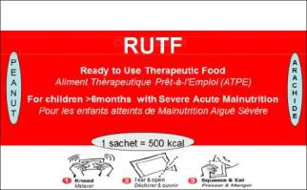  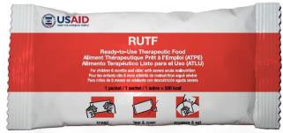 | 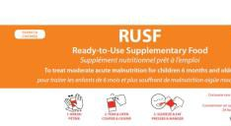   |   Super Cereal (SC)/oil/sugar  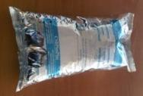  Super Cereal Plus (SC+) | 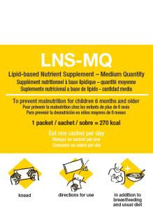   | Super Cereal (SC)/oil/sugar  Super Cereal Plus (SC+) |    |   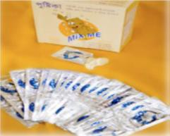 | 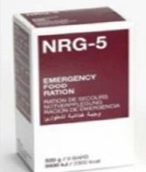  
Purpose | Treatment of uncomplicated  severe acute malnutrition  with continued  breastfeeding | Supplement to  treat moderate  acute  malnutrition with  continued  breastfeeding | Supplement to treat  moderate acute  malnutrition with  continued  breastfeeding | Supplement to  the local diet for  prevention of  acute  malnutrition with  continued  breastfeeding and for  prevention of  micronutrient  deficiency and  stunting | Supplement to  the local diet for  prevention of  acute  malnutrition with  continued  breastfeeding and for  prevention of  micronutrient  deficiency and  stunting | Supplement  to the local  diet with  continued  breastfeeding  to prevent  micronutrient  deficiency and  stunting | Fortification of home-  prepared foods, just  before consumption,  with continued  breastfeeding to prevent  micronutrient  deficiencies | Temporary meal  replacement and for  prevention of acute  malnutrition and  micronutrient  deficiencies  in vulnerable groups

Target Group | 6–59 months  Older children and adults including HIV+ | 6–59 months Others including PLW, HIV+ adults | 6–59 months: SC+ Others including PLW, HIV+ adults: SC | 6-23 (or 6–36)  months³² | 6–23 (or 6–59)  months³³: SC+ PLW: SC | 6–23 months | 6–59 months | General population, vulnerable groups
Energy and Nutrient/ Ration or Dose | 500 kcal 12.5g protein  31.9 g fat | 535 kcal 13g protein 31 g fat | 787 kcal  33g protein 20g fat | 265 kcal 6g protein 16g fat | 787 kcal  33g protein 20g fat | 110 kcal 2.6g protein 7g fat | Daily supplement: RDI: A: 400ug, C: 30ug, D: 5ug, E: 5ug, B1: 0.5ug, B2: 0.5ug, niacin: 6ug, B6: 0.5ug, B12: 0.9ug, folic acid: 150ug, iron: 10ug, zinc: 4.1ug, copper: 0.56ug, iodine: 90ug, selenium: 17ug | 1,800 kcal/400g (biscuits) 2,300kcal/500g (BP-  5, NRG-5)
 |  |  |  |  |  |  |  |  | Age | Bars
 |  |  |  |  |  |  |  |  | 6 mos-3 yrs | 3-4
 |  |  |  |  |  |  |  |  | 4-8 years | 5-6
 |  |  |  |  |  |  |  |  | Adults | 8-9
Packaging | Packet = 92g | Packet = 100g | SC: 25 kg bag  SC+: 1.5kg bag | Packet = 50g | SC: 25 kg bag  SC+: 1.5kg bag | Packet = 20g | Packet = 1g | 400g pks: HEB  500g pks: NRG-5, BP-  5
Shelf Life | 24 months | 24 months | SC: 12 months  SC+: 18 months | 24 months | SC: 12 months  SC+: 18 months | 24 months | 24 months | 5 years
Ration or Dose | According to weight:  6–59m: 200kcal/kg/day | 1 packet/day 100g/day | 200g/day | 1 packet/day 50g/day | 200g/day | 1 packet/day 20g/day | 1 packet/day 1g/day or 5g/day | Adults: 400g/day (HEB), 500g/day  (NRG-5, BP-5)
Approx. Duration of  Intervention | 6–8 weeks | 1–3 months | 3–6 months | 3–6 months | 3–6 months | Up to 18 months | Up to 59 months | 1 week as full diet  1 month for children
Cost/Dose/  Day (USD) | 0.36/packet | 0.29/day | SC: 0.11–16 / day  SC+: 0.24/day | 0.18/day | SC: 0.11–0.16 / day  SC+: 0.24/day |  | 0.028/day | 2.84/day
Example  Producers | Nutriset (Fr); Vitaset (DR); JB  (Mad); Nutivita (I), Edesia (US); Diva (SA); Compact (N, I); Tabatchnick (US); Challenge (US), Mana (US),  Insta (Ke); local producers | Nutriset (Fr);  Edesia (US); Compact (I, N); Nutrivita (I);  Four producers in  Pakistan | Michiels Fabrieken  (B); CerFar (It); ProRata, Somill, J&C (SA); Export Trading, Rab(Mal) | Nutriset (Fr);  Edesia (US); Compact (I, N); Nutrivita (I) | Michiels  Fabrieken (B); CerFar (It); ProRata, Somill, J&C (SA); Export  Trading, Rab(Mal) | Nutriset (Fr);  Edesia (US) | Global Health Initiative;  DSM (Ch); Heinz (I);  Hexagon (I); Piramal (I); Renata (Ban) | NRG-5/BP-5: MSI (D),  Compact (N), Biscuits:  Nuova Biscotti (I);
Abbreviations: B=Belgium, Ban=Bangladesh, Ch=Switzerland, D=Germany, DR=Dominican Republic, Fr=France, I=India, It=Italy, Ke=Kenya, Mad=Madagascar, Mal=Malawi, N=Norway, SA=South Africa, US=United States of America
Adapted from: Global Nutrition Cluster. 2017. Moderate Acute Malnutrition: A Decision Tool for Emergencies. Available at: http://nutritioncluster.net/?get=002086%7C2014/07/MAM-Decision-Tool-final-June-2014-corrected.pdf.
32 The default target group for prevention of acute malnutrition with LNS is children 6–23 months of age, but this may be expanded to children 6–36 months of age.
33 The default target group for prevention of acute malnutrition with Super Cereal Plus is children 6–23 months of age, but this may be expanded to children 6–59 months of age.

Handout 6.11 Supplementary Feeding Ration Card

Name of Child: |  |  |  |  |  |  | Registration Number: / /
Caregiver’s Name: |  |  |  |  |  |  | Sex (M/F):
Dates of Admission: |  |  |  |  |  |  | Age (Months):
Community: |  |  |  |  |  |  | Supplementary Feeding Site:
Admission Criteria: |  |  |  |  |  |  | Discharge Status:
Week | 1 | 2 | 3 | 4 | 5 | 6 | 7 | 8 | 9 | 10 | 11 | 12 | 13
Date
Weight (kg)
MUAC (mm)
WFH
Ration
(type and quantity)

Adapted from: Community-based Therapeutic Care: A Field Manual.

Handout 6.12 Referral Slip

Name of child |  |  |  |  | Community
Age |  |  |  |  | Sex
Date of admission
ADMISSION DATA |  |  |  |  | Site
Weight |  |  | MUAC |  | Referral to
Height |  |  | WFH/WFL |  | Registration No
Bilateral pitting oedema (circle) NONE + ++ +++
INFANTS UNDER 6 MONTHS OF AGE
Is infant exclusively breastfeeding? (circle) Y N
If not breastfeeding, is infant feeding well and exclusively on replacement feed? (circle) Y N
Date of referral
Criteria for referral

Treatment given

Comments

Handout 6.13 Supplementary Feeding Field Visit Checklist

Observe the following:
Admission criteria
Admission procedures
Discharge criteria
Discharge procedures
Individual child’s supplementary feeding treatment card (e.g., information collected, progress)
Ration card
Referral process
Food commodities
Ask the staff:
How they ensure linkages between the supplementary food programme (SFP), outpatient care and other nutrition interventions
How they ensure caregivers know how to use or prepare and give the supplementary food if a fortified blended food (FBF) is used.
What kind of health/nutrition education and counselling they offer
Where their supplementary food commodities come from and how they order and store them

EXERCISES

Exercise 6.1 Referrals in CMAM

Child A
Child A, a girl age 18 months, was admitted to the SFP with a MUAC of 117 mm, weight of 10 kg and no medical complications. At the second visit, the child had developed bilateral pitting oedema on the feet (bilateral oedema +). What action is needed?

Child B
Child B, a boy age 36 months, was referred to the SFP by the outreach worker with a MUAC of 118 mm. On admission, the nurse finds the child has no appetite and an extremely high fever. What action is needed?

Child C
Child C, a boy age 8 months, was admitted to the SFP with a MUAC of 116 mm. After four weeks (third weighing), the child has lost weight and MUAC is now 114. The child has diarrhoea and some appetite. You want to send the child to outpatient care, but the mother/caregiver refuses to go. How would you deal with this?

MODULE SEVEN: Planning CMAM Services at the District Level

Module Overview
This module introduces participants to the issues and considerations in the design and planning of a community-based management of acute malnutrition (CMAM) service or programme. This module focuses on the different steps used to plan a CMAM service or programme. It aims to provide participants with the tools and conceptual frameworks for thinking though the planning stages according to the context. This includes thinking through who should be involved in planning; conducting a situation analysis to define the needs; exploring the operational and policy-level opportunities and constraints; assessing capacity to implement the programme; determining a service or programme design with overall goals, specific objectives, and suitable indicators to measure programme impact and effectiveness; and translating these into an action plan. The module takes into consideration the World Health Organisation (WHO) “building blocks” for health system strengthening, and a system strengthening approach to integrating CMAM into existing health care system
Although budgeting is an important component of planning for CMAM services, this module does not provide specific guidance on budgeting for CMAM services. A Microsoft Excel-based CMAM costing tool designed to help planners and managers at district level plan and cost for CMAM services can be found at: https://www.fantaproject.org/tools/cmam-costing-tool.
Participants will work in groups of five or six for the majority of this module, grouped by country, province, or district, with those of similar origins placed together. Ideally, each group should work on designing and planning CMAM services for its own area. If this is not possible or not appropriate, groups should select an appropriate context and geographical or administrative coverage area for which to design and plan CMAM services.
Participants will stay in the same working group for all the module’s exercises. At the end of the session, participants will have developed an outline of a design and plan for CMAM in their respective areas.
Participants will practice using the concepts and frameworks in this module using a case study based on a real example or using their own district or a district in their country.
Participants should be asked in advance to bring relevant information for CMAM planning in their country, province, or district, and to read Case Study: Situation Analysis, Ghana before the training session.
Learning Objectives | Duration | Handouts and Exercises
- Describe Key Elements of CMAM and Prepare for the Planning Process | 30 minutes | Handout 7.1 Key Elements of CMAM Framework Aligned with the WHO Health Systems Strengthening (HSS) Building Blocks
- Identify Key Components of a Situation Analysis and Conduct a Basic Situation Analysis | 2 hours | Handout 7.2 Case Study: Situation Analysis, Ghana  Handout 7.3 Assessing the Nutrition Situation  Handout 7.4 Mapping Matrices  Handout 7.5 Capacity Grid for CMAM at the District Level  Handout 7.6 SWOT Analysis for CMAM  Handout 7.7 Example Capacity Grids for Outpatient Care at the Health Facility Level and for CMAM at the National Level
- Develop a Logical Framework for CMAM | 1½ hours | Handout 7.1 Key Elements of CMAM Framework  Handout 7.8 Using a Logical Framework for CMAM  Handout 7.9 Example Logical Framework for CMAM
- Develop an Action Plan for CMAM | 2½ hours | Handout 7.1 Key Elements of CMAM Framework  Handout 7.10 Calculating Estimated SAM and MAM Cases  Handout 7.11 Staff Needs, Roles and Responsibilities  Handout 7.12 Calculating Estimated RUTF Needs  Handout 7.13 Overview of Resources for CMAM  Handout 7.14 Matrix for Action Planning
- Plan for Special Cases: Transitioning and Contingencies | 1¼ hours | Handout 7.15 Matrix for Transition Planning of CMAM  Handout 7.16 Guidance for Contingency Planning for CMAM
Wrap-Up and Module Evaluation | 15 minutes

Module Duration: 8 hours
Note: Depending on the needs of their audience(s), trainers may choose to skip or spend more or less time on certain learning objectives and activities. The module duration is an estimate of the time it takes to complete all the learning objectives and activities.

Reference Resources
- Action Contre la Faim (ACF). 2017. Health System Strengthening: From Diagnosis to Planning Guide. Available at: http://nutritioncluster.net/wp-content/uploads/sites/4/2017/02/ACF-HSS-GUIDE-2017-LD.pdf.
- Concern Worldwide. 2016. CMAM Surge Approach: Operational Guide. Available at: https://www.concern.net/sites/default/files/media/resource/cmam_surge_operational_guide_0.pdf.
- Global Nutrition Cluster. 2015. CMAM Caseload Calculations (SAM and MAM Treatment). Available at: http://www.google.com/url?sa=t&rct=j&q=&esrc=s&source=web&cd=3&ved=0ahUKEwjw8eW41YXbAhXRm-AKHcSVDJQQFgg3MAI&url=http%3A%2F%2Fnutritioncluster.net%2Fwp-content%2Fuploads%2Fsites%2F4%2F2016%2F12%2FNC-Caseload-target-and-supplies-calculator.xlsx&usg=AOvVaw0hOL5uVgL7fxU6FW8Y2Y7j.
- World Food Programme (WFP) and United Nations High Commissioner for Refugees (UNHCR). 2011. Guidelines for Selective Feeding: The Management of Malnutrition in Emergencies. Available at: https://cms.emergency.unhcr.org/documents/11982/32558/Guidelines+for+selective+feeding.+The+management+of+malnutrition+in+emergencies/117faa46-7fa4-446b-8104-10f5a4c763e1.
- World Health Organisation (WHO). 2010. Monitoring the Building Blocks of Health Systems: A Handbook of Indicators and Their Measurement Strategies. Available at: http://apps.who.int/iris/bitstream/handle/10665/258734/9789241564052-eng.pdf?sequence=1.
- WHO. 2007. Everybody’s Business—Strengthening Health Systems to Improve Health Outcomes: WHO’s Framework for Action. Available at: http://www.who.int/healthsystems/strategy/everybodys_business.pdf.
- Valid International. 2006. Community-based Therapeutic Care (CTC): A Field Manual. Oxford: Valid International. Available at: https://www.fantaproject.org/sites/default/files/resources/CTC-Field-Manual-Oct2006-508.pdf.

Further Reading Resources
- Bulti, A. et al. 2017. “Improving Estimates of the Burden of Severe Acute Malnutrition and Predictions of Caseload for Programs Treating Severe Acute Malnutrition: Experiences from Nigeria.” Archives of Public Health. 75:66. DOI 10.1186/s13690-017-0234-4. Available at: https://www.ncbi.nlm.nih.gov/pmc/articles/PMC5679511/.
- Deconinck, H. et al. 2016. “Challenges of Estimating the Annual Caseload of Severe Acute Malnutrition: The Case of Niger.” PLoS ONE. 11(9): e0162534. doi:10.1371/journal. Available at: http://journals.plos.org/plosone/article?id=10.1371/journal.pone.0162534.
- Yourchuck, A.; Tumwine, K.; Namugumya, B.; Morla, J.; Doledec, D.; and Mupere, E. 2014. Health Systems Performance for IMAM/NACS in Uganda: Considerations for Delivery of Nutrition Services. Washington, DC: FHI 360/Food and Nutrition Technical Assistance III Project (FANTA). Available at: https://www.fantaproject.org/sites/default/files/resources/Uganda-HSS-Report-Sep2014.pdf.
- FANTA. 2012. CMAM Costing Tool. Washington, DC: FHI 360/FANTA. Available at: https://www.fantaproject.org/tools/cmam-costing-tool.
- Standardised Monitoring and Assessments for Relief and Transition (SMART). Measuring Mortality, Nutritional Status and Food Security in Crisis Situations (interpretation). https://smartmethodology.org/.
Handout 7.1 Key Elements Of CMAM Framework Aligned with the Health Systems Strengthening (HSS) Building Blocks

The World Health Organisation (WHO) Health Systems Strengthening (HSS) Building Blocks
The World Health Organisation’s (WHO) health system strengthening approach identifies six “building blocks” by which health system functions are organized: leadership and governance; workforce; financing; information systems; medical products, vaccines, and technologies; and service delivery. The desirable attributes, or core functions, of each health system building block as defined in the WHO Framework for Action are detailed below.

Health System Building Blocks
Leadership and governance should ensure that strategic policy frameworks exist and are combined with effective oversight, regulations, system design, and accountability.
Workforce should be responsive, fair, and efficient, given available resources and circumstances. There should be sufficient numbers of staff that are fairly distributed, competent, responsive, and productive.
Financing should be sufficient to ensure that health services are accessible and that people can use or pay for them without risk of financial catastrophe or impoverishment.
Information systems should ensure the production, analysis, dissemination, and use of reliable and timely information on health system performance, health determinants, and health status.
Medical products, vaccines, and technologies should be accessible to target communities; should be safe, efficacious, and cost-effective; and should be used properly and in a cost-effective way.
Service delivery should be effective and safe and should provide quality health interventions to those who need them, when and where needed, with minimum waste of resources.
Adapted from: WHO. 2007. Everybody’s Business—Strengthening Health Systems to Improve Health Outcomes: WHO’s Framework for Action. Available at: http://www.who.int/healthsystems/strategy/everybodys_business.pdf

Figure 1 below shows how building blocks that successfully perform their core functions can lead to improved access, coverage, quality, and safety of health services, which in turn contribute to positive health goals and outcomes.

Figure 1. WHO Health System Framework
Source: WHO. 2007. Everybody’s Business—Strengthening Health Systems to Improve Health Outcomes: WHO’s Framework for Action. Available at: http://www.who.int/healthsystems/strategy/everybodys_business.pdf

KEY ELEMENTS FOR CMAM Aligned with the HSS Building Blocks
1. Leadership and Governance for CMAM
Ministry of Health (MOH) technical leadership and at national and sub-national levels
MOH multisector coordination
CMAM integration into national health and nutrition policies and strategic plans
National CMAM guidelines
National database and repository
MOH-led CMAM support unit
Free treatment for children with severe acute malnutrition (SAM)
Contingency planning
Advocacy for management of acute malnutrition
2. Health Financing for CMAM
Planning and allocation of funds for CMAM activities at national and sub-national levels
Sustainability of funding
3. Health Workforce for CMAM
Pre-service training
In-service training
Internships and visits at learning sites
Accountability for health care providers (e.g., job description, roles, responsibilities)
Monetary and non-monetary systems of motivating and incentivising the workforce
Capacity development strategies that account for high staff turnover
4. Knowledge and Information Systems for CMAM
Baseline analysis and assessment of health system capacity and performance
Coverage monitoring and evaluation of barriers to accessing care and service uptake
Supportive supervision, mentoring, and coaching systems
Monitoring of individual care and case management
Monitoring of service performance
Information exchange and document repository
Operations research
Integration of CMAM into health information system and/or nutrition surveillance systems
Link with other national and global initiatives
5. Equipment and Supplies for CMAM
Planning for CMAM supplies, including buffer stock
Procurement of CMAM supplies
Integration and management of CMAM equipment and supplies through the MOH logistics management system
National production capacity for ready-to-use therapeutic food (RUTF) with capacity to cover national need
6. CMAM Service Delivery
Initial implementation of learning sites and gradual scale-up of CMAM services
CMAM integration into the basic health care package
Adequate qualified health care providers
Community outreach for community assessment and mobilisation, active case-finding, and referral
Establishment of outpatient care in decentralized health facilities
CMAM linkages with informal health systems
CMAM linkages with other community services, and safety nets including nutrition-sensitive interventions
Adherence to standardised treatment protocols
Continuous quality improvement to strengthen systems and processes for CMAM
Individual and group counselling for social behaviour change and communication

Handout 7.2 Case Study: Situation Analysis, Ghana
This situation analysis was conducted in August 2007 in preparation of a pilot project to introduce CMAM into the Ghana Health Service (GHS). It provided an overview of the nutrition situation and how undernutrition is addressed in Ghana. At a later stage, after the pilot districts were identified, the situation analysis was repeated at the district level, providing more detailed information for CMAM planning at the district level.

1. Nutrition Situation in Ghana
The 2006 Multiple Indicator Cluster Survey (MICS) shows an 18 percent prevalence of underweight (weight-for-age [WFA]) and a 22 percent prevalence of stunting (height-for-age [HFA]) among children under 5. Wasting (weight-for-height [WFH]) affected 5 percent of children under 5. No information was available on the prevalence of bilateral pitting oedema, but a relatively high incidence of kwashiorkor was expected as numerous cases were reportedly admitted to referral hospitals, especially during the lean period (March through September). Acute malnutrition was highest in the three northern regions (Upper East, Upper West and Northern), in the east (Volta region) and in Greater Accra, where levels were more than double the national average. At the time, Ghana had the 15th highest burden of children suffering from severe wasting globally.

The table below presents the results of nutrition surveys conducted in the different regions of Ghana. None of the surveys measured bilateral pitting oedema or mid-upper arm circumference (MUAC).

Table 1. Undernutrition Rates of Priority Regions in Ghana (indicators based on the NCHS references)
Source  (age group) | Date | Geographic Area | Severe Wasting  (% < -3 z-score) | Wasting  (% < -2 z-score) | Stunting  (% < -2 z-score) | Underweight  (% < -2 z-score)
DHS  (0-59 months) | Aug/Oct 2003 | National | 1.3 | 7.1 | 29.9 | 22.1
DHS  (0-59 months) | Aug/Oct 2003 | Upper East Region | 2.4 | 12.9 | 31.7 | 32.4
DHS  (0-59 months) | Aug/Oct 2003 | Upper West Region | 2.6 | 11.0 | 34.1 | 25.9
DHS  (0-59 months) | Aug/Oct 2003 | Northern Region | 1.0 | 6.6 | 48.8 | 35.5
DHS  (0-59 months) | Aug/Oct 2003 | Volta Region | 3.1 | 13.9 | 23.3 | 25.7
DHS  (0-59 months) | Aug/Oct 2003 | Greater Accra Region | 2.7 | 7.2 | 13.9 | 11.5
DHS  (0-59 months) | Aug/Oct 2003 | Central Region | 0.0 | 3.0 | 31.6 | 22.0
MICS  (0-59 months) | Aug/Oct 2006 | National | 0.9 | 5.4 | 22.4 | 17.8
MICS  (0-59 months) | Aug/Oct 2006 | Upper East Region | 2.8 | 11.6 | 28.4 | 29.1
MICS  (0-59 months) | Aug/Oct 2006 | Upper West Region | 0.3 | 7.7 | 22.5 | 19.1
MICS  (0-59 months) | Aug/Oct 2006 | Northern Region | 1.1 | 7.1 | 30.5 | 26.8
MICS  (0-59 months) | Aug/Oct 2006 | Volta Region | 2.1 | 4.8 | 20.9 | 20.3
MICS  (0-59 months) | Aug/Oct 2006 | Greater Accra Region | 1.1 | 3.1 | 7.7 | 9.8
MICS  (0-59 months) | Aug/Oct 2006 | Central Region | 0.0 | 3.7 | 26.4 | 16.3
GHS  (0-59 months) | 2005 | Dangbe East District, Greater Accra Region | NA | 9.4 | NA | NA
GHS  (0-59 months) | 2005 | Ga District,  Greater Accra Region | NA | 9.9 | NA | NA

2. Capacity for CMAM

2.1 Leadership and Governance for CMAM
Ghana Health System Organisation
The Ghanaian health system is administered through three primary bodies: the Ministry of Health (MOH), the GHS and private and mission health facilities. The MOH is responsible for national health policy formulation, resource mobilisation and health service delivery regulation. It also is responsible for physician pre-service curriculum and training. The three physician teaching hospitals are part of the MOH but have some degree of autonomy. The GHS, an autonomous body, is responsible for health care provision, in accordance with MOH policies, through public non-teaching hospitals and health centres. The GHS provides in-service training and develops guidelines and plans for implementing national policies. Private and faith-based health facilities, such as mission hospitals, administer about 40 percent of health care services in the country. While independent, these facilities are bound by national MOH policies and GHS guidelines, and they submit statistics to the GHS.

The GHS in 2007 was organized into eight divisions, encompassing administrative, financial and care services. Health services were covered under two divisions: Institutional Care, which covered clinical services, and Public Health, which covered maternal and child health and nutrition (MCHN). The Public Health division was divided into three departments: Family Health, Health Promotion, and Disease Surveillance and Control. The Family Health department comprised the Nutrition Unit and the Reproductive and Child Health Unit. The Nutrition Unit had assigned officers for supplementary feeding, infant and young child feeding (IYCF) and micronutrient supplementation and fortification. At the regional and district levels, there were assigned nutrition officers, while at the sub-district levels, a health director was in charge of nutrition and other health activities.

Health and Nutrition Policies
The MOH five-year Programme of Work outlined national priority health and nutrition programs. In the 2007 Annual Programme of Work, there was a strong focus on preventive nutrition through essential nutrition actions (ENAs), IYCF and micronutrient fortification and supplementation. The Programme of Work specified facility- and community-based management of malnutrition, without further defining it.
Nutrition priorities of the GHS were outlined in a strategy document entitled “Imagine Ghana Free of Malnutrition.” Like the MOH Programme of Work, it had a strong emphasis on prevention, but with an overall objective “to contribute to the reduction of malnutrition.” Specific objectives were “to provide curative services to individuals who are … malnourished” and “to improve the management of children with protein energy malnutrition.” As with the MOH Programme of Work, the term “malnutrition” was not defined.
Nutrition was a priority for the MOH. Overall, severe acute malnutrition (SAM) was a recognized medical priority that must be addressed. The Nutrition Unit of the GHS had strong interest in CMAM but lacked the capacity to lead the process of strengthening CMAM services. Most key nutrition stakeholder agencies were represented at a U.S. Agency for International Development (USAID)- and Food and Nutrition Technical Assistance Project (FANTA)-organized meeting on August 23, 2007, in Accra, and all expressed keen interest and support for strengthening CMAM services.
Other GHS health priorities and strategies included the Expanded Programme of Immunisation (EPI), integrated management of childhood illness (IMCI), Guinea worm eradication, and provision of antiretroviral therapy (ART) for HIV.
National CMAM Guidelines
There were no national CMAM guidelines in Ghana. A policy for nutrition rehabilitation, written in 1995, was a significant step that should be updated. Hospitals and nutrition rehabilitation centres (NRCs) had their own treatment protocol, but they were not standardised and varied by facility. Consequently, undernutrition was frequently described in non-specific terms, ranging from underweight to weight loss to wasting, leading to acute malnutrition not being identified, referred or treated in a uniform manner.

2.2. Health Financing for CMAM
USAID’s implementing partners supported the Community-Based Health Planning and Services Initiative (CHPS) and the GHS in general. The Japanese International Cooperation Agency was also supporting the expansion of CHPS coverage. The United Nations Children’s Fund (UNICEF) supported the Catholic Relief Services (CRS) Integrated Nutrition Action Against Malnutrition (INAAM) programme in the Upper West region. Moreover, the UNICEF had committed funds to procure locally produced ready-to-use therapeutic food (RUTF) in 2008. There was no funding in Ghana for training or for procuring therapeutic supplies, including therapeutic foods (e.g., therapeutic milks, RUTF). The World Bank had planned to provide US$15 million for nutrition programming, which would be managed by the GHS.

2.3. Health Workforce for CMAM
In-Service and Pre-Service Training
The June 2007 training workshop was the first introduction to the WHO protocol for the management of SAM.

The lack of national CMAM guidelines led to inadequate pre- and in-service training (and curricula) for physicians, nurses, and nutrition officers. While some facilities benefited from staff that had access to the WHO protocol from the Internet or elsewhere or conducted on-the-job training after the June 2007 workshop, there were no formal curricula or training programs.

The GHS had not profited from the presence of NGO programs for CMAM as seen in countries with recurrent emergencies and high inputs of international expertise (e.g., Ethiopia, Malawi, Niger, Sudan).

Staffing
Hospitals and health centres generally had adequate staffing, with some exceptions in the new districts. Health centres conducted community outreach through outreach satellite points or through CHPS zones. Health centres had state-registered nurses, community health nurses, and/or midwives. As noted, CHPS zones were staffed by one community health officer. The Ministry of Manpower, Youth, and Employment hired and trained senior secondary school students to become extension workers. These students performed tasks for different government agencies, with health as one of the sectors, thus becoming health extension workers (HEWs).

NRCs were staffed by one nutrition officer (requiring a bachelor’s degree) and one nutrition technical officer (requiring a two-year diploma). In reality, they often had just one officer, usually the less-qualified nutrition technical officer. A nurse sometimes managed the NRC. The NRC health worker was also assisted by community volunteers or HEWs.

The community outreach activities often benefited from the supplemental contribution of community health volunteers and community health committees.

2.4. Knowledge and Information Systems for CMAM
Nutrition surveillance was weak, with most information obtained from growth monitoring (WFA). Information on wasting (WFH or MUAC) and bilateral pitting oedema was lacking.

Some information and experience sharing related to nutrition occurred through an inter-agency nutrition technical working group, which was regularly organized by USAID/Ghana for donor agencies, the United Nations (UN) and some nongovernmental organisations (NGOs).

The University of Ghana’s Department of Nutrition and Food Science, in partnership with the University of California at Davis, was conducting research on lipid-based nutrient supplements (LNS) for complementary feeding. Other research institutions in Ghana conducting health, nutrition and medical research included the Food Research Centre, the Noguchi Memorial Institute for Medical Research (part of the University of Ghana, College of Health Sciences), the GHS Health Research Unit, and the Kintampo and Navrongo Health Research Centres.

2.5. Equipment and Supplies for CMAM
Therapeutic foods such as F75, F100, combined mineral and vitamin mix (CMV) and ReSoMal were not available in Ghana. Hospitals and NRCs prepared and administered improved milk recipes, cereal-based porridges, and local foods as an improved diet, though this diet lacks the micronutrient content and energy density to be considered therapeutic foods. Even when these institutions produced improved foods, insufficient quantities required that they be administered as a supplement to porridges. NRCs provided two to three wet meals daily, requiring mothers/caregivers to bring their children to the centre between 8 am and 2 pm Monday through Friday. This burden resulted in high default rates, infrequent attendance, and high relapse rates as children did not fully recover despite the weight gain.

Some health professionals had started innovative initiatives to manage malnutrition. Several initiatives prepared fortified milks and foods based on the F75, F100, and RUTF formulae based on WHO guidelines. However, due to the lack of CMV, the actual F75, F100, or RUTF formulae was not achieved. The Princess Marie Louise Children’s Hospital in Accra produced a peanut butter paste in its kitchen based on the RUTF recipe, with an incomplete mineral and vitamin mix. The hospital produced 5 kg of peanut paste every two days that was neatly packed in plastic containers with lids.

In 2007, an estimate of the expected RUTF needs for the treatment of all severely acutely malnourished children under 5 in Ghana in one year was 958 metric tons. Calculations were based on the estimated point prevalence rate of SAM augmented by the expected yearly incidence rate, the daily provision of 200 kilocalories of RUTF per kilogram of body weight, an average weight of the affected child population of 8 kg and an average length of treatment of eight weeks. However, it was never expected that CMAM services would cover the entire country or achieve national coverage during the initial years of implementation. On the contrary, CMAM services were expected to start at learning sites targeting specific and limited populations in specific locations before gradual scale-up.
WFP provided a fortified supplementary food (e.g., corn-soy blend [CSB])—not a therapeutic food—for use in wet feeding at some of the NRCs. There was a history of producing a fortified blended food (FBF) called Weanimix in Ghana. Some of the hospitals and health centres had been provided mills for producing these local blends as well as for additional income generation from the milling.
The system of provision of essential drugs was generally well established. Procurement of drugs was organised through central medical stores. No stock-outs in the drug supply were reported in the places that were visited.
Hospitals and NRCs lacked infant weighing scales and sometimes infanto-meters (height boards). Patient registers, patient records and statistical forms were not standardised and depended on individual facility efforts.
In contrast, the CRS INAAM program had sufficient therapeutic food and measuring equipment. However, its medical treatment protocol did not include drugs for treating underlying infections. The programme used MUAC for community screening; however, the MUAC tapes used were colour-coded with red measuring up to 125 mm—identifying moderate acute malnutrition (MAM) and SAM—while the cutoff point for severe wasting was 115 mm. In addition, the programme had access to 16 metric tons of imported RUTF (Plumpy’nut), of which a certain quantity is ready-to-use supplementary food (RUSF; e.g., Supplementary Plumpy), whose use in the program was unclear

2.6. CMAM Service Delivery
Inpatient Care
Hospitals in Ghana provided services for treatment of acute malnutrition but had no standardised treatment protocol in place. Nutrition rehabilitation was based on an improved milk diet. About 10 of the 42 NRCs provide residential (i.e., inpatient) care based on administering an improved diet of enriched porridge and local foods. No NGO programmes provided inpatient treatment of SAM.

Outpatient Care
Undernutrition was managed through outpatient services at the 42 (number is uncertain) NRCs provided an improved diet of enriched porridge and local foods. CRS provided outpatient care for SAM with UNICEF support in Upper West region (see section 3 below).

Health Care System
The country comprises 10 regions, divided into 139 districts in 2007. Each region had a regional hospital, which is the highest referral level within the health system. District hospitals operate at the district level, though they vary in levels of staffing and equipment. Some new districts lacked hospitals. Districts are further divided into sub-districts, which have health centres. Health centres are headed by nurses and had other anxillary staff. Some larger urban health centres, called polyclinics, were staffed with physicians.
The GHS operates at each administrative level through regional health directorates, district health directorates and sub-district health directorates. Services for children under 5 were mandated to be free of charge, though this was not been uniformly applied, and central-level reimbursement to facilities did not always occur. Consequently, some facilities charged for services to children under 5. A new national health insurance scheme covered costs of care for the indigent, who must be enrolled in the programme. Several of the health facilities FANTA visited actively encouraged patients to enrol or even assisted them with enrolment in the insurance plan. However, the cost of obtaining a photo needed for the insurance card was frequently cited as an obstacle to registration.
Beyond the sub-district level, community-level health services were provided through different mechanisms. Two of the more-developed mechanisms include child welfare outreach points and CHPS zones. First, health centres operated monthly child welfare outreach services at a community structure or under a tree, where nurses and community volunteers conducted monthly growth monitoring and promotion (GMP) of children under 5, ante- and post-natal care, EPI, treatment of minor illnesses, health and nutrition education, first aid and referral. FANTA observed 50 to more than 100 mothers and children at each of the outreach points visited. There was strong and effective community mobilisation to promote participation in the monthly services.
Next, CHPS zones included communities of 3,000 to 4,500 people (generally one to three communities), to which a community health officer was assigned to provide primary health care (PHC) services out of a CHPS compound (the nurse’s home and office, built by the community) and through frequent follow-up home visits. The community health officer was supported by a number of community health volunteers selected by a community health committee that consisted of community leaders, women’s and youth groups, traditional birth attendants and others. Not all health centres provided child welfare outreach services, and while CHPS zones had been planned nationally, coverage of active zones—i.e., those assigned a trained and equipped community health officer with active volunteers—was limited, with a concentration of active zones in the Upper East region. The GHS was working toward obtaining 100 percent coverage in all districts in Ghana by 2015.
Undernutrition was treated through inpatient care in hospitals and through inpatient or outpatient care at NRCs, which generally had high default rates. The lack of national CMAM guidelines translated into non-standardised treatment and non-uniform admission criteria, ranging from low WFA to low WFH to weight loss to visible wasting. Consequently, undernutrition screening at these facilities did not always target or identify the acutely malnourished, thereby impeding access. Hospitals tended to admit severely acutely malnourished children to the paediatric wards or assigned a specific malnutrition ward. For instance, the Princess Mary Louise Children’s Hospital in Accra had assigned one of their four wards for cases of severe undernutrition. At the time of the visit in 2007, over one-quarter of all the inpatients who were admitted were children with severe undernutrition.
The NRCs, some of which provided residential (inpatient) nutrition care, tended to be clustered in more urban areas. Referral from hospital-based inpatient services to NRCs for continued outpatient nutrition rehabilitation of stabilised cases was done only when a nearby NRC exists. NRCs with day programmes referred cases with serious illness back to inpatient care at the hospital level. In the NRCs, mothers/caregivers of the malnourished children prepared the improved food with guidance and education from the staff.
Thus, there was a well-developed health care delivery system in Ghana from community-based child welfare outreach points and CHPS zones providing primary health care, to sub-district and district health centres and hospitals providing primary and secondary health care. There was good potential to address SAM in inpatient and outpatient care in this structure.

Community Screening and Referral Systems
Community screening for acute malnutrition had been limited to child welfare outreach points organised from the health centres, using weight loss or visible wasting as evidenced on a WFA growth chart.
While referral of cases between hospitals and NRCs occurred, NRC links with the communities were nonexistent. Community screening and referral of SAM cases to NRCs were challenging in the absence of an institutionalized community outreach system. Moreover, active community screening of SAM implied an increased caseload, a situation with which the NRC would had difficulty coping. Without community outreach for early detection, referral and follow-up of cases through HEWs or community health nurses and officers linked with community volunteers, it was difficult for the NRCs to take up outpatient care for SAM.
Adherence to Standardized Treatment Protocols
Due to the lack of national guidelines for CMAM, there were significant variations across facilities in terms of admission and discharge criteria, treatment protocol, patient registration, individual record-keeping and programme monitoring. There was neither a national system of data collation nor surveillance. The ad hoc approach had significant implications for the quality of the individual treatment and for the quality and consistency of the services. For instance, admission and treatment were based on WFH, WFA, visible wasting or bilateral pitting oedema, weight loss or severe clinical anaemia. Target weights or target WFH (z-score or percentage of the median) generally were not documented in patient registers or records. As a result, progress was often subjectively interpreted as any consistent weight gain, which means discharge criteria were not standardised. While staff performed competently—i.e., followed the limited guidelines they had—they were significantly hampered by the lack of guidelines.

3. Mapping of Health, Nutrition and Community Activities and Programmes

3.1. Outpatient Care for SAM
The CRS (and UNICEF) INAAM program in Upper West region covered 108 target communities in four districts and provided 1,000 kilocalories daily of RUTF free of charge to children 6 to 36 months with a MUAC below 115 mm. A food ration (CSB and vegetable oil) was also given as an incentive to all children attending monthly growth monitoring and promotion services.

3.2. Blanket Supplementary Feeding Programme
The World Food Programme (WFP) supported a blanket supplementary feeding programme (SFP) in the three northern regions in 138 centres covering 170 communities in 17 districts. Pregnant and lactating women (about 10,000) and children 6 to 23 months (about 14,000) received a monthly dry take-home ration (e.g., CSB, wheat flour) during the lean season from March through September. Children 2 to 5 years (about 36,000) received wet rations (breakfast and lunch) prepared at the feeding centres by volunteer mothers Monday through Friday year-round. Health services offered at the feeding centres included health and nutrition education, vaccination, deworming and micronutrient supplementation. In addition, a preschool was organized for 4- and 5-year-olds if community volunteers were available. Inputs from the communities were requested in the form of labour and food supplies, such as additional ingredients. WFP procured two-thirds of the food for the SFP locally, with an agreement that 100 percent would be purchased within Ghana by 2010. It was expected that the Ghana government would take over the programme in 2010.

3.3. Other Health and Nutrition Programmes
Child survival activities fell under the High Impact and Rapid Delivery (HIRD) interventions, supported in part by UNICEF. HIRD activities included promotion of breastfeeding and complementary feeding, distribution of insecticide-treated nets (ITNs), use of oral rehydration solution and other services that address the primary causes of mortality for children under 5. There was a strong emphasis on addressing Millennium Development Goals (MDGs) in Ghana’s health system, particularly in reducing child mortality (MDG 4).

USAID-supported programmes included:
- The Community-Based Health Planning and Services Initiative – Technical Assistance (CHPS-TA), a Population Council program, which provided support to the national-level CHPS programme in the 30 USAID priority districts in the seven southern regions. It had updated job descriptions for community health officers and volunteers, developed curricula for community health officer schools and updated the community health officer in-service training manual.
- The USAID/Ghana Sustainable Change Project (GSCP) project supported communication and social marketing activities in more than 100 sub-districts of the 30 USAID priority districts. GSCP developed communication materials (e.g., posters, pamphlets, counselling cards) and training materials, as well as behaviour change communication (BCC) messages, primarily focused on reproductive health, child health (particularly IYCF) and HIV/AIDS care and support. GSCP engaged communities through community mobilisation campaigns organised through national level stakeholders, regional coordination committees, district level advocacy and sub-district action.
- The Quality Health Partners (QHP) programme of EngenderHealth helped the GHS to improve the quality of reproductive and child health services. Other activities included developing a rapid integrated management of childhood illness (IMCI) course with a shortened curriculum, incorporating IMCI into the national pre-service training curricula for nurses and medical assistants (anxillary position below a nurse), developing quality assurance questionnaires and tools, and supporting regional planning workshops for HIRD interventions.
- Opportunities Industrialization Centers International (OICI) conducted a food security and MCHN programme in northern Ghana. Activities included health and nutrition education, GMP, distribution of incentive food rations for BCC session participants, deworming, and training of community health agents.
Programmes run by World Vision, the Adventist Development and Relief Agency, CRS and others had nutrition components, such as nutrition education, promotion of exclusive breastfeeding (EBF) and complementary feeding practices, and Positive Deviance (PD)/Hearth.

4. SWOT Analysis for CMAM
A group of stakeholders involved in nutrition activities in Ghana – comprising the GHS, donors (USAID, the Dutch Embassy), UNICEF, WHO, WFP and NGOs – conducted a brainstorming exercise in August 2007 to review the capacity of the Ghanaian health system in order to introduce CMAM. An analysis of strengths, weaknesses, opportunities and threats (SWOT) was conducted reflecting the following areas:
- Capacity of the Ghanaian health system for CMAM
- Capacity for CMAM service delivery
- CMAM workforce development
  - Capacity of health planners and managers
  - Capacity of physicians, nurses (SRN, CHN/CHO, PHN), nutrition officers and nutrition technical officers
- Capacity of the leadership and governance for CMAM
SWOT Analysis for CMAM (Ghana, August 2007)
Strengths | Weaknesses
- Community outreach points  - CHPS zones  - Health volunteers  - Other community programmes  - Free treatment for children under 5 (policy)  - NGO presence | - No national guidelines or treatment protocols for SAM  - Therapeutic feeding supplies unavailable (e.g., F75, F100, RUTF)  - No teaching curriculum for SAM (pre-service or in-service)  - Lack of equipment (e.g., infantometers, scales, MUAC tapes)  - Not enough staff  - Staff skills and knowledge insufficient  - Community awareness of SAM insufficient
Opportunities | Threats
- Government awareness  - MOH plan of work to address undernutrition  - GHS strategy document  - Development partners are interested and committed  - Community structures:  - District assemblies/government structures can be engaged  - Mother-to-mother support groups  - Training could be mainstreamed: in-service and pre-service  - Other strong nutrition programmes (e.g., promotion of exclusive breastfeeding) | - Funding  - Availability  - Cost of therapeutic foods: F75, F100, RUTF  - Sustainability  - Barriers  - Existing resistance to accessing health services and to long inpatient stays  - Acceptability of RUTF  - Underlying conditions  - Food insecurity and poverty  - Limited access to clean water and sanitation  - Vertical program approach

Conclusion: Determined Needs
The situation analysis confirmed the need to introduce CMAM into Ghana’s health system in a phased manner.

Handout 7.3 Assessing the Nutrition Situation

A. For Emergency Settings
Prevalence of acute malnutrition (nutrition surveys) may be used to indicate whether a CMAM programme is needed. However, to better understand the nutritional status of a population and see the big picture, other data and information should be used in addition to prevalence data.

The decision to start a programme to treat acute malnutrition is often based on large numbers of acutely malnourished children who need life-saving treatment. Prevalence of acute malnutrition (global acute malnutrition [GAM] and severe acute malnutrition [SAM] rates) can provide a good idea of what is going on at that time. In the past WHO used a decision chart based on prevalence rates of wasting to determine when selective feeding programmes were needed. WHO cutoffs for wasting and mortality rates are still used to indicate a possible emergency, which should be investigated and addressed if necessary.

As a rule of thumb, a GAM rate of more than 15 percent and SAM of more than 2 percent and/or a crude death rate (CDR) > 1/10,000/day might indicate an emergency and suggests further investigation is needed to determine if an emergency nutrition intervention is justified. High GAM and SAM rates might occur in situations that are not considered emergencies. For example, prevalence of acute malnutrition is always high in India and Bangladesh. SAM levels often increase sharply during certain seasons and might be high enough on an annual basis to justify provision of treatment of SAM as part of the routine health services for children under 5. GAM of 5 percent and SAM of less than 1 percent are considered normal for a developing country. The levels of GAM relative to SAM should also be considered. This might provide some indication of what is going on. For example in some countries, HIV has contributed to increasing SAM among children in recent years where previously SAM was not a significant problem (e.g., Mozambique, Zambia, Kenya).

If GAM is high and SAM is relatively low: It is likely the causal factors are primarily (but not only)
due to insufficient access to food (N.E. Kenya).
If GAM is very high and SAM low, this could be due to high mortality related to SAM.

If GAM and SAM are both high: This is likely to be due to a combination of food
shortages and insufficient health and care practices
(Niger, Bangladesh).

If SAM is high and GAM is relatively low: This is likely to be due to disease, particularly
HIV (Mozambique, Zambia).

B. For Development Settings
In development settings, it is important to determine the nutrition situation in the community, district, region or country where you will be working. Service or Programme planners should gather important nutrition information using existing resources such as the Demographic and Health Surveys (DHS), the UNICEF Multiple Indicator Cluster Surveys (MICSs) and any surveys done locally or nationally by the government, district or NGOs. Key data include prevalence of moderate and severe wasting, underweight, stunting and, if available, bilateral pitting oedema. It might also be useful to gather information on illness and micronutrient deficiencies.

Example Nutrition Information from Secondary Sources
Source | Age Group | Date | Geographic Area | % Wasting  (weight-for-height < -2 z-score) | % Severe Wasting  (weight-for-height < -3 z-score | % Stunting  (height-for-age < -2 z-score) | % Underweight  (weight-for-age < -2 z-score
DHS | 0-59 months | Sept 2006 | Eastern Region | 8.4 | 1.2 | 35.3 | 22
District Health  Office | 0-36 months | Aug 2007 | Eastern Region | 6.2 | 0.9 | 36 | 25
NGO | 6-59 months | Dec 2007 | District A in Eastern Region | 9.4 | 1.6 | NA | NA

The above information allows planners to determine how critical the nutrition situation is in the districts or regions for which they are planning. The table below is a WHO reference to determine the significance of the nutrition problem, based on anthropometry. This is just one method of classifying the urgency of a problem; other factors must also be considered.

Prevalence Range WHO Uses to Categorize the Public Health Significance of the Prevalence of Different Measures of Undernutrition*
 | % Stunted  (height-for-age)** | % Wasted  (weight-for-height)** | % Underweight  (weight-for-age)**
Low (Acceptable) | < 20 | < 5 | < 10
Medium (Poor) | 20-29 | 5-9 | 10-19
High (Serious) | 30-39 | 10-14 | 20-29
Very High | ≥ 40 | ≥ 15 | ≥ 30
* The above categorization is not based on correlations with functional outcomes; it simply reflects a convenient statistical grouping of prevalence levels from different countries. (WHO. 1995. Physical Status: The use and interpretation of anthropometry, WHO Technical Report Series.)
** These indicators are expressed as <-2 z-score.

C. Triangulate Data
When looking at prevalence rates, it is also important to look at several other sources of information and data. This is often called triangulation.

A joint agency initiative known as Standardised Monitoring and Assessment for Relief and Transition (SMART) has developed a standard methodology and protocol for conducting survey and assessments that incorporate nutrition prevalence data, mortality rates and food security. SMART has been developed for use in crises, but the recommendations for analysis in context apply to non-emergency situations (www.smartindicators.org).

- Trends over time to see what is “normal”: In many countries, there is a seasonal peak for acute malnutrition at the same time every year. For example, in Malawi, seasonal prevalence of SAM begins to rise in December and fall in April in the pre-harvest season. This happens every year. Looking at trends is important because it can:
- Show what is considered “normal” for the context
- Help determine when to plan for expected increases in admissions (increased caseload during peak seasons)

When prevalence and/or admissions increase outside of normal peak periods, this can indicate a possible crisis or changes in access to food and should be investigated. In Malawi, for example, when SAM rates began to creep up in October 2016—well before the seasonal peak—it was clear that this was not the norm. The increase was due to total harvest failure in some areas.

- Admissions for inpatient care, outpatient care, or supplementary feeding: Unexpected increases in the number of admissions (e.g., above previous years and/or outside of normal seasonal peaks) can be a useful early indicator of an impending crisis. For example, in Niger in 2005, admissions to therapeutic feeding began to increase sharply much earlier than would be expected. This information can help planners prepare for increased caseloads.

- Surveillance data (routine screening, growth monitoring and health surveillance data): Severely malnourished children might be detected and referred through ongoing screenings or routine growth monitoring. Health surveillance data can provide information on disease outbreaks and epidemics.

- Death (mortality) rates: It is vital to know whether death rates are above acceptable levels. In extreme cases, prevalence rates might appear low due to high mortality rates.

- Morbidity rates and trends: There might be seasonal trends for illnesses such as diarrhoea and malaria or there might have been a recent epidemic (e.g., measles, whooping cough). This could temporarily lead to a sharp increase in the number of acutely malnourished children.

- Contextual analysis: It is important to look at what is going on in the community. Some key questions to ask are:
  - Are there population movements that could lead to a sudden influx?
  - Are there hot spots where acute malnutrition is always higher than other areas?
  - Are other services or programmes being implemented?

D. Causes of Undernutrition in the Community
In addition to triangulating data and information to confirm their accuracy, it is useful to understand the causes of undernutrition (UNICEF, see Module 2, Handout 2.1 Causal Framework of Undernutrition) and the significance of factors that contribute to undernutrition. This will help planners to better tailor CMAM services to the needs of the community. Below are examples of information to access and triangulate, by source.

- Population surveys: 6-59 months population size and structure, geographic differences, prevalence of illness (diarrhoea, measles, malaria, acute respiratory infections), disease outbreaks, care and feeding practices, health service provision, access to health services

- Surveillance and early warning systems: Seasonal norms and patterns, food security information, household food availability and consumption patterns, household food access, household food diversity, trends (according to seasonal norm)

- Other sources: Care and feeding practices, community norms, barriers to access, causes of defaulting learned from survey reports, focus group discussions, key informant and individual discussions, reports, publications or other sources

Handout 7.4 Mapping Matrices

It is important to know and map how the district health system is structured, what other services and initiatives exist and who is doing what, where and how. CMAM services should complement and link with existing programmes. Use the matrices below and separate sheets to describe or list this information.

Develop a spatial map of the district showing district and sub-district boundaries, major roads, major settlements, rivers, health facilities and other relevant information.

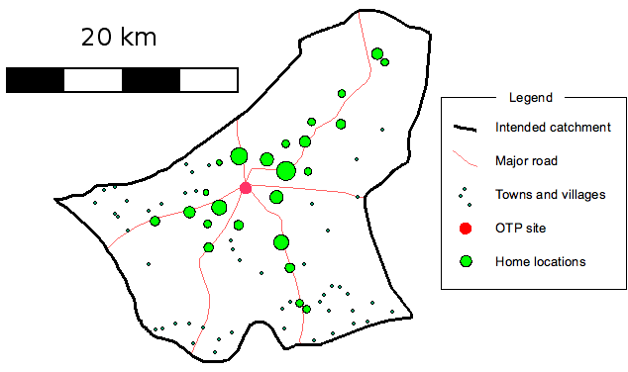

Example of Spatial Mapping (Source: M. Myatt, SQUEAC)

Matrix 1: CMAM, Health and Nutrition Mapping

District:
Organization:
Date:

CMAM
Sub-district | Communities  (list all by name) | Total Population  (add source and date) | Population Under 5  (% of total pop) | Expected Number of Children With SAM/MAM  (prevalence at start/certain date) | Expected Number of Children With SAM/MAM in One Year  (prevalence plus incidence*) | Health Facilities  (list type per location) | Inpatient Care Sites | Outpatient Care Sites | Supple-mentary Feeding Sites | SAM/MAM Service Start Date (per site and partner agency) | Market Place and Day
Sub-district 1 | 1
 | 2
 | 3
 | 4
 | 5
Sub-district 2 | 1
 | 2
 | 3
 | 4
 | 5
Sub-district 3 | 1
 | 2
 | 3
 | 4
 | 5
* To determine the expected number of children with severe acute malnutrition (SAM) or moderate acute malnutrition (MAM) in one year, see Handout 7.10 Calculating Estimated SAM and MAM Cases.

Matrix 2: Outpatient Care Mapping
(If services did not yet start, use this matrix for strategic planning.)

District:
Organization:
Date:
Outpatient Care
Health Facility  With Outpatient Care | Health Facility Catchment Area | Health Care Providers  in Charge of Outpatient Care | Community Health Workers  in Charge of Outpatient Care | Volunteers in Charge of Outpatient Care | Day of Weekly Outpatient Care | CMAM Start Date per site | Comments
(list names) | (list communities) | (list number, function and/or names) |  |  | Day of Weekly Outpatient Care | CMAM Start Date per site | Comments

Matrix 3: Health, Nutrition and Other Community Services, Systems and Initiatives

List (in the matrix or on a separate sheet) all actors involved in strengthening health, nutrition, food security, livelihoods, economic opportunities, orphans and vulnerable children (OVC), community outreach, community-based activities and organisations and other relevant formal and informal activity and information structures. For each, specify focus area, target population, geographical coverage and any other relevant information.

Health, Nutrition and Other Community Services, Systems and Initiatives
Community Services (focus area) | Target Population | Impact Area | Partner Agency | Community Outreach (strategy, actors, #) | Other Relevant Information | Comments

Handout 7.5 Capacity Grid for CMAM at the District Level

Note: Add programs for the management of moderate acute malnutrition (MAM) (e.g., supplementary feeding) if appropriate.

Key Elements of CMAM to Address | Who Currently | How Currently | MOH Capacity to Do This | Gaps | Solutions | Priority
LEADERSHIP AND GOVERNANCE FOR CMAM
CMAM technical leadership (at district level and links with a national/regional technical task force):

CMAM coordination system (at district level and links with a national/regional coordination system):

CMAM guidelines:
-Do CMAM national guidelines exist?
-Are they disseminated and in use?

Free treatment for children under 5 with severe acute malnutrition (SAM) in place:

Contingency planning:
-How will the district manage seasonal and unexpected increases in caseload?
HEALTH FINANCING FOR CMAM
Funding:
-Can costs for outpatient care supplies, supervision. and training (including ready-to-use therapeutic food [RUTF]) be incorporated into the district budget?

Sustainability:
-How will CMAM activities, supplies, and equipment be financed in the long term?
HEALTH WORKFORCE FOR CMAM
Pre-service training:
-Is management of SAM and MAM part of the training curriculum of health professions?

In-service training:
-For inpatient and outpatient care, and at learning sites?

Continuous training (e.g., mentoring, refresher training, learning visits, internships):

Accountability:
-Is CMAM included in job descriptions?
KNOWLEDGE AND INFORMATION FOR CMAM SERVICES
Evaluation of the effectiveness of services (e.g., performance; coverage; barriers to access; causes of defaulting, non-response, and death):

Support and supervision system:
-For health care providers at the health facility?
-For outreach workers (e.g., CHWs, volunteers) in the community?

Individual monitoring of cases:
Registration, treatment cards, ration cards

Monitoring and reporting system of services with standardised tools:
-Tally sheets, monthly site report

Information exchange system:
(Informative research ongoing)

Integration with national health management information system (HMIS):
CMAM SERVICE DELIVERY
Learning site:
-Is there a learning site for inpatient and outpatient care?

Community outreach:
-Are community assessment and mobilisation provided?
-Are effective active case-finding and referral and follow-up home visits of problem cases in place?

Inpatient care:
-Is there inpatient care for children with SAM with medical complications and infants under 6 months with SAM?

Outpatient care:
-Is there outpatient care for children with SAM without medical complications?

Management of MAM:
-are there programmes for the management of children with MAM?

Referral mechanisms:
-What mechanisms exist to ensure children can be referred from outpatient care to inpatient care and vice versa?
-How are they transported?

Staff:
-Are there enough qualified health care providers to provide inpatient and outpatient care? If not, can more be trained?
-Is a district health manager appointed as a CMAM focal point?
-Is a district community outreach coordinator appointed as a CMAM focal point?
-Are there enough outreach workers (e.g., community health workers [CHWs] and/or volunteers) for screening and referral in the community? If not, can more be trained?

Integration into routine health services (e.g., prevention of mother-to-child transmission of HIV [PMTCT], growth monitoring and promotion [GMP], integrated management of childhood illness [IMCI]):

Linkages:
-Is the service linked with the informal health system (e.g., religious leaders, traditional healers, traditional birth attendants)?
-Are there other programmes in the area that provide opportunities for linkages (e.g., essential nutrition actions [ENAs], water, hygiene and sanitation [WASH], HIV/AIDS initiatives, food security and livelihoods initiatives)?
Adherence to national and international guidelines and treatment protocols:

Continuous quality improvement (QI):
Is there a QI system for CMAM services?

Handout 7.6 SWOT Analysis for CMAM

Strengths, Weaknesses, Opportunities and Threats (SWOT)
In planning for CMAM services, it is important to identify the current community/district strengths on which you can build a programme and weaknesses that must be addressed. Opportunities to support the programme and threats (constraints) that could impede the success of CMAM services must be explored.

Capacity of Health Care System for CMAM
Current situation | Strengths | Weaknesses
Considerations for future planning | Opportunities | Threats

Handout 7.7: Example Capacity Grids for Outpatient Care at the Health Facility Level and CMAM at the National Level

Capacity Grids for Outpatient Care at the Health Facility Level

A. Capacities for Community Outreach*

Elements to Address | Who Currently | How Currently | MOH/  Community Organisation  Capacity to Do This | Gaps | Solutions** | Priority
Community assessment
Community mobilisation
Active case-finding
Follow-up home visits for problem cases (non-responders, defaulters)
Health and nutrition education in the community
Supervision of outreach workers (e.g., community health workers [CHWs], volunteers)
Meetings for feedback and problem-solving with outreach workers
Feedback from the community on the service/programme
Ongoing training for outreach workers
Links with other sectors for community outreach (e.g., community case management, growth monitoring, health and nutrition education, food security, livelihoods, agricultural extension programmes)
* Trainer: Determine whether filling out the capacity grid is the responsibility of the district health management team or the health facility and adapt accordingly.
** Suggest solutions to modify organisation, management and support; suggest ideas on how to resolve the gaps or what discussions are needed and with whom.

B. Capacities for Implementing Outpatient Care

Elements to Address | Who Currently | How Currently | MOH Capacity to Do This | Gaps | Solutions* | Priority
Screening and registration of children with severe acute malnutrition (SAM)
Evaluation of the medical condition of child with SAM
Appetite test
Referral to inpatient care/hospital
Giving medicines and ready-to-use therapeutic food (RUTF; according to protocol) to child with SAM
Individual counselling
Group health and nutrition education
Beneficiary monitoring (identify cured, non-response, defaulters)
Identify problem cases and link to outreach worker for follow-up home visit
Discharge of beneficiaries
Fill in tally sheets and site reports
Supply of medicines
Supply of RUTF
Supply of outpatient care treatment cards, RUTF ration cards, monitoring and reporting forms
Storage of medicines and RUTF
Stock control for medicines and RUTF
Ongoing training of health care providers in SAM protocols, monitoring and reporting
Integration/links with other health and nutrition services and programmes
Coordination/links with other community services and programmes
* Suggest solutions to modify organisation, management, protocols and support; suggest ideas on how to address gaps or what discussions are needed and with whom.

C. Capacities for Supervision and Monitoring of Outpatient Care at the Health Facility
Elements to Address | Who Currently | How Currently | MOH Capacity | Gaps | Solutions* | Priority
Support and supervision of health care providers
Support and supervision of outreach workers
Completion and collection of tally sheets
Completion and analysis of monthly site reports
Checking and collection of RUTF and medicines stock control sheets
Compilation of stock reports
Checks on quality of stocks and storage conditions
Problem-solving and coordination meetings
Review of progress toward integration objectives
* Suggest solutions to modify systems, tools and support; suggest ideas on how to address gaps or what discussions are needed and with whom.

Capacity Grid for CMAM at the National Level

Note: Add programs for the management of moderate acute malnutrition (MAM) (e.g., supplementary feeding) if appropriate.
Key Element of CMAM to Address | Who Currently | How Currently | MOH Capacity to Do This | Gaps | Solutions | Priority
1. Leadership and Governance for CMAM
Ministry of Health (MOH) technical leadership at national and sub-national levels
MOH multisector coordination
CMAM integration into national health and nutrition policies and strategic plans
National CMAM guidelines
National database and repository
MOH-led CMAM support unit
Free treatment for children with severe acute malnutrition (SAM)
Contingency planning for CMAM in case of emergencies
Advocacy for management of acute malnutrition
2. Health Financing for CMAM
Planning and allocation of funds for CMAM activities at national and sub-national levels
Sustainability of funding
3. Health Workforce for CMAM
Pre-service training for frontline health care providers and managers includes CMAM
In-service training for health care providers and managers, including continuous professional development
CMAM learning sites, internships, and visits
Accountability for health care providers (e.g., job description, roles, responsibilities)
Monetary and non-monetary systems of motivating and incentivising the workforce
Capacity development strategies that account for high staff turnover
4. Knowledge and Information Systems for CMAM
Baseline analysis and assessment health system capacity and performance
Coverage monitoring and evaluation of barriers to accessing care and service uptake
Supportive supervision, mentoring, and coaching systems
Monitoring of individual care and case management
Monitoring of CMAM service performance
Information exchange and document repository (sharing of evidence and lessons learned)
Operations research to expand the evidence base
Integration of CMAM into health information system and/or nutrition surveillance systems
Link with other national and global initiatives
5. Equipment and supplies for CMAM
Planning for CMAM supplies including buffer stock
Procurement of CMAM supplies
Integration and management of CMAM equipment and supplies through the MOH logistics management system
National production capacity for ready-to-use therapeutic food (RUTF) with capacity to cover national need
6. CMAM Service Delivery
Initial implementation of learning sites and gradual scale-up of CMAM services
CMAM integration into the basic health care package
Adequate qualified health care providers
Community outreach for community assessment and mobilisation, active case-finding and referral
Establishment of outpatient care in decentralized health facilities
Establishment of inpatient care in health facilities with 24-hour care capacity
Referral system between inpatient and outpatient care
CMAM linkages with informal health systems
CMAM linkages with other community services and safety nets including nutrition-sensitive interventions
Adherence to standardised treatment protocols
Continuous quality improvement to strengthen systems and processes for CMAM
Individual and group counselling for social and behaviour change and communication

Handout 7.8 Using a Logical Framework for CMAM

A. Steps for Developing a Logical Framework
A simplified planning chart can help planners think through the CMAM service/programme goal, objectives, indicators and assumptions, and how to measure whether the service/programme is achieving its aims. The goal, service objectives, outcomes and activities are determined based on the situation analysis.

Steps:
- Defining a goal (population level)
- Defining objectives
- Determining outcomes
- Determining activities/outputs
- Identifying performance and output indicators
- Determining inputs
Defining a goal for CMAM: This should be a statement about the service/programme’s broad aims. The service objectives (below) defined will directly contribute to this goal.

Example of a goal: To reduce mortality and morbidity associated with acute malnutrition in District X

Defining CMAM objectives: This should be a more specific statement about what the service/programme hopes to achieve. The objectives of the CMAM service/programme must be clearly defined and measurable, and must directly contribute to achieving the stated goal. This will depend on the context. The objectives will determine what strategy and activities to plan for and what indicators to select to monitor the service/programme.

Example of an objective: To increase the proportion of children with SAM and moderate acute malnutrition (MAM) in District X who are receiving effective treatment through CMAM

Determining outcomes: The expected outcomes will relate to the service/programme’s performance. The outcomes will likely encompass the components of CMAM: community outreach, inpatient care, outpatient care and possibly services/programmes to manage MAM. The outcomes will focus on what each component actually achieves.

Examples of outcomes:
- To conduct effective community outreach in five villages in District X
- To provide effective outpatient care for infants and children (0 to 59 months) without medical complications in District X
- To provide effective inpatient care for infants and children (0 to 59 months) with medical complications as part of routine health services for children under 5
- To provide effective management of MAM for children 6–59 months without medical complications in District X

Determining activities/outputs: The activities or outputs are what the service/programme must do to achieve the expected outcomes and objectives. Much of the service/programme planning will be determined by specific activities.

Examples of activities:
- Establishing X number of sites
- Training X number of health care providers in CMAM
- Recruiting and training X number of volunteers in community outreach
- Sensitising X number of communities

Identifying performance and output indicators: Indicators will measure the service/programme’s performance (are the objectives achieved?) and outcomes (have the planned activities successfully been completed?).

Determining inputs: Inputs are the resources that a service/programme needs to implement its planned activities/outputs. Inputs could include human resources, financial resources, equipment, monitoring/reporting tools and guidelines.

B. CMAM Activities/Outputs

See Handout 7.9 Example Logical Framework for CMAM.

Activities/outputs are identified based on the findings of the situation analysis (assessment of existing capacities and needs). Activities/outputs should help:

  - Strengthen leadership and governance
  - Ensure sustainable financing of CMAM services
  - Develop and strengthen a health workforce for CMAM
  - Improve knowledge and information systems for CMAM
  - Ensure access to equipment and supplies for CMAM
  - Ensure access to CMAM service delivery

C. CMAM Indicators
The indicators selected will depend on the objectives and activities/outputs. There are two basic types of indicators: performance indicators and output indicators.

Performance indicators measure whether a CMAM service/programme has achieved its objectives and planned outcomes. They are measured in percentages.

  - If the objectives or outcomes include increasing access to or coverage of CMAM services, it will be necessary to measure whether the programme is achieving them. The best way to do this is through a coverage survey. International minimum standards for therapeutic feeding programmes, established by the Sphere project for emergency settings, suggest that in emergencies the service/programme coverage in rural, urban and camp contexts should be 50, 70 and 90 percent, respectively, of the total population of children under 5 with acute malnutrition. These Sphere minimum standards might not be applicable in non-emergency contexts, but this has not yet been tested.

Note: Methods to determine coverage for CMAM have been developed (e.g., Semi-Quantitative Evaluation of Access and Coverage [SQUEAC] and Simplified Lot Quality Assurance Sampling Evaluation of Access and Coverage [SLEAC]) and more simple methods are being investigated. Cruder methods, such as comparing actual admissions to expected caseload (based on estimated prevalence and incidence), can be used to estimate coverage for monitoring purposes in between population surveys. Exhaustive screening in communities selected for this purpose can also provide useful information on coverage.

- If the objectives or outcomes include providing effective inpatient and/or outpatient care for children with SAM, it will important to measure the proportion of children receiving CMAM inpatient and outpatient care services who recovered, died, did not respond to treatment or defaulted. Results can be compared with Sphere Minimum Standards. Note that Sphere Minimum Standards might not be applicable to non-emergency contexts. This has not yet been tested. Examples of indicators:
- Percentage discharged who recovered Sphere > 75%
- Percentage discharged who died Sphere < 10%
- Percentage discharged who defaulted Sphere < 15%
- Percentage discharged as non-recovered No Sphere indication

- Additional indicators will depend on the specific objectives and expected outcomes and what is useful to measure to track progress in achieving those aims. Other indicators that might be useful involve quality of services, such as the percentage of children referred by community volunteers who are admitted to outpatient care or the percentage of children requiring follow-up who receive an appropriate follow-up home visit.

- When evaluating the overall performance of CMAM services for SAM specifically, indicators for all objectives should be considered.

  - Output indicators measure whether a programme has successfully completed the planned activities/outputs that are necessary to achieve the established goals and objectives. Output indicators are measured in numbers or percentages and should be specific to the activities/outputs established.

Examples of output indicators include:
- Number of health facilities with established outpatient care
- Number of children with SAM admitted to outpatient care
- Number of children with SAM referred to inpatient care
- Number of children with MAM admitted in programmes for management of MAM
- Number or percentage of health care providers trained and active in SAM case management
- Number or percentage of community health workers (CHWs) trained and active in community outreach
- Number or percentage of volunteers trained and active in community outreach

Barriers to access should be assessed through population surveys and regular meetings with outreach workers (e.g., CHWs, volunteers) and community stakeholders. Possible indicators include:
- Number and percentage of children under 5 screened
  - Number and percentage of children under 5 with SAM or MAM identified and referred for treatment
  - Number and percentage of children under 5 with SAM or MAM referred for treatment and admitted
- Number of meetings (include timeframe) between outreach workers and the community

Handout 7.9 Example Logical Framework for CMAM

Example of Steps for Designing CMAM at the District Level Using a Logical Framework

Note: This simplified framework focuses on outpatient care and on one outcome as an example. CMAM programmes will have multiple activities for each planned outcome.

 | Indicators | Information Source |  | Assumptions
Programme Goal:
What are the broad aims of the programme?
To reduce district-level mortality and morbidity associated with severe acute malnutrition (SAM)
Objective 1:  What are the specific aims of the CMAM service or programme?  To increase the proportion of children with SAM in the district being effectively treated through CMAM | Performance Indicator:  - % of children with SAM in the district receiving CMAM services  In CMAM services:  - % discharged recovered  - % discharged non-recovered  - % discharged died  - % discharged defaulted |  | - Coverage surveys  - CMAM tally sheets and monthly site reports | - Caseload remains at manageable levels  (< 30 children/week)  - Community outreach, screening and referral systems are adequate
Outcome 1:  What can specific CMAM components do to help achieve the service objective?  Provide effective outpatient care services to children 6-59 months in District X | Performance Indicators:  In outpatient care:  - % discharged recovered  - % discharged died  - % discharged defaulted  - % discharged non-recovered  - average length of stay (LOS)  - average weight gain (AWG)  (Note: It is also useful to report changes in these indicators.) |  | - Tally sheets  - Monthly site reports  - Outpatient care treatment cards | - Reliable supply of ready-to-use therapeutic food (RUTF) and essential medicines  - All necessary equipment is available  - Sufficient staffing
Outputs/Activities:  What will you do to achieve your outcomes and objectives?  1) Leadership and governance:  Provide national guidelines to all established sites  2) Sustained financing:  Integrate CMAM activities in district implementation plans and budgets.  3) CMAM health workforce developed/strengthened:  Train X number of staff on outpatient care at all health centres  4) Improve knowledge and information systems for CMAM:  -integrate CMAM into the HMIS  -Establish supervision system  5) Ensure access to equipment and products for CMAM:  - Plan for CMAM supplies including buffer stock  -Establish procurement system for RUTF  6) Access to service delivery:  -Establish and operate X number of outpatient care sites; Establish community outreach  - establish quality improvement system | Output indicators  - # sites with copies of national guidelines  - # functioning outpatient care sites  - # sites with access to RUTF and medicines through established procurement system  - # supervisors with supervision tools  - # and/or % of health care providers trained  - # and/or % of outreach workers trained  - # of community meetings held |  | - Service/programme records  - Monthly site reports  - Health management information system (HMIS) | - Ministry of Health (MOH) remains supportive of outpatient care integration  - Health facility staff is available for training

Handout 7.10 Calculating Estimated SAM and MAM Cases

Example of Estimating the Number of Children with Severe Acute Malnutrition (SAM) Who Will Need Outpatient Care in the Following 12 Months
Total population in target area | 300,000
Population age 6-59 months (e.g., 20%, usually is less) | 60,000
Prevalence of SAM | 2%
Estimated cases of SAM | 1,200 (= 60,000 X 0.02)
Estimated new cases to add in 1 year (incidence over 1 year could be 2x the prevalence | 2,400
Estimated number in need of treatment over 12 months | 3,600 (= 1,200 + 2,400)
Expected coverage of services | 70%
Expected number to be treated in quality CMAM services/programmes | 2,520 (= 2,600 x 0.70)
Expected SAM without complications | 80%
Expected number to be treated in outpatient care only | ≈ 2,000 (= 2,520 x 0.80)
Expected number to be treated in inpatient care + outpatient care | ≈ 500 (= 2,520 x 0.20)

- Prevalence data from nutrition surveys indicate the numbers of children with SAM at a given time. For planning purposes, it is important to know incidence, which is the number of new cases occurring every year.
- In the rough assumption presented above, incidence of about two to three times the prevalence has been used. The use of prevalence to estimate caseload should be interpreted and used with caution as recent studies have shown it could result to gross underestimation of the actual caseload. To better predict the estimated SAM and MAM caseload, emerging evidence suggests applying a simple mathematical model to program data that are readily available to program managers.
- Seasonal fluctuations that cause peaks in numbers should be considered in planning overall expected numbers.
- Coverage of CMAM services ideally is at least 70 percent.
- If you do not have access to local nutrition surveys, Demographic and Health Surveys (DHS) or United Nations Children’s Fund (UNICEF) Multiple Indicator Cluster Survey (MICS) data will give you an idea of the national and district averages for severe wasting. However, these data do not include oedematous malnutrition (kwashiorkor) or wasting identified by low mid-upper arm circumference (MUAC). Therefore, an adjustment on total expected numbers in need of treatment can be considered.
- About 80 percent of the expected caseload can be treated in outpatient care without any inpatient care; less than 20 percent will need inpatient care for stabilisation.
The Nutrition Cluster caseload calculation tool can assist program managers to predict caseload. The tool is available on this link: http://www.google.com/url?sa=t&rct=j&q=&esrc=s&source=web&cd=2&ved=0ahUKEwiC_oKtyIXbAhVQdt8KHeR6DWoQFggvMAE&url=http%3A%2F%2Fnutritioncluster.net%2Fwp-content%2Fuploads%2Fsites%2F4%2F2016%2F12%2FNC-Caseload-target-and-supplies-calculator.xlsx&usg=AOvVaw0hOL5uVgL7fxU6FW8Y2Y7j
Handout 7.11 Staff Needs, Roles and Responsibilities
Source: Community-based Therapeutic Care (CTC): A Field Manual

1. Staff Needs for CMAM

Community Outreach
- A community outreach coordinator
- A team of community outreach workers: community health workers (CHWs) and/or volunteers

Supplementary Feeding
- A team leader (ideally with experience in food distribution)
- Two measurers
- One or two health care providers (nurse)
- One or two general assistants
- One food distributor

Outpatient Care
Appoint in each health facility (and plan rotations if appropriate):
- A qualified health care provider (nurse or medical assistant)
- Two measurers (if weight-for-height [WFH] is used)
- One assistant (if needed due to caseload)

Inpatient Care
- Qualified health care providers, at least one per shift for 24-hour care (e.g., nurse, medical assistant, physician, paediatrician)
- Nutrition assistant or assistant health staff
- Support staff
- Liaison staff

An overall CMAM coordinator and a community outreach coordinator must be identified in the district to manage the various components of the services.
Training should be provided to all health care providers and outreach workers. A one-day orientation is given at the start of the service/programme followed by continuous training (e.g., refresher training, mentoring, feedback meetings).
The budget for human resources will depend on where and how the service/programme is being implemented and by whom. Local salaries and per diems should be in line with the norm in the area. If per diems are given for training and allowances provided to Ministry of Health (MOH) staff, these should be based on the MOH’s scale.
The above list suggests the need for external human resources, such as in case of emergencies. Otherwise the roles and responsibilities should be allocated to the health care providers who are regular staff members of the health facility.

2. Staff Roles and Responsibilities for Outpatient Care

District Health Manager or CMAM Coordinator
  - Resource mobilisation and allocation (e.g., human resources, infrastructure, supplies, transportation, training)
  - Planning of services
  - Support and supervision
  - Monitoring and evaluation (M&E)
  - Training health care providers

District Community Outreach Coordinator
  - Community assessment and mobilisation
  - Support and supervision
  - Training outreach workers

Health Care Provider (nurse, medical assistant)
  - Evaluation of the medical condition (i.e., anthropometry, medical history, physical examination, appetite test)
  - Admission of children to outpatient care
  - Referral to inpatient care
  - Management of SAM (i.e., treatment, prescription of drugs and ready-to-use therapeutic food [RUTF])
  - Organisation and supervision of outpatient care initial and follow-on sessions
  - Discharge of children
  - Monitoring and reporting (i.e., tally sheets, monthly site reporting sheets)
  - Monitoring of equipment and supplies
  - Training CHWs

CHW
  - Anthropometric measurements
  - Group nutrition and health education at the health facility
  - Community-based nutrition and health education and individual counselling
  - Community screening and referral
  - Follow-up home visits for problem cases
  - Training volunteers

Volunteers
  - Community-based nutrition and health education and individual counselling
  - Community screening and referral
  - Follow-up home visits for problem cases

Handout 7.12 Calculating Estimated RUTF Needs
Estimated ready-to-use therapeutic food (RUTF) needs for outpatient care per district per month are based on a RUTF diet (Plumpy’Nut®) of 200 kilocalories (kcal) per kg per day on average.

Each child in outpatient care consumes about 20 packets of RUTF a week. Total consumption in outpatient care per time period is calculated as follows:

RUTF
A | Number of outpatient care beneficiaries | A
B | Monthly consumption per child (@20 packets/child/week) | 80
C | Monthly packet consumption for outpatient care | A x B
D | Monthly carton consumption for outpatient care | C/150
E | Monthly net weight (MT) (@13.8 kg/carton) | D x 13.8/1000
F | Monthly gross weight (MT) (@14.9 kg/carton) | D x 14.9/1000

Example:

RUTF
Number of outpatient care beneficiaries | 1,000 children
Monthly consumption per child (@20 packets/child/week) | 80 packets
Monthly packet consumption for outpatient care | 1,000 x 80= 80,000 packets
Monthly carton consumption for outpatient care | 80,000/150=533.33 cartons
Monthly net weight (MT) (@13.8 kg/carton) | 533.33 x 13.8/1000 = 7.35 MT
Monthly gross weight (MT) (@14.9 kg/carton) | 533.33 x 14.9/1000 = 7.95 MT
+ add for contingencies

Handout 7.13 Overview of Resources for CMAM
Source: Adapted from Community-based Therapeutic Care (CTC): A Field Manual, pages 158-160

1. Staff

See Handout 7.11 Staff Needs, Roles and Responsibilities.

2. Equipment and Supplies

The materials required by the various components of a CMAM service/programme are described below, and detailed lists are given in the respective modules. The following provides an overview of resources needed, in addition to the normal requirements.

- Community outreach: mid-upper arm circumference (MUAC) tapes with correct colour-coding and mm indication, referral slips
- Supplementary feeding: MUAC tapes with correct colour-coding and mm indication, height boards, scales, registration cards/book, fortified blended foods (FBF; plus sugar and oil for premix), mixing equipment, medicines (as per protocols), tally sheets, site reporting sheets, soap, stationery
- Outpatient care: MUAC tapes with correct colour-coding and mm indication, height boards, scales, medicines (as per protocols), ready-to-use therapeutic food (RUTF), FBF (optional), outpatient care treatment cards, RUTF ration cards, site tally sheets, site reporting sheets, soap (distributed to all beneficiaries at every visit), stationery, thermometer, other (extra soap to compensate mothers/caregivers whose child is referred but not admitted to CMAM is optional)
- Inpatient care: MUAC tapes with mm indication, height board, scales, medicines (as per protocols), F75, RUTF, inpatient care treatment cards, site tally sheets, site report sheets, stationery, equipment for preparing F75, cooking equipment (if cooking for mothers/caregivers)

3. Transportation
- Community outreach: The community outreach coordinator needs transportation to sites and/or communities. Outreach workers (e.g., community health workers (CHWs), volunteers) are from the local or nearby community, so they can normally travel on foot. A transportation allowance is needed for training sessions held in a central location.
- Supplementary feeding: Supplies and medicines must be transported to each site, either biweekly or monthly depending on how secure stocks left on site can be. If mobile teams are used, they need daily transportation. Supplies and equipment also must be transported to the site.
- Outpatient care: RUTF and medicines must be transported to each site, either weekly or monthly depending on how secure stocks left on site can be. If mobile teams are used, they need daily transportation. Supplies and equipment also must be transported to the site.
- Inpatient care: Transportation might be needed for referrals between services.
- Support, supervision and training: Extra transportation might be needed for support and supervision if the coordinators cannot link the activity with their ongoing support and supervision duties. Transportation for trainees must be organised if training takes place off-site.

4. Physical Structures
- Community outreach: No new physical structures are needed because community structures are used.
- Supplementary feeding: Many communities have adequate accommodation in existing health facilities, community structures or shaded areas under trees. If not, temporary shelter must be provided. Local materials should be used if possible. Poles and plastic sheeting might be needed.
- Outpatient care: Ideally, outpatient care is provided within the health facility as a routine health service. If the caseload is high, outpatient care can be provided in a specific room at the health facility on the outpatient care day. If the caseload is very high, a simple temporary structure can be built or services can be set up under a tree, so children can be assessed out of public view while being protected from rain and sun.
- Inpatient care: Ideally, inpatient care is integrated into the paediatric ward or in a separate room of a health facility with 24-hour care. However, an existing facility might need to be rehabilitated or extended to accommodate inpatient care. If the caseload is high in an emergency, a temporary structure must be built to provide adequate shelter.

5. Equipment for Outpatient Care (per site)
 | Item |  | Amount
1 | Files for outpatient care treatment cards |  | 1 per clinic
2 | Marker pens (permanent ink) |  | 2
3 | Clipboards |  | 2
4 | Stapler and box of staples |  | 1
5 | Pens |  | 3
6 | Scissors |  | 1 pair
7 | Notebook |  | 1
8 | Calculator |  | 1
9 | Small clock with second hand |  | 1
10 | Bucket with lid |  | 2
11 | Soap for hand-washing |  | 1 bar
12 | Small bowl |  | 1
13 | Small jug |  | 1
14 | Hand towels/paper towels |  | 2
15 | Water jug (with lid) |  | 2
16 | Plastic cups |  | 10
17 | Metal spoons |  | 2
18 | Teaspoons or medicine cups |  | 6
19 | Thermometer |  | 3
20 | Salter scale (25 kg) plus weighing pants |  | 1
21 | Height board |  | 1
22 | MUAC tape |  | 5
23 | Weight-for-height (WFH) table |  | 1
24 | Nail clippers |  | 1
 | Minimum Stock to Keep Topped Up
1 | Outpatient care treatment cards for new admissions | 100
2 | Outpatient care ration cards for new admissions | 100
3 | ID bracelets (optional) | 100
4 | Clear plastic envelopes (for filing treatment cards) | 100
5 | Bags for carrying RUTF (if required) | 100
6 | Drinking water | 1 jerry can
7 | Sugar to make 10% sugar water solution | 500g
8 | Soap (optional) for children admitted plus extra for children referred from the community who do not meet admission criteria | 500 bars
9 | RUTF | (refer to Handout 7.12)
10 | Medicines and dressings | (see separate lists below)

Medicines (per 500 children)
(Note: This list should be adapted to national treatment protocols.)

 | Routine Medicines
1 | Amoxicillin syrup 125 mg/5 ml | 500 bottles
2 | Mebendazole 100 mg | 4 tins
3 | Paracheck (malaria rapid test) | 200
4 | Artesunate tablets* | 600 tablets
5 | Vitamin A capsules | 1 tin
6 | Measles vaccine (where not possible to refer to an existing expanded programme of immunisation [EPI]) | 100 doses
 | *If artemisinin-based combination therapy blister packs available, 200 kits

 | Additional Medicines
7 | Chloramphenicol syrup or tablets | 100 bottles or 1 tin
8 | Tetracycline eye ointment | 50 tubes
9 | Nystatin suspension | 20 bottles
10 | Paracetamol syrup or 100 mg tablets | 2 bottles or 1 tin
11 | Benzyl benzoate 200 ml | 100 bottles
12 | Whitfield’s Ointment | 50 tubes
13 | Gentian violet (powder) | 1 tin
14 | Betadine solution | 2 bottles
15 | Quinine (or suitable 2nd line antimalarial) | 1 tin
16 | Ferrous folate (or iron sulphate and folic acid) for treatment of anaemia | 1 tin
17 | Cotton wool | 5 rolls
18 | Examination gloves (non-sterile) | 1 box
19 | Medicine bags | 100 bags
20 | Rehydration solution for malnutrition (ReSoMal) | 2 packets

Notes:
- All medicines must be clearly labelled.
- Daily stocks carried should be reviewed after the first month, as requirements will vary depending on the number of admissions.
- Stocks should be kept as low as possible to facilitate storage.

Other Supplies

Dressing Materials (where needed)
1 | Gauze 10 x 10 | 20 packets
2 | Small bandages | 10 pieces
3 | Tape | 2 rolls
4 | Zinc ointment | 10 tubes
5 | Normal saline for wounds (100 ml or 200 ml) | 10 pieces
6 | Dressing scissors | 2 pairs

Handout 7.14 Matrix for Action Planning

National Level Example (adaptable to district level)
Activities Months: | 1 | 2 | 3 | 4 | 5 | 6 | 7 | 8 | 9 | 10 | 11 | 12 | Responsible person

Strengthen the leadership and governance for CMAM
- Set up CMAM support team | X | X
- Set up task force (TF), draft scope of work, work plan, timeline, mailing list | X | X | X
- Convene TF planning meeting |  |  | X
- Draft CMAM strategic plan and review process |  |  | X | X
- Develop draft national CMAM guidelines and review process |  | X | X | X
- Convene national workshop for orientation, strategy and draft national guidelines development |  |  |  | X
- Review interim national CMAM guidelines and disseminate |  |  |  | X | X
- Convene TF coordination meetings |  | X |  |  |  | X |  | X |  | X |  | X
- Convene 2nd national workshop for evaluation of performance, sharing of lessons learned and endorsing national guidelines
- Review final national CMAM guidelines, print and disseminate
- Establish national CMAM database and repository |  |  |  |  | X | X | X | X | X | X | X | X
- Advocate for free treatment of children under 5 with severe acute malnutrition (SAM) |  | X | X | X | X | X | X | X | X | X | X | X
- Develop a plan for scaling up CMAM activities to priority districts |  |  |  |  |  |  |  |  |  | X | X | X
- Facilitate integration of CMAM into health policies and plans |  |  |  |  |  |  |  |  |  | X | X | X
Ensure sustainable financing of CMAM services
- Facilitate incorporation of CMAM in Ministry of Health (MOH) work plan and budget |  |  |  |  |  |  |  |  |  | X | X | X
- Advocate for funding to support CMAM |  | X | X | X | X | X | X | X | X | X | X | X

Develop a health workforce for CMAM
- Advocate for and establish pre-service training and integration in the teaching curricula of health professions |  |  |  |  | X | x | x | x | x | x | x | X
- Conduct a planning workshop |  |  |  |  | X
- Provide in-service training for startup |  |  |  |  |  | X | X |  | X |  | X
- Provide continued training (e.g., mentoring, refresher training, internship, learning visits) |  |  |  |  |  |  |  | X | X | X | X | X
- Advocate for integration of CMAM into job descriptions |  |  |  |  |  |  | X | X | X | X | X | X
- Scaling up: Conduct pre-service training and planning workshops, in-service training at priority districts

Facilitate access to CMAM equipment and supplies
- Planning for CMAM supplies including buffer stock | X | X
- Identify procurement system for CMAM equipment and supplies | X | X | X
- Identify supply management system for CMAM equipment and supplies | X | X | X
- Facilitate and access CMAM supplies at learning sites |  |  | X | X
- Facilitate and access CMAM supplies at priority districts
- Facilitate local production of RUTF

Improve knowledge and information systems for CMAM
- Assess national nutrition surveillance system and integrate CMAM into national health management information system |  |  |  |  |  |  |  |  |  |  | X |  | X
- Establish information sharing and learning fora |  | X |  | X | X |  | X |  |  | X |  | X | X | X | X |  | X |  |  | X
- Establish/facilitate information and documentation sharing systems |  |  |  |  |  |  | X |  |  | X |  | X | X | X | X |  | X |  |  | X
- Establish documentation systems |  |  |  |  |  |  | X |  |  | X |  | X | X | X | X |  | X |  |  | X
- Advocate and facilitate for CMAM research |  |  |  |  |  |  | X |  |  | X |  | X | X | X | X |  | X |  |  | X
Develop a health workforce for CMAM
- Advocate for and establish pre-service training and integration in the teaching curricula of health professions |  |  |  |  |  |  |  | X | x |  | x |  | x | x |  | x |  | x | X
- Conduct a planning workshop |  |  |  |  |  |  |  | X
- Provide in-service training for startup |  |  |  |  |  |  |  |  | X |  | X |  |  | X |  |  |  | X
- Provide continued training (e.g., mentoring, refresher training, internship, learning visits) |  |  |  |  |  |  |  |  |  |  |  |  | X | X |  | X |  | X | X
- Advocate for integration of CMAM into job descriptions |  |  |  |  |  |  |  |  |  |  | X |  | X | X |  | X |  | X | X
- Scaling up: Conduct pre-service training and planning workshops, in-service training at priority districts

Improve access to CMAM service Delivery
- Assess capacity and needs at learning sites |  | X | X
- Establish services at learning sites |  |  |  |  | X | X
- Assess capacity and needs at priority districts
- Establish services at priority districts
- Develop support and supervision system and tools |  |  | X | X | X
- Develop and print tools for individual case monitoring |  |  | X | X | X
- Develop system and tools for monitoring and reporting CMAM services |  |  | X | X | X
- Conduct community survey and coverage survey |  |  |  |  |  |  |  |  | X | X
- Review effectiveness of services/programmes

Handout 7.15 Matrix for Transition Planning of CMAM

Transition
In many locations, CMAM has been initiated by nongovernmental organisations (NGOs) or outside donors in collaboration with the Ministry of Health (MOH) or local/district health office. From the outset, a plan should be in place for the MOH to eventually assume control of the CMAM services.
Transition refers to the process leading up to hand-over, including planning and preparation for the gradual transfer of roles and responsibilities for CMAM services from the NGO to the MOH until hand-over is complete.

EXAMPLE (adapt to the specific context)
KEY ELEMENTS OF CMAM | Status - Who Does Currently | MOH Capacity to Do This | Gaps | Solutions | Timeframe
1. Leadership and Governance for CMAM
CMAM support unit for strengthening policy and planning
Technical leadership role for CMAM
(task force chaired by MOH)
Coordination system for CMAM (with stakeholder involvement)
National health and nutrition policies and strategic plans reflecting CMAM
National CMAM guidelines
National database and repository
Free treatment for children under 5 (including severe acute malnutrition [SAM])
Contingency plan for CMAM in case of emergency
2. Health Financing for CMAM
Funding for CMAM services and supplies (long term) – work plans and budgets
3. Health Workforce for CMAM
CMAM support unit for strengthening capacities
Pre-service training; integration in teaching curriculum of health professions
In-service training system for health care providers and outreach workers
CMAM learning site
Accountability system for promoting positive attitudes for CMAM
4. Knowledge and Information Systems for CMAM
National surveillance system in place
Information exchange and documentation system
Informative research system in place, promoted and supported
5. Equipment and Supplies for CMAM
Planning for CMAM supplies including buffer stock
CMAM Support unit for strengthening access to CMAM supplies
Procurement system for CMAM supplies
Management system for CMAM equipment and supplies
National production of RUTF ongoing, with capacity to cover country needs
6. CMAM Service Delivery
CMAM support unit for strengthening implementation of services
Learning sites before gradual scale-up and plan for scaling up
Inpatient and outpatient care in priority districts
Referral system between inpatient and outpatient care
Adequate number of qualified health care providers for CMAM
CMAM community outreach in priority districts
CMAM integrated with routine health and nutrition services
CMAM links with informal health systems
CMAM links with other community services
CMAM support unit for strengthening quality of services
Adherence to national guidelines and treatment protocols
Support and supervision system for implementation of services
Standardized system of monitoring and reporting of services
Evaluation system to analyse effectiveness (services’ performance and coverage)

Handout 7.16 Guidance for Contingency Planning for CMAM
Below is a brief overview of a model contingency planning process for humanitarian crises. This information can be helpful to understand the process for contingency planning and response for CMAM. Each step in the process is presented along with activities and considerations for the step.

Contingencies
Circumstances such as civil unrest, natural disasters, or disease outbreak can rapidly increase the number of cases of severe acute malnutrition (SAM) and moderate acute malnutrition (MAM) among already vulnerable populations. It is important to plan for these contingencies so the system is prepared to handle an increased caseload.

Identify vulnerable districts. For each vulnerable district, it is important to plan for what to do in the event of a major increase in SAM levels, based on several scenarios. The contingency plan for CMAM is part of a broader contingency plan that could include:
- Identifying an emergency coordinator who is responsible for assessing emergency situations and deciding how to respond
- Planning coordination meetings and engaging participants
- Mapping CMAM capacities of the Ministry of Health (MOH) and its partners in the affected district and neighbouring districts
- Mapping health, nutrition and livelihood programmes and partners
- Having written arrangements agreed to by the national and district MOH and health facilities
- Making funding available for emergency equipment and supplies at the health facilities
- Accessing extra CMAM equipment and supplies
- Accessing extra staff with CMAM expertise
- Accessing in-service trainers and mentors

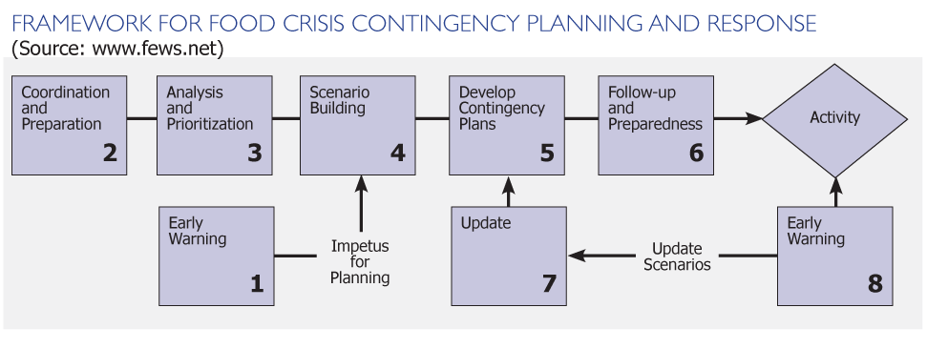

Below is an overview of the main steps in the diagram:

1. Early warning
Early warning triggers the contingency planning process. When the first signs of an emerging crisis are detected, contingency planning should begin or focus on updating relevant contingency plans. For example, when the first signs of drought are detected in an area where people are food insecure, planning for a food crisis should begin.

2. Coordinating and preparing the contingency planning process
An effective contingency planning process involves multiple actors, be they different offices or staff in one organization or staff from different organisations. To ensure that these actors are efficiently integrated into a productive planning process, it is necessary to organise. In essence, this involves making a plan to develop a contingency plan to determine who will do what, when and how.

3.a. Analysing context, hazards and risks
Planning for potential situations that have not yet occurred requires a good understanding of the hazards facing a population and the risks they present. The first substantive step in a contingency planning process is gaining a clear understanding of these hazards and their risks. This is done by collecting and analysing reports, maps, baseline data and other sources of information on the hazards faced in a country or region. This also involves discussing the issues with relevant experts and organisations.

3.b. Prioritising contingencies
Contingency planning can be an intensive process, and it is often done in a busy environment where people have limited time and resources to dedicate to the process. Therefore, planners must select a small number of contingencies and scenarios to address. Criteria for making this decision often include the potential severity of the crisis, its likelihood and the possibility that prevention measures will also guard against other potential contingencies. For example, a plan for dealing with a hurricane could help address flooding in the same area.

4. Building scenarios
A scenario is a set of assumptions on what will happen as the result of the contingency (e.g., hazard, threat, situation) for which you are planning. How many people will be affected? How will they be affected? Where are they situated? How long will they be affected? Plans are developed based on these assumptions. Scenario building is perhaps the most difficult step in the process, because it involves defining what will happen in the future, and, of course, there are infinite possibilities. Experience shows that developing flexible scenarios that support the development of easily adapted plans is the best approach.

5. Developing contingency plan(s)
Based on the scenarios that are developed, planners make decisions about what to do to address the situation they have described. For example, if the scenario estimates that 100,000 people will be food insecure and unable to meet their food needs for six months, a food aid program for that period could be conceived. Contingency plans should go beyond the definition of response options and define what would be required to implement the operation programmatically, operationally, logistically and administratively—and ultimately how much it will cost.

6. Implementing follow-up and preparedness actions
During the contingency planning process, actions that would increase preparedness or require follow-up inevitably emerge in discussions. A good contingency planning process will ensure that these steps are recorded, prioritised and implemented. The implementation of preparedness actions can be the most important part of contingency planning in terms of really improving the quality and speed of response. Without this follow-up contingency preparation, planning will be merely a paper exercise.

7. Updating contingency plans
Contingency plans become outdated as events overtake the assumptions originally made. Contingency plans must be regularly updated to ensure they are relevant. This also can facilitate the continuation of the contingency planning process and the relationships developed during the process.

8. Early warning
Early warning also triggers the implementation of contingency plans and preparedness actions identified during the planning process. When signs of an emerging crisis are detected, response measures—outlined in a contingency plan—should be implemented. Following the example above, when monitoring shows crop and pasture failure as the result of the drought, responses such as food aid, livestock health interventions, seeds and input support should start to be implemented according to the plan and the needs.

9. Activating contingency plans
When a crisis materialises, contingency plans must be implemented. Normally, an emergency assessment should be done and used to validate or repudiate the assumptions made in the contingency plan. Based on the results of the assessment, the contingency plan should be adapted, converted into a response plan and implemented.

Example of an Approach for Strengthening the Health System to Plan and Manage Increased Demand for SAM and MAM Services.

The CMAM surge approach was first piloted in Kenya and has since been applied in Uganda, Niger, Chad and Ethiopia. The approach is evolving as experience and learning is gained from the various countries. CMAM surge aims to make health systems more resilient over time by making them better able to cope with periodic peaks in demand for services for SAM and MAM—when the potential to save lives is often greatest—without undermining the capacity and accountability of government health actors (see Figure 1 below).

Figure 1. Theory of the Surge Approach

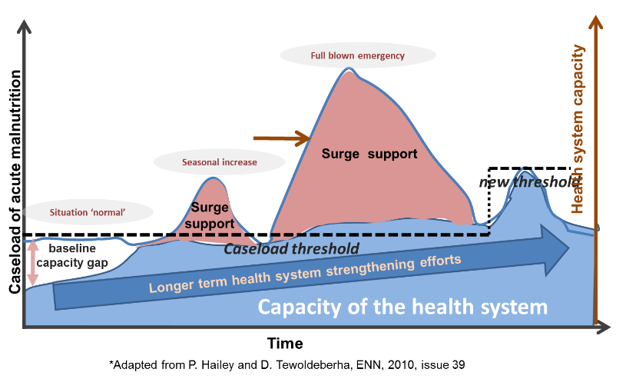

Below are eight steps involving analysing and planning, and real-time monitoring and taking action in response to the increased demand for services:

Step 1 – Trends and Situational Analysis: Aims to identify factors that affect demand for SAM and MAM services within the population around a given health facility or district catchment area. It involves analysing health facility data and the local factors that cause an increase in the SAM and MAM caseload, and periods when the peaks are expected to occur. The analysis also helps with determining the relationship between the identified factors and health facility resource needs, including determining how much staff is needed to meet the workload.

Step 2 – Capacity Review: Assists health facility staff with identifying the “normal” SAM and MAM caseload and their capacity to manage it. In the capacity review, the facility staff also reflect on the past situations when there was an increase in SAM and MAM caseloads to identify actions that need to be put in place before and during the peak periods for effective delivery of CMAM services.

Step 3 – Threshold Setting: Each health facility sets thresholds based on the number of new SAM and MAM admissions. The thresholds indicate four situation categories: normal, alert, serious, and emergency.
- Normal: The health facility can handle the workload and has adequate resources to meet demand for services.
- Alert: The health facility staff begin to be overstretched due to increased demand for SAM and MAM services but can handle the situation by reorganising to focusing on key priorities.
- Serious: The health facility is overstretched from the increased caseload and requires additional support from the District Health Management Team (DHMT) or partners to appropriately meet the additional demand.
- Emergency: The health facility staff is overstretched to the point when greater additional support is required from the DHMT and partners to ensure that services for SAM and MAM are functioning effectively and at full capacity and that the population can access appropriate services in a timely manner.

Step 4 – Defining and Costing the Surge Actions: The health facility staff prioritise actions to be carried out during the normal, alert, serious, and emergency situations. They also determine what actions can be done by health facility staff and when additional support, including funding and resources, are needed from the DHMT or partners.

Step 5 – Formalising Commitments: Ensures that there is confirmed commitment to the surge actions and that there is mutual agreement and understanding between the health facility, DHMT, and partners on who does what, when and how, with appropriate funding and resources allocated.

Step 6 – Monitoring Thresholds: Each health facility monitors new SAM and MAM admissions against their set thresholds for normal, alert, serious, and emergency categories. If admissions cross thresholds, a response is triggered and the relevant health facility staff, DHMT, and partners are alerted so they can implement surge actions they committed to.

Step 7 – Surge Action Scale-Up and Scale-Down: Involves trigger and scale-up of the package of surge actions to manage the increased number of children with SAM and MAM, and slowing down systematically to phase out activities as the situation normalises—according to the defined thresholds.

Step 8 – Reflect (Regular Review and Adaptation): Involves conducting periodic reviews on what was done well and where improvements can be made to thresholds, surge actions, and support interventions before the next surge cycle begins.

The overview provided above is based on Concern Worldwide’s. 2016. CMAM Surge Approach: Operational Guide. Available at: https://www.concern.net/sites/default/files/media/resource/cmam_surge_operational_guide_0.pdf

Module EIGHT: Monitoring and REPORTING oN CMAM

Module Overview
This module introduces participants to the basic principles of monitoring, reporting on and supervising community-based management of acute malnutrition (CMAM) services, with a focus on outpatient care.
The module describes how individual infants and children are tracked and monitored in CMAM and how monitoring information and data are collected and reported for the service/programme as a whole. The purpose and function of support and supervisory visits are discussed.
The importance of tracking infants and children between outpatient care and inpatient care, using referral slips, filling in the outpatient care treatment cards and using a simple numbering system has been previously covered. This module focuses on bringing it together through a simple monitoring system.
This module includes practical exercises that will provide participants with the opportunity to practice compiling data and information. It also includes a half-day field practice at an outpatient care site to observe registration, tracking, monitoring, reporting and supervision procedures.
Monitoring and reporting on CMAM combines outpatient care and inpatient care information, and performance indicators are based on these combined statistics. The monitoring system from each outpatient care and inpatient care site must be well standardized and coordinated to avoid double counting.
Note: This module does not cover monitoring and reporting on the supply system (e.g., management and transportation of equipment, materials, drugs, therapeutic food) or on human resources.

Learning Objectives | Duration | Handouts and Exercises
- Describe the Principles of a Monitoring and Reporting System for CMAM | 15 minutes
- Describe How the Individual Infant or Child Is Tracked and Monitored in CMAM | 45 minutes | Handout 8.1: Monitoring the Individual Infant or Child in Outpatient Care  Handout 8.2: Registration Numbering System Proposed for CMAM  Handout 8.3 Monitoring and Reporting on CMAM  Handout 8.4 Filing Outpatient Care Treatment Cards

- Complete Site Tally Sheets and Site and District Reports; Interpret the Findings | 1 hour | Handout 8.3 Monitoring and Reporting on CMAM  Handout 8.5 Site Tally Sheet for the Management of SAM and Nutritionally Vulnerable Infants Under 6 Months  Handout 8.6 Site Report Sheet for the Management of SAM and Nutritionally Vulnerable Infants Under 6 Months  Handout 8.7 District or National Reporting Sheet for the Management of SAM and Nutritionally Vulnerable Infants Under 6 Months  Exercise 8.1 (a) Outpatient Care Site Tally Sheet and Site Reporting Sheet  Exercise 8.2 Completing Site Tally Sheet
- Calculate and Discuss Service/Programme Performance and Coverage | 45 minutes | Handout 1.2 Terminology for CMAM  Handout 8.8 CMAM Indicators  Handout 8.9 Principles of Coverage  Exercise 8.1 (b) Outpatient Care Site Reporting Sheet
- Monitor and Respond to Barriers to Access | 30 minutes | Handout 8.10 Monitoring Barriers to AccessExercise 8.3 Community Meeting Role-Play
- Explain the Purpose of Support and Supervision Visits and the Role of a Supervisor/Mentor | 1 hour | Handout 8.11 Support and Supervision for CMAM  Handout 8.12 Support and Supervision Checklist for Outpatient Care  Handout 8.13 Support and Supervision Checklist for Community Outreach  Exercise 8.4 Analysis of the Site Reports of Three Outpatient Care Sites and One Inpatient Care Site  OPTIONAL: Supplemental Reference 8.1 Setting Up a CMAM Monitoring System Using an Electronic Database in Excel and Using a CMAM mHealth Application
- Prepare an Outline for CMAM Reporting | 30 minutes | Handout 8.14 Guidance on CMAM Reporting
Wrap-Up and Module Evaluation | 15 minutes
Field Visit for Monitoring and Reporting | ½ day | Handout 8.3 Monitoring and Reporting on CMAM  Handout 8.8 CMAM Indicators  Handout 8.12 Support and Supervision Checklist for Outpatient Care

Module Duration: Five hours in classroom, half-day field practice
Note: Depending on the needs of their audience(s), trainers may skip or spend more or less time on certain learning objectives and activities. The module duration is an estimate of the time it takes to complete all the learning objectives and activities.

Reference Resources
- Frank, T. 2017. A Mobile Health Application to Manage Acute Malnutrition. Lessons from Developing and Piloting the App in Five Countries. World Vision/Save the Children. Available at: http://www.transformnutrition.org/wp-content/uploads/sites/3/2017/04/TN_WorkingPaper1_MobileApp_Online.pdf.
- Myatt, M. et al. 2012. Semi-Quantitative Evaluation of Access and Coverage (SQUEAC)/ Simplified Lot Quality Assurance Sampling Evaluation of Access and Coverage (SLEAC) Technical Reference. Washington, DC: FHI 360/Food and Nutrition Technical Assistance Project (FANTA). Available at: https://www.fantaproject.org/sites/default/files/resources/SQUEAC-SLEAC-Technical-Reference-Oct2012_0.pdf.
- Valid International. 2006. Community-based Therapeutic Care: A Field Manual. (Chapters 9 and 10.) Oxford: Valid International. Available at: https://www.fantaproject.org/sites/default/files/resources/CTC-Field-Manual-Oct2006-508.pdf.

Further Reading Materials
- Roschnik, N.; Chui, J.; and Keane., E. June 2017. Preliminary Findings from a Malnutrition Mobile App Randomised Trial in Wajir, Kenya. Available at: http://www.transformnutrition.org/wp-content/uploads/sites/3/2017/06/TN_ResearchBrief14_Online.pdf.
- The Sphere Project. The Sphere Handbook: Humanitarian Charter and Minimum Standards in Humanitarian Response (2018 Revision). Available at: http://www.sphereproject.org/handbook/revision-sphere-handbook/draft-ready-for-feedback/food-security-nutrition/.
- FANTA. 2008. Report on the International Workshop on the Integration of Community-Based Management of Acute Malnutrition (Washington, D.C., April 28-30, 2008). Available at: http://files.ennonline.net/attachments/1200/integration-of-cmam-washington-enn-2008.pdf.

Handout 8.1 Monitoring the Individual Infant or Child in Outpatient Care
- Individual treatment of infants and children is monitored on an outpatient care treatment card. Each infant or child who is admitted to an outpatient care site will have an outpatient care treatment card, even if she/he is referred to inpatient care.
- The infant’s or child’s unique registration number is recorded on treatment cards, referral slips, ration cards and any other records. This will be the infant’s or child’s identifying number throughout his/her care.
- The outpatient care treatment card is kept on file at the outpatient care site. Registration in a registration book is usually not necessary.
- The mother/caregiver of a child 6-59 months receives a ready-to-use therapeutic food (RUTF) ration card that provides a record of the child’s progress and the RUTF received at each outpatient care follow-on session. The card includes key information about the child and basic information on his/her progress: name, age, caregiver (e.g., mother, father, grandmother), place of origin, outreach worker name, date of admission, dates of outpatient care follow-on sessions. At admission, discharge and each outpatient care follow-on visit, mid-upper arm circumference [MUAC], weight, height and ration received are also recorded. Upon discharge, the RUTF ration card is returned to the health facility to be attached to outpatient care treatment card.
- Individual infants and children are tracked as they are referred to different CMAM services (inpatient care, outpatient care or supplementary feeding) to ensure that admission, discharge and treatment procedures are followed and documented correctly. This is done by ensuring that outpatient and inpatient care treatment cards and referral slips are filled out properly and always include the infant or child’s unique registration number.
- The referral slip keeps track of infants and children who have moved between outpatient care and inpatient care. The referral slip should describe which treatment(s) and medicine(s) were given and why, to avoid giving children the same medicine twice.

Handout 8.2 Registration Numbering System Proposed for CMAM
- Each infant or child receives a registration number when she/he is first admitted to outpatient care, inpatient care or supplementary feeding. Each registration number has three parts: the health facility’s name or code, the infant’s or child’s individual number and the service code indicating where the child started treatment (inpatient care, outpatient care or supplementary feeding). Most infants and children will be admitted to outpatient care, as it is the most decentralised service and, therefore, the most common and accessible entry point for treatment.
- The code for each site must be established before services at that site start, must be unique for that site and must be used consistently by all staff to avoid confusion as to which site a child is receiving services. The site code should be three or four letters and should be easily understood.
- In countries where there is a standard numbering system as part of the health management information system (HMIS), the numbering system for CMAM should be adapted to take this into account. In adapting the HMIS numbering system, ensure that the site where each child entered CMAM and his/her initial CMAM service are included. If national guidelines for CMAM exist, they should be followed.

Table 1 Registration Numbering System
Example 1  Standard 3-part numbering system NYL/OO1/Out  NYL: The code of the site or health facility  001: Infant or child’s individual allocated number (the numbers run sequentially)  Out: Outpatient care, the service where the child started treatment | Example 2  HMIS numbering system from Malawi  77/88/999/MMYY/OTP  77: The 2-digit code for the district  88: The 2-digit code for the health facility  999: Infant or child’s individual allocated number  MMYY: Month and year of admission  OTP: Outpatient Therapeutic Programme, the service where the child started treatment

- To ensure effective tracking and follow-up in the community, ALL records concerning the infant or child should follow the same numbering system. This includes registration books (if used), treatment cards, ration cards and referral slips. Other relevant registration numbers—such as those given at other clinics or hospitals, HIV testing and counselling sites or antiretroviral therapy (ART) sites—should also be recorded on the outpatient care treatment cards.
- The registration number must appear on referral slips. The child retains the number upon return.
- Returning defaulters use the same number they had as they are still suffering from the same episode of undernutrition. Their treatment continues using the same treatment card.
- Readmissions (children who meet admission criteria again after being discharged cured, i.e. they relapsed) receive a new number and a new card as they are now suffering from a different episode of undernutrition and need full treatment again.

Handout 8.3 Monitoring and Reporting on CMAM
Routine quantitative service data are collected on site tally sheets that are filled out at the end of the service session and summarised on monthly site reporting sheets.

- This information is used to monitor the outputs and performance of the service/programme. Health managers and health care providers at the district or health facility level use the information to determine whether the target population is reached, to learn whether there are areas requiring investigation or strengthening or to monitor the effect of any changes made (e.g., new sites are opened, more community volunteers are added, more supplies are accessible).
- Systems should be set up from the beginning to build the monitoring and reporting capacity of health facilities and the District MOH to ensure, for example, that it follows national guidelines or a standarized reporting format and that it is done regularly and accurately. Reporting and feedback should be integrated with the existing health management information system (HMIS) as much as possible. The HMIS might need to be adapted to include indicators on management of acute malnutrition.

Site Tally Sheet Information

(See also Handout 8.5 Site Tally Sheet for the Management of SAM and Nutritionally Vulnerable Infants Under 6 Months.)

Routine service data that are tallied each service/programme session include:
The total number of infants and children under treatment at the Start of Week [A].
- The number of Total Admissions by entry category are either:
New cases < 6 months
New cases 6-59 months
New cases Other: children ≥ 5 years, adolescents or adults.
Old cases: Referrals who returned from inpatient care or outpatient care and are readmitted to the site; or Returned defaulters (who did not recover and returned after discharge to continue treatment)
Optional: New admissions can be categorised by gender or by admission criteria (bilateral pitting oedema, mid-upper arm circumference [MUAC], weight-for-height [WFH]/weight-for-length [WFL]), which can help identify differences in the type of undernutrition in different areas (e.g., cases of bilateral pitting oedema might be much higher in some areas than others or higher in certain seasons)

- The number of Total Discharges by exit category:
Cured: Reached the discharge criteria after treatment -categorised by age group (< 6 months, 6-59 months and other)
Died: Died while in treatment -categorised by age group (< 6 months, 6-59 months and other)
Defaulted: Left the service/programme before reaching the discharge criteria, children were absent for 3 consecutive sessions -categorised by age group (< 6 months, 6-59 months and other)
Non-recovered: Do not meet the discharge criteria after four months in treatment (after medical investigation done) -categorised by age group (< 6 months, 6-59 months and other)

- Other exit category:
    - Referrals: Infants and children who left the site temporarily because they were referred to inpatient or outpatient care or for medical investigation

Note: Because services must track infants and children and not double-count them, infant and children who are referred between outpatient care and inpatient care are not considered full discharges; they are on referral status. They remain in the service/programme. In contrast, non-recovered infants and children—who have been referred earlier for medical investigation—leave the service/programme if they are still not responding to treatment after four months.

Optional quantitative data to collect to monitor effectiveness of treatment include average daily weight gain (AWG), average length of stay (LOS) of cured discharges and the readmission rate. These can be calculated for all infants and children that are discharged cured or on a random sample. AWG and LOS for cured cases of kwashiorkor or marasmus should be calculated separately.

- AWG of cured discharges in outpatient care is expected to be above 4 g/kg/day.
- LOS of cured discharges in outpatient care is expected to be below 60 days.
- Readmissions after discharge (or relapse): Interventions might be needed at the household level to avoid high readmission rates (number of readmissions per total new admissions); high rates might also mean children have been discharged too soon.

Site Reporting Sheet Information

(See also Handout 8.6 Site Report Sheet for the Management of SAM and Nutritionally Vulnerable Infants Under 6 Months.)
- The site tally sheet information is compiled in the site reporting sheet, and rates of infants and children discharged as cured, died, defaulted and non-recovered are listed as proportions of the total discharges. Site reporting sheets are sent to the district health office monthly.
  - Epidemiological weeks can be used to define calendar months for reporting (e.g., weeks 1-4 = January; weeks 5-8 = February).
  - Site reporting sheets feed information into district, sub-national or national reporting sheets.

District Reporting Sheet Information

(See also Handout 8.7 District Reporting Sheet for the Management of SAM and Nutritionally Vulnerable Infants Under 6 Months.)
The reporting sheets from all health facilities with inpatient care and outpatient care are compiled in the district reporting sheet, and rates of infants and children discharged as cured, died, defaulted and non-recovered are listed as proportions of the total discharges. The categories ‘old cases’ and ‘referrals’ are omitted as these children have not exited the service/programme.
- The compiled reporting sheets can be used at sub-national and national levels, and the reporting period can be adjusted as convenient or appropriate (e.g., month, year).

Other Information
- Qualitative information is also collected from the communities and beneficiaries of CMAM to understand the perceptions of the service/programme and to help managers better understand possible problems such as high default rates or low coverage.
- Other information to collect from the mothers/caregivers and/or community:
  - Reported cause and place of death: Recording this information on the infant or child’s outpatient care treatment card can help identify problems with treatment and use of action protocols, and determine where additional training and supervision might be needed.
  - Reasons for default and non-recovery: These could include a high prevalence of tuberculosis (TB) and/or HIV, sharing of food in the household or poor water and sanitation, which might indicate a need for stronger service linkages with other sectors.
- Supervisory and Community Outreach: See Handout 8.10 Monitoring Barriers to Access and Module 3: Community Outreach.
- Coverage: See Handout 8.9 Principles of Coverage.

Using Site Reports to Determine Service Performance
- The health facility site report is developed monthly (using full four or five epidemiological weeks for the month, determined beforehand at the national level) and should be reviewed by the health facility or district management team during monthly or quarterly meetings.
- The supervisor or supervisory team from the District Ministry of Health (MOH) will be responsible for reviewing health facility site reports.
- Service/programme performance (the proportions of infants and children who were cured, died, defaulted and non-recovered) can be compared with Sphere key indicators (the minimum standards). The Sphere standards might not be applicable to development services/programmes. However, there are currently no internationally accepted standards for CMAM in non-emergency contexts. Therefore, the Sphere standards can be used as a benchmark.
- The monthly site reports can be used to address any issues that have emerged. The information can be useful to hold meetings with the community to find out more about the reasons for specific problems, such as high defaulter rates, or issues such as why mothers/caregivers do not bring their children to outpatient care. This can be done through focus group discussions.
- The data can be tracked using an electronic spreadsheet or mobile applications such as mHealth. Supplementary Reference 8.1 Setting Up a CMAM Monitoring System Using an Electronic Database in Excel and Using a CMAM mHealth Applications describes how to use Excel spreadsheets for program monitoring. The reference also provides country experiences and lessons learned with the use of a mobile applicate to manage CMAM data.

Compiling and Analysing Site Reports for National Reporting (Whole Service/Programme)
- The site reports from the different CMAM sites (outpatient care and inpatient care) are compiled into overall district, sub-national or national reports. See Handout 8.7 District or National Reporting Sheet for the Management of SAM and Nutritionally Vulnerable Infants Under 6 Months for an example.
- Individual CMAM sites send their site tally sheets and/or site reporting sheets to the District MOH. The district health officer-in-charge is responsible for compiling the individual site reports into a combined report for the district CMAM service as a whole.
- In a country context where CMAM reporting is integrated with the HMIS, the site or health facility report will be compiled and entered into the HMIS database or platform at the facility or district level depending on the national guidelines.
- The district sends or transmits its compiled monthly district reports to the MOH at the national level.
- The reports will help to identify issues and gaps and determine whether progress has been made toward accomplishing objectives.
Handout 8.4 Filing Outpatient Care Treatment Cards
- All active and past outpatient care treatment cards are kept in files that should be accessible at the health facility at all times. This ensures the ability to monitor infants and children, cross-check readmissions and verify reports.
- There should be two files: one for active cases, with a separate section for referrals, and the other for discharges, with separate sections for cured, died, defaulted and non-recovered.

Table 1. Filing System

File 1: Active Cases | File 2: Exits
Sections:  Infants and children currently in treatment  Note: Mark the outpatient care treatment cards of infants and children who are not responding well and need follow-up home visits and of absentees (infants and children who have missed one or two outpatient care follow-on visits).  Separate section:  Referrals awaiting return: infants and children who have been referred to inpatient care or for medical investigation | Sections:  Cured: infants and children who reached the discharge criteria and exited the service/programme  Note: Check this file for any readmissions after default as the same outpatient care treatment card should be used.  Died: infants and children who died while in treatment  Defaulted: infants and children who have been absent consecutive sessions  Non-recovered: infants and children who did not respond after four months in treatment despite referral for medical investigation

- Referrals to inpatient care: The “referrals awaiting return” file should be checked regularly. The infant or child should receive a follow-up home visit by outreach workers (e.g., community health workers [CHWs], volunteers) if she/he does not return to outpatient care from inpatient care within two weeks. If the infant or child dies in inpatient care, the outpatient care treatment card is filed under “died.”
- Defaulted (absent for three consecutive sessions): Infants or children who defaulted should receive a follow-up home visit, and their mothers/caregivers should be encouraged to return to CMAM services. The reason for default should be investigated by the outreach worker, reported to the health care provider and recorded on the child’s outpatient care treatment card. Steps should be taken to address the cause of the default.
- Died: A record of the infant’s or child’s symptoms and diagnosis should be recorded on the outpatient care treatment card and used to identify any problems with the treatment or the action protocol.
- Infants and children who are not responding well and need a follow-up home visit: When infants or children are not responding well in the service/programme and the action protocol indicates that follow-up at home is needed (e.g., if the child has lost weight), the outreach worker should identify and report to the health care provider all possible reasons the child is not recovering. The health care provider records this information on the child’s outpatient care treatment card and uses the information to decide whether to refer the infant or child to inpatient care or for further medical investigation. Smooth communication channels between outpatient care health care providers and outreach workers are essential for requesting follow-up home visits and monitoring children, especially when outreach workers cannot attend the outpatient care session.

Handout 8.5 Site Tally Sheet for the Management of SAM and Nutritionally Vulnerable Infants Under 6 Months
HEALTH FACILITY NAME:  DISTRICT:  SITE:  WEEK: |  |  |  |  | TOTAL
DATE
TOTAL START OF WEEK (A)
New Cases < 6 months – all admission criteria (B1)
New Cases 6-59 m Bilateral Pitting Oedema (B2a)
New Cases 6-59 m MUAC/WFH (B2b)
Other New Cases, (children ≥ 5 y, adolescents, adults) (B3)
Old cases: Referred from Outpatient or Inpatient care; other outpatient care; or Returned defaulters (C)
TOTAL ADMISSIONS (D) [D=B+C]
Cured < 6 months (E1a)
Cured 6- 59 months (E1b)
Cured Other (children ≥ 5 y, adolescents, adults) (E1c)
Died < 6 months (E2a)
Died 6- 59 months (E2b)
Died Other (children ≥ 5 y, adolescents, adults) (E2c)
Defaulted < 6 months (E3a)
Defaulted 6- 59 months (E3b)
Defaulted Other (children ≥ 5 y, adolescents, adults) (E3c)
Non-recovered < 6 months (E4a)
Non-recovered 6- 59 months (E4b)
Non-recovered Other (children ≥ 5 y, adolescents, adults) (E3c)
REFERRALS TO OUTPATIENT OR INPATIENT CARE (F)
TOTAL DISCHARGES (E) = (E1abc + E2abc + E3abc + E4abc)
TOTAL EXITS (G) [G=E + F]
TOTAL END OF WEEK (H) [H=A+D-G]
Handout 8.6 Site Report Sheet for the Management of SAM and Nutritionally Vulnerable Infants Under 6 Months
MONTHLY REPORT FOR MANAGEMENT OF SAM and Nutritionally Vulnerable Infants Under 6 Months- SITE
SITE |  |  |  | IMPLEMENTED BY
REGION |  |  |  | MONTH / YEAR
 |  |  |  | TYPE OF MANAGEMENT  (CIRCLE) |  |  | Inpatient |  |  | Outpatient
DISTRICT |  |  |  |  |  | ESTIMATED MAXIMUM CAPACITY
ESTIMATED TARGET malnourished <5's
(based on latest survey data and admission criteria)
 |  |  |  |  | RUTF Consumption |  | packets/sachets |  | kg equivalent

Age Category | Total beginning of the month (A) | New Cases  (B) | OLD CASES  (C) |  | TOTAL NEW ADMISSIONS  (D)  B+C = D |  |  |  | Discharges  (E) |  |  |  | REFERRAL (F)  to inpatient or outpatient care | TOTAL EXITS (G)  (E+F=G) | TOTAL END OF THE MONTH (H)  (A+D-G=H)
 |  |  |  |  |  |  |  |  | CURED  (E1) | DIED  (E2) | DEFAULTED (E3) | NON-RECOVERED (E4) | REFERRAL (F)  to inpatient or outpatient care | TOTAL EXITS (G)  (E+F=G)
< 6 Months (according to admission criteria)
6-59 Months
(according to admission criteria)
Other
(children ≥ 5 y, adolescents, adults)
TOTAL
 |  |  |  |  |  |  |  |  | % | % | % | %
 |  |  |  | TARGET  (Sphere Standards) |  |  |  |  | >75% | <10% | <15%
Handout 8.7 District or National Reporting for the Management of SAM and Nutritionally Vulnerable Infants Under 6 Months

DISTRICT (or NATIONAL) REPORTING SHEET (combining inpatient care with outpatient care)

(PERIOD/YEARLY) REPORT FOR MANAGEMENT OF SAM IN CMAM (INPATIENT CARE AND OUTPATIENT CARE)
COUNTRY/  STATE/DISTRICT |  |  |  |  |  |  | IMPLEMENTING PARTNER(S)
NUMBER OF TREATMENT SITES |  |  |  | NUMBER OF  OUTPATIENT CARE SITES
 |  |  |  | NUMBER OF  INPATIENT CARE SITES |  | REPORTING PERIOD
 |  |  |  | ESTIMATED MAXIMUM CAPACITY
ESTIMATED TARGET;
Children with SAM 6-59 months of age in a given period
ESTIMATED COVERAGE
RUTF Consumption

Age Category | Total beginning of the period (A) | New Cases  (B) |  |  | TOTAL ADMISSION  (B) | Discharges  (E)
Age Category |  |  |  |  | TOTAL ADMISSION  (B) | CURED  (E1) | DIED  (E2) | DEFAULTED (E3) | NON-RECOVERED (E4)
< 6 Months
(according to admission criteria)
6-59 Months
(according to admission criteria)
Other
(children ≥ 5 y, adolescents, adults)
TOTAL
 |  |  |  |  |  | % | % | % |  | %
 |  |  |  | TARGET  (Sphere standards) |  | >75% | <10% | <15%

Handout 8.8 CMAM Indicators

There are two basic sets of indicators: performance indicators and output indicators.

1. Performance indicators (or outcome indicators) measure whether a CMAM service/programme has achieved its objectives and planned outcomes, which are measured in percentages.

- These indicators tell how many infants and children (and proportion in percentage) who are admitted in the service/programme are discharged as cured, died, defaulted or non-recovered. Indicators for outpatient care and inpatient care per district or at the national level will be merged to evaluate the overall performance of the service/programme. Results can be compared with international minimum standards for therapeutic feeding programmes in emergency settings, established by the Sphere Project. These Sphere minimum standards might not be applicable in non-emergency contexts, but this has not yet been tested.

- % cured (or recovered) Sphere minimum standard: > 75%
- % died Sphere minimum standard: < 10%
- % defaulted Sphere minimum standard: < 15%
- % non-recovered No Sphere indication

- In addition, it is important to determine whether the service/programme is achieving its aims, in terms of access and utilization (coverage). The best way to do this is through a population-based coverage survey. In rural contexts, the programme should achieve at least 50 percent coverage of the total eligible population—malnourished infants and children under 5—according to Sphere minimum standards.
Simple methods to determine coverage without conducting an expensive coverage survey are being investigated. Cruder methods, such as comparing actual admissions to the expected caseload (based on estimated prevalence and incidence), can be used to estimate coverage for monitoring purposes, in between population surveys. Exhaustive screening in purposively selected communities can also provide useful information on coverage.

- The optional indicators of average daily weight gain (AWG) and average length of stay (LOS) of cured infants and children could be calculated for all infants and children or a random sample of infants and children (new cases only) who are discharged cured. The indicators are calculated for marasmus and kwashiorkor cases separately.
Note: AWG and LOS for outpatient care are not essential information but can provide information on the effectiveness of treatment.

- The AWG of cured infants and children in outpatient care is expected to exceed 4 g/kg/day (the Sphere minimum standard for AWG based on traditional centre-based inpatient care is at least 8 g/kg/day). A low AWG could indicate factors such as a high absence rate, high default rate, ineffective treatment, sharing of ready-to-use therapeutic food (RUTF) and/or non-compliance to the treatment protocol.
To calculate AWG, first determine weight gain of each cured infant or child in the sample: Weight gain (g/kg/day) is [discharge weight in g – minimum weight in g] divided by [minimum weight in kg x number of days between minimum weight and discharge day]. AWG is the sum of the weight gains (g/kg/day) in the sample divided by the number of cured children/treatment cards per category (marasmus or kwashiorkor) in the sample.

- The LOS of cured infants and children in outpatient care is expected to be less than 60 days. A long LOS might be the result of factors such as a high proportion of infants or children who do not recover, frequent absences, defaulting, sharing of the RUTF and/or unresolved illness. A short LOS might indicate that infants and children are discharged too soon, a finding that could be supported by a high relapse rate.
LOS is calculated by adding the length of stay for all cured children in the sample and dividing the sum by the number of cured children/treatment cards per group of cured children in the sample.

2. Output indicators measure whether a service/programme has completed the planned activities/outputs needed to achieve the established goals and objectives. They are measured in numbers or percentages and should be specific to the activities/outputs established.

Examples of output indicators are:
- Number of health facilities with established inpatient care and/or outpatient care
- Number of infants and children admitted to inpatient care or in outpatient care per time period
- Number of infants and children under treatment per time period
- Number of infants and children discharged per time period
- Number or percentage of health care providers trained and active in case management in outpatient care
- Number or percentage of health care providers trained and active in case management in inpatient care
- Number or percentage of community health workers (CHWs) trained and active in community outreach
- Number or percentage of volunteers trained and active in community outreach
- Number or percentage of mothers and caregivers trained in MUAC measurement and checking for bilateral pitting oedema

Additional indicators will depend on the service/programme’s aim and monitoring needs. For example:
- Number of infants and children referred by mothers, caregivers, and volunteers and admitted to outpatient care
- Percentage of communities in the target area within one day’s return walk to CMAM services
- Percentage of health facilities in the district or target area that provide CMAM services
- To ensure that barriers to access are assessed through regular meetings with volunteers and community stakeholders, possible indicators include:

- Number and percentage of infants and children under 5 years screened in the community
- Number of infants and children under 5 years identified and referred for treatment
- Number of infants and children under 5 years referred for treatment and admitted

- Number of meetings between community outreach coordinators and/or workers and the community per time period

Table 1. Summary of Performance Indicators

- Total number of new admissions
- Total number of discharges*
- Total number of infants and children in treatment
- Information on new admission <6 months (based on all admission criteria)
- Information on new admissions 6-59 months:
a. Proportion of children with SAM admitted on bilateral pitting oedema, low mid-upper arm circumference (MUAC), low weight-for-height (WFH)
b. Proportion of children with SAM admitted by gender

Benchmarks | Sphere Standards  (Emergencies) | CMAM  (Adapted)
% Cured  Proportion of infants and children discharged cured, out of total discharges* | > 75% | > 75%
% Died  Proportion of infants and children who died while in treatment, out of total discharges* | < 10% | < 10%
% Defaulted  Proportion of infants and children recorded as absent for three consecutive sessions, out of total discharges* | < 15% | < 15%
% Non-recovered  Proportion of infants and children who had been referred for further medical investigation and are discharged non-cured after four months in treatment , out of total discharges* | < 10% | < 10%
% Coverage  Proportion of infants and children with SAM who are in treatment out of total number of children with SAM in the community | 50% (rural)  70% (urban) | > 70%
Average daily weight gain (AWG) (calculated from a sample of infants and children cured per category [kwashiorkor or marasmus])
= sum of weight gains in a sample divided by number of children cured or treatment cards in the sample
Average length of stay (LOS) (calculated from a sample of infants and children discharged cured of kwashiorkor and marasmus)
= sum of length of stay in a sample divided by number of infants and children cured or treatment cards in the sample
* Total discharges comprises the cured, died, defaulted and non-recovered categories.

Table 2. Summary of Output Indicators

Number of functioning outpatient care sites
Number of functioning inpatient care sites
Number of functioning supplementary feeding sites
Number of health care providers trained in outpatient care and referral based on action protocol (plus gender distribution of trainees)
Number of health care providers trained in inpatient care and case management (plus gender distribution of trainees)
Number of CHWs trained in community outreach (plus gender distribution)
Number of volunteers trained in community outreach (plus gender distribution)
Number of mothers and caregivers trained in MUAC measurement and checking for bilateral pitting oedema
Number of communities mobilised

Handout 8.9 Principles of Coverage
- The priority in CMAM is to make treatment available to the greatest number of infants and children in an affected population. Therefore, it is important to assess coverage, the proportion of children who need assistance who actually receive care in the service/programme. Infants under 6 months of age should be included when assessing coverage.
- Coverage is usually expressed as a percentage. For example, if there are 100 children with SAM in a service/programme area and 70 of them are in the service/programme, then coverage is 70 percent.
- Coverage is one of the most important indicators of how well a service/programme is meeting the need. A service/programme with a high coverage rate and a low cure rate might be better at meeting the need than one with a low coverage rate and a high cure rate.
“Met need” is the product of the coverage rate and the cure rate. If, for example, a service/programme has a coverage rate of 70 percent and a cure rate of 90 percent then “met need” expressed as a percentage can be calculated as: 70 x 90/100= 63%, indicating that the service/programme is meeting 63% of the need.

- High-quality services/programmes have both high coverage and high cure rates.
- The coverage of a CMAM service/programme is mapped and estimated using a population-based coverage survey. The coverage survey methods called Semi-Quantitative Evaluation of Access and Coverage (SQUEAC)/ Simplified Lot Quality Assurance Sampling Evaluation of Access and Coverage (SLEAC) are commonly used in CMAM. SQUEAC combines routine program monitoring data, an array of qualitative information, and small-sample quantitative surveys. This combination of data permits identification of key issues affecting timely presentation at a clinic programme and estimates of the level of programme coverage achieved. SLEAC is a small-sample quantitative method for mapping and estimating coverage over large areas; it is low-resource method for classifying and estimating the coverage of selective feeding programmes. The two methods are normally used together. More information on SQUEAC and SLEAC is available at: https://www.fantaproject.org/monitoring-and-evaluation/squeac-sleac.

Handout 8.10 Monitoring Barriers to Access
Since coverage surveys are infrequent and resource-intensive, it is important to monitor barriers to access regularly by keeping an eye on routine data collected by the service/programme.

- Barriers of special concern: The starting point for routine monitoring should be the information collected during the community assessment (see Module 3: Community Outreach), which can reveal context-specific barriers that must be addressed. For example, if the community assessment showed that certain communities, ethnic groups or locations are marginalised, then enrolment data from these areas should be watched closely. If the assessment indicated that adherence to traditional treatments and healers was particularly strong in a specific area or that tension exists between community leaders and service providers, then the routine monthly and quarterly reporting from these communities should be scrutinised carefully.
- Common barriers: In addition to issues highlighted by the community assessment, routine monitoring can reveal additional information on barriers to access, e.g.:
  - Comparing admission numbers across outpatient care sites, which would show whether the numbers reflect the size of known populations or catchment areas
  - Watching for health facilities or communities where admissions drop abruptly, which could indicate that a supervisory visit is needed to help staff clarify confusing admissions procedures, to correct misconceptions about eligibility in the community or to address other reasons for the decline
  - Monitoring the number of absentees and defaults at the outpatient care sites; for example, an increase could signal a variety of local problems such as interruptions to the supply chain, seasonal barriers to access or poor quality of service or instruction from the outpatient care providers
  - Scrutinising reports to ensure that community outreach is being performed

- Corrective actions: Monitoring should be tied to actions designed to address the problem. Corrective actions can usually take place in the context of routine supervisory visits, where service/programme managers meet and mentor local facility-based staff (see Learning Objective 6). In devising corrective measures, it is useful for managers to seek non-staff perspectives, including the views of community leaders, people who use the service/programme and those who do not.
- Local monitoring: Health care providers should conduct their own routine monitoring. For example, they could divide their catchment area into segments and use registration data to check whether outreach is taking place and whether admissions are coming from the parts of the community they were expected to. Finding solutions to issues flagged by routine monitoring requires health care providers to meet occasionally with community members and outreach workers.

Handout 8.11 Support and Supervision for CMAM
- Support and supervision/mentorship, meaning continuous support and motivation with the purpose of improving performance, should be the overarching objective of the supervisor or supervisory team.
- Responsibility for supervising all CMAM services/programmes should be established during the planning stages. Supervisors are responsible for ensuring that the service/programme is running smoothly and for overall service quality.
- Supervision visits may be conducted by the district health management team or equivalent and may be part of an integrated supervisory visit, where supervisors check as well on other services.
- Supervisors should ensure that treatment cards are completed and filed correctly. Supervisory visits should include review of the treatment cards, particularly the cards of infants and children who have died, defaulted or not recovered. The supervisor should ensure that admissions and discharges are made according to established criteria and that treatment protocols are performed correctly. The supervisor also should check whether the action protocol is properly followed so that cases are referred and/or followed up where appropriate.
- Supervisors should work closely with the health care providers and outreach workers (e.g., community health workers [CHWs], volunteers) at the outpatient care site to ensure that any issues regarding service delivery, follow-up home visits or the management of individual cases can be identified and followed up.
- Supervisors can use a supervisor checklist. This can be adapted to the context and should follow national protocols and the national health management information system (HMIS).
- Supervisors, health care providers and outreach workers (e.g., CHWs, volunteers) should have scheduled meetings to discuss any service/programme issues. The meetings should cover:
- Issues in service/programme management, including a review of the caseload to determine whether it is manageable for the number of staff available, any expected increases/decreases in the caseload because of the season or a sudden population influx and a contingency plan to handle unexpected changes in caseload or other management challenges
- Other staff issues
- Factors that might affect attendance or require adjusting the outpatient care schedule (e.g., when the harvest season approaches)
- Supply issues and planning
- A review of deaths in outpatient care and inpatient care to identify any problems with using the action protocol or treatment protocol and to determine whether actions and treatments could have been conducted differently
- A review of defaults
- A review of infants and children who do not respond to treatment, such as infants and children who do not gain weight or who lose weight
- A review of non-recovered children (those who do not meet discharge criteria after four months of treatment [after medical investigation is done])
- A review of referrals to ensure effective tracking within the CMAM service/programme
- Any issues in the community that might affect service/programme access and uptake (coverage)
- A review of monitoring and reporting systems
- A review of site tally sheets and site reports
- It is good practice to keep supervision reports on file to track the progress of individual sites over time.

Table 1. Supervisor Responsibilities (example for outpatient care at the health facility level)

Observation of Treatment and Completion of Treatment Cards | Tracking and Reporting
- Outpatient care treatment cards, ready-to-use therapeutic food (RUTF) ration cards (and health passports/health cards, where used) are completed  - Infant or child’s progress is closely monitored and recorded on his/her treatment card throughout treatment.  - Admissions and discharges are made according to protocols and noted on the treatment cards.  - Medical assessments (medical history and physical examination) are conducted and noted on the treatment cards.  - Routine and supplemental medicines are given and noted on the treatment cards.  - Appetite tests are conducted and noted on the treatment cards.  - Feeding assessment is conducted and recorded on the infant treatment card  - Breastfeeding counselling and support is conducted and recorded on the infant treatment card  - Illnesses reported by the mothers/caregivers are noted on the treatment cards.  - Any deterioration in infant or child’s condition is identified, addressed according to the action protocol and noted on his/her treatment card.  - Absences and defaults are noted on the treatment cards and followed up.  - Referrals are noted on the treatment cards and followed up.  - Deaths are noted, and symptoms and the reported cause of death are investigated and recorded on the treatment cards. | - Unique number system is being used.  - Referral slips are completed.  - Tally sheets are completed, compiled and filed.  - Site reports are developed from the tally sheets and sent on time to the appropriate agency (e.g., Ministry of Health [MOH], a specific nongovernmental organisation [NGO], the United Nations Children’s Fund [UNICEF]).
 | Supplies and Planning
- RUTF supplies are adequate and stored appropriately.

- Request for RUTF supplies is made to the appropriate agency or the MOH.

- Supply of essential drugs (routine medicines) is adequate.

- Request for medicine supplies is made to the appropriate agency or the MOH.

- Stock records for medicines and RUTF are completed.

Tips for Supervisors/Mentors
- Supervisory visits are conducted to help health care providers improve their performance. The visits should be seen as an ongoing part of the capacity development strategy and the motivation of health care providers.
- The best way to determine whether a health care provider is performing well is to watch him/her perform on the job. This observation should be followed by a discussion of what was observed and of the data the supervisor collected and recorded on monitoring forms (supervision checklist).
- Supervisory visits are the best time to identify any important areas in which particular health care providers can improve before the next supervisory visit.
- People who are praised for what they are doing well are motivated to continue to do a good job.
- If a health care provider needs to improve on a certain action, the supervisor first should show him/her how to perform the action more accurately. Then the supervisor should ask him/her to repeat the improved action on his/her own while the supervisor observes.
- If a health care provider has several areas to improve on for the next supervisory visit, the supervisor should have the person work on the area that will make the biggest difference if improved. The supervisor should address less important issues after the health care provider has mastered the priority area.

Guidance Checklist for a Supervisory Visit

During the pre-arranged supervisory visit, the supervisor/mentor:
- Courteously asks to accompany individual health care providers during their regular activities
- Observes the job performance of health care providers
- Stays in the background during the activities and does not interfere or give feedback until all the health care provider’s activities are finished
- Discusses job performance with health care provider in private
- Provides feedback to the health care provider
- Praises the health care provider for what she/he is doing well to motivate her/him to continue this performance
- Works with the health care provider to identify important areas for improvement
- Shows the health care provider what has worked well in her/his experience and then gives him/her a chance to try it while observing
- Plays the role of mentor
- Schedules a follow-up supervisory visit

Handout 8.12 Support and Supervision Checklist for Outpatient Care (Example)

Health Facility:_____________________________ Date:_________________
 | Total observed | Total correct | Direct observation at site | Quality  1 – Done correctly  2 – Done but needs improvement  3 – Not done/ done incorrectly |  |  | Comment
Number of health care providers (staff) and volunteers present |  |  |  |  |  |  | Staff:  Volunteers:
Staff greet mothers/caregivers and are friendly and helpful
Registration numbers assigned correctly | Total new admissions in past month__
Registration numbers written on all documents
Grade of bilateral pitting oedema measured accurately | Total bilateral pitting oedema checks observed___
Mid-upper arm circumference (MUAC) measured accurately | Total MUAC checks observed___
Weight measured accurately | Total weighings observed___
Height measured accurately | Total measurements observed___
Weight-for-height (WFH) classification done correctly | Total WFH checked___
Admission is according to correct criteria | Total treatment cards checked___ |  |  |  |  |  | (Spot check cards)
Medical history recorded accurately | Total medical histories observed____
Physical examination performed and recorded accurately | Total treatment cards checked___ | Total w/full exam ____ |  |  |  |  | (Check card)
Infant under 6 months: Initial breastfeeding assessment performed and recorded accurately | Total treatment cards checked___ | Total w/full exam ____ |  |  |  |  | (Check card)
Infant under 6 months: Follow-on breastfeeding counselling and support provided and recorded accurately | Total treatment cards checked___ | Total w/full exam ____ |  |  |  |  | (Check card)
Child’s appetite tested using ready-to-use therapeutic food (RUTF), upon admission and during outpatient care follow-on sessions |  |  |  |  |  |  | How tested and by whom?
Routine medication given according to protocol and recorded accurately | Total treatment cards checked___ | Total with correct medicines__
Amount of RUTF needed is correctly calculated | Total treatment and ration cards checked____
Appropriate education given to mothers/caregivers |  |  |  |  |  |  | Note topic and form:
Follow-up medicines given according to protocol and recorded accurately | Total treatment cards checked___
RUTF ration cards completed correctly | Total treatment cards checked ____ |  |  |  |  |  | (Spot check)
Slow responders are identified according to the definition for follow-up and communicated to outreach workers | Total problem cases needing follow-up home visit during past month___ | Total
Priorities for follow-up home visits discussed with outreach worker; list of names recorded/ cards marked |  |  | List/ clear discussion?
Beneficiaries discharged according to protocol | Total treatment cards checked___
Correct number of absentees/defaults identified for follow-up home visits | Total number of absentees/ defaults according to treatment cards___ | Total w/ outcome recorded___
Tally sheets, reporting sheets and stock cards completed correctly | Total weeks reviewed____ |  |  |  |  |  | (Spot check)

Handout 8.13 Support and Supervision Checklist for Community Outreach (Example)

Question/Issue | Why?
Coordination of Outreach
Has someone at the facility level been designated as responsible for managing/coordinating community outreach efforts? | Outreach is less clear-cut and less glamorous than clinical work, and health managers and health care providers might need reminding that outreach is also part of CMAM.
Has the job of the outreach worker (case-finder) been clearly defined, including his/her range of responsibilities and level of effort? | Case-finders are sometimes recruited before the amount of work required is specified.
Do outreach workers meet periodically (e.g., monthly, quarterly) with the designated outreach coordinator? | Supervisory meetings might help to motivate case-finders, especially when they are unpaid.
In general, do outreach workers feel they receive adequate information and support from the outreach coordinator? | Supervisory meetings should be an opportunity for two-way communication, not just for giving instructions.
Does the outreach coordinator appear familiar with basic service/programme data (e.g., admissions, absentees, defaults)? | The outreach coordinator should be interpreting this data and using it to adjust outreach methods and priorities.
Does the outreach coordinator have a means of discussing outreach problems or issues with community leaders? Is this being used? | Not all issues can be addressed by discussion between the outreach coordinator and the outreach workers alone. Problems such as defaulting and barriers to access might require the inclusion of community leaders, mothers/caregivers and other stakeholders.
Case-Finding
What form of case-finding is being used locally? Is it still the most appropriate form? | The service/programme might need to alter case-finding methods as levels of acute malnutrition and community awareness change.
How active are case-finders? Is this level of activity appropriate, given SAM prevalence? | Active case-finding should not be so frequent as to be intrusive, but neither should it be left alone for too long. During periods of high acute malnutrition prevalence and while awareness of CMAM is still low, monthly screenings might be appropriate.
Follow-Up Home Visits
Has responsibility for follow-up home visits been clearly designated and accepted in all parts of the health facility catchment area? | Follow-up might break down unless it is worked out in advance who is responsible for following up cases in a given location.
Are absentees and infants or children who defaulted being followed up reliably with follow-up home visits? | Even with clear lines of responsibility, follow-up might not occur. The reasons for this must be understood and addressed.
What do outreach workers and community members say about the value of these visits? | Outreach workers who perform follow-up home visits sometimes need further training on advising and negotiating effectively with families.

Handout 8.14 Guidance on CMAM Reporting

Monthly Site or District Reports
The monthly report (per site, district or overall at the national level) presents quantitative information on service/programme performance (key performance indicators). It provides basic information to monitor the effectiveness of the CMAM service/programme.

Reporting on Service/Programme Performance
The monthly, quarterly, or yearly report presents key quantitative and qualitative information and analysis and interprets the information in a comprehensive manner. The report should include the following essential information:

General
- Author of report  - Date and period of reporting  - Geographical catchment area and population | - Name of health facilities with outpatient care and/or inpatient care  - Starting date of services/programmes

Performance and output indicators for case management in inpatient care and outpatient care combined, per time period:
- Number of new admissions  - Number of discharges  - Number of beneficiaries in treatment  - Number and percentage cured  - Number and percentage died  - Number and percentage defaulted  - Number and percentage non-recovered  - Number of referrals to inpatient care or hospital | - Number of sites  - Number of new sites added  - Number of staff (e.g., health managers, health care providers, community health workers [CHWs], volunteers) trained  - Number of mothers and caregivers trained  - Number admitted from community outreach referral

Figures
- Figure (graph) with trends of key performance and output indicators (see example figure below):
  - Bars with new admissions, discharges, beneficiaries in treatment
  - Lines for cured, died, defaulted and non-recovered rates
- Figure (graph) for monthly average length of stay (LOS) and average weight gain (AWG) per category of admission criteria
- Figure (pie chart) with distribution of admission criteria
- Figure (pie chart) with distribution of discharge categories (see example figure below)

Death records: Date, sex, age, reported cause of death, LOS in service/programme

Default records: Date, sex, age, reported/presumed reason for defaulting, LOS in service/programme
Interpretation of overall progress
- Interpret findings on performance and coverage and any qualitative information that was obtained through community meetings, focus group discussions, etc.; then, triangulate the information.
- Discuss challenges, opportunities, lessons learned and success stories.

Example Graph Figures
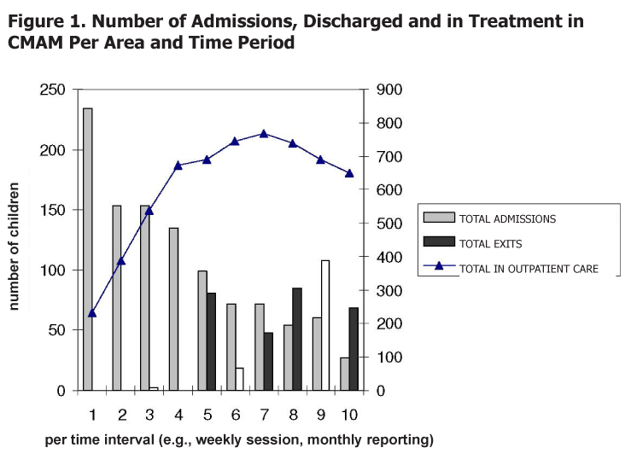

Figure 2. Discharge categories in CMAM per area and time period
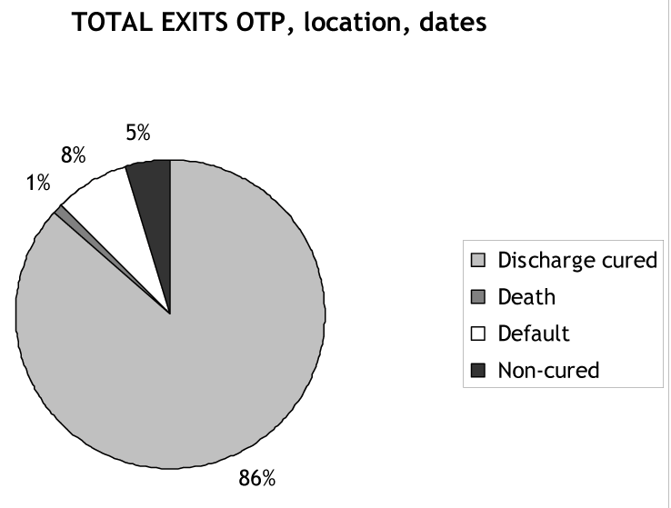

Exercise 8.1 Outpatient Care Site Tally Sheet and Site Reporting Sheet

Exercise 8.1(a) Outpatient Care Site Tally Sheet

SITE | Kawale
 | Wk 6 | wk 7 | wk 8 | wk 9 | TOTAL
Date | 4/02/18 | 11/02/18 | 18/02/18 | 25/02/18
(A) Total start of week | 50
New Cases < 6 m (B1) | 2 | 1 | 3 | 0 | 6
New Cases 6-59 m bilateral pitting oedema (B2a) | 5 | 3 | 2 | 3 | 13
New Cases 6-59 m MUAC/WFH (B2b) | 7 | 15 | 1 | 6 | 29
Other New Cases (children ≥ 5 y, adolescents, adults) (B3) | 0 | 0 | 0 | 1 | 1
Old cases: Referred from inpatient care; other outpatient care; or Returned defaulters (C) | 2 | 1 | 0 | 1 | 4
(D) TOTAL ADMISSIONS (D=B+C)
Cured < 6 months (E1a) | 1 | 2 | 2 | 2 | 7
Cured 6- 59 months (E1b) | 3 | 4 | 6 | 5 | 18
Cured Other (children ≥ 5 y, adolescents, adults) (E1c) | 1 | 2 | 2 | 2 | 7
Died < 6 months (E2a) | 0 | 1 | 0 | 0 | 1
Died 6- 59 months (E2b) | 1 | 0 | 0 | 0 | 1
Died Other (children ≥ 5 y, adolescents, adults) (E2c) | 0 | 0 | 0 | 0 | 0
Defaulted < 6 months (E3a) | 1 | 1 | 0 | 1 | 3
Defaulted 6- 59 months (E3b) | 1 | 0 | 0 | 0 | 1
Defaulted Other (children ≥ 5 y, adolescents, adults) (E3c) | 0 | 0 | 0 | 0 | 0
Non-recovered < 6 months (E4a) | 1 | 0 | 0 | 0 | 1
Non-recovered 6- 59 months (E4b) | 0 | 1 | 0 | 1 | 2
Non-recovered Other (children ≥ 5 y, adolescents, adults) (E3c) | 0 | 0 | 0 | 0 | 0
Referrals to inpatient or outpatient care (F) | 1 | 3 | 1 | 2 | 7
(E) TOTAL DISCHARGES | 9 | 11 | 10 | 11 | 41
(G) TOTAL EXITS (G=E + F)
(H) Total end of week (H=A+D-G)

Exercise 8.1(b) Outpatient Care Site Reporting Sheet
MONTHLY REPORT FOR MANAGEMENT OF SAM - SITE
SITE | Kawale |  |  | IMPLEMENTED BY
REGION |  |  |  | MONTH / YEAR |  |  | February | 2018
 |  |  |  | TYPE OF MANAGEMENT  (CIRCLE) |  |  | Inpatient |  |  | Outpatient
DISTRICT |  |  |  |  |  | ESTIMATED MAXIMUM CAPACITY
ESTIMATED TARGET malnourished <5's
(based on latest survey data and admission criteria)
 |  |  |  |  | RUTF Consumption |  | packets/sachets |  | kg equivalent
Age Category | Total beginning of the month (A) | New Cases  (B) | Old Cases  (C) |  | TOTAL ADMISSIONS (D)  B+C = D |  | Discharges  (E) |  |  |  | REFERRAL (F)  to inpatient or outpatient care | TOTAL EXITS (G)  (E+F=G) | TOTAL END OF THE MONTH (H)  (A+D-G=H)
 |  |  |  |  |  |  | CURED  (E1) | DIED  (E2) | DEFAULTED (E3) | NON-RECOVERED (E4) | REFERRAL (F)  to inpatient or outpatient care | TOTAL EXITS (G)  (E+F=G)
< 6 Months (according to admission criteria)
6-59 Months
(according to admission criteria)
Other
(children ≥ 5 y, adolescents, adults )
TOTAL
 |  |  |  |  |  |  | % | % | % | %
 |  |  |  | TARGET  (Sphere Standards) |  |  | >75% | <10% | <15%
E1: Cured = reached discharge criteria
E2: Defaulted = absent for 3 consecutive sessions
E3: Non-recovered = does not read the discharge criteria after 4 months in treatment (after medical investigations)

Exercise 8.2 Completing Site Tally Sheet

The organisation is assumed to be an outpatient care site at the Yirba health centre in the Boricha district in the Southern Nations, Nationalities and People's Region (SNNPR) in Ethiopia. Six outpatient care treatment cards are filled in for the first two weeks of admission to the Yirba outpatient care site.

Handouts
- Outpatient care treatment cards for six children in the Yirba outpatient care site
- Site tally sheets for Yirba’s outpatient care site
- Site report for Yirba

Instructions
Go through the outpatient care treatment cards and the text below, and complete the site tally sheet for each week.

Yirba outpatient care admission pattern:
- Week 1: One infant under 6 months and two children 6-59 months with mid-upper arm circumference (MUAC) < 115 mm were admitted to the service.
- Week 2: Two children were admitted, one with bilateral pitting oedema +++ and the other with weight-for-height (WFH)/weight-for-length (WFL) < -3 z-score.
- Week 3: Two children were admitted, one with bilateral pitting oedema ++ and the other with MUAC < 115 mm.
- Week 4: Four admissions: three with MUAC < 115 mm, one with WFH/WFL < -3 z-score, and one moved in from inpatient care.

Outpatient Care Site Tally Sheet

Health facility name
District
Site | Inpatient care | Outpatient care
 | wk 1 | wk 2 | wk 3 | wk 4 | TOTAL
Date
Total start of week (A)
New Cases < 6 m (B1)
New Cases 6-59m Bilateral Pitting oedema (B2a)
New Cases 6-59m MUAC (B2b)
New Cases 6-59m WFH/WFL (B2c)
Other New Cases (children ≥ 5 y, adolescents, adults) (B3)
Old Cases: Referred from inpatient care, or Returned defaulters (C)
TOTAL ADMISSIONS (D=B+C)
Cured < 6 months (E1a)
Cured 6- 59 months (E1b)
Cured Other (children ≥ 5 y, adolescents, adults) (E1c)
Died < 6 months (E2a)
Died 6- 59 months (E2b)
Died Other (children ≥ 5 y, adolescents, adults) (E2c)
Defaulted < 6 months (E3a)
Defaulted 6- 59 months (E3b)
Defaulted Other (children ≥ 5 y, adolescents, adults) (E3c)
Non-recovered < 6 months (E4a)
Non-recovered 6- 59 months (E4b)
Non-recovered Other (children ≥ 5 y, adolescents, adults) (E3c)
Referred to inpatient care (F)
TOTAL DISCHARGES (E)
TOTAL EXITS (G=E + F)
Total end of week (H=A+D-G)

Exercise 8.4 Analysis of the Site Reports of Three Outpatient Care Sites and One Inpatient Care Site

Outpatient Care Site A

Age Category | Total beginning of the month (A) | New Cases  (B) | OLD CASES  (C) |  | TOTAL NEW ADMISSIONS  (D)  B+C = D |  |  |  | Discharges  (E) |  |  |  | REFERRAL (F)  to inpatient or outpatient care | TOTAL EXITS (G)  (E+F=G) | TOTAL END OF THE MONTH (H)  (A+D-G=H)
 |  |  |  |  |  |  |  |  | CURED  (E1) | DIED  (E2) | DEFAULTED (E3) | NON-RECOVERED (E4) | REFERRAL (F)  to inpatient or outpatient care | TOTAL EXITS (G)  (E+F=G)
< 6 Months (according to admission criteria) |  | 1
6-59 Months  (according to admission criteria) |  | 47
Other  (children ≥ 5 y, adolescents, adults) |  | 0
TOTAL | 50 | 48 | 4+1 |  | 49 |  |  |  | 30 | 3 | 6 | 9
 |  |  |  |  |  |  |  |  | 62.5% | 6.3% | 12.5% | 18.8%
 |  |  |  | TARGET  (Sphere Standards) |  |  |  |  | >75% | <10% | <15%

Outpatient Care Site B

Age Category | Total beginning of the month (A) | New Cases  (B) | OLD CASES  (C) |  | TOTAL NEW ADMISSIONS  (D)  B+C = D |  |  |  | Discharges  (E) |  |  |  | REFERRAL (F)  to inpatient or outpatient care | TOTAL EXITS (G)  (E+F=G) | TOTAL END OF THE MONTH (H)  (A+D-G=H)
 |  |  |  |  |  |  |  |  | CURED  (E1) | DIED  (E2) | DEFAULTED (E3) | NON-RECOVERED (E4) | REFERRAL (F)  to inpatient or outpatient care | TOTAL EXITS (G)  (E+F=G)
< 6 Months (according to admission criteria) |  | 3
6-59 Months  (according to admission criteria) |  | 117
Other  (children ≥ 5 y, adolescents, adults) |  | 0
TOTAL | 140 | 120 | 7+7 |  | 134 |  |  |  | 79 | 1 | 15 | 7
 |  |  |  |  |  |  |  |  | 77.5% | 0.9% | 14.7% | 6.8%
 |  |  |  | TARGET  (Sphere Standards) |  |  |  |  | >75% | <10% | <15%

Outpatient Care Site C

Age Category | Total beginning of the month (A) | New Cases  (B) | OLD CASES  (C) |  | TOTAL NEW ADMISSIONS  (D)  B+C = D |  |  |  | Discharges  (E) |  |  |  | REFERRAL (F)  to inpatient or outpatient care | TOTAL EXITS (G)  (E+F=G) | TOTAL END OF THE MONTH (H)  (A+D-G=H)
 |  |  |  |  |  |  |  |  | CURED  (E1) | DIED  (E2) | DEFAULTED (E3) | NON-RECOVERED (E4) | REFERRAL (F)  to inpatient or outpatient care | TOTAL EXITS (G)  (E+F=G)
< 6 Months (according to admission criteria) |  | 1
6-59 Months  (according to admission criteria) |  | 58
Other  (children ≥ 5 y, adolescents, adults) |  | 0
TOTAL | 40 | 59 | 3+4 |  | 66 |  |  |  | 40 | 0 | 4 | 6
 |  |  |  |  |  |  |  |  | 80.0% | 0% | 8.0% | 12.0%
 |  |  |  | TARGET  (Sphere Standards) |  |  |  |  | >75% | <10% | <15%

Inpatient Care Site

Age Category | Total beginning of the month (A) | New Cases  (B) | OLD CASES  (C) |  | TOTAL NEW ADMISSIONS  (D)  B+C = D |  |  |  | Discharges  (E) |  |  |  | REFERRAL (F)  to inpatient or outpatient care | TOTAL EXITS (G)  (E+F=G) | TOTAL END OF THE MONTH (H)  (A+D-G=H)
 |  |  |  |  |  |  |  |  | CURED  (E1) | DIED  (E2) | DEFAULTED (E3) | NON-RECOVERED (E4) | REFERRAL (F)  to inpatient or outpatient care | TOTAL EXITS (G)  (E+F=G)
< 6 Months (according to admission criteria) |  | 5
6-59 Months  (according to admission criteria) |  | 14
Other  (children ≥ 5 y, adolescents, adults) |  | 0
TOTAL | 18 | 19 | 11+0 |  | 30 |  |  |  | 0 | 1 | 2 | 1
 |  |  |  |  |  |  |  |  | NA% | NA% | NA% | NA%
 |  |  |  | TARGET  (Sphere Standards) |  |  |  |  | >75% | <10% | <15%

Monthly CMAM District Report (Consolidated for inpatient care and outpatient care)

Age Category | Total beginning of the period (A) | New Cases  (B) |  |  | TOTAL ADMISSION  (B) | Discharges  (E)
Age Category |  |  |  |  | TOTAL ADMISSION  (B) | CURED  (E1) | DIED  (E2) | DEFAULTED (E3) | NON-RECOVERED (E4)
< 6 Months  (according to admission criteria) |  | 10
6-59 Months  (according to admission criteria) |  | 236
Other  (children ≥ 5 y, adolescents, adults) |  | 0
TOTAL | 248 | 246 |  |  | 246 | 149 | 5 | 27 | 23
 |  |  |  |  |  | 73% | 2.5% | 13.2% |  | 11.2%
 |  |  |  | TARGET  (Sphere standards) |  | >75% | <10% | <15%

Conclusions Drawn from the Reports | Questions to Ask or Possible Explanations
1. Health centre B has more patients than the other centres. | 1. Is this normal? Does it cover a highly populated area or a very wide area? What are the walking distances to the centre? Is this centre manageable? Could a second centre be opened with existing resources?
2. At health centre C, more than half the admissions are from bilateral pitting oedema. | 2. Is this normal? Are the other health centres neglecting this diagnosis? Or, the opposite—is there an over-diagnosis of bilateral pitting oedema here? Is this health centre in a different food economy area? Was the same observation made in previous months and in surveys?
3. Out of the overall 246 new admissions, 227 were admitted directly to outpatient care (92.3%) and 19 to inpatient care (7.7%). | 3. This could be an indicator of the efficacy of “early detection” and therefore of the quality of community mobilisation. It also could indicate that children with serious conditions are hidden at households and are not reached.
4. Health centre A is not referring any patients to inpatient care. | 4. This could mean that no patients required transfer, but it should be checked through supervision.
5. The death and non-recovered rates in health centre A are quite high for outpatient care. | 5. This raises questions about the quality of the assessment of patients in this centre and the application of and adherence to treatment and action protocols.
6. Health centre B’s default rate is quite high and warrants follow-up to determine the reasons. | 6. Perhaps mothers/caregivers decide not to return because waiting times or walking distances are too long. It will be necessary to visit the centre to determine the reasons.
7. Health centre C’s cured rate is good although there are questions about the non-recovered rate. | 7. Is this related to the number of cases with bilateral pitting oedema, noted above? Could this be investigated?
8. Overall, 211 children left outpatient care during the month; 200 of these children were discharged. However, 11 were referred back to inpatient care, meaning that the conditions of 5.5% of the children under treatment in outpatient care deteriorated. | 8. Why is the condition of children deteriorating when under treatment in outpatient care? Is there compliance to medicine and RUTF protocols? What health and nutrition messages are mothers/caregivers receiving? Are there other underlying health conditions that must be addressed?
9. While 17 children were referred from inpatient care to outpatient care, the outpatient care sites admitted only 14 children referred from inpatient care. Note that 11 patients were referred from outpatient care to inpatient care and 11 admissions are registered in the inpatient care site report as referred from outpatient care. | 9. The difference between referrals from inpatient care and admissions to outpatient care could be due to a weak registration system or because some referred children did not go to the outpatient care sites. This observation should trigger closer assessment and supervision of the registration and referral system (e.g., the use of referral slips, the provision of transportation, the messages and explanations given to the mother/caregiver at the time of referral). Note that children who were referred left the site where they were being treated but did not leave the service/programme. The compiled number of cases under treatment in the district is 209, which counts 9 cases less than the sum of the individual report. This difference is due to the 3 missed referrals. Other missed cases may have been in transit while referred across months  (Note: This could be a shortcoming of the exercise and if this is repeated at the district level in the field, it should be reported for review of the compilation system).

Note: The specific discharge rates from the inpatient care site are not calculated. Children that improve are referred to outpatient care to continue treatment. The specific discharge rates would not reflect poor quality as they include ONLY those children with SAM that had medical complications. This is one of the reasons why the programme needs also to be evaluated as a whole, combining information from both inpatient and outpatient care as presented in the combined reporting sheet, where the performance indicators provide information of the CMAM service in the district for the management of SAM.

Supplemental Reference 8.1 Setting Up a CMAM Monitoring System Using an Electronic Database in Excel and Using a CMAM mHealth Application

- Setting Up a CMAM Monitoring System Using an Electronic Database

The following instructions can be used to construct a database for outpatient care and inpatient care sites per district in Excel.

STEP 1. Creating the Data Input Sheet (see Site Tally and Reporting Sheets)

1.1. Create Columns
• Create a spreadsheet in Excel with four columns titled: ‘Session Week’, ‘Site’ and ‘Month’.
• Create columns corresponding to the admission and exit criteria on your site tally and reporting sheet
• Ensure each column title is written in its own cell.
• Create columns titled:

Total End Last Session (or Total end of the week/month)
New Cases < 6 months
New Cases 6-59 months
New Cases Other
Old Cases
Total Admissions
Cured (disaggregated by age category: < 6 months, 6-59 months and other)
Death (disaggregated by age category: < 6 months, 6-59 months and other)
Defaulter (disaggregated by age category: < 6 months, 6-59 months and other)
Non-recovered (disaggregated by age category: < 6 months, 6-59 months and other)
Total Discharged
Referral
Total Exits
Total Under Treatment (or Total beginning of week/month)

1.2. Create Rows
• Write site names (e.g., names of health facilities with outpatient care or inpatient care sites) of the district in rows moving down the spreadsheet for cycle 1. (Leave some space to add extra sites as the service/programme progresses.)
• Write 1 in the each cycle number box.
• For the first row corresponding to cycle 2, write in a formula of the first box +1.
• Do not write site names for cycle 2. Write a formula of the appropriate cell in cycle 1.
• Make a bold line under the first cycle

1.3. Enter Formulas
• Add in formulas for:
Total end of last session (For cycle 1, there is no formula. Put 0 in the cells. For subsequent cycles, use Total under Treatment from the previous cycle).
Total Admissions = New cases <6 months + New cases 6-59 months + New cases other + Old cases

- Total Discharged = Cured + Deaths + Defaulters + Non-recovered
- Total Exits = Cured + Deaths + Defaulters + Non-recovered + Referral
-Total Under Treatment = Total End Last Session + Total Admissions – Total Exits

• For all formulas, click and copy formulas down the sheet to fill as many weekly cycles as required. (We recommend no more than one year’s data in one database.)

• Data can now be entered by cycle from the weekly tally sheets (Optional database at national level can use monthly cycles using the monthly district reporting sheets )

STEP 2. Creating the Data Report

• From the input sheet under ‘Data’ on the top menu, select ‘Pivot Table Report’.
• Click ‘Microsoft Excel List or database’.
• Highlight all of the spreadsheet
• Click ‘Next’ to get to the Pivot Table construction.
• Into ‘Page’, drag Site and Month.
• Into ‘Column’, drag Week.
• Into ‘Data’, drag the following variables in the following order: New cases 6-59 months, New cases other, Old cases, Total Admissions, Cured, Death, Defaulters, Non-recovered, Total Discharges, Referral, Total Exits, Total under treatment.
• Double click on all variables in data sheet in the Pivot Table construction. Perform the following on each one:

-Change title by removing Count of. Do not shift the title too much to the left or Pivot Table alarm will be set off.
-Change from Count to Sum.
-Click Number – click Number again – tick Use 1000 separator. Change decimal place to 0.
-Click Next – click new work sheet – rename it ‘Report’.

• Blank out number in grand total column for ‘Total under Treatment’ (the number is meaningless for CMAM data).
• Once data is added to the input sheet, the report can be updated. Place the cursor inside the report, right click and select ‘refresh data’.
• Data can be viewed by cycle for the whole service/programme or, if required, for individual sites or months.

For additional guidance on the construction and use of pivot tables, see:
https://support.office.com/en-us/article/create-a-pivottable-to-analyze-worksheet-data-a9a84538-bfe9-40a9-a8e9-f99134456576.

STEP 3. Creating the Graphs

Create Chart of Admission and Discharge Trends

• To make the bar chart, first click on the chart icon.
• In Custom Type, select ‘Line – Column’.
• In Series, click ‘Add’.
• Click ‘Name’ bar and write in ‘Total Admission’.
• Click ‘Values’ and highlight ‘Total Admission’ row in report (leave out grand total).
• Click ‘category x labels’ and highlight distribution cycles row.
• Click ‘Add’ again
• Click ‘Name’ bar and write in ‘Total Discharged’.
• Click ‘Values’ and highlight ‘Total Discharged’ row in report (leave out grand total).
• Click ‘Add’ again.
• Click ‘Name’ bar and highlight ‘Total under treatment’ row in report.
• Click ‘Next’, click ‘Chart Title’ and add in overall title and titles for axes.
• Put in new sheet – rename Graphs.

Create Pie Chart Showing Breakdown of Discharge Categories

• Click on the chart icon.
• Click on pie chart.
• In ‘Series’, click ‘Add’.
• Click ‘Values’ and highlight the data in ‘Grand Total’ for discharge variables (i.e. Cured, Death, Defaulter, Non-recovered). Do not include Referral or Total Exits.
• Click ‘Category labels’ and highlight the exit titles (i.e. Cured, Death, Defaulter, Non-recovered).
• Click Next, click Chart Title and write in title.
• Click Data label and tick percent.

See Figures in Handout 8.14 Guidance on CMAM Reporting for an example of how the graph and pie should look.

Note: When you start to input data into the database, columns corresponding to cycles where no data has yet been entered can be hidden. This makes it easier to view the report and graphs.

- Using a CMAM mHealth Application

To improve adherence to CMAM protocol and data management, mobile applications have been developed and used in several countries. Examples include:
- The CMAM application (CMAM app) developed by World Vision and Dimagi in 2013 and piloted in five countries (Chad, Kenya, Mali, Niger, and Afghanistan) with Save the Children and International Medical Corps. The mHealth app provides health workers with simple, step-by-step guidance to help them assess, treat, or refer children visiting the CMAM programme. The app is built on the CommCare platform, which uses a touch swiping function to take health workers through the steps, remind them of the treatment protocol and counselling messages, and calculate z-scores and the necessart amounts of ready-to-use therapeutic foods (RUTF) packets and routine medications. It also records the child’s information (making child follow-up easier) and uploads the data to the ‘cloud,’ providing live and accurate data for district and national level decision-making and management.
In 2015, Save the Children evaluated the app through the Transform Nutrition research consortium in Kenya and found that it reduced reporting errors by 25 percent (compared to the CMAM paper-based system), provided caseload and treatment data to decision-makers within 1.3 days, and improved health worker adherence to the CMAM protocol. More information on the app is available at http://www.transformnutrition.org/wp-content/uploads/sites/3/2017/04/TN_WorkingPaper1_MobileApp_Online.pdf and at http://www.transformnutrition.org/wp-content/uploads/sites/3/2017/06/TN_ResearchBrief14_Online.pdf.

- The World Food Programme (WFP) has also developed an application called SCOPE CODA (Conditional OnDemand Assistance) which builds upon WFP’s existing beneficiary management system, SCOPE, to meet the technical needs of nutrition treatment programmes, in providing a unified platform for registering individuals and monitoring performance. More information on the app is available at: https://innovation.wfp.org/project/scope-coda.


Collins et al. 2006. Management of severe acute malnutrition in children. The Lancet. 368: 1992-2000.
Collins, S. 2004. “Community-Based Therapeutic Care: A New Paradigm for Selective Feeding in Nutritional Crisis.” Humanitarian Practice Network Paper 48. Overseas Development Institute (ODI).
UNICEF. 2014. Nutridash 2013: Global Report on the Pilot Year. New York: UNICEF. Available at: https://unicefeapronutritionwashtoolkit.files.wordpress.com/2017/09/unicef-global-nutridash-report-2013.pdf.
In 2017, this term was redefined from ‘management of acute malnutrition in infants under 6 months’ to ‘management of at-risk mothers and infants under 6 months’ to reflect the profile of the mother-infant pair being identified, their associated risks, and consequently, the wider scope of interventions needed to cater for or support them; these include but are not limited to nutrition.
The training modules are: WHO. 2013. Updates on the Management of Severe Acute Malnutrition in Infants and Children. Geneva: WHO. WHO. 2012. Technical Note on Supplementary Foods for the Management of Moderate Acute Malnutrition in Infants and Children 6–59 Months. Geneva: WHO. WHO. 1998, updated in 2017–2018. Management of Severe Malnutrition: A Manual for Physicians and Other Senior Health Workers. Geneva: WHO. WHO. 2002, updated in 2009. Training Course on the Management of Severe Acute Malnutrition. Geneva: WHO. WHO. 2000. Management of the Child with Serious Infection or Severe Acute Malnutrition.
Lelijveld, N. et al. 2017. A Review of Methods to Detect Cases of Severely Malnourished Infants Less Than 6 Months for Their Admission into Therapeutic Care. Emergency Nutrition Network. Available at: https://www.ennonline.net/attachments/2615/MAMI-June-2017_Final-SHARE.pdf.
Caulfield, L.; de Onis, M.; Blössner, M.; and Black, R. 2004. “Undernutrition as an Underlying Cause of Child Deaths Associated with Diarrhea, Pneumonia, Malaria, and Measles.” American Journal of Clinical Nutrition. 80:193–8.
Briend, A, Maire, B, Fontaine, O et al. 2012. Mid-upper arm circumference and weight-for-height to identify high-risk malnourished under-five children. Maternal Child Nutrition 8, 130–133. Available at: https://onlinelibrary.wiley.com/doi/pdf/10.1111/j.1740-8709.2011.00340.x
Blackwell, N. et al. 2015. “Mothers Understand and Can Do It (MUAC): A Comparison of Mothers and Community Health Workers Determining Mid-Upper Arm Circumference in 103 Children Aged From 6 Months To 5 Years.” Archives of Public Health. Available at: https://archpublichealth.biomedcentral.com/articles/10.1186/s13690-015-0074-z.
Briend, A, Maire, B, Fontaine, O et al. 2012. Mid-upper arm circumference and weight-for-height to identify high-risk malnourished under-five children. Maternal Child Nutrition 8, 130–133. Available at: https://onlinelibrary.wiley.com/doi/pdf/10.1111/j.1740-8709.2011.00340.x
Lelijveld, N. et al. 2017. A Review of Methods to Detect Cases of Severely Malnourished Infants Less Than 6 Months for Their Admission into Therapeutic Care. Emergency Nutrition Network. Available at: https://www.ennonline.net/mamicasedetectionreview.
See videos as part of newborn and small baby series (Global Health Media) that include: ‘Danger Signs for Health Workers’ and ‘Fast Breathing as a Single Sign of Illness’, www.globalhealthmedia.org/videos/. Also see short videos (Medical Aid Films) at www.medicalaidfilms.org. Note that in acutely malnourished infants, usual clinical signs may be absent or reduced. It is essential to consider the full clinical picture and history in assessment.
Lower chest wall in-drawing is when the lower chest wall goes in when the child breathes in; if only the soft tissue between the ribs or above the clavicle goes in when a child breathes, this is not lower chest in drawing (it is recession). See ‘Danger Signs for Health Workers’ for video (footnote 1).
Grunting is a short, hoarse sound at the end of expiration (when the child breathes out) and is a sign of moderate to severe respiratory distress in young infants and children with lower airway disease, such as pneumonia, lung collapse (atelectasis) or fluid in the lungs (pulmonary oedema). See ‘Danger Signs for Health Workers’ for video (footnote 1).
Diarrhoea: for infants older than 1 month, 3 or more abnormally loose or watery stools per 24 hours [Note: breastfed infants up to 1 month of age can have a stool after every breastfeed].
IMCI for young infant says: “if you do not have a thermometer, feel the infant’s abdomen or armpit and determine if it feels hot or unusually cold”.
WHO cut-offs vary when pregnant and not pregnant and pregnancy defined until 6 weeks post-partum.
Recent evidence has shown that WFA can help identify underweight infants who are also at higher risk to mortality. WFA is therefore used as a criterion for enrolment of nutritionally vulnerable infants under 6 months. A cut-off of WFA <-2 is used to ensure consistency with WFL cut-offs.
There is recent growing evidence on the use of MUAC to identify acute malnutrition and nutrition vulnerability in infants under 6 months. However, a nutrition classification cutoff has not yet been established. Countries and programmes are encouraged to collect MUAC data for infants under 6 months to help build the evidence base for cutoffs and case management.
Nutritional oedema is rare in infants and therefore infants with oedema should always be admitted to in-patient care to investigate possible underlying medical cause. (feet, legs, whole body). Grade + Mild: Both feet/ankles; Grade ++ Moderate: Both feet, plus lower legs, hands or lower arms; Grade +++ Severe: Generalised bilateral pitting oedema, including both feet, legs, arms and face
In many settings, it can be difficult for a health worker or mother to detect acute weight loss in an infant. Where reported or detected, weight loss in infants should be interpreted alongside the general clinical condition; “lost more than 10% of previous weight”.
Questions are sensitive and context specific. Work with staff to decide together what works best in your particular situation.
Recent evidence has shown that WFA can help identify underweight infants who are also at higher risk to mortality. WFA is therefore used as a criterion for enrolment of nutritionally vulnerable infants under 6 months. A cut-off of WFA <-2 is used to ensure consistency with WFL cut-offs.
There is recent growing evidence on the use of MUAC to identify acute malnutrition and nutrition vulnerability in infants under 6 months. However, a nutrition classification cutoff has not yet been established. Countries and programmes are encouraged to collect MUAC data for infants under 6 months to help build the evidence base for cutoffs and case management.
This is context specific. Local adaptation may be needed depending on food security issues in the community and availability of programmes to refer to.
Lelijveld, N. et al. 2017. A Review of Methods to Detect Cases of Severely Malnourished Infants Less Than 6 Months for Their Admission into Therapeutic Care. Emergency Nutrition Network. Available at: https://www.ennonline.net/attachments/2615/MAMI-June-2017_Final-SHARE.pdf.
Nutrition vulnerability captures broader characteristics of the needs of infants under 6 months of age, and recognizes that not all the infants are equally vulnerable. For example, some had a low birth weight but are subsequently growing well; other infants are presently not wasted but are at risk and therefore in need of intervention. It is important that infants “at risk” are distinguished and that case management identifies and addresses underlying problems such as poor ability to feed, underlying medical conditions, maternal illness and poor mental health, and adverse social circumstances.
1 Lipid-based RUTF: e.g., Plumpy’nut^{® is} produced by Nutriset, France; similar RUTF products are produced by other companies in several countries, e.g., Ethiopia, Niger, Malawi, DRC.
3 The ENA approach, which has been adopted in several countries in Africa, Asia, and Latin America, identifies the key nutrition actions that can be promoted at key contact points in the life cycle through research-based messages that are contextually appropriate. The seven key action areas are: 1) promotion of optimal breastfeeding practices during the first six months; 2) promotion of optimal complementary feeding beginning at six months with continued breastfeeding to 2 years and beyond; 3) promotion of feeding of the child during and after illness; 4) prevention of Vitamin A deficiency (e.g., breastfeeding, consumption of fortified and Vitamin A-rich foods, maternal and child Vitamin A supplementation); 5) prevention of anaemia (e.g., maternal and child iron supplementation, deworming, malaria control, consumption of fortified and iron-rich foods); 6) promotion of iodized salt consumption by all families; and 7) promotion of improved women's nutrition (e.g., consumption of diversified and/or fortified foods during adolescence, increased food intake during pregnancy and lactation, iron and/or folic acid supplementation, treatment and prevention of malaria, deworming during pregnancy, postpartum Vitamin A supplementation). Visit http://coregroup.nonprofitsoapbox.com/resources/488-essential-nutrition-actions-and-essential-hygiene-actions-framework for more information.
Israel-Ballard K et al. Flash heat inactivation of HIV-1 in human milk. A potential method to reduce postnatal transmission in developing countries. J Acquir Immun Defic Syndr 45 (3): 318-323, 2007)
Depending on national guidelines for discharge from outpatient care, recovery from SAM can include one or more of the following criteria: no bilateral pitting oedema for more than two consecutive sessions; mid-upper arm circumference (MUAC) ≥ 125 mm; weight-for-height (WFH)/ weight-for-length (WFL) ≥ -2 z-score for more than two consecutive sessions; clinically well and alert.
An infant under 6 months of age can be discharged from outpatient care when s/he has no bilateral pitting oedema for more than two consecutive sessions, is exclusively breastfeeding effectively, is consistently gaining adequate weight, is clinically well and alert, and the mother is confident with feeding and care, and follow-up is scheduled.
2 These include cases when there is a lack of outpatient care in the area, concern about safety, or no mother/caregiver at home, or when a patient or mother/caregiver’s preference to stay in inpatient care.
Lelijveld, N. et al. 2017. A Review of Methods to Detect Cases of Severely Malnourished Infants Less Than 6 Months for Their Admission into Therapeutic Care. Emergency Nutrition Network. Available at: https://www.ennonline.net/attachments/2615/MAMI-June-2017_Final-SHARE.pdf.
Lelijveld, N. et al. 2017. A Review of Methods to Detect Cases of Severely Malnourished Infants Less Than 6 Months for Their Admission into Therapeutic Care. Emergency Nutrition Network. Available at: https://www.ennonline.net/attachments/2615/MAMI-June-2017_Final-SHARE.pdf.
Source: Adapted from Global Nutrition Cluster. 2017. Moderate Acute Malnutrition: A Decision Tool for Emergencies. Available at: http://nutritioncluster.net/?get=002086%7C2014/07/MAM-Decision-Tool-final-June-2014-corrected.pdf.
Source: Adapted from Global Nutrition Cluster. 2017. Moderate Acute Malnutrition: A Decision Tool for Emergencies. Available at: http://nutritioncluster.net/?get=002086%7C2014/07/MAM-Decision-Tool-final-June-2014-corrected.pdf.
“Nutrition vulnerability” captures broader characteristics of the needs of infants under 6 months of age and recognizes that not all infants are equally vulnerable; for example, some had a low birth weight but are subsequently growing well while other infants are presently not wasted but are at risk and therefore in need of intervention. It is important that infants who are “at risk” are distinguished and that case management identifies and addresses underlying problems such as poor ability to feed, underlying medical conditions, maternal illness and poor mental health, and adverse social circumstances.
Lelijveld, N. et al. 2017. A Review of Methods to Detect Cases of Severely Malnourished Infants Less Than 6 Months for Their Admission into Therapeutic Care. Emergency Nutrition Network. Available at: https://www.ennonline.net/attachments/2615/MAMI-June-2017_Final-SHARE.pdf.
WFP has renamed its FBFs as follows: CSB+=CSB Super Cereal, CSB++=CSB Super Cereal Plus, WSB+=WSB Super Cereal, WSB++=WSB Super Cereal Plus, RSB+=RSB Super Cereal, RSB++=RSB Super Cereal Plus.
Ghana Statistical Service. February 2007. Ghana Multiple Indicator Cluster Survey 2006.
Gross, R. and Webb, P. 2006. “Wasting Time for Wasted Children: Severe Child Undernutrition Must Be Resolved in Non-Emergency Settings—Viewpoint.” The Lancet. 367:1209–1211.
RUTF is not administered to infant under 6 months; however, the RUTF estimates were based on children 0–59 months and are therefore slightly overestimated. Neither the Demographic and Health Survey (DHS) nor the MICS provided wasting prevalence rates for the 6–59-month age group.
Weanimix was composed of four measures of cereal (maize, millet, rice or sorghum) and one-half measure of legumes (peanuts or beans).
A community health officer is a community health nurse or midwife with additional training.
The nutrition situation is also considered serious if GAM is between 10 percent and 14 percent and there are aggravating factors such as a general ration that is below the mean energy requirement, an epidemic of measles or whooping cough, a high incidence of respiratory infections or diarrhoeal disease and/or a CDR > 1/10,000/day. (World Food Programme [WFP] and United Nations High Commissioner for Refugees (UNHCR). 2011. Guidelines for Selective Feeding: The Management of Malnutrition in Emergencies. Available at: https://cms.emergency.unhcr.org/documents/11982/32558/Guidelines+for+selective+feeding.+The+management+of+malnutrition+in+emergencies/117faa46-7fa4-446b-8104-10f5a4c763e1)
Young, H. and Marshak, A. 2017. Persistent Global Acute Malnutrition. Boston: Feinstein International Center, Tufts University. Available at: https://pdfs.semanticscholar.org/80be/b88f02eed22667e9ae927b50af4b518a04ae.pdf.
Deconinck, H. et al. 2016. “Challenges of Estimating the Annual Caseload of Severe Acute Malnutrition: The Case of Niger.” PLoS ONE. 11(9): e0162534. doi:10.1371/journal.
Bulti, A. et al. 2017. “Improving Estimates of the Burden of Severe Acute Malnutrition and Predictions of Caseload for Programs Treating Severe Acute Malnutrition: Experiences from Nigeria.” Archives of Public Health. 75:66 DOI 10.1186/s13690-017-0234-4.
If outpatient care is functioning well, the inpatient caseload should be low (normally five to 10 patients, depending on the catchment area and prevalence of severe acute malnutrition [SAM]). Therefore, staff roles can be combined.
SCOPE is WFP’s beneficiary and transfer management platform that supports the WFP programme intervention cycle from beginning to end. The SCOPE platform is a web-based application used for beneficiary registrations, intervention setups, distribution planning, transfers and distribution reporting

