SQUEAC Investigation Report – Quality Assurance Guidelines
STAGE 2 - Key focus: In stage 1, the areas of high and low coverage and the reasons for coverage failures are identified and a hypothesis is developed for further investigation. In Stage 2, a hypothesis is formed based on this finding which is then tested.
Hypothesis: Must be derived from evidence in stage 1. | An example of hypothesis;  ‘Higher awareness of CMAM programme amongst communities close to CMAM sites. Lower awareness of CMAM programme amongst communities far from CMAM site.’  General rule:  Findings from Stage one may generate more than one hypothesis, however it is always advisable to select one hypothesis to test.  N.B. Do not always use distance as a hypothesis to test if others are more relevant  For more information please refer to the SQUEAC & SLEAC manual – P. 12
Study description: Describe the nature of the study;  - Small Study  - Small Survey  - Small Area Survey | The details of the study should be detailed;  Small Studies  Semi-quantitative pieces of work that focus on testing a single hypothesis, generally relating processes that affect coverage rather than coverage directly. E.g. OTP-SFP Interface could be tested through an observational study  Small Surveys  Small sample surveys undertaken in population groups (Christians/Muslims, Pastoralists/Agriculturalists, etc)  E.g. Coverage is higher in Sedentary populations and lower in Pastoralist populations  Small-area Surveys  Small sample size surveys used to test hypotheses regarding the spatial distribution of coverage  E.g. Coverage is likely to be low where there are few admissions.
Methodology: describe sampling methodology appropriate to hypothesis | Sample sizes for small surveys and small-area surveys are not calculated in advance. The survey sample size is the number of cases found by the survey. There is no minimum sample size to be achieved as we are not calculating coverage, rather testing a hypothesis.  Important to detail:  - Villages to be sampled  - Why these villages have been selected  - What method will be used to sample in the village (i.e. Active / adaptive or door to door)  As a general rule-of-thumb, small area survey field data collection should be completed in a single day. Therefore the number of villages/section for small area surveys should be selected based on the number of survey teams (6- 8 villages). Of the selected villages half are assumed to have satisfactory coverage and half unsatisfactory coverage.
Case definition: Define the type of cases included in the study (include anthropometry if applicable) | The case definition generally used for a SQUEAC/SLEAC can be defined as “a child matching the admission criteria of the programme”. The admission criteria of CMAM programmes include children aged between 6 and 59 months with at least one of the following criteria for SAM:  - A Mid Upper Arm Circumference (MUAC) of <11.5 cm  - Bilateral pitting oedema  For the SQUEAC assessment local names are used for case finding.  For more information please refer to the SQUEAC & SLEAC manual – P. 42
LQAS decision rule: Indicate appropriate decision rule and rationale / indicate calculations | The sample size (i.e. the number of cases found) in small-area surveys will usually be too small to estimate coverage with reasonable precision. However, it is possible, to classify coverage with small sample sizes using the formula below.  The SPHERE minimum standard for coverage of therapeutic feeding programs in rural settings is 50%. The rule-of-thumb formula may be used to calculate a value for classifying coverage as being above or below a standard of 50% for any sample size (n): see formulae below:  n  d = [ ]  2  For example,  Analysis of data using the above formula involves examining the number of cases found (n) and the number of covered cases found. If the number of covered cases found exceeds the threshold value (d) then coverage is classified as being satisfactory. If the number of covered cases found does not exceed this threshold value (d) then coverage is classified as being unsatisfactory. The value of d depends on the number of cases found (n) and the standard against which coverage is being evaluated, i.e. 50% for rural area, 70% for Urban and 90% for camp settings.
Quantitative data results: Tabulate / graph data results | The data in the table demonstrates the number of SAM cases found in the ‘small area survey’ and how many are in the programme and not in programme.  Table xx: Active SAM cases found ‘Small Area Survey’ in xx
  Status | Total case found | In prog. | not in prog.
  high admission sites (ward xx ) | 44 | 28 | 16
  Low admission sites (ward xx ) | 5 | 3 | 2
Hypothesis rejection or confirmation: Accept / reject the hypothesis. | The findings of the small-area survey confirm or reject the hypothesis under test. It also identifies the barriers to access and coverage.  Example:  Table: xx Knowledge levels of communities; far away/close by villages from OTP sites
  Close by villages (< 1 hour walking distance) | Number | Far away villages ≥ 3 hours walking distance) | Number
  Communities aware of the CMAM programme | 75% (  3 out of 4) | Communities aware of the CMAM programme | 75%  (3 out of 4)
  Communities not aware of the CMAM programme | 25%  (1 out of 4) | Communities not aware of the CMAM programme | 25%  (1 out of 4)
  Community aware about malnutrition | 50%  (2 out of 4) | Community aware about malnutrition | 25%  (1 out of 4)
  Community aware about malnutrition | 50%  (2 out of 4) | Community not aware about malnutrition | 75%  (3 out of 4)
  More than 50% respondents were aware about the programme and malnutrition, therefore this part of the hypothesis was confirmed. |  | Not more than 50% respondents were aware about the programme and malnutrition therefore this part of the hypothesis was confirmed.
Qualitative data results: Describe / tabulate / graph data results | Qualitative data results (Barriers): graph on data results (cases not in prog.) are listed and then triangulated with the findings from stage one. For example see graph below  Figure: xx Reasons given by the mothers for being ‘not in programme’ xx, SQUEAC, 2014
Triangulate findings of Small area survey with findings of Stage 1. | Findings of Small area survey should try to ensure that data and findings are triangulated with stage 1 (contextual data, by both source and routine program data and data from small-area surveys).  For more information please refer to the SQUEAC & SLEAC manual – P. 40

STAGE 3- Key focus
Setting of the ‘Prior’ based on findings/ results of Stage One and Stage Two, using Bayesian SQUEAC. | Bayesian statistic allows for smaller survey sample sizes to be used to provide credible results. In the Bayesian approach, a ‘Prior’ (the mode of the probability density) can be set which assumes the most likely coverage rate that a programme expects.  To set the prior, many methods can be used:  - A histogram can be drawn based on the results from Stage 1 &2  - The Boosters and Barriers are counted  - The Boosters and Barriers are weighted in terms of their relative importance  - A concept map is drawn clarifying the interconnections between the barriers and boosters. The negative arrows and positive arrows are then summed to calculate a mode.  All of these methods should be detailed in their entirety. For concept maps, a photo should be included where possible.  The average of these methods should then be calculated and a prior produced.  For more information please refer to the SQUEAC & SLEAC manual – P. 73-74  Using the calculations in the manual the α and β should be calculated and entered into the Bayes calculator  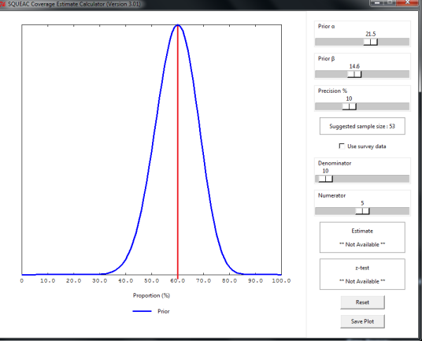
Sample size & Precision | The sample size required for a likelihood survey depends on the prior and the precision required. The precision should be set at 10%, and should go no higher than 14%.  The sample size can be calculated using the formula, or by Bayesian SQUEAC by computer simulation approach. See in graph above, ‘suggested sample size’.
Primary sampling units/framework: | In order to use a spatial stratified quadrant approach, an up-to-date map should be used where all villages are listed with a scale of 1: 100,000.  If this is not available then a list of the villages should be used with an appropriate sampling interval.  A list of the villages visited should be included with the amount children in the target population in the village surveyed, detailing those who were covered and not covered.  For more information please refer to the SQUEAC & SLEAC manual – P. 93
Number of villages to be sampled | The calculated sample size is the number of SAM cases (n) required. This needs to be translated into the minimum number of villages that need to be sampled to achieve this sample size. This is done using the following formula:  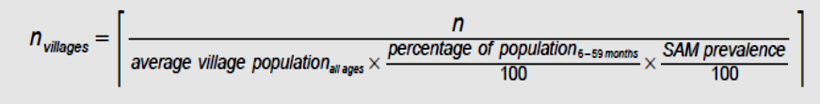  For more information please refer to the SQUEAC & SLEAC manual – P. 99
Case finding methodology: | Active Adaptive / ‘Door to Door’ etc. Same as Small area survey.
Qualitative data framework: | Questionnaires for cases ‘NOT IN’ the programme are to be administered to identify the barriers to access services. Same as Small area Survey.
Coverage Estimations | To estimate the coverage of a programme, either Point coverage or Period coverage must be chosen. Only one estimation should be reported.  Point coverage. This estimator uses data for current cases only. It is calculated using the following formula:  Period coverage. This estimator uses data for both current and recovering cases. It is calculated using the following formula:  For more information please refer to the SQUEAC & SLEAC manual – P.104
Bayes coverage estimate with credibility intervals (point / period coverage) | To estimate coverage use the pre-set prior, total number of SAM cases (denominator) identified in the Wide area survey and total number of SAM cases found in the programme (numerator).  The graph below shows that the prior & likelihood are nicely overlapped, this means that there is no conflict between the prior and likelihood and posterior.  This result can also be verified by P value. Should the P value be <0.05, there is a significant conflict between the prior and likelihood, therefore the results may not be validated. See example below:  For more information please refer to the SQUEAC & SLEAC manual – P.92  Point coverage of SAM, XX programme, Bayesian-SQUEAC graph  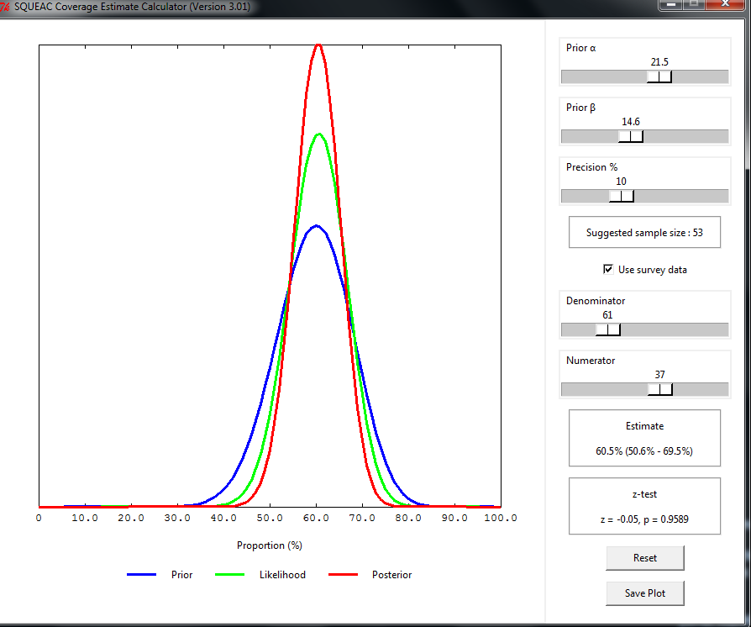
Bayes coverage estimate with credibility intervals (point / period coverage) | The graph above shows that the ‘Point’ coverage is estimated at 60.5% rate with Credible Interval (CI- 50.6% - 69.5%), which lies with the expected upper (80%) and lower (40%) coverage rate and the z test revealed that the P value 0.9589 (meaning >0.05). Therefore there is sufficient overlap between the curves (prior and likelihood) meaning no conflict is detected between the curves. Therefore the survey result is valid.
Manual calculation of coverage | If Bayesian calculator is un-available then calculate manually to estimate coverage.  37 (# cases in prog.)  Point coverage x 100 = 60.65%  61 (total # of cases found)
Qualitative data results: Qualitative data tabulated or graphed (reasons for non- attendance or default). | This finding on reasons for cases ‘not attending’ the programme. The reasons are presented in charts. See example in Stage 2.

Myatt, Mark et al. 2012. Semi-Quantitative Evaluation of Access and Coverage (SQUEAC)/Simplified Lot Quality Assurance Sampling Evaluation of Access and Coverage (SLEAC) Technical Reference. Washington, DC: FHI 360/FANTA.
Myatt, Mark et al. 2012. Semi-Quantitative Evaluation of Access and Coverage (SQUEAC)/Simplified Lot Quality Assurance Sampling Evaluation of Access and Coverage (SLEAC) Technical Reference. Washington, DC: FHI 360/FANTA.
Myatt, Mark et al. 2012. Semi-Quantitative Evaluation of Access and Coverage (SQUEAC)/Simplified Lot Quality Assurance Sampling Evaluation of Access and Coverage (SLEAC) Technical Reference. Washington, DC: FHI 360/FANTA.
Myatt, Mark et al. 2012. Semi-Quantitative Evaluation of Access and Coverage (SQUEAC)/Simplified Lot Quality Assurance Sampling Evaluation of Access and Coverage (SLEAC) Technical Reference. Washington, DC: FHI 360/FANTA.
Myatt, Mark et al. 2012. Semi-Quantitative Evaluation of Access and Coverage (SQUEAC)/Simplified Lot Quality Assurance Sampling Evaluation of Access and Coverage (SLEAC) Technical Reference. Washington, DC: FHI 360/FANTA.
Myatt, Mark et al. 2012. Semi-Quantitative Evaluation of Access and Coverage (SQUEAC)/Simplified Lot Quality Assurance Sampling Evaluation of Access and Coverage (SLEAC) Technical Reference. Washington, DC: FHI 360/FANTA.
Myatt, Mark et al. 2012. Semi-Quantitative Evaluation of Access and Coverage (SQUEAC)/Simplified Lot Quality Assurance Sampling Evaluation of Access and Coverage (SLEAC) Technical Reference. Washington, DC: FHI 360/FANTA.
Myatt, Mark et al. 2012. Semi-Quantitative Evaluation of Access and Coverage (SQUEAC)/Simplified Lot Quality Assurance Sampling Evaluation of Access and Coverage (SLEAC) Technical Reference. Washington, DC: FHI 360/FANTA.

